THE HISTORY OF SI ABERDEEN (1970 -2000)
1970 also saw the presentation of a watch to Poppy Vejjubil, the Thai nurse whose training had been supported by the club, and a gift from her to the club of a silver rose bowl which is annually presented to the club’s outgoing president. In 1971 the club raised funds to rescue stained glass windows, illustrating the city’s association with the sea, from the swimming baths at Aberdeen beach which were being demolished. The windows were restored and presented to the Winter Gardens in the Duthie Park to mark the 50th year of Soroptimist International. Over the next few years members heard from speakers covering a variety of subjects including the work of the Children’s Panel and the Lady Provost as well as topics on coastal fishing and jewellery making. Monies continued to being raised for the club’s Golden Jubilee, funds were donated to Aberdeen Old People’s Welfare Council Day Club, the YMCA, and support was again extended to the Victoria Lodging House.
During the year 1975 to 1976 a group of members attended the Scottish Conference in Dundee, and amongst the donations was a sum to the Federation Emergency Fund. The club supported the very first Quadrennial project in 1978, raising funds for the Maldive Islands, to train twenty paramedics and to provide fourteen medical boats to carry medical supplies and equipment to the islands. In 1979 the Glasgow Conference celebrated the International Year of the Child and over the next year the club was part of a project with local organisations to purchase an Evoked Response Audiometer machine for the Royal Aberdeen Children’s Hospital. It was the first of its kind in Scotland and enabled doctors to test for deafness in new-born babies.
Over many years the Victoria Lodging House had been supported by club members and in 1981 it was reported that since 1963 the club had handed over 709 pairs of socks, 39 pairs of gloves, 61 pairs of mittens, 93 pairs of cuffs, 3 pullovers,1 shawl and a blanket which were all knitted by past members! A year later, in 1982, the Soroptimist Housing project was initiated to provide accommodation for women over 60 years of age in the former home of Dr Mary Esslemont who had bequeathed her house and grounds to the club. Elizabeth Henry, a past club president, was heavily involved in the establishment of the housing development and one of the new blocks of flats was named and remains, Elizabeth Henry House, as the result of her involvement. The Aberdeen Soroptimist Housing Association was established and in May 1987 the association was proud to welcome its first tenant. The official opening was performed in July that year by the Lady Provost.
1982 also saw the first International President’s December 10th Appeal which has been supported by the club ever since, and for a number of years, with an annual club auction and on occasions, with sales of donated goods. The following year a successful project was launched to raise funds for a Meals on Wheels vehicle for the WRVS, and around this time club member volunteers began to help at Roxburghe House, a local palliative care unit, by manning their coffee shop. This continued for nearly thirty years.
In 1985 the club’s involvement with the Phoenix Club started. This is a local social club for adults with learning disabilities, offering a range of activities. For nearly thirty years members drove the club members to their club. An International Students’ party was arranged by SI Aberdeen in 1986, and club members heard talks on Teaching in Peterhead Prison, Caring for the Handicapped, Conservation of the Environment, and Street Children. Later in the eighties the Friends of Aberdeen Cyrenians was launched, and members attended the SI Convention in Melbourne. The club celebrated its Diamond Jubilee in 1989 with a weekend of events, starting with tree planting in the Duthie Park and a civic reception in the Winter Garden. Supper followed in a local hotel and on the Saturday there was a bus tour of the city followed by a formal dinner for a hundred and sixty guests. There was also a floral display in Union Terrace Gardens. Funds were given to the BBC Children in Need appeal, Newton Dee and to Guide Dogs for the Blind.

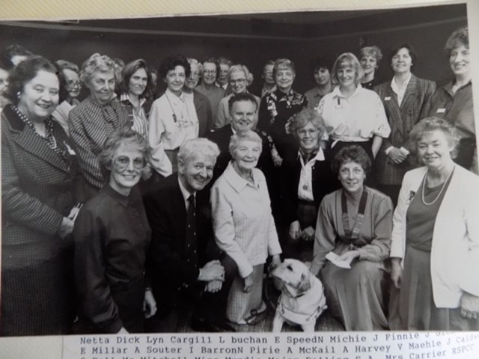

In 1990 the club’s ‘100 club’ started and still runs to this day. A silent auction was also held and donations were made to the Parkinson’s Disease Society, Operation Raleigh and to the local Smithfield School. Between 1991 and 1992 members supported the SI Quadrennial project for Sightsavers which raised funds to save the eyesight of under-fives in Bangladesh and Africa. Along with other organisations the club ran a very successful Fun Day raising funds for an ophthalmology machine, used to save the sight of diabetes patients in Grampian. Four members participated in the Grampian TV quiz, ‘Top Club’ and finished in second place. Between 1992 and 1994 money was raised for research into MS, and a talk on Gomel and the plight of the Cerebral Palsy Family Group there led to a club initiative to offer support, and created a link with the local Friends of Gomel. A talk on Bosnia served to highlight the plight of women in the war-torn country. In 1994 the club celebrated its sixty-fifth anniversary and welcomed visitors from Japan, Poland, France and Malta. Members also made a trip to Regensberg, one of the club’s friendship links. Amongst those who benefitted from donations were the Instant Neighbour Trust, the Salvation Army, and the Leukaemia in Children charity. Around this time a group of members began visiting patients in the long stay women’s ward of Cornhill Hospital. The visits continued for 10 years.
The club went on to support projects in Bosnia and Romania and initiated ‘operation washbag’, emphasising the importance of personal items for women in war-torn Kosovo who had nothing. A local newspaper appeal resulted in the provision of over 1200 washbags as well as soap and children’s toys. Transport to London and on to Kosovo by the RAF was provided with no charge. Following a plea to the club from her family members later supported a young Kosovan woman to complete her architect degree.
In 1996 the stained- glass windows in the Winter Gardens were repaired, cleaned and reframed, this time to celebrate the 75th anniversary of Soroptimist International. Members attended a fundraising gourmet evening in Aberdeen (North East) College and prizes were given to the most improved catering students. This event had been established for some time and continued annually for several years. Members attended the Federation Conference in Harrogate, there was a clean-up of Balmedie beach and a donation was made to the Maryculter Driving for the Disabled.
In 1998 the Walkathon was a very successful event initiated by the club. The event ran for ten years and raised thousands of pounds for local good causes. Another initiative that year was a week’s use of the Aberdeen City Council’s charity shop and this continued to feature in the club’s fundraising efforts for twenty years. Donations were made to ActionAid, Books Abroad and Crossroads. A weekend of events to celebrate the club’s 70th anniversary included a civic reception at the Maritime Museum and a dinner at the Town and County Hall. During the same year the club was visited by the Soroptimist International President. Later, following the death of club member Lavina Buchan, a bequest from her to the club was used to erect a commemorative bench in her name. It can be seen in Johnson Gardens.

