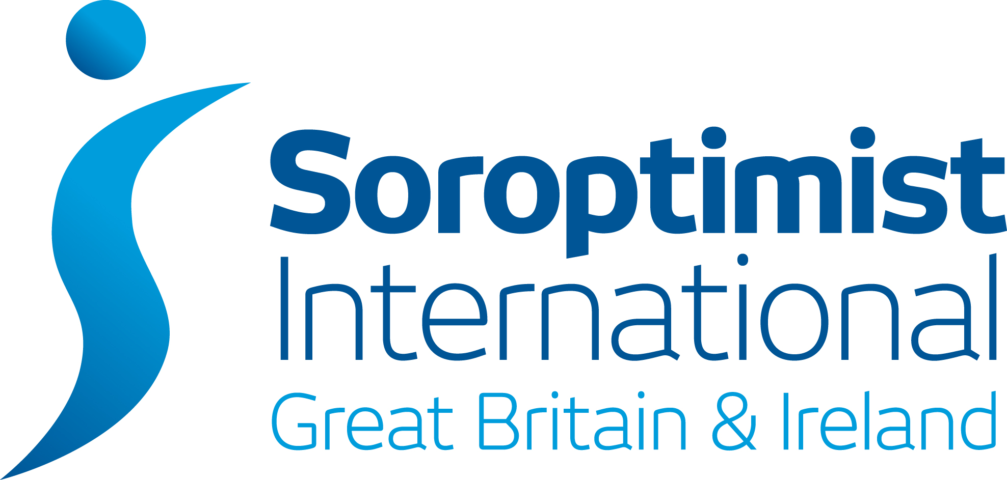 | 2nd Floor Beckwith House,  1 Wellington Road North, Stockport Cheshire SK4 1AF  Company Number 07058666  Telephone Number: +44 (0)161 480 7686  Email: hq@sigbi.org Website: www.sigbi.org

DONATION FORM

From Soroptimist International of: …………………………………………………….

Date: …………………………………………………….

Name: …………………………………………………….

Position: …………………………………………………….

Email: …………………………………………………….

Please find enclosed donation(s) for the funds listed below:-

Soroptimist International Foundation £

Benevolent Fund £

Diamond Education Grant £

Emergency Relief Fund £

SIGBI Ltd £

Total £

Your support is vital for these funds to continue to be effective and all donations are very much appreciated.

Cheque: Completed donation form and cheques should be made payable to SIGBI Ltd and sent to SIGBI HQ at the
above address. Full details of each of the charities can be found on the SIGBI Website – www.sigbi.org.

BACS: Account Name: SIGBI Ltd
Account Number: 55780083
Sort Code: 01-08-38
IBAN: GB54NWBK01083855780083
IBAN BIC: NWBKGB2L
Bank: NatWest – Great Underbank, Stockport

Bank Reference: Please include the first seven digits of your Club Name (without the SI) in the reference, plus include one of the following abbreviations:
SIF — Soroptimist International Foundation
Ben—Benevolent Fund
DEG—Diamond Education Grant
ERF—Emergency Relief Fund
SIGBI – SIGBI Ltd

Donations will be acknowledged by email to person named on this form. If you have any queries, please contact SIGBI HQ.

Updated 26 September 2023

