CANTERBURY WOMAN OF THE YEAR 2021
Celebrating our SIXTIETH ANNIVERSARY
NOMINATOR

Name | Click here to enter text.

Address | Click here to enter text.
Email | Click here to enter text.
Telephone | Click here to enter text.

WOMAN I AM NOMINATING

Name | Click here to enter text.

Address | Click here to enter text.
Email | Click here to enter text.
Telephone | Click here to enter text.

How do you know the woman you are nominating?
Friend ☐
Relative ☐
Colleague ☐
Other Click here to enter text.

Is she aware that you have nominated her?
YES ☐ NO ☐

If no, we advise that you inform her of the nomination.

In order to qualify, the woman you are nominating should live and / or work within the boundaries shown in the map below.
Please confirm: Works ☐ Lives ☐
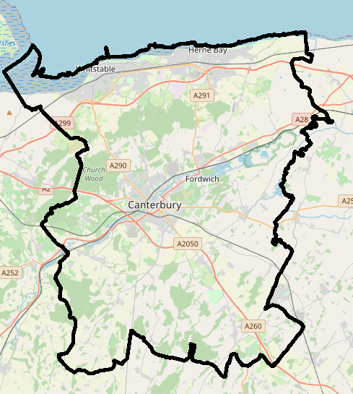
Canterbury City Council: Administrative Boundaries Information (canterbury.gov.uk)
CT1 – CT6

In one sentence why are you nominating this woman?
Click here to enter text.

What is her contribution? Why do you consider this to be exceptional?
Click here to enter text.

What challenges has she overcome?
Click here to enter text.

What impact / what difference has she made?
I am proud to nominate this person, she has made a difference by…
Click here to enter text.

Forms to be returned to:
womanoftheyear.canterbury@gmail.com
or by post to
Carol Reed BEM
President 2021 SOROPTIMIST INTERNATIONAL Canterbury
25 Cherry Garden Road Canterbury CT2 8EP
T: 01227 451192
M: 07753 502762
www.sigbi.org
www.sigbi.org/canterbury
https://www.facebook.com/CanterburySoroptimists

Launching on
Deadline for nominations: Monday 24 May 2021
The winner will receive a £100 donation to the Charity of her choice.
AWARD CEREMONY: 19 June 2021

