September 2018

LOUD AND PROUD
2018-2019 Public Speaking Competition for Year 6 Girls
Sponsored by Soroptimist International Croydon and District

Dear Head Teacher

On behalf of the Croydon Soroptimists, I would like to invite your school to participate in our Girls’ Public Speaking Competition, ‘Loud and Proud’, which is open to year 6 girls. Schools are invited to send a maximum of two representatives.

The competition will be organised as follows:

(1) Internal Heats to be arranged by each school, which will select its own two representatives.

(2) The Final will be held in the Council Chamber, Croydon Town Hall on Friday 1st March 2019
from 11:00 to 13:00, followed by refreshments. Prizes will be presented by The Mayor of Croydon and all competitors will be offered a tour of the House of Commons. In addition, the winners will receive a Whitgift/Centrale Shopping Centre gift voucher.

The competition gives girls an opportunity to improve the art of communication and research their chosen topic. Whilst encouraging participation in public life, it also allows them to develop confidence and the skills to speak effectively. We therefore welcome your participation.

Please pass the enclosed information to the teachers in your school with responsibility for English, speech and drama, and/or performing arts. If you would like your school to take part, the entry form (attached to the Competition Notes document which accompanies this letter) should be completed and returned to me by Friday 7th December 2018. Additional copies of the competition rules and entry form may be downloaded from our website: https://sigbi.org/croydon-and-district/ Please note that following oversubscription of this competition in previous years, places are limited and allocated strictly on a first-come-first-served basis.

If you have any further questions, please email me at sheilapatel@sky.com

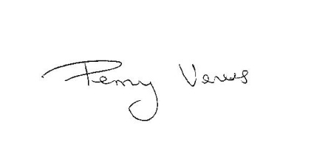
Yours sincerely,

Penny Veness (Mrs)
Competition Convenor
Soroptimist International Croydon and District

