EXECUTIVE

President : Marion Coleman
President Elect :
Vice President : -
Immediate Past President : Julie Williams
Secretary : Sharon Edwards
Treasurer : Mary Plant
Programme Action Officer Andrea Pearson
Communications Officer : Julie Williams Membership Officer : Janet Porter
Regional Representatives
November 2021 to October 2022 : Theresa Banks
November 2022 to October 2023 : Julie Williams
Friendship Link Co-Ordinator : Corinne Tereszczuk

President’s Charity

East Anglia Air Ambulance

Club Charity

Support for Ukrainian refugees (SI Krakow)

FRIENDSHIP LINK CLUB CORRESPONDENTS

SI Amber Valley – Derbyshire : Julie Williams
SI Krakow - Poland : Corinne Tereszcuk SI Lübeck - Germany : Lynis Lord
SI Pune - India : Carolyn Slynn
SI Solihull - West Midlands : Julie Williams
SI Waimea - New Zealand : Margaret Taylor
SI Waterland - Holland : Kim Bramham

THE OBJECTS OF SOROPTIMISM ARE:
The advancement of education
The advancement of health and saving lives
The relief and/or prevention of poverty
The advancement of good citizenship and community development
The advancement of human rights
The advancement of equality and diversity

SOROPTIMIST LINKS WITH THE UNITED NATIONS
Soroptimist International (SI) is privileged to hold General Consultative Status with the United Nations (UN) Economic and Social Council (ECOSOC). Soroptimist International Great Britain and Ireland (SIGBI) was granted special consultative status with ECOSOC in 2013. We have representatives at UN Centres around the world. We maintain this privilege because of the work that we do.

UNITED NATIONS DAYS

8 March International Women’s Day
22 March World Water Day
5 June World Environment Day
8 September International Literacy Day
30 July International Day of Friendship
21 Sept International Day of Peace
25 Nov International Day for the Elimination of
Violence against Women and 16 Days of
Action
2 Dec International Day for the Abolition of Slavery
10 Dec Human Rights Day

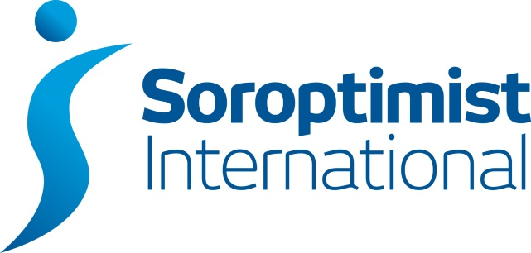

King’s Lynn
2022-2023

President
Marion Coleman

01553 617494

Secretary
Sharon Edwards
01328 853039

Treasurer
Mary Plant
01553 774106

Membership Officer
Janet Porter
01353 777493

SIKL meetings are held on the first and third Mondays of the month (except January) at 7.30pm.
On the first Monday we meet on the top floor of Marriott’s Warehouse, South Quay, King’s Lynn, with the opportunity for a light meal beforehand in Marriott’s Restaurant on the ground floor. On the third Monday we meet online via Zoom.
www.sigbi.org/kings-lynn

sikingslynn@gmail.com

@SIKingsLynn

