From left to right: retiring President Sheila Miles, incoming president Eileen Potter, retiring President Linda Benson
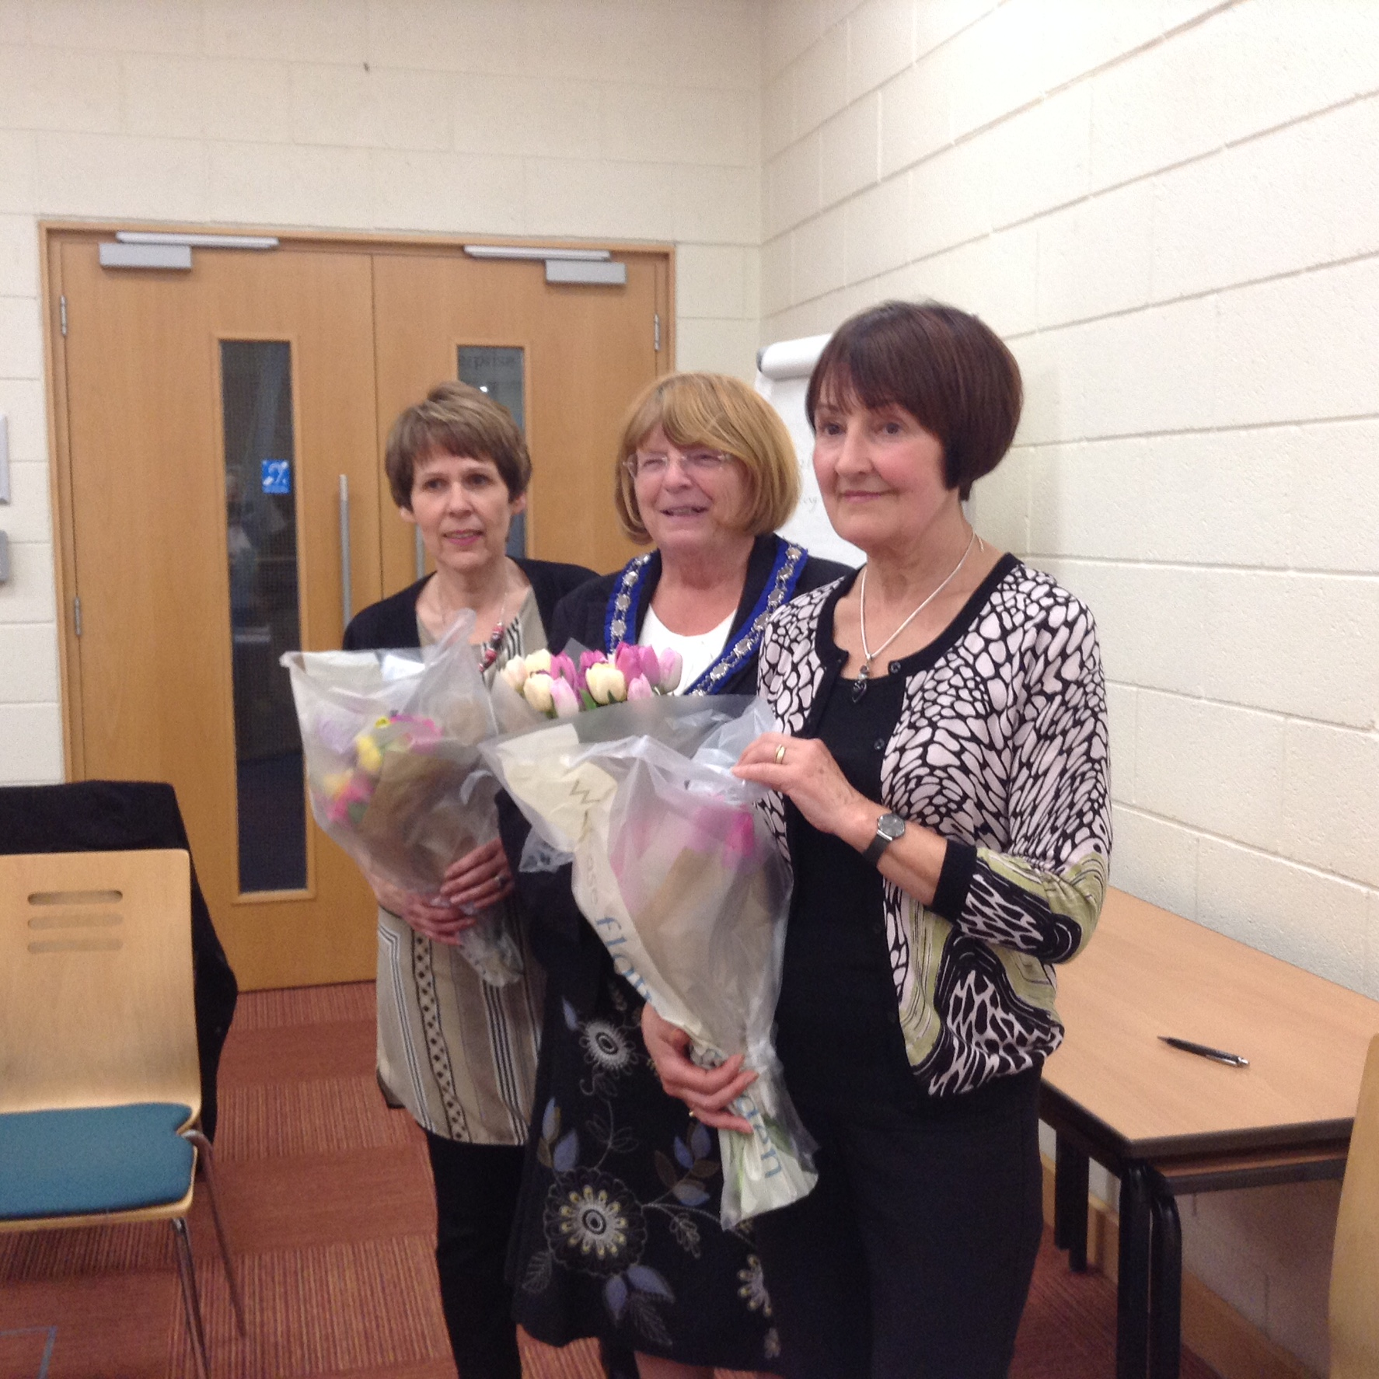
Lincoln S.I. Presidents' themes, 2014-15

We began with two main themes, our chosen charities, the first prompted by the decision to fundraise and work for a local charity called familyfocus, which supports women and families and was set up to combat cuts in Lincoln's SureStart provision; the second, St Barnabas Hospice, chosen following the death of a valued friend and fellow Soroptimist Diana Oldfield, who had worked for the hospice for many years and was looked after by the Hospice at Home service in the weeks leading up to her death.

Regarding familyfocus, Lincoln S.I. has raised funds, conducted research into community needs (which helped the charity to gain a grant of £12,000) and provided support for autistic children and their parents.

Following a speech by Lieran Docherty from 'Together Women' at a regional meeting, a third theme was added to our year. We asked the Charity's CEO to speak to our Lincoln club. As a result of that inspirational evening's talk, we have forged an alliance with the local branch and our PAC is exploring ways to help further, starting with providing everyday necessities for women trying to rebuild their lives after release from prison.

If Sheila and I were to sum these initiatives up as one main theme, I think our aims have been to provide support for women whose disadvantages have been exacerbated by welfare cuts and by entrenched prejudices. - Linda Benson and Sheila Mile

