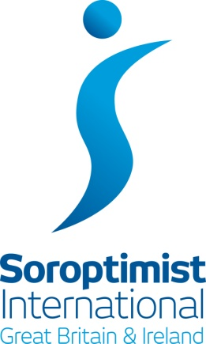 | Region of  North West England &  the Isle of Man  Regional President:  Maureen Howarth

FEDERATION CONFERENCE – LIVERPOL 2018

On behalf of all members in the Region, it gives me great pleasure to welcome you all to Liverpool to this Conference with the theme of:

‘Empower today, Enable tomorrow’

The conference committee have worked hard to not only secure this splendid venue, in a vibrant city, but also to conjure up an array of speakers to deliver a varied, interesting, and entertaining programme for everyone.

So – enjoy your visit. Meet up with old friends and make new ones.

Remember – Soroptimists do always work hard, but we also have fun!

In friendship

Maureen Howarth
May 2018

