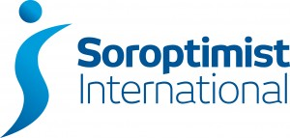
LONDON CHILTERNS REGION
PROGRAMME ACTION REPORT – June 17th 2017
- Congratulations to SI Hertford and SI St. Albans who appeared twice in the May edition of Soroptimist News.

- In July, I shall attend the UKPAC meeting on your behalf but I had to submit a report on the region’s activities by 12th June. I submitted a full report, but some clubs were not represented. These clubs have been active I am sure, but report forms had not been completed, so I do urge you to complete the PA forms as soon as possible after the event. In future, I’ll try to send a reminder and a deadline, but meanwhile do get those forms completed and they’ll feature in the next report.

- You should all be aware that I have circulated a request for clubs to take part in a survey on Human Trafficking. This has been carried out successfully in Northern Ireland and recently I circulated further information from Kay Richmond on the possibility of doing the survey on line. I hope you have discussed, or shortly will be discussing this in your clubs, because I need to reply to UKPAC by the end of June. If clubs do feel they can do this, it can be done on a club basis, it doesn’t have to be a collective regional undertaking. Please email your decision to pamelarobertson807@btinternet.com by 30th June.

- Dates to remember:

International Women in Engineering Day: 23rd June 2017
SIGBI Day of Action: 15th July 2017

Pam Robertson

