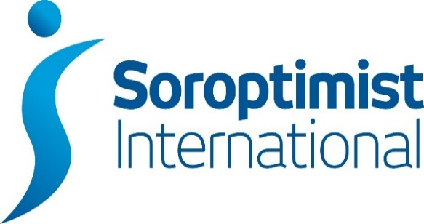

London Chilterns Region

Lockdown Newsletter – 12th July 2020

Message from President Denise

Dear Members
I am writing this contemplating my first post-lockdown haircut (coming up at the end of the month), remembering my first hug with my son (who lives alone and has made us his 'bubble') and thinking about the changes that Covid-19 has brought us. Who would have thought that so many Soroptimists would become technical giants, able to master the intricacies of Zoom, Skype and GoToMeeting with ease? Quite familiar with 'gallery view', 'waiting rooms' and turning mute on and off.
I attended another meeting hosted by SIGBI President Isobel for Regional Presidents a couple of weeks ago, and a familiar theme from many of the Regional Presidents was how pleased they were to see that attendance at virtual Club meetings was not only holding up, but actually in many cases was greater than at physical meetings. Those who struggle to get to physical meetings because of infirmity or other commitments have embraced the technology with gusto! This has given us all food for thought, and I wouldn't be at all surprised to see virtual meetings become a regular feature in Club programmes - though of course we are all aching to have a REAL meeting! I have joined some virtual Club meetings myself, and found them to be hugely pleasurable - I have got a great feeling of warmth and friendship from each one. Thank you to the Clubs that invited me.
It was at the call with President Isobel that she announced that Conference was going virtual - a hybrid, made up of live televised sessions intermingled with recorded presentations. I hope you have taken the time to watch her video announcement. I for one am quite excited to see this new format. I firmly believe that the way in which Soroptimists have embraced change so quickly and enthusiastically will make us appear an attractive organisation to younger potential members. I do urge you all, even if you were not contemplating going to Conference, to keep an eye on the announcements and consider attending at least part of the session - I am sure you will be entranced and your Soroptimism will be reinvigorated.
Having had President Isobel's announcement, it seemed an obvious decision that our October Regional Meeting and AGM should also be virtual - we could not contemplate encouraging attendees to travel into London and sit in a rather poorly ventilated room in the Lancaster House Hotel even if it was allowed by then. The details are still being worked out, but we have 2 super speakers lined up, so please do keep the date (October 10th) in your diaries and look out for further details. President Elect Helen Byrne has some exciting plans for her year, which I am sure she will share during the Change of Insignia part of the session.
As we talk about bringing my year to a close, we must also think about the other roles on Exec. As you will see elsewhere in this newsletter, there are still posts to be filled and I want to urge every single woman reading this to think about whether they could consider taking one of the roles. We do not want Executive to be a clique, we want it to represent the Region's membership. it is not hugely onerous, and most roles could be shared. So please have a think, talk to me or other Exec members if you want further information about what is involved - and then get stuck in. Region has a great role to play in providing a forum for clubs to work together, so let's make it vibrant with the introduction of new blood to go along with the experience that many Exec members bring.
By the time my next Presidents Piece comes out, I expect there will be further relaxing of lockdown and I look forward to seeing how Clubs emerge from this period. Do send in your news and Rita will include in the next Newsletter. Meantime, as always, I wish you all to be safe and well and I look forward to seeing you face to face when that is possible.
Yours in friendship
Denise
Good News Story!
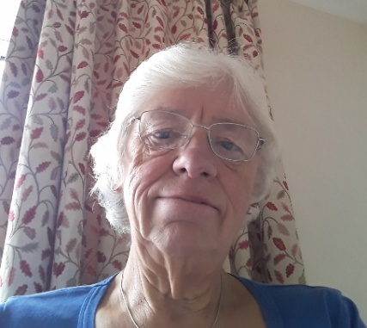
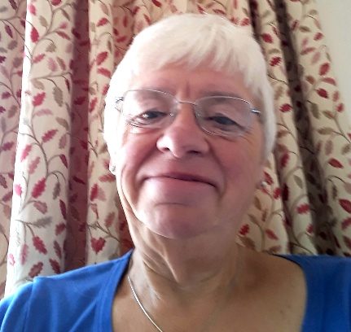
Friday 10th July was the red letter day ~ the lockdown locks were dealt with!!
Before! After!
Communications: Jane Slatter: Regional Communication Officer

Club and Member Communication
I have been pondering the different stages people are at in managing the current COVID-19 pandemic and how that affects communication. Communication is important in supporting our mental and physical health:
- Communication to make sure we are ok on a personal level
- Communication with others close to us to make sure they are ok on a personal level
- Reaching out beyond those close to us to make a difference to a wider group of people
I think we can all see ourselves in one or more of these stages and as Soroptimists I expect we are doing what we can to ensure our Members are supported and some are able to reach out beyond. We mustn't feel bad if we can't do much reaching out at the moment, we must just continue to look out for ourselves and one another. We need to stay as healthy, mentally and physically, as we can, so that we can enjoy our lives to the full when we move into the new normal…

Region Communications to and from Clubs
What's happening? With two Regional events cancelled this year I am really missing hearing about what Clubs have been up to and I'd love to know! If you have any stories and/or pics please send me an email to silondonchilterns@hotmail.com and I will update the website www.sigbi.org/london-chilterns - then I can share with everyone in the Region.
If you have anything for Dear Diary please send an email to silondonchilterns@hotmail.com and we can start issuing again (if you're wondering why it hasn't been issued, it's because I haven't been sent anything....).
Jane x
Programmes Action: Pam Robertson, Programme Action Officer
SIGBI NEWS BRIEFING June 19th – You will have seen that there was a survey for ‘Masks for Equality Campaign’ (part of the International President’s appeal ‘The Road to Equality’). This is very short and asks us to provide information on any COVID-19 related projects which we have undertaken. Please do complete this for your club.
However, this is entirely separate from Programme Action Report Forms on the SIGBI website! So, do please ensure that you club’s activities are recorded here as well.
You will have seen that Conference will be in a rather different format this year but that Good Practice Awards will take place. The Powers that Be will be searching the database at the end of July; this means that for your activities to be considered, you really need to have submitted your reports by 15th July at the latest for them to be processed in time. Remember – if an activity is related to Covid-19, include this at the start of the title. Additionally, if you have pre-lockdown reports to be submitted, it’s not too late!
If you need help, don’t hesitate to call me – 01920 822631 (Pam).
Empowering Girls in Nepal: Pauline Panter, Regional Ambassador
Hello Ladies.
We had a Zoom meeting for Ambassadors of Empowering Girls in Nepal on 2nd July 2020.
There are now 2 overseas Ambassadors for this project:
- Sandra Dieffenthaller for SI Trinidad and Tobago
- Talat Pasha for SI Karachi.
These ladies were welcomed to the group.
Fundraising
Fundraising has been very variable across SIGBI during this difficult time. However the total raised this last quarter (1st April - 30th June) is amazing £11,357 making the total for the project £27,742.
Fundraising initiatives have included:
- Making and selling washable face masks.
- A virtual Northern Soul Party.
- A Poetry and Pimms evening.
- A virtual Kilt Walk.
The Big Story
The Big Story finishes on 31st July but sponsorship continues for another 2 weeks.
To date there have been 70 entries for this initiative. There was discussion about perhaps producing a book of all the stories produced. The costs of this appeared quite high and we would need to sell in excess of 1000 books to ensure we make £5000. Ambassadors have been asked for suggestions about how we can move forward with this. There was a suggestion we could look at a kindle version.
PowerPoint Presentation
An up to date PowerPoint presentation has been produced for use by Ambassadors at meetings etc.
The file is very large so a copy of the presentation will be sent to each club separately

Our next meeting is on Thursday 16th July and I will feedback after that meeting.
Best wishes,
Pauline pauline.panter@hotmail.co.uk

Rita's Ramblings!
Notes from Regional Secretary Rita Beaumont

Club Officer Details

It is that time of the year again when we are all completing our Club Officer returns for SIGBI; so we hold up to date contact details for each club across the region please could I request you send me the names of post holders with their contact details

Regional Officer Vacancies
Before we all joined the “world of lockdown” I circulated a list of Regional Officer Vacancies; so much has happened I am now sending them to you again
In October the Members of the Executive will be:
- Helen Byrne becomes our President & Denise Powell becomes Immediate Past President
- President Elect & Vice President ~ both posts are vacant
- Secretary ~ Linda Shall continues as our Minute Secretary & Rita Beaumont as Secretary but would like a member to shadow her and take over during the year
- Treasurer ~ Sylvia Watson continues in post for a second year
- Programme Action Officers ~ Pam Robertson & Jackie Paling continue in post for a final year
- Regional Federation Councillor ~ Application with SIGBI
- Membership Officer ~ Post Vacant: why not combine talents with a second member as a job share?
- Communications Officer ~ Jane Slatter continues in post but would like someone to take on being Dear Diary Editor
- Project Ambassador: Empowering Girls in Nepal ~ Pauline Panter continues in post
- 63 Representative ~ Barbara Diamant
- Benevolent Fund Trustee~ Rita Beaumont continues in post
- Executive Member ~ Jen Simpson
To run the Region we need Officers to not only fill upcoming vacancies but also to plan for future years so we would be delighted to have any members come along to shadow any of the Officer Posts ~ just contact Denise, Rita or any of the officer. Why not think about joining the Regional Executive, it is not an arduous task and enjoyable being part of the regional team
Date for your Diary

- Regional Meeting via Zoom
Saturday 10th October 2020

Look out for full details & joining instruction in the future

SIGBI Benevolent Fund ~ Reminder: Rita Beaumont, Regional Trustee

We are still living in unknown times as we continue to comply with the Government response to the Coronavirus pandemic. It is a challenging time for us all but for some members it will be exceptionally difficult.

The Benevolent Fund is a confidential fund available to ease financial difficulties for those eligible to apply.
The fund can give a quarterly payment to help cover outgoings or a one-off payment to help cover an unexpected item. Discretionary help may be considered for such items as utility bills, telephone bills, essential living expenses or house maintenance

Who is Eligible to Apply?
Any Soroptimist who has been a member for 3 years or more living in the UK, including the Channel Islands and the Isle of Man, and the Republic of Ireland. The support is given subject to simple confidential financial checks

How to Apply
If member would like to apply, contact me and I will talk through the application process

Rita Beaumont: Regional Trustee
r.beaumont3@ntlworld.com

Telephone: 01234 401475
Mobile: 07764511006

