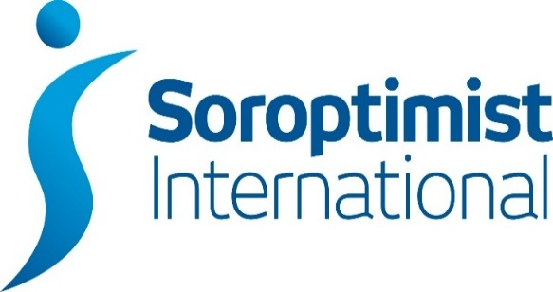

London Chilterns Region

Lockdown Newsletter – 12th June 2020

Message from President Denise

Dear Members

So, lockdown continues, I hope you are all safe and well. There has been a little bit of easing that has allowed many of us to spend time with friends and family that we have been missing - I have certainly taken advantage of a 'back-garden party', with all the social distancing and limited attendance of course.
I am sure that all the Clubs round the Region are finding ways to operate, to stay in touch with Members and to ensure support for those who need it. I am still buzzing from the event that my own club arranged on Monday night. Talking in Executive we felt that for the sake of our Members, and our cohesion as a Club, we needed to try and return to our regular pattern of working as much as possible, Our Zoom weekly coffee mornings have successfully taken the place of our monthly Club meetings, and we thought it would be good to have some evening meetings as well for those that are still working. So the idea was born to reinstitute our regular Speaker meetings, over Zoom. That developed into the thought of a bit of fund-raising for our Refuge and the possibility of inviting friends/contacts which of course included Friendship Links, We were blown away to get nearly 100 bookings and raise over £300 - and we had a great evening with a really inspirational speaker. We were delighted that 2 of our Friendship Links joined us, as well as many Soroptimists from the Region and beyond, This was the first in a series of 3 events, held at fortnightly intervals. I can't wait for the next two (diary details in this newsletter and in Dear Diary).
I am going to be attending Oxford and District's Club Zoom meeting shortly and am very much looking forward to that - my plans for visiting all the Clubs in the Region has, or course, taken a huge knock, but I would be more than happy to receive further invites to Zoom.
Next Saturday, I am joining the 3rd online call that SIGBI President Isobel has been hosting for Regional Presidents, If your club is planning or has done anything unusual, do let me know and I will be happy to 'boast' about it on the call. If there is anything any Club wants me to raise, again, do let me know and of course, if there is any news to share I will be sure to pass it on.
I very much hope that we will continue to get positive news about getting through the Coronavirus crisis and can start to plan for a certain amount of normality, although it remains to be seen how long we will have to wait to restart our normal activities. In the meantime, I am sure that the Region's Soroptimists are doing what Soroptimists are best at - just getting on with it and trying to make things better for women and girls everywhere.
Keep safe and well
Denise

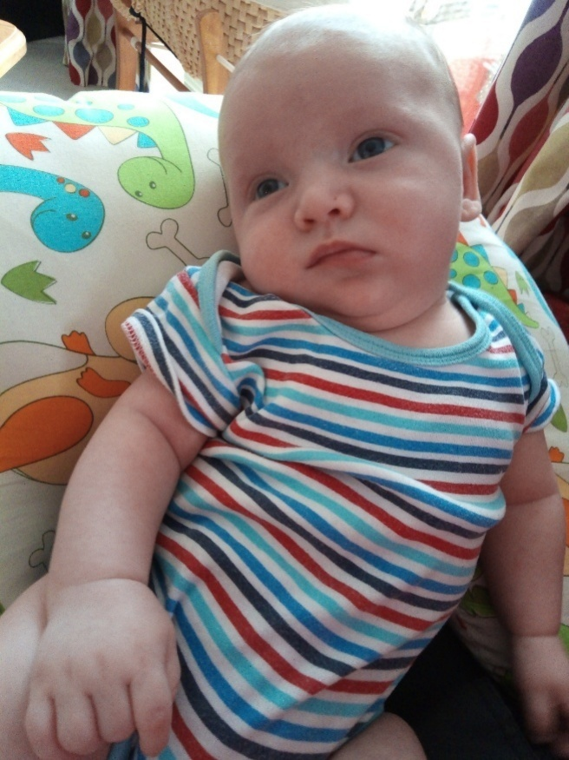
Good News Story

Meet the gorgeous Samuel John Jenkinson, son of Sarah Jenkinson from SI Oxford
While still Club President Sarah gave birth to her beautiful first baby during lockdown on Tuesday 7 April. He joined the club for some of their AGM held in May by Zooom.

Communications: Jane Slatter: Regional Communication Officer

It has been wonderful to hear how Clubs are supporting one another through whatever means they have available to them. Zoom has been a bit of a revolution for many Clubs. I have to say it was new to me and now I am a huge fan! If you haven't tried a Club meeting using it please think about giving it a try - I am happy to help. You don't need a camera just a microphone on whatever device you use to connect and did you know you can join in by telephone too?
Dear Diary - next issue July - entries by 28 June to silondonchilterns@hotmail.com If you do organise any virtual events on Zoom please share the times/dates and who to contact to get connected so that Members around the Region can join your events. My own Club, St Albans, was delighted to have so many guests from around the Region at their event on Mon 8 June.
Club Website Editors/Administrators - lots of things have changed on the new SIGBI websites. There were a series of Webinars which were great and they were all recorded and available to view in the Members area of the SIGBI Website (first you need to log in with your Membership number here https://sigbi.org/members/ and then click on the link to the resources:
https://sigbi.org/members/resources/marketing-resources/websites/
The new Club Editor's User Guide is in 3 parts and is excellent. If you need help please don't struggle, let me know and I'll see if I can help, just email me pinkyslatter@hotmail.com
Region Website www.sigbi.org/london-chilterns/ I've still got some work to do to bring our Region's website up to date and if you have anything you'd like added/amended please just email me on pinkyslatter@hotmail.com The Facebook and Twitter feeds are now on the home page of the SILC website - and it is simple to join and follow by clicking on the links.

Programme Action: Pam Robertson and Jackie Palin, Programme Action Officers
Congratulations to SI St. Albans for their interesting and stimulating talk on LIFESTYLE by Dr. Alka Patel via Zoom. Lots of members from across the region joined in and over £300 was raised for their local Women’s Refuge.

Thank you to SI Slough, Windsor and Maidenhead, SI Thames Valley, SI High Wycombe and SI Greater London for submitting Programme Action Report Forms. A special mention goes to SI High Wycombe and SI Thames Valley for their Covid-19 related Programme Action.

How about signing a petition? There are one or two new ones on the website, including one related to a Covid-19 vaccine. Do have a look.

Jackie and I will be attending a Go To UKPAC meeting on Saturday 20th June. If you haven’t yet submitted a Report Form but have done some Programme Action you’d like us to know about please email me on pamelarobertson807@btinternet.com

Predatory Marriage Bill
We have been asked by Soroptimist UK Programme Action to write to our MPs about Predatory Marriage - there is information on both the websites below - just click the links.
https://sigbi.org/ukpac/2020/05/15/predatory-marriage/
https://www.justiceforjoan.com/
Sounds like a really important piece of legislation to protect women's rights.
Below is the template email to send to MPs. Prepared by Jane Slatter
Email Subject: Predatory Marriage Bill – Reforming marriage laws and procedures to protect people with dementia
To: xxx - MP for xxx

Dear xxx

Predatory Marriage Bill – Reforming marriage laws and procedures to protect people with dementia

I am writing as a constituent of yours and as a Member of Soroptimist International XXXXXXXX - a Club which is part of the global women's group. I am asking you to support amendments to the Predatory Marriage Bill proposed by Fabian Hamilton MP and endorsed by an impressive range of individuals and organisations: https://www.justiceforjoan.com MP Fabian Hamilton (Leeds North West) raised the issue in Parliament in a Private Member’s Bill in November 2018. It was passed unanimously for a second reading, but then ran out of Parliamentary time last year. This Bill needs to be brought back to parliament. If a marriage no longer revoked a will, it would remove much of the incentive for predatory marriage.

The Campaign aims to...
- Change the law such that a marriage does not automatically annul a Will
- Create an offence of Predatory Marriage.
- Publish Notices/Banns on the Internet.
- Train Registrars to look for signs of insufficient mental capacity to marry.
- Ensure Registrars will stop a marriage ceremony if there are any doubts.
- Add "The marriage was fraudulent" to the permitted reasons to annul a marriage after one party has died.

With an ageing population and consequent rise in dementia, procedures need to be put in place now before many more people are affected.

Please think about anyone that might be affected by this and let them know. Many people do not know about these issues: the rise in dementia and the newness of the Law (Anti-Social Behaviour Act, 2014) means that it's new territory to most, even to professionals. If we can prevent even one case it will all be worthwhile.

Thanks very much for your attention,
yours sincerely,
Name
Address
Empowering Girls in Nepal: Pauline Panter, Regional Ambassador
Hello Ladies
The latest news from Nepal is that activities are at a temporary standstill as the country is in shutdown because of the Covid-19 pandemic. Once the shutdown is lifted the girls will need even more support, so our fund raising remains a high priority. Money raised via The Big Story will be highly appreciated; don't forget the deadline for submission has been extended to the end of July. So ladies, time to put creative pen to paper or you could make a donation or sponsor a submitting member, if you do this online the amount will be match funded until the amount committed is exhausted, remember to add Soroptimist in the comments box. Go to www.thebigstory.org.uk and follow the instructions. Do you have a member who has written her story, if not you might like to sponsor Ann-Marie Parker of SI Hertford and District; her story is attached to inspire you!

Stay safe and best wishes.
Pauline : pauline.panter@hotmail.co.uk

Rita's Ramblings!
Notes from Regional Secretary Rita Beaumont

Well ladies, not sure about you but I cannot wait to get my “lockdown hair” cut! The article below is interesting and it would be simple for us to ask our hairdressers, once we are able to visit them, if they have heard of the campaign. Our local Further Education College has hairdressing as one of it’s largest courses and it will be interesting to find out if the course tutors and workplace mentors are aware of the campaign and if not would be willing to include information in the curriculum.

Cut It Out! Campaign- Hair Salons, Beauticians, & Spa Professionals Mobilize Against Domestic Abuse - Spotting the Signs of Domestic Abuse in Your Salon Clients

Domestic abuse affects one in four women and one in six men in their lifetime. And now a new campaign has been launched to help hair and beauty professionals spot the signs a client may be experiencing domestic abuse.

Nadia Norman, a Police Community Support Officer who is leading the Cut It Out Campaign in Northamptonshire, says, “A lot of the people I spoke to about domestic abuse thought it meant physical violence. They didn’t understand about controlling and coercive behaviour, they didn’t understand what support services were available.
“We want to equip hair and beauty professionals to recognise the signs of domestic abuse and awareness of where they can signpost clients to get help.”
What is domestic abuse?
According to the charity Women’s Aid, domestic abuse is “an incident or pattern of incidents of controlling, coercive, threatening, degrading and violent behaviour, including sexual violence.”
It’s either carried out by a current or former partner, a family member or a carer. It could include:
· Coercive control
· Psychological or emotional abuse
· Financial abuse
· Online abuse
· Harassment or stalking
· Physical or sexual abuse

“Our aim is that as many salons, mobile hairdressers, beauticians and freelance technicians have the opportunity to come to a session and learn about what domestic abuse is and what they can do to recognise the signs.”

What is the #CutItOut Campaign?

The Cut It Out campaign first launched in Norfolk after Kerri McAuley was killed by her abusive partner.
Nadia says, “A few weeks before she died in 2017, Kerri had confided in her hairdresser that she thought her ex-partner was going to kill her. A review into her death found there was a lack of awareness of where people can go for information and support.”
The campaign, which has since launched in Rochdale and Northamptonshire, is aimed at training hair and beauty professionals to recognise if a client is a victim of domestic abuse.
The free Cut It Out training sessions include learning the signs of domestic violence and abuse, advice on how to open the conversation with clients and also information on the different places they can contact for support.
Nadia says, “Our aim is that as many salons, mobile hairdressers, beauticians and freelance technicians have the opportunity to come to a session and learn about what domestic abuse is and what they can do to recognise the signs: both physical and emotional.
“Our Cut It Out programme will also equip them with knowledge about how they can support their client. We had 160 people turn up to our launch event which was amazing. They’ve gone out and shared it with their clients, friends and family.”
What are the domestic abuse signs to look out for?

It’s not always obvious if someone is suffering from domestic abuse. And this is why hairdressers and beauticians are ideally placed to spot things other people might miss. Nadia says, “The hair and beauty industry is such a personal service. It’s usually the same salon you’ve been to a long time or you’ve been recommended by a friend, so there is always that personal link.
“Because of your close proximity you’ll see things other people might not notice: hidden bruises, flinching or nervousness, receiving a ridiculous number of phone calls or texts. You might also see changes in behaviour or things that are said that might point towards a controlling and coercive partner.”
How can I support my client if they’re experiencing domestic abuse?
There are a number of support services you can suggest, including the National Domestic Abuse Helpline.
#CutItOut salons will get a badge for the window to show that it is a safe space. “Everyone who takes part in the training will also get a pin badge which is a great way to start a conversation with your client” says Nadia. “It can be awkward starting conversations about domestic abuse but this way you can talk about your training and then offering support phone numbers if you think your client needs them.”
Even if you don’t live in an area that has the Cut It Out campaign, you can contact your local council or police to get a list of support services for anyone experiencing domestic abuse.
For more information visit:
https://www.salon-services.com/blogs/article?fdid=blog&cid=Cut-it-out-campaign-for-Hair-and-Beauty-Proffessionals
(Source: Women’s UN Report Network (WUNRN) 2nd June 2020)
Club Officers Details
It is that time of the year again when we are all completing our Club Officer Returns to Federation; so that we hold up to date contact details for each club across the region please could I request you send me the names of post holders with their contact email address
Regional Officer Vacancies
Before we all joined the “world of lockdown” I circulated a list of Regional Officer Vacancies – now an early warning that I will circulate the list again with the next Newsletter so why not think about joining the Regional Executive, it is not an arduous task and enjoyable being part of the regional team
Dates for your Diary
SI St Albans – Speaker Meetings via Zoom
- Monday 22nd June 2020: 7.30pm to 8.30pm ~ Buteyko Breathing Technique ~ 45 minute interactive session covering the breathing technique and evidence for health benefits: Speaker: Jenn Tiller
- Monday 13th July 2020: 7.30pm to 8.30pm ~ “Spice Way” ~ 30 minute talk & demonstration followed by questions& answers: Speaker: Louise Caplin
Full details and booking instructions will be circulated nearer the dates so watch out for my emails!
SIGBI Benevolent Fund ~ Reminder: Rita Beaumont, Regional Trustee

The Benevolent Fund is a confidential fund available to ease financial difficulties for those eligible to apply.
The fund can give a quarterly payment to help cover outgoings or a one-off payment to help cover an unexpected item. Discretionary help may be considered for such items as utility bills, telephone bills, essential living expenses or house maintenance

Who is Eligible to Apply?
Any Soroptimist who has been a member for 3 years or more living in the UK, including the Channel Islands and the Isle of Man, and the Republic of Ireland. The support is given subject to simple confidential financial checks

How to Apply
If member would like to apply, contact me and I will talk through the application process

Rita Beaumont: Regional Trustee
r.beaumont3@ntlworld.com
Phone: 01234 401475 Mobile: 07764511006

