London Chilterns Region

Lockdown Newsletter – August 2020

Message from President Denise

Dear Members

Now is the time of the year when traditionally Soroptimist activities take a pause whilst members go on holidays with family and enjoy the good weather. 2020 is somewhat different. Many of us do not want to entertain the idea of travelling, certainly not abroad. We are at least blessed with a return of warm (some would say hot or too hot) weather.
As an organisation, we have two main purposes - to carry out our Programme Action, doing service activities for the benefit of and to promote the cause of women and girls across the world,, and to provide friendship and support to each other. I know many of the Clubs in the Region have been considering how to do both of those through this very strange time and have found innovative things to do - each one should be congratulated. As restrictions continue (we hope) to ease, there is the prospect of us being able to meet in person once more and perhaps to reconnect with some of our traditional activities. But I do think we will all be slightly changed, perhaps a little more open to different approaches - and I don't see the demise of the Zoom call anytime soon! As a Region, our role is to support Clubs, so do reach out if you need us.
I am proud that we had two outstanding candidates standing for election to Federation roles. Many congratulations to Sylvia Watson on becoming Director of Governance, I am sure you will be fantastic and the Region will be behind you all the way. Commiserations to Rita Beaumont who was pipped at the post in the election for Director of Membership. I know that Rita has already offered her assistance to Chevonne Agana, so in many ways SIGBI has the best of both worlds for this hugely important role - I am sure we are all excited to see the projects that come forward to drive our membership base.
Whilst it is great that our Region is providing women to serve at Federation level, it does mean that they leave spaces within the Regional Exec. As we approach he AGM, I can only ask that each Club and indeed each member think about how they can support the Region. There are still vacancies on Exec, and it would be really good to have some new blood - we are not stuffy and hide bound by process, we are enthusiastic Soroptimists who want to support the work of the Region’s Clubs.
Talking about the AGM, do put the date (October 10th) in your diary. You will start to see details of this virtual event over the next little while but be assured it will be a brilliant morning. Both I and Region President Elect Helen Byrne would love a large audience for the Change of Insignia (however we are able to do it).
I also encourage you all to sign up for the Virtual SIGBI conference.. This looks to be a really interesting event - completely different from 'normal' conferences, and yet strangely familiar. Being a bit of a techno freak, I for one am really looking forward to seeing how it all works, as well as hearing from a plethora of excellent speakers and of course finding out about all the wonderful Programme Action going on in our Federation. I am very excited to see the installation of our very own Johanna Raffan as Federation President..
Yours in friendship
Denise
Good News Stories!
From Jackie Paling, Friendship Link Co-ordinator for SI Slough Windsor and Maidenhead
As Friendship Link Co-ordinator for SI Slough Windsor and Maidenhead, I looked at the possibility of having Zoom meetings with our Friendship Links, taking into account the time differences concerned.
We have two European Links, one of which is SI Amsterdam Amstel in the Netherlands. The Dutch members both speak and understand English very well, so we had a Zoom meeting with them.
Our Club was originally going to visiting them in April to help them celebrate their 50th anniversary but unfortunately Covid 19 stopped that.
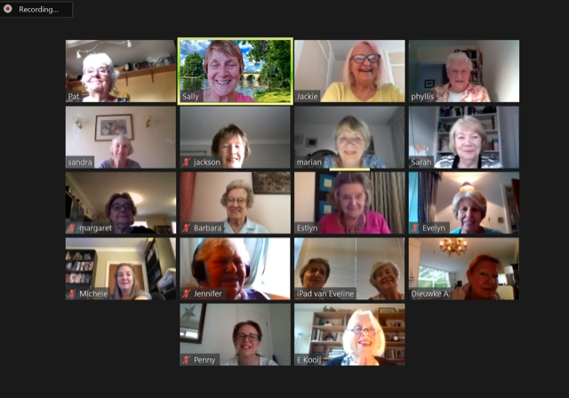
The meeting was a huge success with 14 of our members and 5/6 of their members taking part.

It was so lovely to “see” them again. Whilst we are still having Business meetings via Zoom, we will consider asking our Dutch friends if they want to join us

Star of the Month ~ Phyllis Sigworth
Phyllis Sigsworth is a member of SI Slough Windsor and Maidenhead. She is very sprightly at 90 years old and has been a Soroptimist for over 50 years. She had a very distinguished career in the Police Service and was awarded the Queen’s Police Medal for distinguished Police Service. She has worked tirelessly on issues affecting women and children including domestic violence, human trafficking, and child protection, in both her working life in the Service and Soroptimist life.
A book has been written covering her thirty years of service and shows social changes and changes in women’s role in law enforcement since 1950. The book is called “A Beat From The Heart To The Heart Of Power”. The proceeds from the sale of this book will be given to our local women’s refuge organisation DASH – Domestic Abuse Stops Here. The book will be published on 27th August and is available initially via Amazon, but other outlets will be sought. The Club members are all very proud of her.

The Sky at Night! ~ Sky watching in lockdown with Pauline Panter
Hello friends I hope you are all safe and well and dealing well with this total change in our lives? I know that many of my friends, family and colleagues have found some very different and inventive ways of dealing with the last 5 months in ways that they would never have considered previously. For us (my husband and I) who have both been “shielding" it was a new found interest in sky watching. Prior to lockdown we were not really interested in this, however our 6-year-old granddaughter Olivia is totally enchanted by all things related to astrology so we decided to “take a look!”
Our first exploration of the sky at night was in early April when Olivia informed us that if we went out into the garden at 10pm we would get an excellent view of the Elon Musk Star Linked Satellites and the International space station. We ventured out into the garden at the appointed time and after several false sightings and much hilarity we eventually got a brilliant view of the linked Satellites passing the international space station. We created so much noise and excitement that the neighbours also came outside to see what all the fuss was about! It was a truly socially distanced back gardens party atmosphere and the first of many such evenings.
Since that time, we have spent several pleasant evenings “sky watching", we have seen the linked Satellites on a few occasions, the space station moving across the sky on many, many occasions and even seen shooting stars or meteor showers as Olivia informs me. The past week we have seen the Perseid Meteor Showers on two occasions. These were brilliant displays of many “shooting stars" whizzing across the night skies in the early hours, you see there are benefits of being kept awake by the heat, although I am sure one neighbour is convinced, we are both mad! We are getting to know and recognise the planets that we see regularly. Luckily we have been blessed with beautiful long and warm evenings over this period of lockdown made even more pleasant by sky watching together (and with our neighbours) often with a large glass of wine in hand, although not this past week as I think 3.30am is a little late or should that be early??
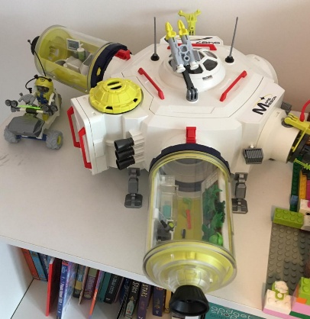
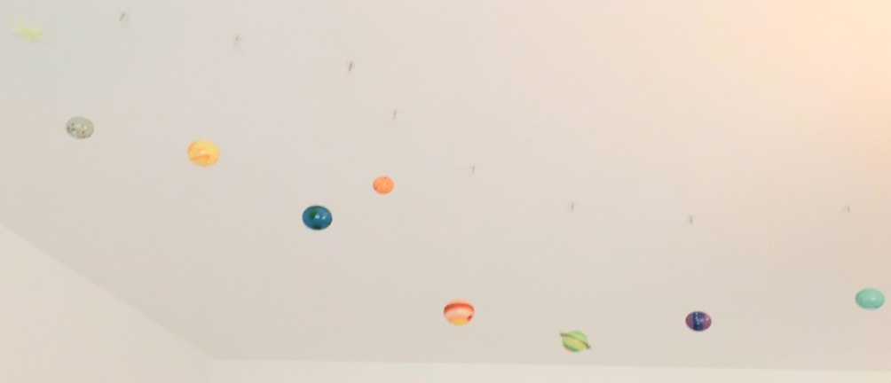
It’s been great to realise that despite the fact that we could not see or be with our granddaughter over these past few months we could at least know that we were watching the same sky at the same time and were able to compare notes at our weekly zoom meetings. It’s wonderful now since we can meet up as a family and Olivia can continue with my astrological education classes! I did get an extra Brownie point this week when she was telling me about her heroine Helen Sharman the first British Astronaut and I was able to tell her I had met Helen at conference! Of course, I then had to tell her all about Helen

The Planets on the Ceiling! Planning to go to Mars!
Olivia's Bedroom!!

President Elect & Membership Officer: Helen Byrne

Centenary - #PlantTrees for a Brilliant Future

Has your club started planning your contribution to SIGBI’s Project to plant trees in 2021? As our Federation leads the way with this great initiative so closely connected with the beginnings of SI and yet so important for our current times, it would be fantastic to see stories from our Regional Clubs appearing on the Centenary website.

Mitigating carbon emissions couldn’t be more vital with the lives of women and girls so adversely affected by climate change; and with the UK one of the first countries to commit to Net Zero by 2050 and sharing the chair of COP26, there are lots of national and local tree planting initiatives you can catch onto.

So lots of ways to get started - from working with schools, collaborating with organisations like the Woodland Trust or your local authority on greening your local area, to organising a formal tree planting to celebrate your Club and the Centenary. All offer great opportunities for publicity!

If your Club already has plans we would really love to hear them - please email Programme Action Officers : Pam Robertson (pamelarobertson807@btinternet.com) and Jackie Paling (jackiepaling@hotmail.com) so they can share your stories to encourage other Regional Clubs and possibly some joint working between Clubs. And if you haven’t yet got started, do take a look at the really comprehensive information on the Centenary website :
https://sigbi.org/soroptimistcentenary2021/a-brilliant/planting-trees-for-a-brilliant-future/

And if you want to do something personally, why not read how you can contribute to tree planting from the comfort of your own home by switching to Ecosia- https://www.ecosia.org - as your search engine
For more info– https://sigbi.org/soroptimistcentenary2021/files/Ecosia-Information-Download.pdf

Membership - being digital and creative.
I am sure many Clubs will be taking the opportunity of our usual August break and the lovely weather for some small socially distanced get togethers: a much needed opportunity to reconnect face to face.

However this doesn’t mean that the online meetings many of us have been having recently are an inferior option , they are just different with as many advantages as disadvantages. My Club has certainly found some surprising opportunities , once the initial panic was over and the first online meetings proved a success.

Online meetings can:
- enable much needed fund raising e.g. by offering attendees the opportunity to donate or enabling payment when booking via something like Eventbrite ( set up a free account and then a page for each event)
- provide opportunities to widen the net of attendees- it is easy to invite friends and acquaintances and promote to other interested groups who can sign up and attend online. And if permission is sought there may be opportunities to follow up or encourage attendees to keep in touch via social media.
- allow members to join in who otherwise find attending meetings difficult whether because of mobility challenges or because their work or other commitments leave them little time - we have a Member who joins on the phone and one who joins in around her work, leaving early if she needs to.
- enable connections with friendship links and charity partners- we have been delighted to be joined by Friendship Link Club Members from Europe and America and had a great catch up with our local Refuge Manager.

It is equally clear that online meetings need to be carefully planned: not everything is suitable for the online environment and meetings need to be focused and shorter than face to face meet ups.
It also helps to have:
- a mechanism for booking
- a protocol for the safety of Members and so they know how and when to get involved in the meeting. There is a Zoom Protocol on the SI London Chilterns website. www.sigbi.org/london-chilterns/zoom/
- someone confident to run the tech
- a Session Leader who works with a light touch to set and maintain a tone of openness and welcome

So whilst we may all be looking forward to a time, in this new and confusing normal, when we can meet face to face, digital meetings are here to stay too and quite rightly so. And if we can be creative with topics , publicity and follow ups they offer many opportunities from a Membership point of view.

Last but not least - Do sign up for the Conference in October- there is a Membership event on the programme which looks like just what we need.

Good Wishes
Helen

Communications: Jane Slatter: Regional Communication Officer

Please see the news item on the SILC website for the July Soroptimists Day of Action #SoroptimistsConnect www.sigbi.org/london-chilterns/2020/07/25/connect/ If Clubs have anything to add please send to Jane Slatter silondonchilterns@hotmail.com
The latest news items are on the Home Page www.sigbi.org/london-chilterns/
Facebook and Twitter Feeds are live on the Website too.
If you use Facebook and Twitter please follow SILC and share any updates.
The SI London Chilterns Programme is on the website and is kept updated:
www.sigbi.org/london-chilterns/programme

NEW ~ VISIT THE SOROPTIMIST LAB!
The Soroptimist International LAB was officially launched during SI’s first ever digital Annual General Meeting, held on Wednesday 29 July. The SI LAB is an inspired new online platform established for Soroptimists, where you can learn about SI’s global advocacy work at the United Nations, the SI President Appeal, Road to Equality and much much more. Become a member of the SI LAB and you can discuss, contribute, collaborate, and connect with Soroptimists from all around the world.
We invite all Soroptimists to join our global online communication platform
To join the Soroptimist Lab please visit https://www.mightynetworks.com
Choose: Sign in (Right upper corner)
Our network is: SoroptimistLAB

Programmes Action: Pam Robertson & Jackie Paling Programme Action Officers
- The last UKPAC meeting held on Saturday 1st August via Zoom, was devoted to hearing about the programme work across the regions. For London Chilterns, we selected SI St. Albans’ series of three excellent virtual sessions on the subject of health and well-being, both physical and mental, to support their own members, members across the region and a wider audience of Soroptimists and friends, including their Friendship Links in California and Germany. Participants were also given the opportunity to make a voluntary donation and their selected charities benefited to the tune of £703. Well done St. Albans!

- To read their reports, go to Members’ Area, scroll down to Search Membership and Programme Databases, click on Project Search and type in the Project Identity Number (you don’t need to fill in any other details) and scroll down to Search. The three ID numbers are 54933; 54935; 55331.

- Don’t forget to put your project on the database. Unless you shout about it, we can’t know about it! Remember, there is now the facility for including the work of an individual club member. You may not have been able to come together as a club, but we are sure that there will have been good work going on.

- And… have you signed any good petitions lately?

Pam Robertson
Jackie Paling
If you need help, don’t hesitate to call me – 01920 822631 (Pam).

Empowering Girls in Nepal (EGIN) : Pauline Panter, Regional Ambassador
Following an EGIN Ambassadors Zoom meeting on Thursday I am delighted to inform you all that as a result of The Big Story we have almost met our projected fundraising target for the first 12 months of the project. Thank you so much to all of you who wrote or sponsored a story.
The total of stories entered was 125 of those 111 were Soroptimist stories. The money raised from these stories was £20,765.28 when this is added to the general fundraising undertaken since the start of the project it adds up to £48,500, which is just £2,000 short of our end of year target of £50,000. Brilliant news and such a relief in this difficult time for any type of fundraising. We are hopeful that we can reach or even exceed that £50,000 by the time we get to November.
The stories are being judged next week by an external team. There was a general discussion about what we can or should do with them after the judging including the production of a book. However this could be quite costly and time consuming and requires careful consideration, especially distribution issues.
The meeting also focused on the type of fundraising that is possible in these difficult times and any suggestions are great fully received from all members, clubs and regions. Suggestions already received include production of greeting/Christmas cards, coins for Nepal (collecting small change) and sponsored zoom meetings.
The virtual SIGBI conference in November will include a question and answer session with Philip Holmes about aspects of the project. If you have anything you or your club wants to know about EGIN project now or in the future, please let me know.
That’s all for now folks. Take care and hope to see you all soon.
Best wishes,
Pauline Panter.
EGIN Ambassador.

Rita's Ramblings!
Notes from Regional Secretary Rita Beaumont

Reminder: Club Officer Details!!

It is that time of the year again when we are all completing our Club Officer returns for SIGBI; so we hold up to date contact details for each club across the region please could I request you send me the names of post holders with their contact details

Reminder: Regional Officer Vacancies!!!
Before we all joined the “world of lockdown” I circulated a list of Regional Officer Vacancies; so much has happened I am now sending them to you again
In October the Members of the Executive will be:
- Helen Byrne becomes our President & Denise Powell becomes Immediate Past President
- President Elect & Vice President ~ both posts are vacant
- Secretary ~ Linda Shall continues as our Minute Secretary & Rita Beaumont as Secretary but would like a member to shadow her and take over during the year
- Treasurer ~ Sylvia Watson continues in post for a second year
- Programme Action Officers ~ Pam Robertson & Jackie Paling continue in post for a final year
- Regional Federation Councillor ~ Application with SIGBI: Rita Beaumont
- Membership Officer ~ Post Vacant: why not combine talents with a second member as a job share?
- Communications Officer ~ Jane Slatter continues in post but would like someone to take on being Dear Diary Editor
- Project Ambassador: Empowering Girls in Nepal ~ Pauline Panter continues in post
- 63 Representative ~ Barbara Diamant
- Benevolent Fund Trustee~ Rita Beaumont continues in post
- Executive Member ~ Jen Simpson
To run the Region we need Officers to not only fill upcoming vacancies but also to plan for future years so we would be delighted to have any members come along to shadow any of the Officer Posts ~ just contact Denise, Rita or any of the officer. Why not think about joining the Regional Executive, it is not an arduous task and enjoyable being part of the regional team

SIGBI Benevolent Fund ~ Reminder: Rita Beaumont, Regional Trustee

The Benevolent Fund is a confidential fund available to ease financial difficulties for those eligible to apply.
The fund can give a quarterly payment to help cover outgoings or a one-off payment to help cover an unexpected item. Discretionary help may be considered for such items as utility bills, telephone bills, essential living expenses or house maintenance

Who is Eligible to Apply?
Any Soroptimist who has been a member for 3 years or more living in the UK, including the Channel Islands and the Isle of Man, and the Republic of Ireland. The support is given subject to simple confidential financial checks

How to Apply
If member would like to apply, contact me and I will talk through the application process

Rita Beaumont: Regional Trustee
r.beaumont3@ntlworld.com

Telephone: 01234 401475
Mobile: 07764511006

Important Dates for your Diary!!!

- Regional Meeting via Zoom
Saturday 10th October 2020
Including excellent speakers Phillip Holmes and Janis Feely MBE and a Virtual Change of Insignia
Visit www.sigbi.org/london-chilterns/2020/08/08/agm2020 for details

To book your place follow the link for Eventbrite below
www.eventbrite.co.uk/e/soroptimist-international-london-chilterns-region-conference-and-agm-tickets-116331920907
It is important to book on Eventbrite so we can send the Zoom link the day directly to you before the AGM.

- NOW BOOKING ~Virtual SIGBI Conference from Belfast via Video Link
October 29th to 31st October 2020

- There will be a virtual FPAC meeting on Thursday 29th October
2020 from 13.30 to 17.00 (GMT) then two Conference sessions on
Friday 30th & Saturday 31st October
- There will not be a General Meeting this year, but some parts of
the usual General Meeting will be included.
- The Conference Programme is now on the Conference Website:
https://sigbi.org/belfast2020/programme-timings/

