London Chilterns Region

Regional Newsletter – October 2020

Welcome to the first newsletter of our new Presidential Year. At our AGM, our first venture in to Zoom for a Regional Meeting, we thanked Denise for her excellent year as our President despite all the challenges presented by the
Covid-19 Pandemic and were delighted to welcome Helen Byrne of our leader for the new coming year.

Message from President Helen

My first delightful duty is to thank Denise for everything she has done to “keep the show on the road” in very uncertain times. No doubt she feels rather cheated for all sorts of reasons but perhaps especially because she hasn’t been able to visit all the Region’s Clubs. I am sure you, like me , feel she has reached out to you with her perfectly-pitched Newsletter pieces and helped your confidence in other ways to keep on doing what Soroptimists do best. Denise is a very hard act to follow and as our dance with COVID-19 goes on I am very grateful that she is still going to be on the Exec. contributing to our Region’s success.

Life in 2020-2021 with COVID will continue being a balancing act. A world in which we need to keep planning for the medium and long term whilst, to quote Denise, “fleet of footedly” looking for and doing what is needed in the present. We need to be urgent and adaptable - to take on board all that the Pandemic, the Climate Crisis and Black Lives Matter demand, whilst holding fast to values in Women’s Rights and our work to empower women and girls to achieve them - sadly needed now more than ever.

2021 brings another balancing act, this one closer to home and, hopefully, more enjoyable - the Centenary of the founding of the first Soroptimist Club in Oakland, California. My theme is about that balancing act - “ Celebrating the Past whilst Creating the Future”- by which I mean allowing ourselves the time and energy to honour and celebrate how far we, our Clubs, Federation, Soroptimist International and women and girls in general have come, while, at the same time, continuing to bear witness to ever changing needs, creating a positive vision of what the future looks like for women and girls and seeking innovative ways and means to get there.

One of our most recent and helpful innovations is joining together on Zoom which, though not the same as face to face, has enabled us to keep meeting. My year therefore starts as this ends, with our Human Rights Day Meeting planned to be on Zoom on Sat 12th December. On the 12th, we will hear from Kimberley Lamb, an inspirational lady leading some amazing work at Bedfordshire’s Violence & Exploitation Unit, and from our own Johanna Raffan, who will by then be our Federation President. Johanna will speak about Human Rights and our role in achieving the Sustainable Development Goals as well as inspiring us with plans for her year and for the Centenary.

During my year I will develop our other meetings over time in line with Government Guidelines and also fully embrace:

- the Black Lives Matter call for us all to look for ways to make our work, Clubs and events inclusive, by ensuring diversity in the speakers I invite.
- and the Soroptimist International Centenary by looking for ways to celebrate our Region’s members and successes and by taking part in the Centenary Climate Action Project #Plant Trees for a Brighter Future - I am challenging each club in our Region to undertake at least 1 tree planting activity and, if possible, to share your story on the Centenary website.

On the fun and friendship front though sadly, we can’t have our Regional Meal at Conference, I am hopeful we can achieve some face to face get together and will work with SI Milton Keynes to include a Centenary Celebration in our Regional Meeting in June 2021.

I am humbled to be your Regional President and look forward to visiting you all, even if only on Zoom, and hearing more about you and your amazing work. ~ Thank you.

Watch highlights from the meeting on SI London Chilterns Online Conference and AGM a Great Success www.sigbi.org/london-chilterns/2020/08/08/agm2020/
President's Message www.sigbi.org/london-chilterns/president/

Region Officers 2020/2021
- President ~ Helen Byrne
- Immediate Past President ~ Denise Powell
- President Elect & Vice President ~ both posts are vacant
- Secretary ~ Linda Shall continue as our Minute Secretary & Rita Beaumont as Secretary
- Treasurer ~ Sylvia Watson
- Programme Action Officers ~ Pam Robertson & Jackie Paling
- Regional Federation Councillor ~ Rita Beaumont
- Membership Officer ~ Denise Powell
- Communications Officer ~ Jane Slatter continues in post but would like someone to take on being Dear Diary Editor
- Project Ambassador: Empowering Girls in Nepal ~ Pauline Panter
- 63 Representative ~ Barbara Diamant
- Benevolent Fund Trustee~ Rita Beaumont
- Executive Member ~ Jen Simpson

Feedback from the AGM 10 October 2020 on Zoom
Thank you everyone who responded with your feedback on the AGM held on Saturday.
We were delighted that over 50 members attend the meeting and the overwhelming feeling was that holding the meeting on Zoom worked very well. Members were happy with the morning and felt 3 hours with a short coffee break was about right. Therefore, we will go ahead and organise a morning Human Rights Day meeting on Sat 12 December- with apologies to the one person who prefers the afternoon!
We thought Zoom might prevent some regional members attending but that hasn’t proved to be the case indeed we received this feedback:
Being able to Zoom enables people who perhaps find it difficult to travel, (me sometimes), to be able to take part in a meeting.
There were lots of generous and enthusiastic comments about the meeting and speakers
- ......unusual to have so much pleasure and joy from an AGM!!
- Positive experience! Excellent speakers, enjoyable, relaxed zoom meeting.
- This was a well organised event and the speakers were excellent.
- The two speakers were inspiring
- An interesting, informative and inspiring way to spend a Saturday morning!

The Bookings and technical stuff went well thanks to Jane and Denise’s hard work. A couple of members didn’t receive the invitation email and one member couldn’t find the Zoom link in the email. These challenges were almost all resolved before the meeting by members contacting Jane. In future we will try to highlight the Zoom link more and Jane will advertise that the Waiting Room will be open 15 minutes before the start time so any glitches can be got over. We will continue to be diligent in checking everyone is muted too as there was a little interference on Saturday.

Like me, several members thought the experience on Zoom allowed a surprising intimacy with the speakers and encouraged just the sort of connection between members upon which Programme Action thrives
- As each member was based at home, the meeting felt relaxed, informal and ‘among friends.
- The Zoom screen format makes it easier than at ‘real’ meetings, to relate names to faces for the future.
- The speakers were given a good amount of time to talk, plus there was lots of time to ask questions.
All in all, Denise and her Exec can be very proud – with their hard work and planning our foray into meeting on Zoom has been a resounding success. Good Wishes, Helen

Good News Stories!
SI Slough Windsor and Maidenhead
Phyllis Sigsworth is a member of SI Slough Windsor and Maidenhead. She is very sprightly at 90 years old and has been a Soroptimist for over 50 years. She had a very distinguished career in the Police Service and was awarded the Queen’s Police Medal for distinguished Police Service. She has worked tirelessly on issues affecting women and children including domestic violence, human trafficking, and child protection, in both her working life in the Service and Soroptimist life.
A book has been written covering her thirty years of service and shows social changes and changes in women’s role in law enforcement since 1950. The book is called “A Beat from The Heart to The Heart of Power”. The proceeds from the sale of this book will be given to our local women’s refuge organisation DASH – Domestic Abuse Stops Here.

The book was published on 27th August and is available at Waterstones or via Amazon, or direct from Phyllis, email phyllis853@btinternet.com The cost is £10.00

Keep Britain Tidy Campaign’s Great September Clean Up!
Six members of SI Slough Windsor and Maidenhead took part in different areas
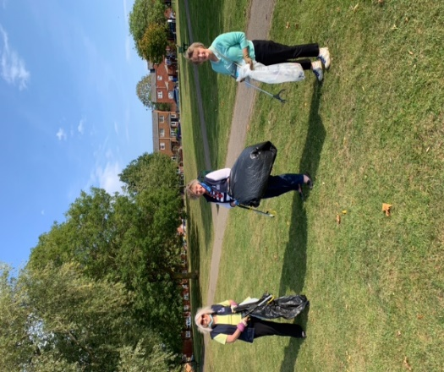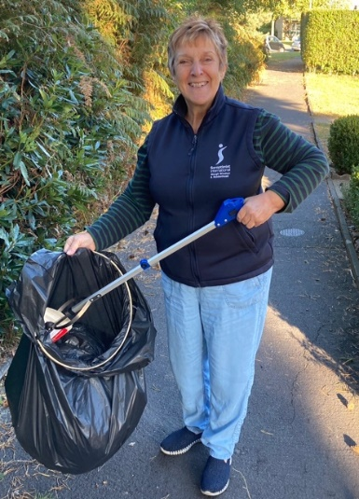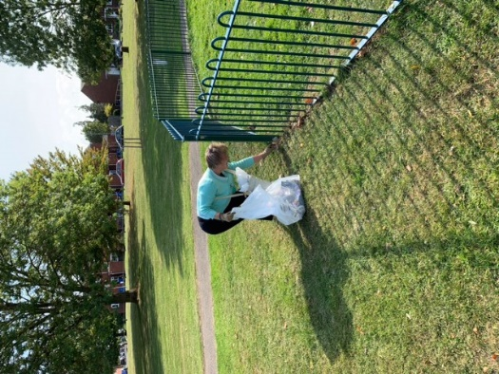
Jackie Paling , Estlyn Davies President Sally Jennette Jackson
& Janette Jackson.

SI Thames Valley: News from Kori Development Project

Hello Kori Supporters!

We hope you are all surviving these really hard times which have affected the whole world.
Thankfully in Sierra Leone they seem to be doing quite well at present, having locked down really fast at
the beginning – due to their previous terrible experience with Ebola. Rose has just departed to Sierra
Leone to check on progress at the Bob Simson Technical Secondary School rebuild. We are all excited
that the builders are back on site and preparing to put on the roof – which you all helped us to purchase.

In the meantime, here are two ways you can easily help right now. Neither costs anything to do but will really benefit our charity.
- Each time you go on to amazon to buy something, please go onto www.smile.amazon.co.uk or www.smile.amazon.com The site will ask what charity you wish to support and you can the nominate Kori Development Project Ltd. This will result in Amazon donating 0.5% of their profit to Kori. That sounds a really small amount but, if enough of us do it, a really useful sum will come to the charity which could help us build that borehole for the school – or help to build some latrines, both things essential for the health of the school children.
- Second thing we need you to do is to go to: www.koridp.org/newsletter/ and subscribe to the newsletter. We will then be able to share with you up to date information and photographs of what’s happening with all our projects in Taiama and the surrounding area. Your contact information will be very carefully looked after and not shared with any other organisation. If in future you wish to go straight to the newsletter, just tap on “news and events “on the Kori website.
Thanks in advance for helping to make our Kori Development Project Ltd successful. Be assured that a lot of children and their families really appreciate your support.

Kay Heppell

Rita's Ramblings!
Notes from your Regional Secretary
Don’t Miss ~ SI Voices Podcasts & Webinars

Hosted by Soroptimist International, the SI Voices Series of Podcasts and Webinars welcomes experts, renowned speakers, Soroptimists and friends, to take on many of the tough topics and challenges affecting the lives of women and girls today. The Series also takes a look back over 100 years of service; uncovering a vast range of Soroptimist International projects, programmes and people, whilst putting policies and practice under the microscope. The programme of Podcasts and Webinars are be available on Youtube @SoroptimistGlobal. Additionally, the SI Voices Podcasts will be available via Spotify, Apple Podcasts and Google Podcast apps, and on Buzzsprout, simply search SI Voices – and keep up with our regular broadcasts, or catch up in your own time.

Visit: www.soroptimistinternational.org/podcasts/

Centenary - #PlantTrees for a Brilliant Future

Has your club started planning your contribution to SIGBI’s Project to plant trees in 2021? As our Federation leads the way with this great initiative so closely connected with the beginnings of SI and yet so important for our current times, it would be fantastic to see stories from our Regional Clubs appearing on the Centenary website.

Mitigating carbon emissions couldn’t be more vital with the lives of women and girls so adversely affected by climate change; and with the UK one of the first countries to commit to Net Zero by 2050 and sharing the chair of COP26, there are lots of national and local tree planting initiatives you can catch onto.

So lots of ways to get started - from working with schools, collaborating with organisations like the Woodland Trust or your local authority on greening your local area, to organising a formal tree planting to celebrate your Club and the Centenary. All offer great opportunities for publicity!

If your Club already has plans we would really love to hear them - please email Programme Action Officers : Pam Robertson (pamelarobertson807@btinternet.com) and Jackie Paling (jackiepaling@hotmail.com) so they can share your stories to encourage other Regional Clubs and possibly some joint working between Clubs. And if you haven’t yet got started, do take a look at the really comprehensive information on the Centenary website :
https://sigbi.org/soroptimistcentenary2021/a-brilliant/planting-trees-for-a-brilliant-future/

