London Chilterns Region

Regional Newsletter – March 2021

Welcome to our latest Newsletter of Helen’s Presidential Year

Message from President Helen

It does my heart good to see daffodils and hear cheery birdsong - lovely signs of spring- on my regular walks. I don’t know about you, but this last lockdown has felt particularly tough, and the natural world has certainly helped my mental health.

It’s hard to know what normal is going to be in future but nature is going to continue to be vital. I have been delighted to hear about Clubs’ plans for tree planting, but this is only part of the story. Women and girls are disproportionately affected by climate change so it’s an important issue for Soroptimists. Having been involved in a successful session on the role of women in reducing carbon footprints with my club earlier this week I know that further work on tackling our impact on the planet must be a priority too.

If you haven’t checked your own Carbon footprint, I can recommend the quick and easy World Wildlife Fund’s version as a simple way to get started. https://footprint.wwf.org.uk/#/ Once you have your score there are helpful suggestions on how to reduce it, if you find your footprint needs work. And if you enjoy being encouraged November to challenge yourself, the WWF’s new My Footprint App will be right up your street.

With the U.K. hosting the UN Climate Change Conference of the Parties (COP26) in Glasgow in ukcop26.org , all eyes will be on our Government to achieve a workable plan for the world to reach carbon neutral by 2050. Whilst our country was the first in the world to declare a climate emergency so far there is little flesh on the bones of a plan to handle it. So, it’s a vital issue which is going to hot up and something we all need to know about and get involved with.

This year’s Soroptimist Day of Action on Saturday 17th July focusses on climate change so do look for something simple your Club might do to get involved. And if you would like to join other Regional Club members to share sustainability ideas and encourage each other in the meantime I would love to hear from you (email address below).
On the Violence against Women and Girls front, in the wake of Sarah Everard’s murder, the Domestic Abuse Bill continues its progress, but it seems there is little other good news. The latest challenge being the withdrawal of Turkey from the Istanbul Convention, another indicator of the dramatically worsening position of women’s rights globally. At least we can be cheered by the success of Asda Female Shop workers with the U.K. Supreme Court upholding their long-standing equal pay claim.

This seems to make our Centenary even more important. Soroptimists have been working on these and many other issues, making a different for women and girls, for 100 years. That story has got to be worth sharing with charity partners and our community and worth celebrating too. It isn’t too late to plan some Centenary activities and I hope you have the date of our Regional Celebration - Saturday 12 June, 2-5pm - in your diary. Although our event will be on Zoom it promises to be a fun and inspiring Celebration of SI’s Centenary with, among other things, a play about the history of SI and a meet up online with founding club SI Oakland in California. I want us to come together to acknowledge and celebrate our achievements, to have a party despite the constraints. So do talk in your Clubs about whether you might be able to get together in small groups to join in on Zoom and please plan to have some sort of celebration cake with you and a cup of tea or some bubbles. More information will be coming out soon.
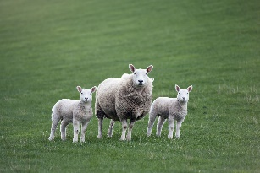
Take care whatever you are involved in and have an enjoyable Easter Break.

Yours in Friendship

Helen

Helen Byrne: President 2020-21
Email: helenbsorop@yahoo.co.uk

Stories from Clubs Across the Region
SI Thames Valley
Kori Development Project Update from Peggy Simson
Many of you will have heard us in Thames Valley Club, talking about our projects in Kori District, Sierra Leone and this is a brief update on the progress of the Bob Simson Technical Secondary School – obviously very dear to my heart.
Well, good news! The school is built, roof is on, windows and doors in – and the best news yet is that it has a borehole and pump! So clean water to drink and wash in! Hopefully the latrines are almost finished and then the children won’t have to go into the bush.
We are working on finding desks and chairs too. We have been given links to other really useful charities too – School in a Bag was recommended to us by Ann Beatty who spoke to us in region from St. Albans Club and subsequently came and spoke -on Zoom of course – to Thames Valley.
School in a Bag has more than one purpose – here is one – for £20 you get this sturdy rucksack and inside is a maths set, a pencil case, three kinds of pencils and pens, six exercise books, lined, squared and plain, plus a water bottle and a box for food – with a spork.
So, if your club – or any of your members -would like to sponsor a bag for a child in our school – we can make sure you know who it goes to. All bags are numbered. I think if every child got one of these it would certainly inspire them to go to school. Just go onto www.koridp.org and donate your £20 and some little girl will be very grateful.
We hope to get one to every child in the first class It should last them all through school. It’s certainly sturdy enough.
Rose, our Chairman, is out in Sierra Leone now and hopes to officially register the school – that way the teachers hopefully get paid, and textbooks should be provided.
Lastly, if you can’t plant a tree, what about a Soroptimist Rose? We’ve only got 9 left bare- rooted for £14.95, or one in a pot for £24.95. Nice way to mark our centenary year. Just email me with your details and I can arrange it.
Thank you.
pegsimson@gmail.com
Kay Heppell Invites Us to Join the fight against Modern Slavery
Do you recognize the signs of modern slavery? Do you know how to report them to the authorities? In their on-going work on violence against women, Soroptimist International of Thames Valley invited Caroline Virgo of the Clewer Initiative to be one of their monthly speakers, on Zoom of course because of current Covid restrictions. Soroptimist International of Thames Valley members were joined on Zoom by Soroptimists from other clubs throughout the UK and by 7 members from their link club in Belgium, Soroptimist International of Val Brabant.
Caroline explained that the Clewer Initiative had its origins in the 1900s, founded by nuns, but that now they are a group of women plus a Bishop of the Church of England, Bishop Alistair Redfern, who work to combat modern slavery in the UK and Africa. Their thinking is that in every UK community there is a Church of England presence and that they are well placed therefore to fight modern slavery in all its new manifestations. Such relatively new manifestations were listed for example as car washes and County Lines.
Caroline showed the audience several informative videos which highlight victims’ stories and these videos are also available on their site and on YouTube.
Unfortunately, often if people are found legally to be victims, their “reward” would seem to be that they are deported, since they have no proper papers for entry into the UK. The offenders, i.e., the exploiters, can be sentenced from 4 to 10 years’ imprisonment, be made to pay compensation and stopped from operating. Little redress for ruining lives.
When asked how Soroptimists can help, Caroline reminded us to report suspicious acts but said we can also help by putting pressure on the media to run stories about modern slavery and local events which concern it. It was also suggested that we befriend our local community police who are often very aware of local happenings. We can also download the Clewer Initiative’s Apps for example “Safe Car Wash” or read “Brave Bear” from the Brave Bear Trust to small children to make them aware of exploitation from an early age.
The Clewer Initiative: www.theclewerinitiative.org
“Brave Bear” https://www.jointhebravebear.org/author/heather/
Soroptimist International of Thames Valley meet during this Covid moment on Zoom every 3rd Tuesday of the month (except August). To see who we are, what we do and how we do it, contact us on: www.sigbi.org/thames-valley
Or sitvclub@gmail.com
You’ll be very welcome!

SI Hertford & District
Programme Action News from Pam Robertson

We have managed to support Safer Places, our local Women’s Refuge throughout the pandemic, with washing up bowls, filled with essential cleaning items, toiletries, a garden table and seven chairs, money raised through two virtual quizzes with some of it earmarked to buy tablets to help the children cope with online learning, and Christmas gifts. At Christmas, for the past few years now, in addition to emergency toiletries, we have collected gifts for women and delivered them unwrapped so that the children could choose a gift to give to their mums. Normally, everyone brings their donations to our Christmas party, but of course, we couldn’t have our party. So, one of our members, Anne, kindly offered her home as a collection point and her spare bedroom was soon transformed into an Aladdin’s cave, such was the generosity of members and friends.

Meanwhile, our newest and youngest member, who lives in a different town, advertised our project on her street app. and she was inundated with toiletries. She set to and made up gift sets which she prettily wrapped in cellophane. We had already ascertained the number of children in refuge at Christmas and knew that we had a minimum of 38 gifts to find to enable each child to give their mother one gift. As it turned out, each child was able to choose at least one gift set of toiletries plus several other presents. I collected all the items from both homes and delivered them, by prior arrangement, to Safer Places. My boot was packed to the gunnels and overflowing onto the back seat. We were delighted as was everybody in the Refuge. Of course we shared our letter of thanks with friends and neighbours on the WhatsApp group, and I quote part of it here: ‘Thank you so much for your donations to us this year. We really appreciate being thought of especially during such a hard year’.

Given the disturbing increase in domestic violence which we have seen during the pandemic, it has been particularly important to us to support Safer Places in their challenging work.

Anne Miles reports on A Virtual Quiz Night Fund Raiser on Friday 5th February 2021
Once again, the technical team of Kate and Karin organised another successful Virtual Quiz Night with President Jenny as Quiz Mistress relaxing us all and keeping everything moving and Valerie Seddon setting us some imaginative questions with the last round giving everyone a completely different challenge!
We were delighted that Jen Simpson from S.I. High Wycombe won the Quiz and we congratulate her.
£660 was raised which has been equally divided between Safer Places and The Living Room. We hope that these Quizzes will have raised the profile of the two charities as well as giving people an enjoyable and stimulating evening and the opportunity to meet friends and new people.
A Friendship Tale from Pam Robertson
SI Hertford and District were invited by one of their friendship links SI Enniskillen in Northern Ireland to join their club meeting on 2nd March. Both clubs explained what they had been doing over the last twelve months. It was lovely to see old friends, meet club members and reminisce about meeting up at previous conferences. While chatting, it came to light that the sister of one of Enniskilllen’s members lives in the same road as one of our members! Contact has been made with the promise to meet up properly once lockdown rules are relaxed.

SI Slough, Maidenhead & Windsor
Jackie Palin Reports on Tree Planting in St Helena
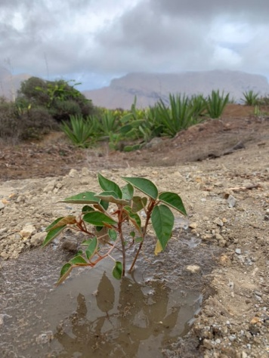
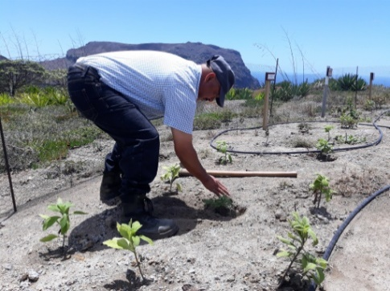
SI Slough Windsor and Maidenhead Club has had trees planted in a forest restoration project on one of the most remote inhabited islands in the world - St Helena, in the South Atlantic. This was done through the island’s National Trust, which aims to preserve its unique environmental and cultural heritage. St Helena is a treasure trove of some of the world’s rarest biodiversity, with over 400 species which occur nowhere else on the planet, including the wire bird, giant tree daisies and desert- dwelling nocturnal spiders.
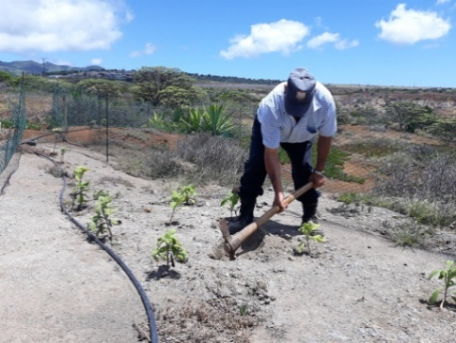
The seas around the island are also home to 10 species of endemic fish. Part of the island was once covered with a native forest called the Great Wood but over the last 300 years it has been decimated by settlers felling the wood and rooting by animals. The site became semi-desert. Restoring the wood will not only be of benefit to the island but also help biodiversity. Gumwoods are found nowhere else in the world, and like other trees endemic to St Helena e.g., the ebony, they are all threatened with extinction. The decision was made to embark upon an historic reforestation project which would inevitably need to continue for decades if most of the area previously occupied by the Great Wood was again to become an established forest. The enormity of the task is magnified by the miniscule size of St Helena and the resources available on the Island for a project of this sort.
Ebony trees were planted by Jackie Paling on behalf of the Club last year, and though she was unable to visit this year for obvious reasons, she arranged for several Gumwood trees to be planted this month to celebrate the Soroptimist Centenary, SI Slough Windsor, and Maidenhead’s 60th Anniversary and also one in the name of SIGBI.

Charter Lunch News from Sandra Bond

The Club’s postponed Charter Lunch is now planned to take place on Sunday 10th October 2021, 12.30pm for 1pm

The venue will be the beautiful Stirrups Country House Hotel in Maidens Green, Bracknell RG42 6LD

For more information contact Sandra on sandra.bond2017@outlook.com

News from your Regional Executive
Regional Programme Action News from Pam Robertson & Jackie Paling

- Have you visited the United Kingdom Programme Action Committee (UKPAC) website recently? It has been updated with new content, and weblinks between all four platforms have been developed. It has been designed to inspire, inform and signpost members to ideas. The Useful links page is new and very informative

Tip: If you Google UKPAC it will come up as the first entry. If you are using Ecosia (thereby helping to plant trees), it will be lower down the list of entries on your first search; thereafter, it will move to the top. You can then go straight to Programme Action.

- UKPAC met on Saturday 27th March 2021.Minutes from the meeting and reports will appear on the website in due course, once they have been approved. To access these and previous Minutes and Reports, go to the UKPAC website, sign in as a member, click on Programme Action, click on Member Resources, then scroll down to appropriate meeting date.

CSW – members spoke enthusiastically and positively about their experiences of attending virtually. You can read Soroptimists’ blogs on the SIGBI website and the SIGBI parallel event will be downloaded onto the YouTube channel next week. It is likely that CSW in 2022 will be a mixture of face to face and virtual.

- Have you registered for Study Day on April 17th? There is a great line up of speakers and it’s free, but you do need to book your place.

- Thank you to all who completed the government’s consultation on violence against women and girls, and to all who have written to your MP in support of the statutory defence amendments to the Domestic Abuse Bill. The former has now closed but there is still time to write to your MP regarding the latter (template letter previously circulated) as we do not yet have a date when the Bill will return to the Commons.
If you receive a reply from you MP, please do let Pam or Jackie know.

- The next UKPAC meeting will take place on Saturday 3rd July when the focus will be on climate change. Please submit a Report Form on any work undertaken by 12th June.

Pam Robertson
Jackie Paling
Regional UKPAC Representatives

Communications Officer: Jane Slatter

17 April UKPAC Study Day - I have included all the info on the SILC website.
https://sigbi.org/london-chilterns/programme/
Any extra info for the 12 June event gratefully received - I could do with adding some meat on the bones on the website and for the April Dear Diary next week....
Region News
For those who missed the March IWD Region meeting, or just want to be reminded about what a brilliant event it was check out the website:
https://sigbi.org/london-chilterns/2021/03/13/iwd21/
SI Milton Keynes in the news to mark the Soroptimist Centenary.
https://sigbi.org/london-chilterns/2021/03/12/milton-keynes/
SI Thames Valley fighting Modern Slavery.
https://sigbi.org/london-chilterns/2021/03/11/modern-slavery/
Reminder for people to please send things to me for Dear Diary and for the website to silondonchilterns@hotmail.com
and also to follow and share things with SI London Chilterns on Facebook and Twitter - www.facebook.com/silondonchilterns & twitter.com/SoroptimistLC or @SoroptimistLC

Rita's Ramblings! Notes from your Regional Secretary.

Celebrating our Centenary ~ Remember to order your commemorative items from SIGBI Trading

- A Unique Piece of Soroptimist Jewellery to commemorate 100 years of Soroptimists – a beautiful Soroptimist brooch to add to your collection.
- Commemorative Envelopes with our own Soroptimist Stamps. – Own a Little Piece of Soroptimist History.
Keep as a memento or give as a present to promote our Soroptimists worldwide.

Membership Long Service Awards: Because of the Covid-19 restrictions we were unable to meeting in person in October 2020 and no Long Service Awards were presented. I am now catching up with this new way of working and if you have a member who has been a Soroptimist for 25, 40 or 50 years please let me know by 17th May 2021 so I can organise a certificate to be produced for them ready for our June Regional Meeting r.beaumont3@ntlworld.com

Diamond Education Grant: members who joined our Celebration of Human Rights Day in December 2020 will remember donations were invited when booking for the Diamond Education Grant; I am delighted to confirm we have been able to send £400 to the fund and have received a thankyou letter

Why not join the Regional Executive and help shape your region? We are looking to recruit new members to become part of our regional team, in particular we will have vacancies for the posts of President, President Elect and Secretary, all can be a job share and provide an opportunity to be an important part of our great organisation. If you would like to know more about the roles then contact Helen or I for a chat.

SIGBI Benevolent Fund: Regional Trustee Rita Beaumont
This has been difficult time for all of us and our families but for some members the sudden reduction in income has caused of extreme hardship, so just a reminder about the Benevolent Fund.

The fund is a totally confidential service available to help the financial difficulties of those who are eligible to apply.
The fund may be in the form of a quarterly payment or a one-off payment to pay for an unexpected item.

Examples of how Discretionary help that could be considered includes:
- Utility bills
- Telephone Bills
- Essential living expenses
- House maintenance
Who is Eligible?
You must have been a Member of a Soroptimist Club in the UK, including the Channel Islands and the Isle of Man, or
the Republic of Ireland for 3 years or more. The support given is subject to a simple confidential financial check.

How to Apply
A member who might need financial help at this time can contact me so I can talk through the application process.
Rita Beaumont
Email: r.beaumont3@ntlworld.com
Telephone: 01234 401475 or Mobile: 0776 4511 006

End Snip-It!
Need something to look forward to ~ it is never too early to make a date in your 2023 diary!

Why not share your club activities with your friends across the Region?
Send me your news on r.beaumont3@ntlworld.com
Copy Date for the May 2021 Edition of the Newsletter is 24th May 2021.

