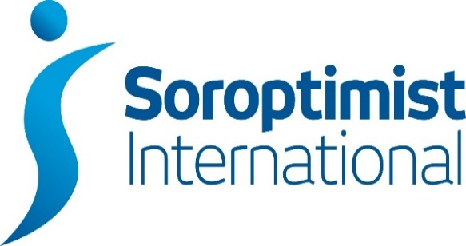
London Chilterns Region

Regional Newsletter – May 2021

Welcome to our latest Newsletter of Helen’s Presidential Year

Message from President Helen

Finally we have some sun and it looks like it might be staying around for a while!
So, whilst none of us is quite sure whether the 21st June is going to be the final curve on the roadmap, we can at least start to enjoy what I am sure will be a better summer.
I hope you’re looking forward to our Regional Conference and Centenary Celebration on Sat 12th June, 2-5pm. It would have been nice for us all to have met up as a Region face to face but we can at least meet up in our Clubs and holding the event on Zoom allows the Founding Club, SI Oakland, California to join us.
If you haven’t already take a look at the Event webpage: www.sigbi.org/london-chilterns/12jun and please book through Eventbrite by clicking on this link: www.eventbrite.co.uk/e/soroptimist-international-london-chilterns-conferencecentenary-celebration-tickets-155679634979
Holding the Celebration on Zoom also allows Regional friends and past members to join in. So do think if there is anyone connected with your Club who would enjoy sharing this lovely event with you and send them the links too.
To whet your appetite further, Jane has created a page about the Regional #WhoIsShe Soroptimists we will be celebrating on 12th : https://www.sigbi.org/london-chilterns/history/

These women are inspirational and give personality to our organisation. As May is Membership Month you might want to share this webpage with any potential or new members along with the new ”Why be a Soroptimist?” video page: https://sigbi.org/london-chilterns/why-be-a-soroptimist/

Sadly we won’t now have Federation President Johanna with us on 12th. We have sent best wishes on behalf of the Region and will be thinking of Johanna and her family and hoping for a speedy recovery.
See you on the 12th with your cake and bubbles (or tea) for our once in a generation opportunity!

Yours in Friendship

Helen

Helen Byrne: President 2020-21
Email: helenbsorop@yahoo.co.uk

Stories from Clubs Across the Region
SI Thames Valley
Kay Heppell asks us “How can you get personally get involved to save our environment?”
SI Thames Valley found out this week when their PA Officer Sushi Gow invited Summreen Sheikh of Greenpeace to speak at a club meeting to give practical hints on how to help. We can, of course, join a local environmental group and participate in their actions. But on a personal level there is a lot more we can do.
She herself now car shares and cycles when she possibly can. She advised us to think carefully about the food we eat to produce less waste. She told us of her own experiments with vegetarianism and veganism. It was her small way to help reduce the world-wide demand for more land, such as rain forests, to cultivate and help meet this demand for more meat and soya. Our own gardens should ideally be biologically diverse to give Nature a helping hand to help us. As regards the energy we use, we could investigate the installation of solar panels to reduce our consumption and contribute to the grid. Our water use could be more closely monitored. If we have not already installed a water meter. we can easily recycle rain water for our garden use with the simple aid of a water butt to collect it. Think of the energy we use as we go around the garden with a watering can instead of a hose connected to the mains. So it helps us monitor our weight as well! For those of us with money to spare and invested we should look closely at what the funds and make sure they too are “green” funds.
Our aim should be always to reduce the plastic we use. Think, for example, of buying meat directly from a butcher, if this is possible and getting rid of all those plastic trays, we leave the supermarket with. Take part in lobbying for the reduction of plastic. Greenpeace has some excellent anti-plastic use videos we can view on YouTube and use to spread the word.
We can also organise or take part in anti-litter campaigns or in beach clean-ups.
Shireen also gave an account of the organisation that is Greenpeace, its history and where it is now. But most of all she reminded us of the things we could be doing to help our present environment improve and survive. Things which as Soroptimists we should lead as examples.

SI Hertford & District
Pam Robertson tells us how the club Celebrated a Big Birthday!

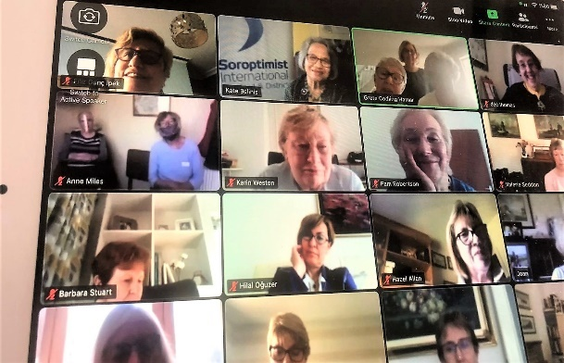

We celebrated our 65th Anniversary on 24th April by linking up with our Friendship Clubs in Enniskillen in Northern
Ireland, Hamar in Norway, and Gaziosmanpasa in Ankara, Turkey.

It was good to catch up with friends, exchange news and share successful Programme Action activities. We were delighted that President Helen was able to join us and propose a toast to the success of our club. We look forward to celebrating with friends across the region on November 20th at our re-scheduled 65th Anniversary Lunch.

SI Slough, Maidenhead & Windsor
Jackie Paling has arranged for 100 trees to be planted on behalf of the Club in Northern Afghanistan, through the charity Afghanaid. Afghanaid has launched a new reforestation project which will benefit 6000 men and women. The trees are to be planted in Hazrat-e-Sultan in the Hindu Kush Province of Samangan. They will be almond trees due to their durability and drought resistant nature - something which is crucial for members of the Hazrat-e -Sultan Community, who have been increasingly feeling the effects of the climate crisis in recent years. These trees will play an essential role in revitalising the watershed and repairing land degradation in the area. As part of this reforestation project, Afghanaid are also setting up forest management associations to ensure that local women and men will learn to work together to collectively manage their resources in a sustainable and inclusive way. Afghanaid will run a variety of training courses and provide the equipment the community will need to properly look after all aspects of the forest landscapes on which they rely.
Afghanaid particularly targets vulnerable individuals and families, including female-headed households, people with disabilities, and the unemployed youth with this support. Unfortunately the Club will not be able to have a plaque but hopefully, once the trees are planted in the autumn, it will receive a photo of the beneficiaries with their almond tree saplings.

News from your Regional Executive
Regional Programme Action News from Pam Robertson & Jackie Paling

- Minutes of the UKPAC (United Kingdom Programme Action Committee) together with other reports from the meeting are now on the website under Programme Action resources.
- Also on the PA website are the presentations on Modern Day Slavery, the morning session of the Study Day on 17th April. The afternoon session was postponed owing to the funeral of HRH Prince Philip. This session will now take place on the morning of Saturday 3rd July at 9.55am with the Zoom platform opening at 9.30am. You are asked to use the link you received for the 17th April meeting. If you no longer have this, I suggest you contact: ukpacsecretary@gmail.com.
- On 24th April, a webinar took place on Programme/Membership. Links to the presentations and videos can be accessed by going to Members Area of SIGBI website, clicking on Programme and again on Webinar 24th April. While you are there, you can also access an informative update on completing Programme Report Forms by clicking on PA Webinar Report.
- The next UKPAC meeting will take place in the afternoon of 3rd July where the focus will be on Climate Change. If you have completed any related projects, please submit a Programme Action report by Tuesday 8th June to be considered.

Update: The Hope Foundation UK from Pauline Panter

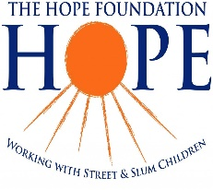
I have recently been in communication with the Directors of The Hope Foundation working for Women and Children in the slums of Kolkata. Members will remember a young lady who gave us an excellent presentation at our Regional Meeting in 2018 in The Lancaster Hotel about the work being undertaken in the city of Kolkata. The Hope Foundation has an excellent fundraising and publicity group in Bedford and has been working with other charities in the town to raise awareness and support for the most vulnerable in Kolkata society.
The priorities for the charity are usually:
- Protection of Women and Children including exploitation and other forms of abuse and neglect.
- Drug Rehabilitation.
- Education.
- Vocational Training.
- Healthcare.
- Nutrition.
Due to the present Coronavirus pandemic, priorities have changed a good deal, however the welfare of women and children remain paramount for the charity. A 50 bedded satellite health centre has just been opened (May 2021) by the Hope Foundation to assist in caring for slum dwelling victims of this dreadful disease. The 10 bedded Hope Hospital usually used for children’s non urgent surgery has also reopened (April 2021) to care for those with coronavirus but are unable to access healthcare. Additionally, there has been a very proactive campaign to distribute food and other necessities to those in acute need, over 800 extended families were supported in this way in one week alone. There is a great shortage of food throughout Kolkata.
An emergency support team from the Hope Foundation is also working with other charities in the city in a concerted attempt to ensure that the most desperate people get some form of assistance.
As if this was not bad enough the city of Kolkata is bracing itself for Cyclone Yaas which is heading towards them this weekend with widespread and extensive damage expected.
If you are interested in learning a little more about this charity and how you can help the website is excellent and donors are sent regular updates about how and where their donations are being spent.
www.thehopefoundation.org.uk

Communications Officer: Jane Slatter

Websites - does yours attract prospective new Members?
What would a prospective Member make of your Club website? especially the home page? Did you know that most prospective Members look at your website before they decide to contact your Club? Does it showcase what you do and what you have planned? Are you struggling with the SIGBI website - please ask for help if you need it.
Publicity for the New Club Year
A new Club Year is an opportunity for publicity - telling local publications (online or printed) about your Club successes for the previous year and what you're planning for the year ahead.
Being the centenary of Soroptimist International is definitely something to tell your local papers about!
It doesn't matter if you're a bit late with new items like these.
This one from SI Hertford and District is a great example and includes a lovely photo of the new President Kate Belinis
www.inyourarea.co.uk/news/hertford-volunteer-service-president-reflects-on-past-year
Well done to the Hertford Soroptimists!
Meeting Plans for the Year Ahead - to Zoom or not to Zoom?
It sounds as if all Clubs in the Region turned to Zoom during the pandemic. What are your Club's plans for the future? Will you go back to face-to-face meetings, or will you continue to have some meetings on Zoom? Please let us know what your plans are by emailing silondonchilterns@hotmail.com and we can compile the information and share with other Clubs in the Region.
Planned Communications Webinars by Nisha Ghosh SIGBI Director of Marketing
Nisha Ghosh is planning communications webinars - initially for Regions, so I will be attending for London Chilterns and representing Clubs in our Region. A separate email has been sent to Clubs from Region asking for views on how the webinars should be run and what Clubs would like to know. Replies are needed by June 3 so I can collate and get to Nisha by 7 June, which is why it was sent separately.
- Remember to follow and share things with SI London Chilterns on Facebook and Twitter - www.facebook.com/silondonchilterns & twitter.com/SoroptimistLC or @SoroptimistLC

Jane Slatter, SI London Chilterns Region Communications Officer pinkyslatter@hotmail.com

Rita's Ramblings! Notes from your Regional Secretary.

Celebrating our Centenary ~ Remember to order your commemorative items from SIGBI Trading

- A Unique Piece of Soroptimist Jewellery to commemorate 100 years of Soroptimists – a beautiful Soroptimist brooch to add to your collection.
- Commemorative Envelopes with our own Soroptimist Stamps. – Own a Little Piece of Soroptimist History.
Keep as a memento or give as a present to promote our Soroptimists worldwide.

Why not join the Regional Executive and help shape your region? We are looking to recruit new members to become part of our regional team, in particular we will have vacancies for the posts of President, President Elect and Secretary, all can be a job share and provide an opportunity to be an important part of our great organisation. If you would like to know more about the roles then contact Helen or I for a chat.

SIGBI Benevolent Fund: Regional Trustee Rita Beaumont
This has been difficult time for all of us and our families but for some members the sudden reduction in income has caused of extreme hardship, so just a reminder about the Benevolent Fund.

The fund is a totally confidential service available to help the financial difficulties of those who are eligible to apply.
The fund may be in the form of a quarterly payment or a one-off payment to pay for an unexpected item.

Examples of how Discretionary help that could be considered includes:

- Utility bills
- Telephone Bills
- Essential living expenses
- House maintenance

Who is Eligible?
You must have been a Member of a Soroptimist Club in the UK, including the Channel Islands and the Isle of Man, or
the Republic of Ireland for 3 years or more. The support given is subject to a simple confidential financial check.

How to Apply
A member who might need financial help at this time can contact me so I can talk through the application process.
Rita Beaumont: Email: r.beaumont3@ntlworld.com :Telephone: 01234 401475 or Mobile: 0776 4511 006
End Snip-It!
Need something to look forward to ~ it is never too early to make a date in your 2023 diary!

Why not share your club activities with your friends across the Region?
Send me your news on r.beaumont3@ntlworld.com
Copy Date for the July 2021 Edition of the Newsletter is 26th July 2021.

