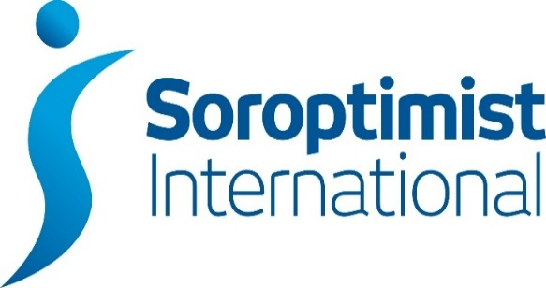
London Chilterns Region

Regional Newsletter – August 2021

Welcome to our latest Newsletter of Helen’s Presidential Year

Message from President Helen

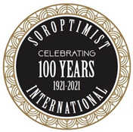
As I write this in sunshine after a tropical downpour, I hope you are all managing to keep dry!

I was delighted to see so many Clubs on the Regional Club Call on Saturday 24th July. We had some very useful discussions: clubs sharing plans for 2021-22, sharing ideas on Programme Action and comparing notes on how to ensure members feel comfortable moving forward with meetings i.e. to Zoom or face to face or both and other development ideas. Rita will be sending out her amazing notes of the meeting soon and I can thoroughly recommend you read them, whether your Club was able to attend or not.

And do please put the date of the next Club Call in your diary during morning of 25th September 2021

Having held two successful speaker events focused on domestic abuse the SI London Collective- a partnership of the London Soroptimist Clubs - is beginning to gain momentum, with members discussing plans for shared Programme Action. Now with involvement from almost all the clubs in London from all 4 regions covering the area, we will be looking to get the partnership on a more formal footing over the coming months. I will update you fully as part of my report for the AGM.

As my year draws to a conclusion, I am beginning to reflect on the pleasure I have had in meeting you all, even if only on Zoom. I am planning our AGM and will be in touch very soon to ask how you and your Club have got on with the Centenary #Plant Trees Project so I can report back at the AGM. As the U.K. gears up to lead the world at COP 26 in November it becomes more and more important for Soroptimists to be visible in taking tree planting and other climate change actions.

I am delighted to announce that the speaker at our AGM will be the Rt Hon & Rt Revd Dame Sarah Mullally , the Bishop of London, formally the Chief Nursing Officer for England. Having risen to senior roles in two professions with the exact opposite gender-mix Bishop Sarah will share her experience of “Career and gender” as well as of the Commission on the Status of Women which she attended for the first time last year. As a clear and compassionate thinker I am sure Bishop Sarah will offer us an interesting and valuable perspective.

Our AGM will also allow us the opportunity to celebrate our sadly missed Federation President Johanna Raffan.

May I wish you all a safe and enjoyable summer.

Yours in Friendship

Helen

Helen Byrne: President 2020-21
Email: helenbsorop@yahoo.co.uk

Celebrating The Centenary at Our June Regional Meeting
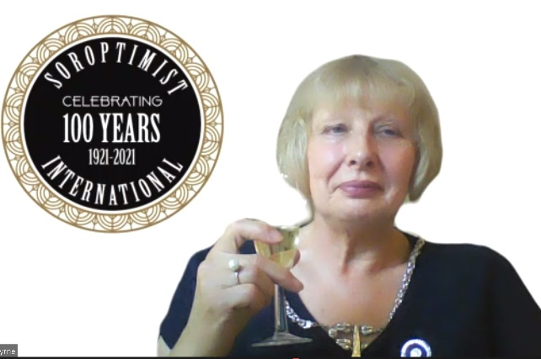

President Helen

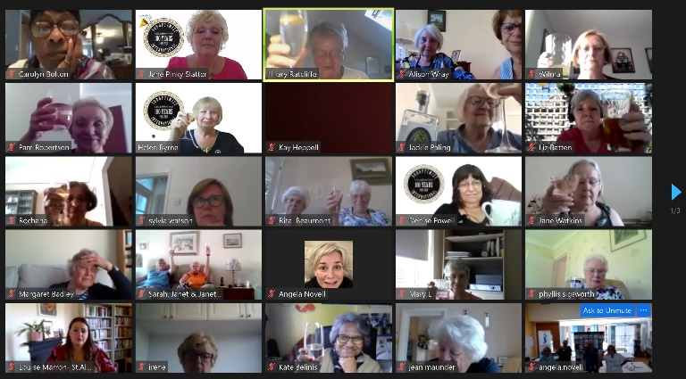
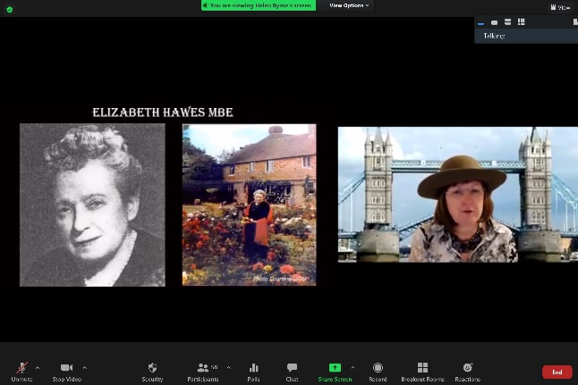

Milton Keynes & The Play We All Scrubbed Up Well!
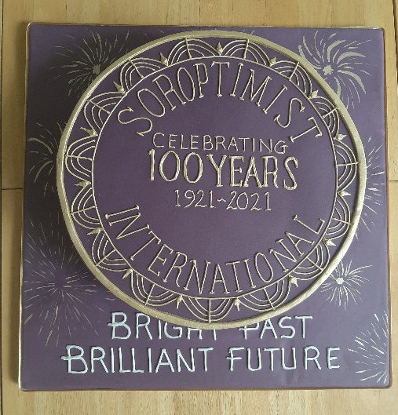
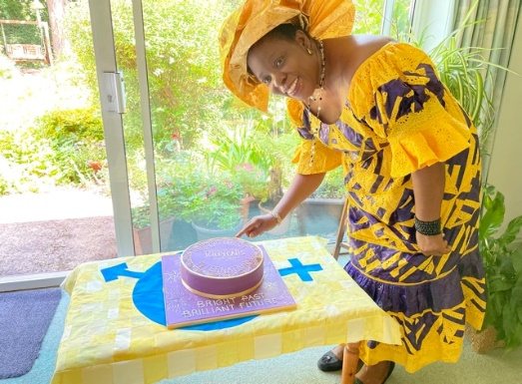

The Gorgeous Cake Rose Cutting the Cake

Soroptimists Love Celebrating with Cake & a Glass of Bubbly!!
SI Milton Keynes ~ Our Hostesses
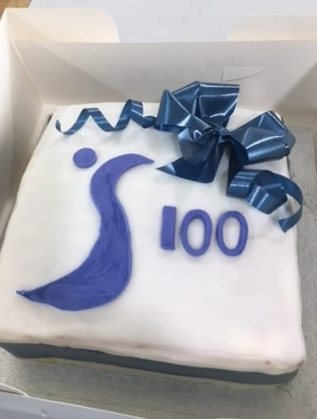
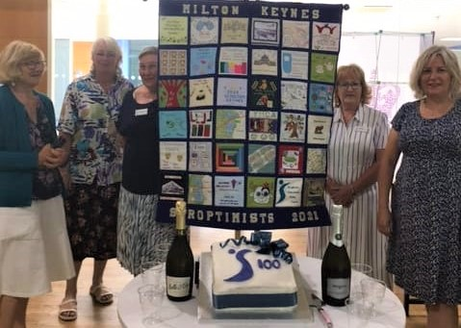
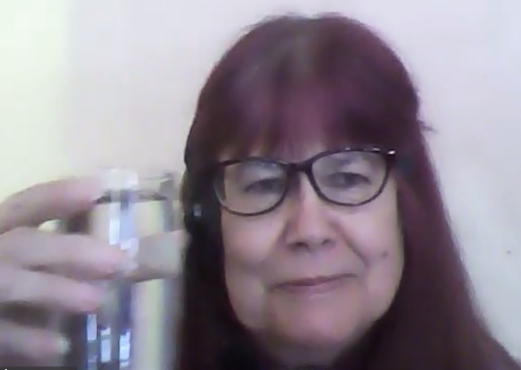

SI Thames Valley

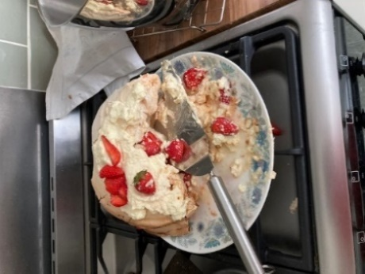
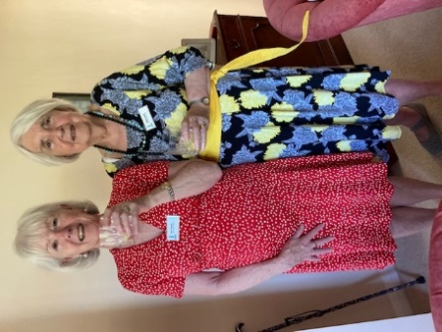
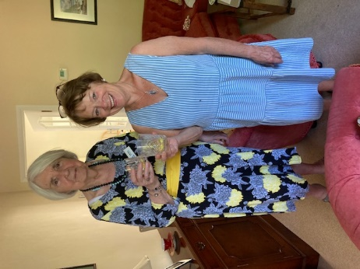

St Albans SI Newbury
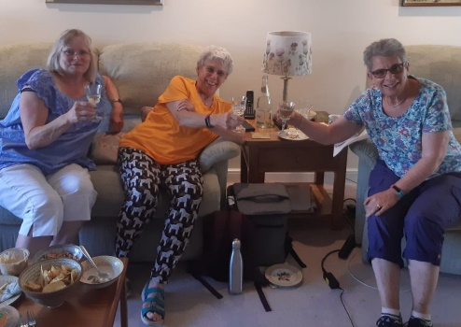
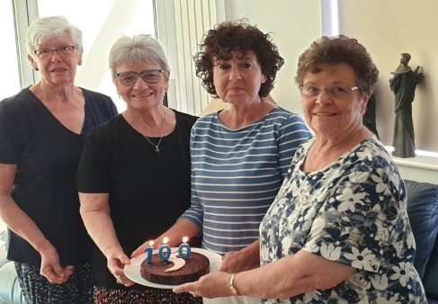

We joined in the Celebrations with over 90 members of many #Soroptimists clubs for our 100th Birthday! Thank you @SIMiltonKeynes for hosting a super meeting. We too had cake and bubbly! @SIGBI1
Stories from Clubs Across the Region
SI High Wycombe
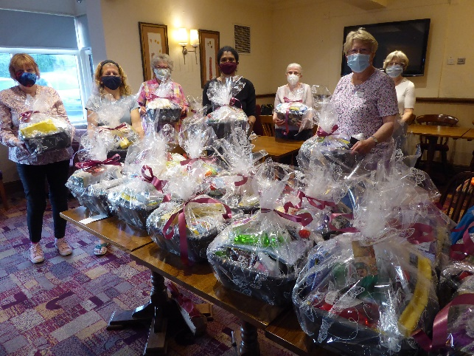

On Tuesday 13th July, 8 members of SIHW came together to continue our support for Wycombe Women's Aid. We have helped WWA since 2004, and the bowls evening is now a yearly event. Women leaving the Refuge for their new homes often forget the "little things" so for several years we have made up welcome packs in washing up bowls with household items such as washing up liquid, gloves, cleaners, tea towels, brushes etc . We always try to include a little luxury such as hand cream too. We have a pretty efficient assembly line, and the bowls are packed to the brim then wrapped in pretty florists wrapping and tied with a bow and a card saying "Welcome to your New Home from High Wycombe and District Soroptimists". The bowls are delivered to WWA offices by one of our members and are very much appreciated. This year we filled and wrapped 20 bowls.
Below is the letter of thanks received from WWA
Wycombe Women’s Aid Ltd
PO Box 1477
High Wycombe
Bucks HP11 9HP
Tel: 01494 461367
Email: enquiries@wycombewomensaid.org.uk
www.wycombewomensaid.org.uk

Dear Kathleen

On behalf of all of us here at Wycombe Women’s Aid, a very heartfelt thank you for the 20 washing up ‘starter bowls’ that you so kindly delivered this afternoon. Could you please thank everyone at High Wycombe & District Soroptimists for their kindness and generosity and for taking so much time, care and attention over the bowls. They are absolutely fantastic, as they always are, and will be of huge benefit to the women that we support over the coming months.

We remain exceedingly grateful for the ongoing support we receive from your group of Soroptimists and thank you for your commitment and passion over so many years.

Thank you again.

With all good wishes

Sophie

Sophie
On behalf of Wycombe Women’s Aid

SI Hertford & District

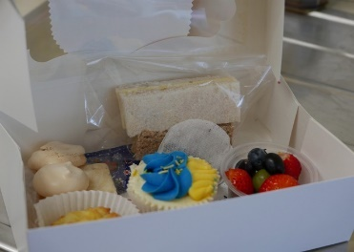
The Alternative Isabel Hospice Tea

Each year, Hertford and District Soroptimists have held a Hospice Tea in the garden of one of the members in Bengeo. With no Party last year or this year because of COVID, we decided to give an option to our supporters of having a Tea Box provided by our members on Monday 28th June. These were very well received, ‘lovely to look at and delicious to taste’. With many generous donations from friends and the Tea Box supporters, we have raised over £910 for The Isabel Hospice.

SI Newbury
Unique Recipe Opportunity to support Tree Planting in Ghana
The Newbury club are “planting” a mango and a cashew tree in each of 7 schools in Lawra, NW Ghana in August as continued support for Action Through Enterprise. Many of you will remember when Sarah Gardner talked at the Regional meeting held in Newbury. These will provide shade, fruit and a project for children in the schools in which ATE runs a feeding programme.
Over half the funds “are in” but plans for the second fund raising event were moved twice & are now cancelled. Instead, we hope that some of you would like to support us by donating in return for 2 recipes from Newbury’s Henry & Joe’s; a restaurant reviewed in the national press as a “must try”. Henry kindly produced “Cashew hummus with butternut & light curry dressing with roasted vegetables” starter & “Mango & passionfruit cheesecake” recipes for us.
We’re asking for £3 plus for the 2 recipes, with a “free” Ghanaian Jollof recipe as a bonus. This vegetarian rice dish is served with chicken when affordable.
Find out more about ATE on www.ateghana.org
What we need to do: We ask you to group donations together & send one cheque per club. In return we will email the recipes to one person in the club for distribution.
Cheques to Pam Freeman, 5 Sherrardmead, Shaw, Newbury, RG14 2DF.
Please don’t forget to include an email address for the recipes.

SI Slough, Maidenhead & Windsor
Dates for your Diary
- August Speaker Meeting: On 18th August 2021 at 7.30pm a representative from The National Association for Ovarian Cancer which will be via Zoom
Contact sallyradford@btinternet.com who will send them the link.

- Annual Charter Lunch which will be happening on Sunday, 10 October, hopefully there will be no more restrictions or lockdowns. Places are available. please contact Sally Bond on sandra.bond2017@outlook.com for menu choices and booking.

- We are hoping to hold Nepalese evening on 16 October 2021 at the WADE (Wokingham & District for the Elderly)
with a meal and two speakers (Jonna Bega who helps run the "Child Rescue Nepal" charity) and another speaker from kidasha. More information to follow shortly.

New Feature ~ Speaker Recommendations
The following have recently spoken at SI Hertford supporting President Kate Bellis theme of Equality in Action
- Speaker: Inter-Sectional Diversity
Dr Sham Qayyum
Senior Lecturer in Law and Leadership
SOAS, University of London

- Speaker: Gypsy, Roma Travellers
Josie O'Driscoll
CEO GATE Herts
GATE= Gypsy And Traveller Empowerment

- Speaker: Charanjit Kang
Assistant Head of Business Family Placement South East and responsible for fostering and adoption Barnardo’s

If you have a speaker that you would like to recommend then send details to Rita for inclusion in the Newsletter
News from your Regional Executive
Regional Programme Action News from Pam Robertson & Jackie Paling

- If you haven’t already done so, do look at the Minutes of Regional President Helen’s Club Call, recently circulated by Rita – there is a lot of useful Programme Action information

- Under ‘Actions we can take’ – A template letter to ask MPs to support Dame Vera Baird’s Amendments to the Police, Crime, Sentencing and Courts Bill re. digital disclosures has already been circulated to clubs.
Do look at the Women’s Aid Campaign Champion website and see if there is anything that you or your club could do.
The other issues, we will pick up as appropriate in September

- If you missed the Study Day on 3rd July, this can be accessed by going to: www.sigbi.org/ukpac/virtual-study-day2021/

- Are you helping to plant trees by using Ecosia as your search engine?

- Are you helping to support SI Thames Valley’s Kori Development Project by using Amazon Smile?

- How about signing a petition on the SIGBI website

- Are you up to date with your Programme Focus Report Forms? Need help with these? Contact Pam on pamelarobertson807@btinternet.com or Jackie on jackiepaling@hotmail.com

Rita's Ramblings! Notes from your Regional Secretary.

- Soroptimist International AGM

The SI AGM was held on Thursday 29th July 2021; the evening included a number of excellent presentations highlighting the diverse programme work of SI ~ if you missed the meeting, you can watch the presentations on the SI YouTube channel by visiting www.soroptimistinternational.org and following the SI Voices link or SI Lab

- Hot off the Press!!

The next SI President’s Appeal will be launched on 1st October 2021 . Incoming International President Maureen Maguire has chosen as her focus Changing Lives Through Education with the title: Open Doors to a Bright Future Watch out for further information

- Why not join the Regional Executive and help shape your region?
We are looking to recruit new members to become part of our regional team, in particular we will have vacancies for the posts of President, President Elect and Secretary, all can be a job share and provide an opportunity to be an important part of our great organisation. If you would like to know more about the roles then contact Helen or I for a chat.

SIGBI Benevolent Fund: Regional Trustee Rita Beaumont
This has been difficult time for all of us and our families but for some members the sudden reduction in income has caused of extreme hardship, so just a reminder about the Benevolent Fund.

The fund is a totally confidential service available to help the financial difficulties of those who are eligible to apply.
The fund may be in the form of a quarterly payment or a one-off payment to pay for an unexpected item.

Examples of how Discretionary help that could be considered includes:

- Utility bills
- Telephone Bills
- Essential living expenses
- House maintenance

Who is Eligible?
You must have been a Member of a Soroptimist Club in the UK, including the Channel Islands and the Isle of Man, or
the Republic of Ireland for 3 years or more. The support given is subject to a simple confidential financial check.

How to Apply
A member who might need financial help at this time can contact me so I can talk through the application process.
Rita Beaumont: Email: r.beaumont3@ntlworld.com :Telephone: 01234 401475 or Mobile: 0776 4511 006

End Snip-It!
Need something to look forward to ~ it is never too early to make a date in your 2023 diary!
Early Bird Registration open January 2022
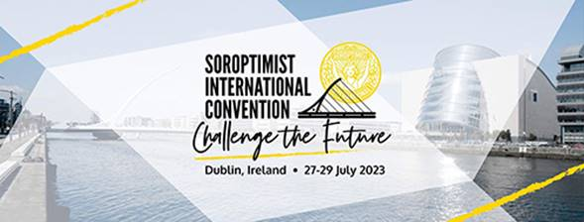

Why not share your club activities with your friends across the Region?
Send me your news on r.beaumont3@ntlworld.com
Copy Date for the September 2021 Edition of the Newsletter is 20th September 2021

