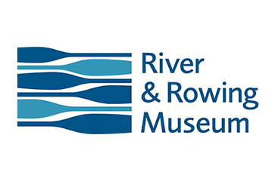

Join us to celebrate Thirty Years of services to women locally, within Great Britain and Internationally.

Our charter Lunch will be at the River and Rowing Museum, Henley on Thames RG9 1BF. This contemporary Venue offers great views of the river, has its own car park and is convenient for the train station.

**Sunday 21st November 2021**.

**Reception time 12.00pm, for 12.30pm lunch.**

The cost per Head is £50.00 to include a welcome drink and a glass of something special for the toasts, a table prize draw ticket, a small donation to charity and, time allowing, the opportunity to walk around the exhibition after lunch.

There will also be a fundraising raffle.

-------------------------------------------------------------------------------------------------------------------------------

Please send your remittance and application by Monday 8th November.

Full Name:

Address:

Club Name (if applicable):

Please reserve places for SITV’S 30TH Charter Lunch. I enclose a cheque to the value of £50.00

Please advise any dietary requirements.

Reply to Mrs R M Kirk; 1 Kingswood Cottages, Tag Lane, Hare Hatch, Berks, RG10 9SX

Or email [sithamesvalleysecretary@gmail.com](mailto:sithamesvalleysecretary@gmail.com) for payment online details.

***Incorporating a celebration of the life and work of our much-loved founder member Johanna Raffan MBE.***

**Soroptimist International**

**Thames Valley**

**30th (Pearl) ANNIVERSARY**