London Chilterns Region

The London Chilterns Challengers 2021/2022
“Respecting Differences, Celebrating Similarities”

Regional Newsletter – October 2021 Post AGM Special

Celebrating An Excellent Year with President Helen at Our October Regional Meeting
President Helen’s Review of the Year
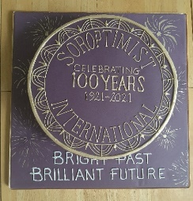
It has been a privilege to be SI London Chilterns President in SI’s Centenary Year. Thank you for all your support during what has been a busy and challenging year. I hope you have valued the Programme we have organized and have felt supported.
My theme was “Celebrate the Past, Create the future. Despite COVID I am pleased that we were able to celebrate properly, even if we couldn’t meet face to face, and that many Clubs have taken the opportunity to use the Centenary to promote themselves in their local press and with special events. And with every Club using and seeing the benefits of Zoom, in some cases attracting new members as a result, I think we have lived up to my theme very successfully. And don’t forget It isn’t too late to take advantage of the Centenary to promote yourselves.
In December, we celebrated Human Rights Day welcoming Kimberley Lamb, Head of Bedfordshire’s Violence & Exploitation Reducation Unit. Kimberley shared her unique and successful methods for harnessing the community and staff with lived-experience to tackle crime and to help turn the lives of victims and perpetrators around. Our second speaker was Federation President Johanna Raffan MBE who in one of her first visits of the year told us about her path to Federation President and her exciting plans for her Presidential year.
At our International Women’s Day Conference in March, we heard from two special Women Leaders. First Assistant Chief Constable Kerrin Wilson QPM who shared her experience as the first of only two female Chief Officers in the UK from an ethnic minority. She shared some great insights into how to encourage women into leadership and how to respond to the challenge of gender-based violence. Our second speaker, Shrabani Basu, a well-known journalist and author inspired us not only with “The Spy Princess” the life story of the first female spy in WWII Noor Inayat Khan but also Shrabani’s own single- minded campaign for official recognition of Noor’s achievements.
In June we held our Centenary celebration, ably hosted by SI Milton Keynes who provided our fascinating speaker – from the Milton Keynes Parks Trust. Who knew there was so much beautiful countryside and parkland in Milton Keynes? We were able to fully embrace our Centenary with a meet up online with the Founding Club SI Oakland who touched us with the work they do to support vulnerable women in their community. And we celebrated 8 of our 100 for100 Regional Soroptimists. There was a smashing cake and we shared a toast together, thought sadly without Johanna.
Holding all our Regional meetings on Zoom has had the advantage that we’ve been able to make several charitable donations rather than spending money on speakers travelling expenses. It also enabled us to reduce Regional fees for this year.although we will need to renew them for next year. However, the shorter online meetings meant less time for networking and sharing Programme action. As I also wanted to keep in touch with Clubs so we were able to support your needs I started regular Club Calls with Presidents and Regional Reps which have enabled much valuable sharing and proved very popular. The advent of Zoom also enable Federation President Johanna and later Cathy Cottridge to hold regular meetings with Regional Presidents. These too have proved valuable for Regions and SIGBI alike and are set to continue.
It has been a delight to visit Clubs during my year, even if sadly only on Zoom. I have heard some fascinating speakers and learned more about the amazing programme action you are involved in. Everyone has made me very welcome and been interested to hear about the reasons behind my focus on diversity and my other plans.
Whilst Programme Action has in some ways been curtailed by COVID it is good to know that Clubs have been able to pivot - finding new ways to fundraise and support their charities. Sadly, the Nepal Federation Project fell to the impact of COVID but Clubs had been able to contribute and the Project had made an impact. I am very pleased Clubs have taken up my challenge to undertake at least one tree planting activity during the year. Many of the trees will by necessity be planted during this Autumn but it is brilliant that we have been able to contribute to the Centenary Project #Planttrees for a Brilliant Future. I hope you will continue to look for ways to tackle climate change, including tree planting, in the coming year.
The idea of a Centenary stall at the Women of the World Festival (WOW) in London in March 2020 prompted me to arrange a meeting of the London Clubs in our Region and SI London Anglia. The live WOW festival never happened but discussions continued and we now have a cross-London partnership of Clubs – the SI London Collective - which has held several successful online speakers’ meetings. We are planning some joint Programme Action and as the WOW Festival is going to be live again next year, we have the possibility of working together to promoting SI at this important women’s event.
I am always keen to engage young women in our activities and, thanks to SI Slough, Windsor & Maidenhead, Region has been able to sponsor a young woman interested in our work to attend the SIGBI Conference at the end of the month. We will hear more about this at our December meeting.
I have certainly enjoyed my year - I hope you have too. However, I have to offer my heartfelt thanks to my Executive who have risen to the year’s challenges with generosity, commitment and humour. We have met more often than usual and it has needed flexibility and flare from every Officer to see us through and make the most of this Centenary Year. I look forward to working together with my other Executive colleagues next year in another shared presidency.
Thank you for a Great Year Helen
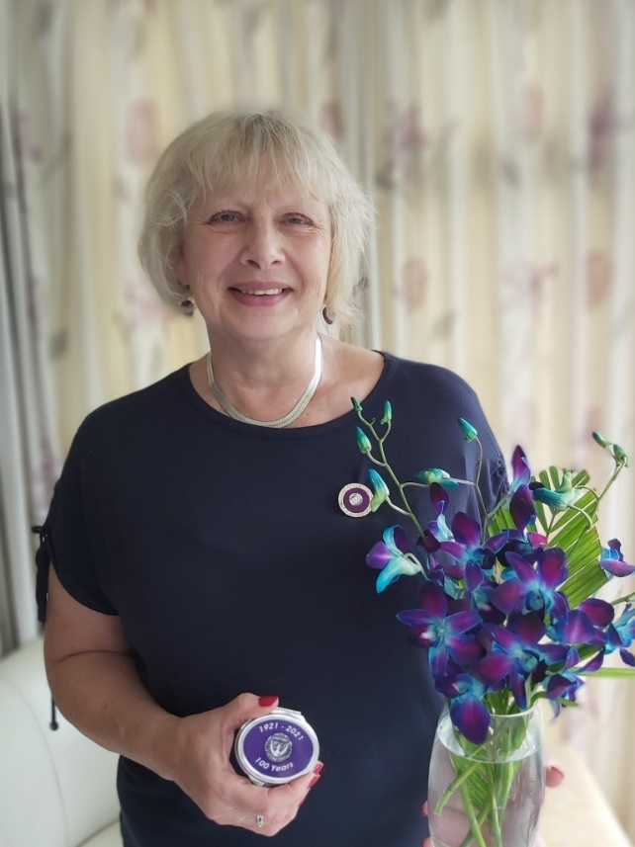

The last event of Helen’s Year as President was on Saturday 9th October with the very successful Regional Conference & AGM ~ read all about it on the Regional Web Site www.sigbi.org/london-chilterns/
News from your Regional Executive
Region Officers for 2021/2022
We have no Regional President this year so meet The London Chiltern Challengers!
Post | Post Holder | Club | Contact Details
President | No President | Regional Executive | Correspondence to Rita Beaumont  Email: r.beaumont3@ntlworld.com  Telephone: 01234 401475  Mobile: 07764500116
Immediate Past President | Helen Byrne | SI St Albans & District | helenbsorop@yahoo.co.uk
Secretary | Rita Beaumont | SI Bedford | r.beaumont3@ntlworld.com
Minute Secretary | Linda Shall | SI St Albans & District | Linda.shall@outlook.com
Treasurer | Denise Powell | SI St Albans & District | denise.m.powell@googlemail.com
Programme Action Officer | Pam Robertson  And  Jen Simpson | SI Hertford  SI High Wycombe & District | pamelarobertson807@btinternet.com  jensimpson@blueyonder.co.uk
Membership Officers | Helen Byrne  And  Pauline Panter | SI St Albans & District  SI Bedford | helenbsorop@yahoo.co.uk  pauline.panter@hotmail.com
Public Relations Officer  And  Communications & Website Administrator | Jane Slatter | SI St Albans & District | pinkyslatter@hotmail.com
Federation Councillor | Rita Beaumont | SI Bedford | r.beaumont3@ntlworld.com
Benevolent Fund Trustee | Rita Beaumont | SI Bedford | r.beaumont3@ntlworld.com
63 Representative | Barbara Diamant | SI London Central & South West | barbdiamant@gmail.com

Executive Group Meetings
We are a friendly group who would like new members to bring fresh ideas to the management of the Region so why not join us for a meeting ~ just let Rita know so we can send you the papers and meting link
The timetable of dates below are when we plan to meet but it does on occasion change and Rita will let you know any alterations . All the meetings will be via Zoom so you do not even have to travel into London
Date | Start Time
16th November 2021 | at 7.30pm
6th January 2022 | at 5.30pm
17th February 2022 | at 5.30pm
7th April 2022 | at 5.30pm
19th May 2022 | at 5.30pm
7th July 2022 | at 5.30pm
22nd September2022 | at 5.30pm

Club Calls

At the last call with Helen those present agreed the discussions and sharing on the calls had been very helpful so over the next year we will be organising four calls on Zoom ~ watch out for details

Regional Executive Club Contacts

Have you ever thought it would be good to share ideas (and frustrations!) with another club, plan some shared speaker meetings and activities, then here is your opportunity! As part of our planning for an Executive Shared Year we thought you might like to try pairing with a neighbouring club ~ your Link Officer is ready to start the process if you think you would like to give it a try and will contact you to talk about your ideas & set up a meeting if you wish

Club Pairings | Club | Link Officer
Pair 1 | Aylesbury & District  Milton Keynes | Jane Slatter  Jen Simpson
Pair 2 | Bedford  Hertford & District | Pam Robertson  Pauline Panter
Pair 3  As Part of London Collective | Greater London  London Central & South West | Helen Byrne  &  Denise Powell
Pair 4 | High Wycombe & District  St Albans & District | Jane Slatter  Jen Simpson
Pair 5 | Newbury & District  Oxford & District | Rita Beaumont  Pam Robertson
Pair 6 | Slough Windsor & Maidenhead  Thames Valley | Rita Beaumont  Pauline Panter

The Violet Awards for Women of Action - Sept 2021 ~ attended by President Helen

In September I was delighted to attend SI Milton Keynes Violet Awards , named in memory of Violet Richardson Ward, 1st President of SI Oakland, the Founding Soroptimist Club.

I wanted to share details because as well as being an inspiring way to showcase the work of the charities SIMK supports and celebrate the contribution of some outstanding female volunteers and staff it was also an enjoyable way to recognise the SI Centenary and SI Milton Keynes work. It is a great idea which other clubs could replicate with some planning.

Whilst it takes quite a lot of work to set up it provides a wonderful promotional opportunity for your charities and your Club in a way which doesn’t have to be too big. The evening was all about the women who stories were told by their managers or the CEOs of the charities they work or volunteer for. Everyone was inspired and left with a great buzz connected both with the women and SIMK : a win win in anybody's book.

If you want to know more do contact SI Milton Keynes

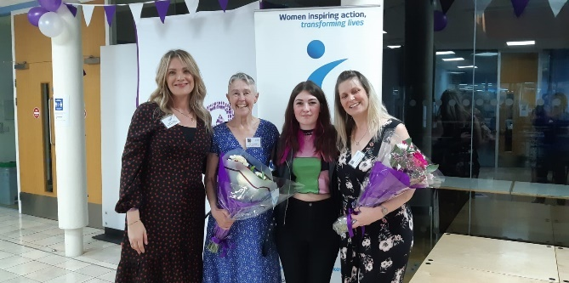
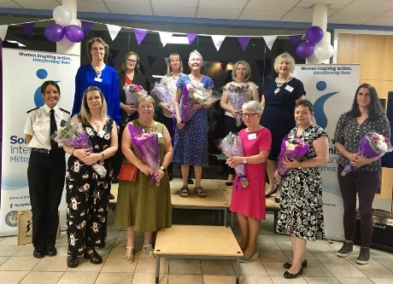

Club News

SI Slough, Maidenhead & Windsor ~ out & about doing Programme Action!

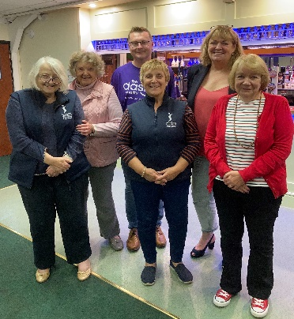
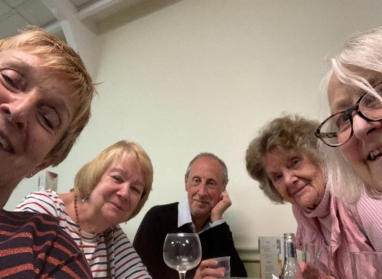

A team of members took part in a quiz set up by supporters of the DASH local refuge charity.

The team came a very respectable third out of ten teams.
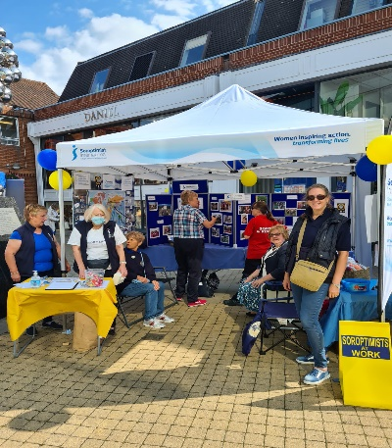
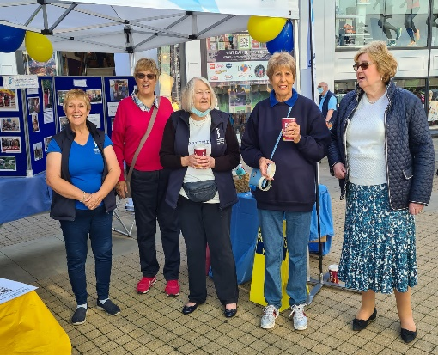

A Community Showcase was held in the Windsor Yards shopping precinct on Saturday 18th September.
Several local organisations took part. SI Slough Windsor and Maidenhead were able to show off their
new gazebo and had an excellent display of things they get involved with. The Club decided they would
use the event to try and recruit new members and several people showed an interest. Oh yes Costa Coffee
now recycle their coffee cups!
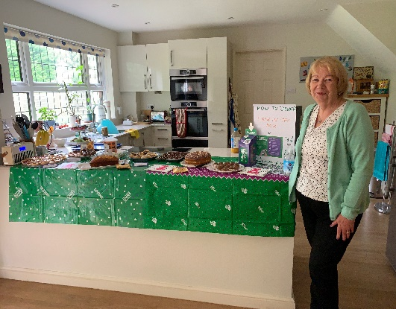
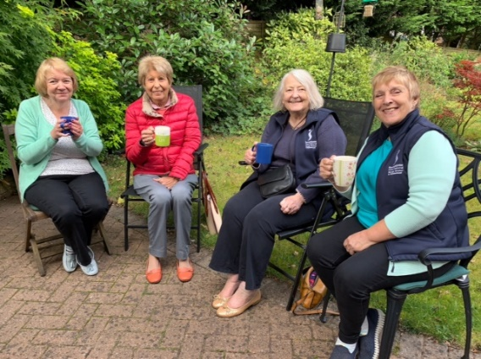

On Friday 24th September, Sarah Newstead of SI Slough Windsor and Maidenhead hosted a coffee morning
at her home in Wokingham under Macmillan’s initiative of the Biggest Coffee Morning in the World.
Several members of the Club attended as well as Sarah’s neighbours. In the afternoon
Sarah sat outside with a table of cakes and accosted dog walkers and parents returning from collecting their
children! She has made nearly £500 for the Macmillan Cancer Support - a stupendous result!

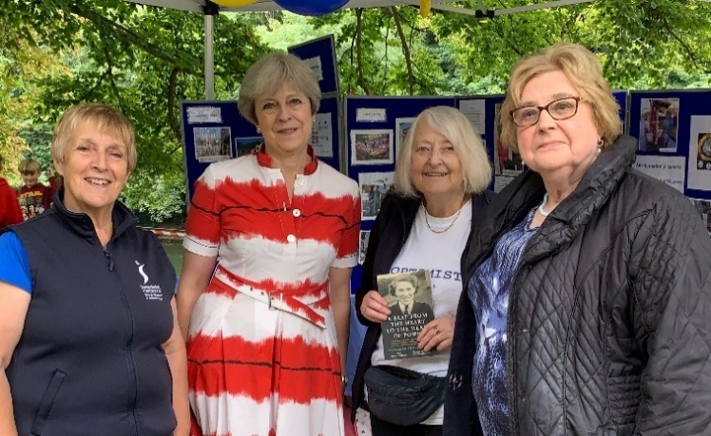
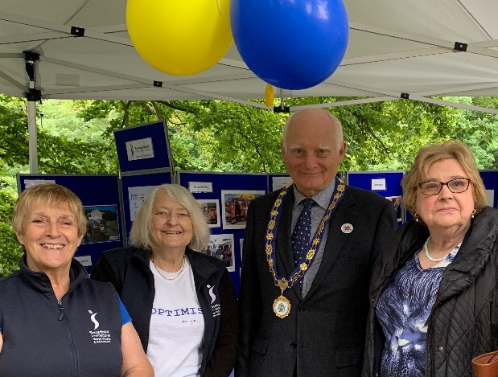

SI Slough Windsor and Maidenhead had a stand at the Maidenhead Lion’s Annual Duck Derby on Sunday 19th
September 2021. The Club was raising money for the DASH (Domestic Abuse Stops Here) Refugee, and also
garnered some potential new members. Visitors to the stand included Theresa May MP for Maidenhead and Twyford, and John Story, the Mayor of the Royal Borough of Windsor and Maidenhead. Theresa May MP mentioned that she was attending the House of Lords Luncheon organised to celebrate the Soroptimist Centenary. Jackie is holding Club member Phyllis Sigsworth autobiography which was on sale, and for which Theresa had written the. Preface

Memorial Fruit Orchard for Johanna Raffan
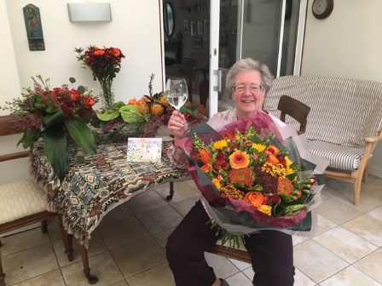

To pay tribute to the memory and achievements of our founding member, and President of our Federation Johanna Raffan we are proposing to create an orchard on an acre of land donated by a grateful Sierra Leonian. This will be adjacent to the secondary school we have built in Bai Largo, Kori district, Sierra Leone. The planting of trees was very dear to Johanna’s heart – and so was our Kori project of which she was Chair.

It is hoped that the school children will help to plant the trees and eventually take part in harvesting the crops. We will need to fence the land, buy tree guards to protect the young trees from smaller animals. and also want to build sturdy benches.

All of this is anticipated to cost £5,000 and we are hoping that Johanna’s Soroptimist friends will consider helping to finance this project in her memory
.
If your club would consider making a donation to our project it can be done directly to our club bank account, marking it “Memorial Orchard”.
HSBC Bank plc
Soroptimist International of Thames Valley
Sort code: 40 27 34
Account no. 11130870
Or send a cheque made out to Soroptimist International of Thames Valley to:
Ros Kirk, 1 Kingswood Cottages, Tag Lane, Hare Hatch, Berks RG10 9SX.

Please also email us to let us know so that we can acknowledge your kind contribution, to: sithamesvalleysecretary@gmail.com

Thank You for Your Support from us all at Si Thames Valley Club.
SI Hertford & District

Annual Frugal Supper
SI Hertford and District were delighted to be able to hold our Frugal Supper again (inaugurated by the late Sylvia Mear (one of the #WhoisShe 100for 100 Soroptimists) on 4th October. We are grateful to The Living Room in Stevenage (www.livingroomherts.org) for hosting our event, enabling us to raise £171 for UNICEF.

A Date for your Diary
SI Hertford and District are very much looking forward to celebrating the Centenary of Soroptimist International and our own 65th Anniversary on Saturday 20th November (postponed from April) and would love you to join us. See flyer on Page 8 for details.

End Snip-Its!
Pam Robertson Remembering Johanna Raffan

How would you say ‘no’ to Johanna? I couldn’t!
It was at a Study Day – Nottingham I think – I was just coming out of a break out session for coffee and there was Johanna with her smile and those twinkling eyes. “I understand you would be willing to stand for Regional President next year”, she said. I can’t remember what I replied – it just seemed to be a done deal! Fortunately,
I had 15 months before taking office, but I can honestly say that I really enjoyed my year as Regional President.

Thank you, Johanna.

Need something to look forward to ~ it is never too early to make a date in your 2023 diary!
Early Bird Registration open January 2022

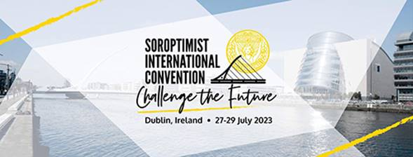

Let your Club be Part of the Next Newsletter
Copy Date for the January 2022 Edition of the Newsletter is 31st December 2021 If you have a speaker that you would like to recommend then send details to me for inclusion.
Send me your news on r.beaumont3@ntlworld.com

SI HERTFORD AND DISTRICT
invite you to join us in celebrating the
65th ANNIVERSARY of our CHARTER and
CENTENARY of SOROPTIMIST INTERNATIONAL
Our celebratory lunch will be held on Saturday 20th November2021, 12noon for 1.00pm at Mayflower Place, Hertingfordbury, SG14 2LG.
MENU
STARTER:
Tomato and Basil Soup
Chicken Liver Pate
Parma Ham with Melon
MAIN COURSE:
Traditional Roast Beef
Salmon en Croute
Wild Mushroom Risotto

DESSERT:
Seasonal Fruit Crumble
Strawberry Cheese Cake
Selection of Cheese and Biscuits

Tea or Coffee & Petits Fours
£50 (includes welcome drink)
_______________________

If you would like to be part of our celebrations, please complete the form below, indicating your choice of menu, and return to Pam Robertson, 20 St. Johns, Puckeridge, Ware, Herts. SG11 1SY by 2nd November 2021. Alternatively, email your reply to pamelarobertson807@btinternet.com

NAME and Club | STARTER | MAIN COURSE | DESSERT

I would like to join you for your 65th Anniversary Lunch and enclose a cheque made payable to
SI Hertford & District for £............../ I have made a bank transfer of £............. to 30 94 17, 00142971
SI Hertford & District ref. Anniversary Lunch. Please delete as appropriate.

e-mail ..................................................................................... Tel. ...................................................

Please state any dietary requirements ................................................................................................

