****London Chilterns Region

**The London Chilterns Challengers 2021/2022**

**“Respecting Differences, Celebrating Similarities”**

**Regional Newsletter – January 2022**

**Welcome to our first Newsletter of 2022 & a Happy New Year from Your Regional Executive Team!**

**And Looking Forward to Spring!**

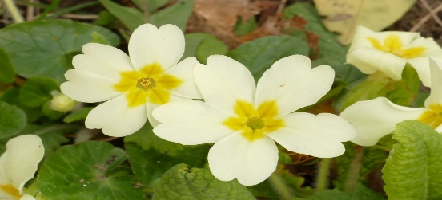

I hope despite the challenges of Omicron you were able to enjoy your Christmas and to see friends and family. Although it was strange to have unseasonably warm weather at least it meant we could meet each other outdoors more easily!

January is traditionally a time for new beginnings and potential members will be considering new activities. Now is the time to look out for that new interest and actively promote your club and its activities perhaps ‘spring cleaning’ the welcome you give enquirers at the same time. Even though our own “new year” isn’t for a few months yet we can further entice that new interest, as well as exciting our existing members’ enthusiasm, by starting to plan and promote at least the highlights of the coming year - 2022-23.

No doubt you will have aims for your Programme Action for the coming year but have you reviewed the other elements of your Club’s Strategic goals for 2022-23 or, preferably, do you have a 3 year Plan?

3 of Federation’s Strategic goals 2022- 25 are also very relevant to clubs:

:increase membership and reduce our age profile

:increase our public profile

:ensure governance, structures and finances are fit for purpose.

Governance is high on our list of priorities at Region with a large number of Officers in crucial roles due to leave Exec at the end of September. Members are needed to step forward for these roles if we are to maintain the Region and the support it provides to clubs and members going forward. We will be following this up through Club Exec buddies and would love to hear from anyone who might be interested.

As for the Regional year ahead, plans are afoot for our **Regional International Women’s Day Conference on Saturday 5th March 2022 between 10am & 1pm**  which will be on Zoom. We hope to have details of our exciting speakers in the not too distant future so please put the date in your diary if it is not already there.

Do also add the **2022 Federation Conference** to your diary. After such a brilliant Centenary Conference 2021 with such amazing speakers I can’t wait for our next one which will take place **27-29 October 2022 in Belfast**and is entitled **Climate for Change.**

**Helen Byrne**

**Lead for IWD Event 2022 and SILC Executive January - March 2022**

**News from Your Regional Officers**

**Communications ~ Jane Slatter Communications Officer**

**Orange the World - 16 Days of Activism to End Gender Based Violence**

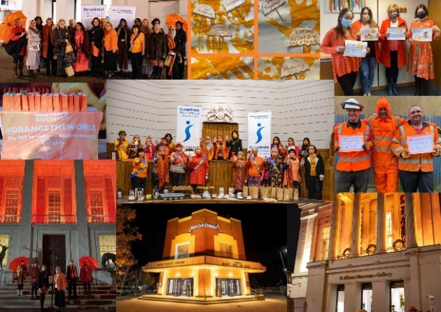In this latest newsletter I thought I’d share with you the excellent “Orange the World”, “16 Days of Activism to End Gender Based Violence” campaign by SI St Albans & District 25 Nov to 10 Dec 21 [www.sigbi.org/st-albans/orange21](http://www.sigbi.org/st-albans/orange21) . If any Clubs in the Region want to join in this year please make contact with the Club [sistalbans@hotmail.com](mailto:sistalbans@hotmail.com)

The montage photo was the SIGBI Photo of the Month for January and there is a video which will be shared as soon as it is ready.

The two paragraphs below are from Denise Powell – facilitator of the Programme Action Peace Team for SI St Albans & District:

**St Albans & District Soroptimists Oranged the world (well Hertfordshire anyway!)**

Building on our success last year when we ‘Oranged’ the beautiful St Albans Museum, this year we set out to ‘Orange’ Hertfordshire as part of the UN **Orange the World Campaign** and the **16 days of activism to end gender-based violence** from 25 Nov to 16 Dec.

We wrote to significant buildings, councillors, businesses and senior schools, seeking support…..and we got it!. The photo montage shows St Albans Museum and Gallery outside and with Members and guests in the old courtroom inside the museum. Also shown are County Hall Hertford, Broadway Cinema Letchworth, Herts Community Foundation staff, Burton's biscuits in St Albans and Rattigans plant-hire in Welwyn Garden City. The handprint artwork was produced by the St Albans and Hertsmere women's refuge who were able to use the campaign in some sessions with clients and children staying at the Refuge to explore why ending violence against women is so important. The event was so successful in raising awareness and our own profile that we're planning next year's event already! For more see [www.sigbi.org/st-albans/orange21](https://emea01.safelinks.protection.outlook.com/?url=http%3A%2F%2Fwww.sigbi.org%2Fst-albans%2Forange21&data=04%7C01%7C%7Ce06255b554914a598d5008d9d738dcb8%7C84df9e7fe9f640afb435aaaaaaaaaaaa%7C1%7C0%7C637777461496927150%7CUnknown%7CTWFpbGZsb3d8eyJWIjoiMC4wLjAwMDAiLCJQIjoiV2luMzIiLCJBTiI6Ik1haWwiLCJXVCI6Mn0%3D%7C3000&sdata=HJ9WhOZgSBKef%2BqYwXcIFGon2kamDyLGrmrQmXRAyCQ%3D&reserved=0)

It really was a big communications effort by the Club’s Peace Team, on the back of what SIGBI, SI and many other organisations were doing – **Orange the World and 16 Days of Activism** is a growing global movement to end violence against women. Support for the campaign was amplified because of the murders of Sarah Everard, Bibaa Henry, Nicole Smallman and now with the horrific death of Aisling Murphy we know that we need to shout even louder to raise awareness that things must change.

The campaign gained a lot of publicity in both local papers and social media. Reaching out to many different organisations has raised the Club's Profile. It has attracted prospective new Members, supporters and partners for the Club and raised awareness of domestic abuse actions across Hertfordshire businesses and communities.

**Many congratulations to the St Albans Club and especially to the Peace Team!**

SI St Albans & District are happy to share the materials they produced with other Clubs, and in addition Clubs can easily just join in with the campaign this year and make it region-wide – just email [sistalbans@hotmail.com](mailto:sistalbans@hotmail.com) .

**Programme Action ~ Pam Robertson & Jen Simpson, Programme Action Officers**

It was great to see a number of you at the excellent **training session for the** **Special Domestic Violence Courts** **Observations project on Saturday 22nd January. Thanks** go to the London Collective, led by Immediate Past Regional President Helen, Jonaki and Molly of SI Greater London, for organising this and, with support from UKPAC, opening it up to regions across the country.The session was recorded so the plan is to re-run the training across our region at a future date. Some clubs have already forwarded to me details of members unable to attend Saturday’s training but who are interested in taking part in the project. If you are interested, please get in touch with Pam - [pamelarobertson807@btinternet.com](mailto:pamelarobertson807@btinternet.com) This is a valuable piece of Programme Action work which could have a significant impact on the experiences of women in the courts.

Thank you to those members/clubs who have taken action on the recent circulations from UKPAC (United Kingdom Programme Action Committee). Don’t forget to complete a Programme Action Report Form – either as a club or as an individual.

Following extensive discussions at the **Webinar on 15th January** **on the future of a SIGBI project,** 64% of attendees voted not to go ahead with another SIGBI project, with the overwhelming desire to support the **International President’s** **Appeal “Opening Doors to a Bright Future”** (details on the SIGBI/UKPAC website) and not forgetting the **Diamond Education Fund**. It is interesting to note that the previous Federation project gained minimal support from outside the UK. However, no decision has been made, so if you would like your voice heard on this, please get back to me either by email [pamelarobertson807@btinternet.com](mailto:pamelarobertson807@btinternet.com) or on 01920 822631 so that I can forward your comments to Director of Programme Kay Richmond by the end of February.

**Membership and Social Media ~ Helen Byrne & Pauline Panter, Membership Officers**

Rachel Weinhold , *GrowTraffic* who ran the **Increase your Membership through Social Media Workshop**at the SIGBI Conference has kindly agreed to run the session again for our Region on **Sat 26 February 2022, 10 - 12 online**. During the workshop, which is 45 mins to 1 hr Rachel will highlight the various social media , their differences and strengths and use real examples to show how you can best use them to promote your club and its programme action and attract attention and interest from potential members. There will then be an opportunity for clubs to share ideas and experiences and seek help from Rachel with current and planned campaigns.

I would like to encourage any Club Members who use social media to attend, not just the Club’s main Social Media Officer , as well as Membership Officers. Social media is one of the best ways to attract new, active members and can also help your club make Programme Action contacts and supporters. More details of the session will be coming out soon, please email me to express interest.

And do register with [selina@sigbi.org](mailto:selina@sigbi.org) if you are a Club Membership or Development Officer for the **Membership Webinar “ Taking Membership into the Future**” which**Director of Membership, Chevonne Agana**is running on **Sat 2 April at 14:00**. Details in the recent SIGBI News Briefing.

I am always happy to help with anything to do with membership or organisational development.

Helen Byrne, Regional Membership Officer

Email : [helenbsorop@yahoo.co.uk](mailto:helenbsorop@yahoo.co.uk)

**SIGBI Benevolent Fund: Regional Trustee Rita Beaumont**

This has been difficult time for all of us and our families but for some members the sudden reduction in income has caused of extreme hardship, so just a reminder about the Benevolent Fund.The fund is a totally confidential service available to help the financial difficulties of those who are eligible to apply.

The fund may be in the form of a quarterly payment or a one-off payment to pay for an unexpected item

**Who is Eligible?**

You must have been a Member of a Soroptimist Club in the UK, including the Channel Islands and the Isle of Man, or

the Republic of Ireland for 3 years or more. The support given is subject to a simple confidential financial check.

**How to Apply**

A member who might need financial help at this time can contact me so I can talk through the application process.

Rita Beaumont: Email: [r.beaumont3@ntlworld.com](mailto:r.beaumont3@ntlworld.com) :Telephone: 01234 401475 or Mobile: 0776 4511 006

**The Benevolent Fund is always pleased to receive donations from Clubs ~ if your club is interested please contact me and I will provide you with all the information you need**

**News From “63”**

***Article written by the Number 63 Representative on the Board of Directors for the London Chilterns area, Barbara Diamant ,with the assistance of fellow Directors, photographs courtesy of Director Barbara Jeremiah and details of the 500 club from Director Pat Dale.***

Our hotel Number 63 is a Grade 2 Victorian building boasting many beautiful and valuable architectural features the most significant being the Italianate window designed by William Arthur Benson (1854-1924)

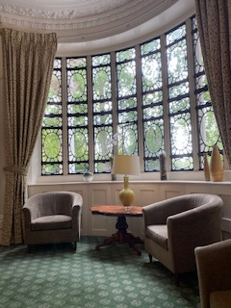The hotel is used regularly used for meetings by two of our London Clubs and the Executive. It is also visited by many Soroptimists, who regard it as their London “Home from Home.” The meeting rooms are much used by various institutions. There is a steady stream of visitors from home and abroad who love the atmosphere of the building. The staff is welcoming and the prime location of the place is attractive.

During the last two years due to the pandemic numbers of visitors have decreased and it is in common with all Hotels the premises have been closed for lengthy periods. The Directors have strived to maintain the building but the elements and the age of the building have caused much damage which needs to be addressed and obviously requires us to raise finances.

Most of the damage was caused by the **flash floods of July 2021,** which can be seen in the pictures. The kitchen area suffered significantly, as did the dining area. Also as can be seen, bedrooms sustained damage with the ceiling collapsing in Room 101.

The roof requires substantial repairs; the common parts need redecorating, and several rooms show signs of damage through recent leaks. The exterior needs repainting. **The estimated cost will be in the region of £150,000.**

*Italianate Window*

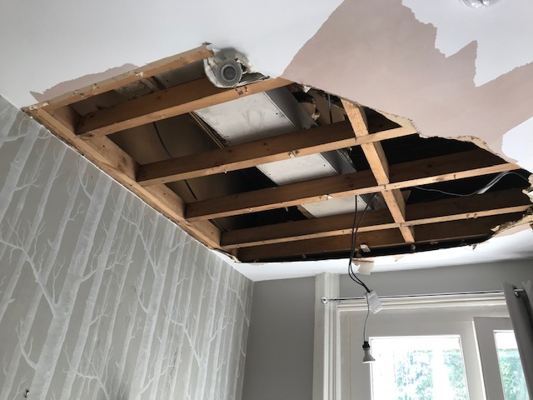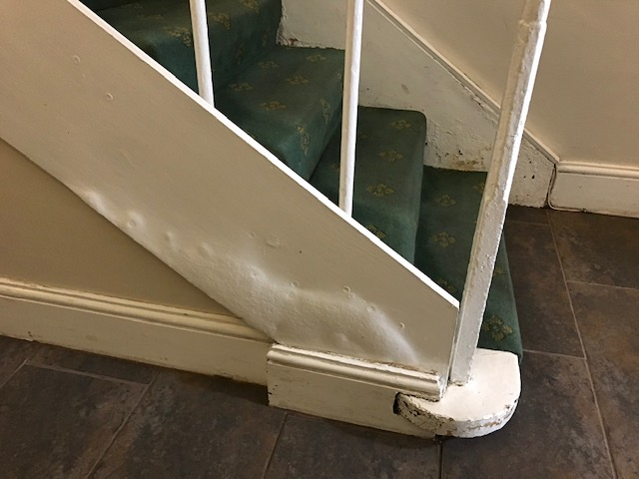

*Ceiling in room 101*

*Basement Damage*

Wewould like to invite you to help us in our attempts to raise this sum so that we can maintain our beautiful asset in central London to the standard it deserves.

There are various ways in which you could help.

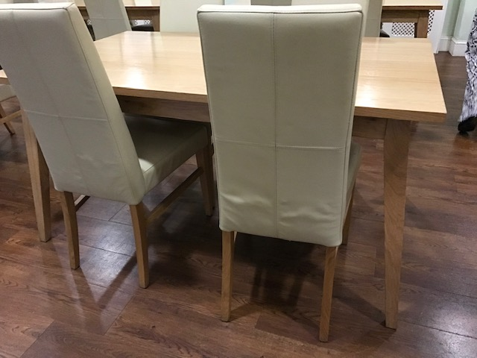I would like to refer you to the website which has further current information.

[www.number63.co.uk](http://www.number63.co.uk)

As a Soroptimist you can

* buy shares
* donate to the Platinum Appeal stared in 2018
* leave a legacy
* book a stay at the hotel or indeed hold a meeting
* Join the 500 club
* Make a pledge and raise funds

*Damage in Dining Room*

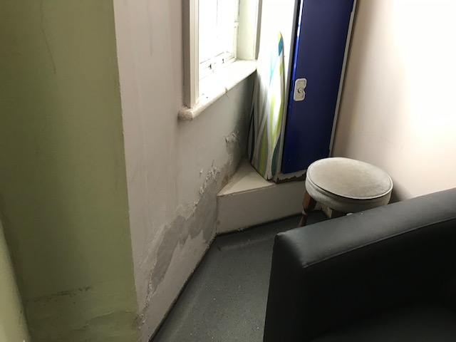

Through buying numbers from the 500 club you can win money for an annual stake of £12, this puts your number in a monthly draw, the more numbers you buy the higher the chances of your winning. Each month two numbers get £50 each. Clubs can buy tickets in the hope of winning and raising extra fund for their club, as can individuals. In the past the 500 club has been in a position to donate up to £3000 a year to the Hotel. This year £4500 have been transferred to support 63 from this fund. Also, you can buy tickets for friends as a token of thanks, which I am sure would be much appreciated. It is easier to set up a standing order to be renewed annually. Forms are on the website. For ease see the link below.

*Water Damage to walls*

[500 Club - Number 63](https://number63.co.uk/500-club/)

You can support by buying Number 63 gin available directly from the hotel. See the link below. A book, “History of Number 63” produced by ex-Director Liz Batten is available from Number 63 at the cost of £5 plus postage.

<https://number63.co.uk/number-63-gin/>

A short video is also being made and will be made available on the website and to your clubs. An earlier version was shown at the AGM.

Please do support us, your ideas are welcomed.

Contact with Number 63 is advised via [info@number63.co.uk](mailto:info@number63.co.uk)

**Reminders from your Regional Executive**

**Region Officers for 2021/2022**

**Reminder ~ we have no Regional President this year so meet The London Chiltern Challengers!**

|  |  |  |  |
| --- | --- | --- | --- |
| **Post** | **Post Holder** | **Club** | **Contact Details** |
| President | No President | Regional Executive | **Correspondence to Rita Beaumont**  Email: [r.beaumont3@ntlworld.com](mailto:r.beaumont3@ntlworld.com)  Telephone: 01234 401475  Mobile: 07764500116 |
| Immediate Past President | Helen Byrne | SI St Albans & District | [helenbsorop@yahoo.co.uk](mailto:helenbsorop@yahoo.co.uk) |
| Secretary | Rita Beaumont | SI Bedford | [r.beaumont3@ntlworld.com](mailto:r.beaumont3@ntlworld.com) |
| Minute Secretary | Linda Shall | SI St Albans & District | [Linda.shall@outlook.com](mailto:Linda.shall@outlook.com) |
| Treasurer | Denise Powell | SI St Albans & District | [denise.m.powell@googlemail.com](mailto:denise.m.powell@googlemail.com) |
| Programme Action Officer | Pam Robertson  And  Jen Simpson | SI Hertford  SI High Wycombe & District | [pamelarobertson807@btinternet.com](mailto:pamelarobertson807@btinternet.com)  [jensimpson@blueyonder.co.uk](mailto:jensimpson@blueyonder.co.uk) |
| Membership Officers | Helen Byrne  And  Pauline Panter | SI St Albans & District  SI Bedford | [helenbsorop@yahoo.co.uk](mailto:helenbsorop@yahoo.co.uk)  [pauline.panter@hotmail.com](mailto:pauline.panter@hotmail.com) |
| Public Relations Officer  And  Communications & Website Administrator | Jane Slatter | SI St Albans & District | [pinkyslatter@hotmail.com](mailto:pinkyslatter@hotmail.com) |
| Federation Councillor | Rita Beaumont | SI Bedford | [r.beaumont3@ntlworld.com](mailto:r.beaumont3@ntlworld.com) |
| Benevolent Fund Trustee | Rita Beaumont | SI Bedford | [r.beaumont3@ntlworld.com](mailto:r.beaumont3@ntlworld.com) |
| 63 Representative | Barbara Diamant | SI London Central & South West | [barbdiamant@gmail.com](mailto:barbdiamant@gmail.com) |

**Executive Group Meetings**

**Your Region Needs You!**

We are a friendly group who would like new members to bring fresh ideas to the management of the Region so why not join us for a meeting ~ just let Rita know so we can send you the papers and meting link

The timetable of dates below are when we plan to meet but it does on occasion change and Rita will let you know any alterations . All the meetings will be via Zoom so you do not even have to travel into London

|  |  |
| --- | --- |
| **Date** | **Start Time** |
| 24th February 2022 | at 5.30pm |
| 7th April 2022 | at 5.30pm |
| 12th May 2022 | at 5.30pm |
| 7th July 2022 | at 5.30pm |
| 22nd September2022 | at 5.30pm |

**Regional Executive Club Contacts**

Have you ever thought it would be good to share ideas (and frustrations!)with another club, plan some shared speaker meetings and activities, then here is your opportunity! As part of our planning for an Executive Shared Year we thought you might like to try pairing with a neighbouring club ~ your Link Officer is ready to start the process if you think you would like to give it a try and will contact you to talk about your ideas & set up a meeting if you wish

|  |  |  |
| --- | --- | --- |
| **Club Pairings** | **Club** | **Link Officer** |
| Pair 1 | Aylesbury & District  Milton Keynes | Jane Slatter  Jen Simpson |
| Pair 2 | Bedford  Hertford & District | Pam Robertson  Pauline Panter |
| Pair 3  As Part of London Collective | Greater London  London Central & South West | Helen Byrne  &  Denise Powell |
| Pair 4 | High Wycombe & District  St Albans & District | Jane Slatter  Jen Simpson |
| Pair 5 | Newbury & District  Oxford & District | Rita Beaumont  Pam Robertson |
| Pair 6 | Slough Windsor & Maidenhead  Thames Valley | Rita Beaumont  Pauline Panter |

**Reminder for Your Diary!**

**Saturday 5th March** is our next **Region Meeting/Conference and Celebration of International Women’s Day** between **10am to 1pm on Zoom**.

 We are delighted to announce that our first confirmed speaker is   **Dr Sue Hills co-founder of the Alice Ruggles Trust**[**www.alicerugglestrust.org**](http://www.alicerugglestrust.org) Sue’s daughter Alice was stalked and murdered by her ex-partner in 2016.

She will speak about   **Coercive Control and Stalking** , the fantastic work of the Trust and what can and should be being done to support victims and eliminate stalking.

Our second International Women’s Day speaker will be confirmed soon.

Booking information will be sent to Clubs.

**For Information Soroptimist International Facebook Page**

Facebook shutdown the Soroptimist International Facebook page at the end of last year. SI has had to create a new page @SoroptimistIntl [www.facebook.com/SoroptimistIntl](http://www.facebook.com/SoroptimistIntl)  Please like and follow the new page, share and encourage others to follow. This is particularly important ahead of the UN Commission on the Status of Women and International Women's Day in March to ensure you don't miss any important news.

**News From Clubs**

**Soroptimist International Hertford and District from Anne Miles**

**Hertford and District Club celebrated their 65th Anniversary and 100 years of Soroptimism on Saturday, 21st November 2021 with a celebratory lunch at Mayflower Place, Hertingfordbury.**

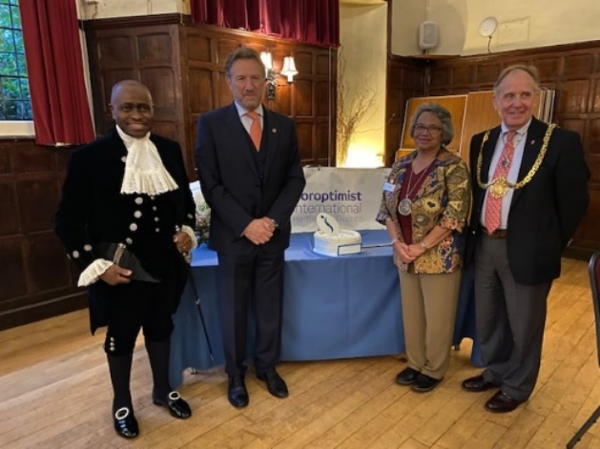The club was delighted to welcome the Lord Lieutenant, Robert Voss, the High Sheriff, Lionel Wallace, the Mayor of Hertford, Councillor Bob Deering, former members, members from Regional clubs, relations and friends. We thank Helen Byrne for her contribution and the lunch concluded with the cutting of the two Celebration cakes, Soroptimist 100 years and 65 years of the Club.

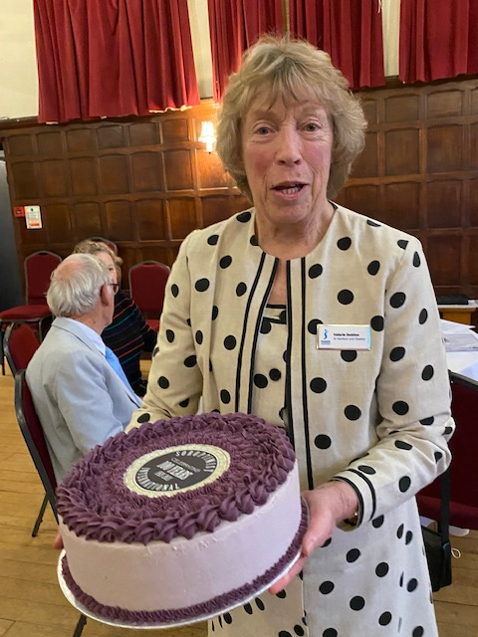 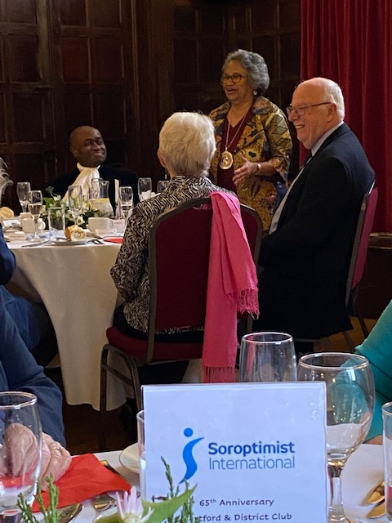

On **Sunday, 16th January 2022**, the club joined in with a Tree Planting event at **Hertford Castle.**

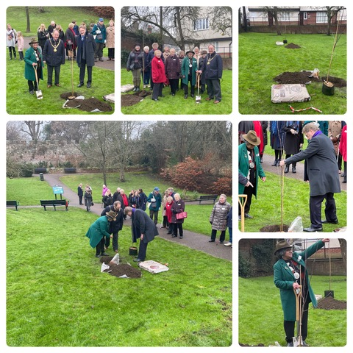

Oak trees were planted remembering the Holocaust near the river and two Rowan trees in the Moat Garden, one tree for our President’s charity, Community Development Action –CDA- by the Lord Lieutenant Robert Voss and the other by the Mayor of Hertford, Bob Deering celebrating the 100 years Anniversary and our own 65 years. Both plantings were able assisted by our President, Kate Belinis!

These trees will be part of the Queen’s Green Canopy Celebration. We were especially pleased with the location of the trees as they are near the Sensory Garden which was planted by the club in1994.

**Soroptimist International Thames Valley**

**A Big Thankyou to the Region**

*I have received your cheque for £305.00 from the Region.*

*Thank you so much, members might like to know that to date we have raised over £3,200 of our target of £5,000. Fundraising will continue until June 2022, which will be the anniversary of Johanna's passing. She would be very pleased and proud.*

*May I wish you and yours the happiest of Christmases and a healthy New Year.*

*Kind Regards,*

*Rosalind Kirk: Treasurer of Thames Valley*

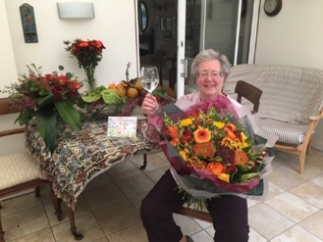

**Soroptimist International Thames Valley Club** members would like to thank all

the clubs and individuals who have sent generous donations towards the Memorial Her fellow club members would like you to know that we have nearly reached our target and plans are being drawn up to plant the orchard in the Kori chiefdom in Sierra Leone. Rose Simbo will be visiting her home area in a few months and will set everything in motion.  She will be taking photos which will be posted on the SITV website

**If your club would like to help raise the last £1,000 to reach our target, you can donate either online, marking it “Memorial Orchard”.**

HSBC Bank plc

Soroptimist International of Thames Valley

Sort code: 40 27 34

Account no. 11130870

Or send a cheque made out to Soroptimist International of Thames Valley to:

Ros Kirk, 1 Kingswood Cottages, Tag Lane, Hare Hatch, Berks RG10 9SX.

Please also email us to let us know so that we can acknowledge your kind contribution, to: [sithamesvalleysecretary@gmail.com](mailto:sithamesvalleysecretary@gmail.com)

**Soroptimist, Rose Simbo alongside our ‘Giving Tree’** displaying the names of SI Clubs and individuals who have helped us almost reach our appeal’s target

**Soroptimists of Thames Valley multi-task for the future!**

Three Soroptimists of SI Thames Valley multi-task.

Alison Mayall, Alison Wray and Peggy Simson are planting a tree as part of their Club’s contribution to the **Soroptimist Centennial “Plant a Tree Project.”**

The club raised the funds for the tree, a **Conference Pear**, and thanks to the collaboration of  the **Wooburn Parish Council** were able to plant it on Parish recreational land for the future enjoyment of the local community.

They were also able to raise the profile of Soroptimism in the local community by purchasing a commemorative plaque for the public to see….and one of the Soroptimist planters cleverly reversed her tabard to get its important recruiting message into the photo too.

**Soroptimist International Slough, Maidenhead & Windsor**

**CHARTER CELEBRATION WEEKEND**

**Saturday 26th March 2022 at 2pm Norden Farm Centre Maidenhead SL6 4PF**

Conference – Climate Change – The reality - What can we do?

Chaired by:  Councillor Donna Stimson, Cabinet Lead for Environmental Services, Climate Change, Sustainability, Parks and Countryside RBWM

Tickets £15 each including coffee or tea and biscuits  (Students £10)

**Sunday 27th March 2022 at 12.30 – Celebration Lunch at historic Ditton Manor near Datchet**

Ditton Manor, Ditton Park Road, Berkshire, SL3 7JB

3 course Lunch – Welcome drink - Choice of menu plus drink and coffee or tea £50

Guest Speakers:  Tan Ikram [CBE](https://en.wikipedia.org/wiki/Commander_of_the_Order_of_the_British_Empire)  Deputy Senior [District Judge](https://en.wikipedia.org/wiki/Judiciary_of_England_and_Wales#District_judges) Deputy Chief Magistrate and International President Maureen Maguire

**See the Book Form Below**

**FUNDRAISING EVENT TO BE HELD ON SATURDAY 9TH APRIL FROM 18.30 To 22.00 Hrs.**

**AT ST PAUL’S CHURCH HALL, WOKINGHAM RG41 1EH  £20pp**

We have key speakers from 2 Nepalese charities to give us more insight into the issues facing Nepal there will be Nepalese food available as well as an alternative.

Drinks will be available to purchase

This event is to raise funds for our Nepalese student who we are supporting through a law degree

Please contact Dee on 07967146976 for more details and to book a ticket

**End Snip-Its!**

Need something to look forward to ~ it is never too early to make a date in your 2023 diary!

Early Bird Registration open May 2022

**Let your Club be Part of the Next Newsletter**

Copy Date for the **April 2022 Edition of the Newsletter is 8th April 2022**

If you have a speaker that you would like to recommend then send details to me for inclusion.

Send me your news on [**r.beaumont3@ntlworld.com**](mailto:r.beaumont3@ntlworld.com)

**SI Slough Windsor & Maidenhead Diamond Anniversary Lunch Sunday 27th March 2022**

**Ditton Manor, Ditton Park Road, Berkshire SL3 7JB**

**3 course Lunch with welcome drink, a glass of wine and coffee or tea**

**Booking Form**

**Menu Choices:**

Starters:

1A Carrot & Coriander Soup (V)

1B Chicken Liver parfait

1C Beetroot & Goats Cheese with Walnut Crumble (V)

Mains:

2A Chicken Supreme wrapped in Smoked Bacon

2B Pan Fried Sea Bream Fillet

2C Wild Mushroom Risotto (V)

Sweets:

3A Vanilla Crème Brulé served with Fresh Berries

3B Rich Chocolate Tart served with White Chocolate Ganache

3C Spiced Caramelised Pineapple Steak with Chantilly Cream

Please return to Ms Sandra Bond, 54 Springfield Park, Holyport SL6 2YN

email: [Sandra.bond2017@outlook.com](mailto:Sandra.bond2017@outlook.com)

Name

Address

Club

Email Phone No.

No of Tickets required: @ £50 each Total £

I enclose a cheque made out to SI Slough Windsor & Maidenhead or Bank Transfer to

Soroptimist International Slough Windsor & Maidenhead, Sort Code **30-99-72** A/C **00315130** Reference Diamond Please indicate names of guests and their menu choices and any dietary requirements

|  |  |  |  |  |
| --- | --- | --- | --- | --- |
| Name |  | Starter | Main | Sweet |
|  |  |  |  |  |
|  |  |  |  |  |
|  |  |  |  |  |
|  |  |  |  |  |
|  |  |  |  |  |