****London Chilterns Region

**The London Chilterns Challengers 2021/2022**

**“Respecting Differences, Celebrating Similarities”**

**Regional Newsletter – April 2022**

**Happy Easter from Your Regional Executive Team!**

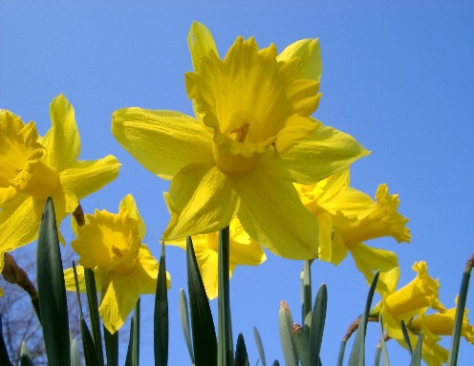

It has been a difficult couple of years for us all. The Covid -19 pandemic has touched all our lives in many different ways: we have worked to support our communities; we have learnt many new skills, who had heard of “Meeting on Zoom” before April 2020; we have mourned the lives of family, friends and members we have lost but celebrated the joy they brought to us and our communities.

In her book The History of Soroptimist International published in 1995 Janet Haywood included words written in 1939 during World War II, by a British Soroptimist:

“Two things are clear to us in the midst of the bewilderment and distress of these present days. One is that, as a band of women whose aim is the furthering of international understanding, we must stick together and keep in active working order our Soroptimist organisation, the value of which is greater than ever before. The other is that when we emerge from this nightmare and the struggle is over, we must be stronger than ever to see that all our influence is used on the side of a just and lasting peace.”

During the pandemic Soroptimists across the world have again demonstrated what we all knew ~ we are a practical group of ladies with plenty of common sense who get on and do what is needed to support our communities just as our Wartime members did and we can be proud of our achievements.

Now is a time to meet our next challenge ~ having a regional meeting Face to Face again! It has been a long time coming but at last we will be able to meet together again! Our next **Regional Meeting & Conference** will be on **Saturday 11th June 2022 between 10am to 3.3pm**. Our host club will be **SI**  **Slough, Maidenhead & Windsor.**

Look out for a booking form after Easter but in the meantime, everyone put the date in your diary!

We look forward to seeing you all

Rita Beaumont

**Region Officers for 2021/2022**

**Reminder ~ we have no Regional President this year so meet The London Chiltern Challengers!**

|  |  |  |  |
| --- | --- | --- | --- |
| **Post** | **Post Holder** | **Club** | **Contact Details** |
| President | No President | Regional Executive | **Correspondence to Rita Beaumont**  Email: [r.beaumont3@ntlworld.com](mailto:r.beaumont3@ntlworld.com)  Telephone: 01234 401475  Mobile: 07764500116 |
| Immediate Past President | Helen Byrne | SI St Albans & District | [helenbsorop@yahoo.co.uk](mailto:helenbsorop@yahoo.co.uk) |
| Secretary | Rita Beaumont | SI Bedford | [r.beaumont3@ntlworld.com](mailto:r.beaumont3@ntlworld.com) |
| Minute Secretary | Linda Shall | SI St Albans & District | [Linda.shall@outlook.com](mailto:Linda.shall@outlook.com) |
| Treasurer | Denise Powell | SI St Albans & District | [denise.m.powell@googlemail.com](mailto:denise.m.powell@googlemail.com) |
| Programme Action Officer | Pam Robertson  And  Jen Simpson | SI Hertford  SI High Wycombe & District | [pamelarobertson807@btinternet.com](mailto:pamelarobertson807@btinternet.com)  [jensimpson@blueyonder.co.uk](mailto:jensimpson@blueyonder.co.uk) |
| Membership Officers | Helen Byrne  And  Pauline Panter | SI St Albans & District  SI Bedford | [helenbsorop@yahoo.co.uk](mailto:helenbsorop@yahoo.co.uk)  [pauline.panter@hotmail.com](mailto:pauline.panter@hotmail.com) |
| Public Relations Officer  And  Communications & Website Administrator | Jane Slatter | SI St Albans & District | [pinkyslatter@hotmail.com](mailto:pinkyslatter@hotmail.com) |
| Federation Councillor | Rita Beaumont | SI Bedford | [r.beaumont3@ntlworld.com](mailto:r.beaumont3@ntlworld.com) |
| Benevolent Fund Trustee | Rita Beaumont | SI Bedford | [r.beaumont3@ntlworld.com](mailto:r.beaumont3@ntlworld.com) |
| 63 Representative | Barbara Diamant | SI London Central & South West | [barbdiamant@gmail.com](mailto:barbdiamant@gmail.com) |

**For Information Soroptimist International Facebook Page**

Facebook shutdown the Soroptimist International Facebook page at the end of last year. SI has had to create a new page @SoroptimistIntl [www.facebook.com/SoroptimistIntl](http://www.facebook.com/SoroptimistIntl)  Please like and follow the new page, share and encourage others to follow: don't miss any important news.

**Regional Election: Federation Councillor**

Do not forget to look out for the voting papers for the important post of **Federation Councillor for our region**; they were circulated by Selina Murphy at SIGBI on 11th April and are due back by Friday 3rd June 2022

* **Communications ~ Jane Slatter Communications Officer**

**Planning Club Programmes and Having the Programme on Club Websites**

One of the most important pieces of information to communicate about your Club is your Programme of events. It is therefore important to have your Club Programme on your website (even if you don’t have much else on there) so that anyone visiting your website, whether a member or potential guest, can see events that they can come along to.

At the St Albans Club we no longer have a printed programme and we find we can be more flexible by only having the programme on the website. When we are planning the year ahead, we do create an outline programme with dates and ideas for the forthcoming year that the Club's Exec (this can be Excel or Word document that can easily be emailed to those doing the planning).

When you post your programme on your Club's website it is worth thinking about doing it so that your latest event is at the top so that when events have happened, they can be deleted the from the top and you can easily add events to the programme (and make any amendments too). This is how I do it for the St Albans Club [www.sigbi.org/st-albans/club-programme](http://www.sigbi.org/st-albans/club-programme) and also for the Region [www.sigbi.org/london-chilterns/programme](http://www.sigbi.org/london-chilterns/programme)  If you want to include more detail about any of the events then you could create a page or post and include a link on the programme page.

I have just been updating these 2 websites with future programme information so thought it might be helpful for me to share this with you – I hope it’s helpful.

If any Club wants help with their website please just ask.

**Jane Slatter, Region Communications Officer,** [**pinkyslatter@hotmail.com**](mailto:pinkyslatter@hotmail.com) **07834345796**

* **Programme Action ~ Pam Robertson & Jen Simpson, Programme Action Officers**

Have you Seen President Cathy’s message on SIGBI website – **We Stand with Ukraine?** And have you seen our Programme Director Kay Richmond’s April message on the crisis in Ukraine?

<https://sigbi.org/2022/programme-directors-message-april-2022>

While on the website, it is worth looking at **the blogs of attendees at the Commission on the Status of Women 14th - 25th March 2022**

**Special Domestic Abuse Courts Observations** – the West Midlands Report due out on March 8th was postponed as the news agenda focused rightly on Ukraine and the Sarah Everard anniversary. In addition, there was a Government report on Violence Against Women and Girls published on March 8th. We will keep you updated. Meanwhile, thanks to all members involved, or getting involved, in the project in the London Collective and across our wider region.

Have a look at these two initiatives concerning **Violence Against Women and Girls:**

<https://enough.campaign.gov.uk>

<https://www.strutsafe.org/>

Are you running a project on **Modern Day Slavery?** If so there are flyers and a poster on the website which you can download and print. Alternatively, we have a supply of both, ‘ready to go’ – contact Jen on [jensimpson@blueyonder.co.uk](mailto:jensimpson@blueyonder.co.uk) or Pam on [pamelarobertson807@btinternet.com](mailto:pamelarobertson807@btinternet.com)

**Save the date: Saturday 7th May 2022, 10.00am -11.30am** - Club Call focusing on Programme Action. We shall be looking at how we can better promote our Programme Action, including on social media. Open to all, but especially Programme Action Officers and social media users. Programme Action Officers will be asked to share a forthcoming programme activity. Please send names of those attending to Pam or Jen.

Pam Robertson [pamelarobertson807@btinternet.com](mailto:pamelarobertson807@btinternet.com)

Jen Simpson [jensimpson@blueyonder.co.uk](mailto:jensimpson@blueyonder.co.uk)

* + **Membership and Social Media ~ Helen Byrne & Pauline Panter, Membership Officers**

**Using the 16 Days of Action towards the Elimination of Gender-based Violence in November- December to publicise your Club**

**Louise Marron from SI St Albans & District** shared a video at the last Regional Meeting about her Club's work to Orange the World by lighting up buildings in and around St Albans for the 16 Days of Action in November 2021.

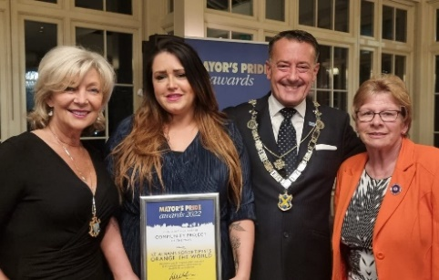At the end of March Louise,  Club President Barbara and Peace Team member Ameeta were delighted to attend the  St Albans Mayors Pride Awards 2022 as the Project had been selected as one of 3 finalists in the Community Project category .Although the Project didn't win, being selected as finalists has provided great free publicity for the Club and it looks like Louise's networking during the evening may have gained the Club a new recruit - from one of the winning projects.The 16 Days of Action is a great opportunity for Clubs to gain publicity and make contact with like-minded women. If you are considering lighting up your neighbourhood, check out the SI St Albans Project here [www.sigbi.org/st-albans/orange21](http://www.sigbi.org/st-albans/orange21).

However it is also great to start small - sharing pictures on social media of individual members wearing an orange item of clothing - or holding an orange item - one for each day of the 16 Days or altogether for a big splash.

**SIGBI Belfast Conference 27th - 29th Oct 2022 - Climate for Change**

<https://sigbi.org/belfast2022/>

We are hoping SI London Chilterns is going to be well represented at this year's Annual Conference in October. Whilst we wait to hear more about the four dynamic Keynote Speakers on Education, Health, Environment/Climate Change and Women/Gender Equality now is the time to book your hotel. It should be quite easy to book now with the option to cancel for free should your plans change.

The Conference webpage provides a good hotel list however I and many other Regional members have booked into the Premier Inn Cathedral Quarter having found it good value , comfortable & convenient when the SIGBI Conference was last in Belfast.

<https://www.premierinn.com/gb/en/hotels/northern-ireland/antrim/belfast/belfast-city-cathedral-quarter.html>

As the Conference will be a great opportunity to meet up after such a long time meeting only on Zoom Regional Exec will be organising a get together during the Conference - probably a meal on Friday evening. If you and your Club members are interested in joining us please let me know.

Helen Byrne, Regional Membership Officer

Email: [helenbsorop@yahoo.co.uk](mailto:helenbsorop@yahoo.co.uk)

* + **SIGBI Benevolent Fund: Regional Trustee Rita Beaumont**

This has been difficult time for all of us and our families but for some members the sudden reduction in income has caused of extreme hardship, so just a reminder about the Benevolent Fund. The fund is a totally confidential service available to help the financial difficulties of those who are eligible to apply. The fund may be in the form of a quarterly payment or a one-off payment to pay for an unexpected item

**Who is Eligible?**

You must have been a Member of a Soroptimist Club in the UK, including the Channel Islands and the Isle of Man, or

the Republic of Ireland for 3 years or more. The support given is subject to a simple confidential financial check.

**How to Apply**

A member who might need financial help at this time can contact me so I can talk through the application process.

Rita Beaumont: Email: [r.beaumont3@ntlworld.com](mailto:r.beaumont3@ntlworld.com) :Telephone: 01234 401475 or Mobile: 0776 4511 006

**The Benevolent Fund is always pleased to receive donations from Clubs, without funding we cannot provide vital support when it is needed ~ if your club is interested, please contact me and I will provide you with all the information you need**

* + **Executive Group Meetings**

**Your Region Needs You!**

We are a friendly group who would like new members to bring fresh ideas to the management of the Region so why not join us for a meeting ~ just let Rita know so we can send you the papers and meting link

The timetable of dates below are when we plan to meet but it does on occasion change and Rita will let you know any alterations . All the meetings will be via Zoom so you do not even have to travel into London

|  |  |
| --- | --- |
| **Date** | **Start Time** |
| 12th May 2022 | at 5.30pm |
| 7th July 2022 | at 5.30pm |
| 22nd September2022 | at 5.30pm |

* + **News From “63” ~ *Article written by the Number 63 “500 Club Administrator” & 63 Board Director Pat Dale***

**500 Club**

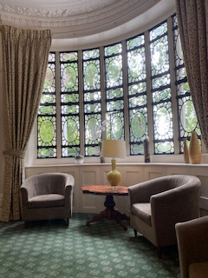500 club was started by Anne Hudson in 1994. The idea was to raise funds for ongoing support towards the maintenance of “63”

Members can buy one or more than one number for £12 for the year. This can be done by setting up a standing order and should be set up for renewal once a year. The draw takes place on the last Friday of each month and two winners are drawn. They receive £50 each. The winners are posted on “63” website every month. This month the club drew three numbers as a bonus month.

Clubs can buy numbers as a collective with a view of winning and raising funds. It would be wonderful if you could buy more than one ticket to increase your chances of winning.

Members are buying numbers as gift tokens, and it is a brilliant idea. Chairman Ann Garvie thought of this, and it is proving extremely popular.

50% of all contribution helps towards the maintenance. 45% is issued as prize money. 5% is for admin costs. Each 500 numbers sold will contribute £3000 annually for maintenance of “63”, but I need to increase the number of participants to achieve that figure. The finance director of “63” has direct access to the account.

500 club donated £8000 to 63 towards the maintenance in the last year. Last couple of years have been difficult and with the help of you all we can make a difference.

It would be my aim to get at least 500 members for 500 club. I would be delighted if everyone can share and start buying numbers as a way of thanking speakers, friends, birthday and Christmas presents.

Please help me to achieve that for your own “63” club.

Here is the link [https://number63.co.uk/wp-content/uploads/2021/03/500-form.pdf](https://nam12.safelinks.protection.outlook.com/?url=https%3A%2F%2Fnumber63.co.uk%2Fwp-content%2Fuploads%2F2021%2F03%2F500-form.pdf&data=04%7C01%7C%7Cc6e0c4683e384bfbc8d008da1fc7e3da%7C84df9e7fe9f640afb435aaaaaaaaaaaa%7C1%7C0%7C637857240629949919%7CUnknown%7CTWFpbGZsb3d8eyJWIjoiMC4wLjAwMDAiLCJQIjoiV2luMzIiLCJBTiI6Ik1haWwiLCJXVCI6Mn0%3D%7C3000&sdata=h5dAED3z6WyGvpymcznW0WhbtKxejN1Jk59vItHLoDQ%3D&reserved=0)

In Friendship

Pat Dale

**News From Clubs**

**Soroptimist International of Aylesbury**

**Tree Planting at The Women’s** **Refuge**

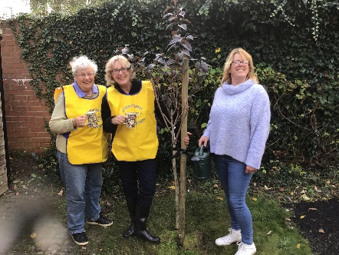

This is a photo taken after successfully planting a cherry tree at Aylesbury Women’s Refuge for the centenary. We chose a flowering cherry, so the families at the Refuge can enjoy the blossom in the spring and berries in the autumn. At our March meeting we were pleased to hear from the refuge manager, April Benson (pictured), that our tree had weathered the Winter and was in bud 😊

**Soroptimist International Slough, Maidenhead & Windsor**

**March 26th & 27th 2022 ~ A Weekend of Celebrations!**

**SI Slough Windsor and Maidenhead held its Diamond Anniversary**, by holding **a Climate Change Conference** in the **Long Barn at Norden Farm, Maidenhead on Saturday** and having a **Celebratory lunch at Ditton Manor, Langley on Sunday**

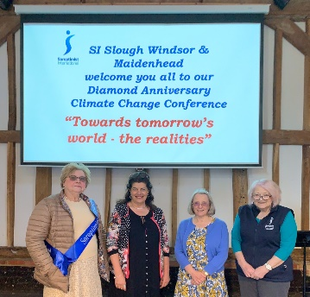

The theme of their **Climate Change Conference was ”Towards Tomorrow’s World - the Realities?”** For this they had some very inspiring speakers**. Cllr. Donna Stimson,** who attended COP26 on behalf of the Royal Borough, spoke about what she took away from it and what we all could do. SI St Albans member **Linda Shall** talked about building her Passive House - the concept of this type of house is based on a voluntary standard for energy efficiency in a building which reduces the building's ecological footprint. It results in ultra-low energy buildings that require little energy for space heating or cooling. The third speaker, Internationally renowned **Professor Amir Sharif, Dean of the Faculty of Management, Law and Social Sciences and Professor of Circular Economy at Bradford University,** sent a video of his presentation where he spoke about the different types of economy and how the circular type helps us to reduce, re-use, and recycle.

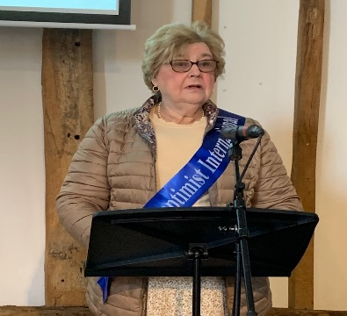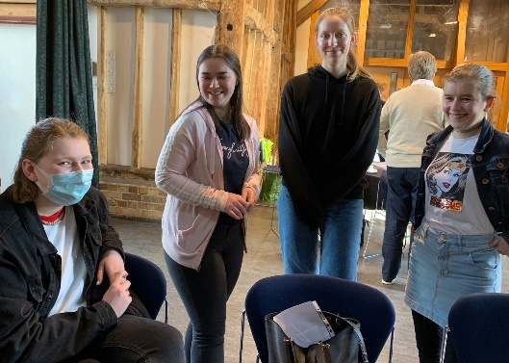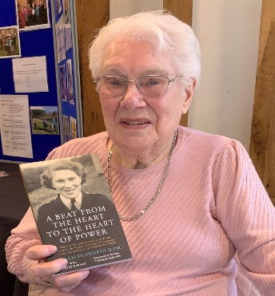

On Sunday, a celebration lunch was held in the library of the beautiful setting of Ditton Manor, Langley, near Slough. The Guest speaker was **Tan Ikram CBE, who is Deputy Senior District Judge (Deputy Chief Magistrate) for England and** **Wales**. He gave a very good speech on topics of importance to Soroptimists e.g. violence against women, forced marriage, and trafficking. He mentioned the Victims Commissioner and was unaware that she was a Soroptimist. He was soon put right!

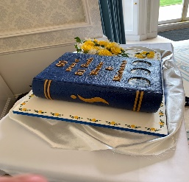

A cake in the shape of a book on the 60 year history of the Club and a sugar posy of roses was made by Jackie Paling.

Pictures on the front of the book were taken from drawings by a now deceased past member who was very artistic.

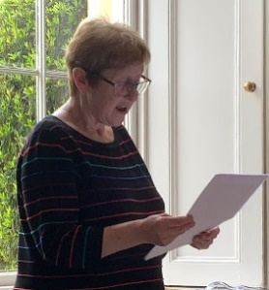

Unfortunately International President Maureen Maguire was unable to attend the weekend as planned Associate Member Alison Sutherland read Maureen’s Toast to the Guests on her behalf at the lunch.

A raffle raised over £300 towards the SI President’s Appeal “Opening Doors to a Bright Future” and also the aid effort for Ukraine.”

**Sunday Lunchtime Enjoyment!**

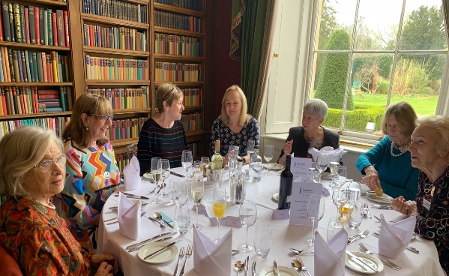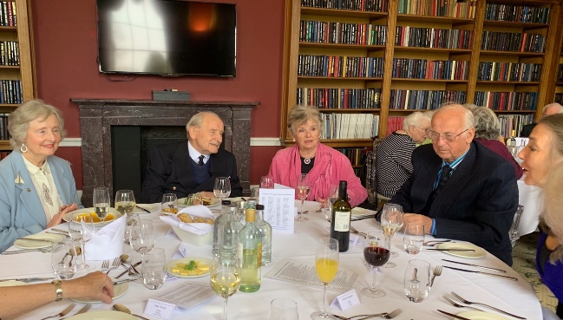

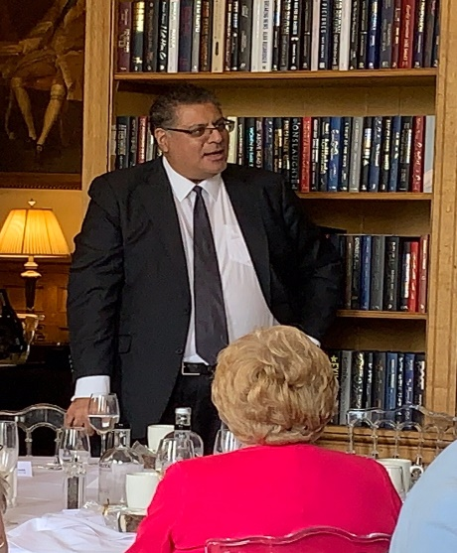

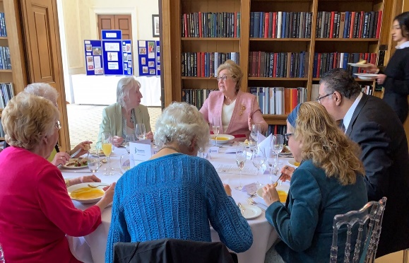

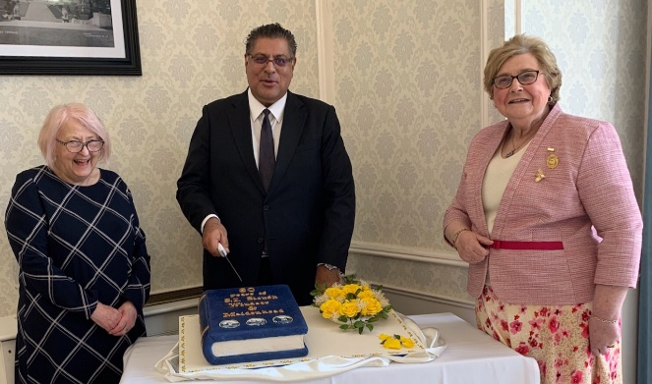

**Soroptimist International of Milton Keynes**

SI Milton Keynes held an **afternoon tea event to celebrate International Women’s Day** and ran a **raffle for** **Ukraine  raising £400** which we have **sent to SI Krakow** following the information provide by Gill Curry at SI Thames Valley; the club were keen for the money to go to a Soroptimist group helping on the front line so this was perfect.

**End Snip-Its!**

**Dates for the Diary**

* + Saturday 8th October 2022 on Zoom - SILC Region AGM/Conference
  + Thursday 27th October – Saturday 29th October 2022 – SI Great Britain and Ireland (SIGBI) Conference Belfast "Climate for Change" [www.sigbi.org/belfast2022](https://sigbi.org/belfast2022/)
  + Saturday 10th December 2022- SILC Region Meeting/Conference and Celebration of Human Rights Day - 10am to 1pm on Zoom
  + Saturday 11th March 2023 - SILC Region Meeting/Conference and Celebration of International Women's Day - 10am to 4pm in person at Cecil Sharp House 2 Regent’s Park Road, London NW1 7AY [www.efdss.org/cecil-sharp-house](https://www.efdss.org/cecil-sharp-house)

More details will be available nearer the time

**And Finally** ~ Need something to look forward to ~ it is never too early to make a date in your 2023 diary!

Early Bird Registration open May 2022

**Let your Club be Part of the Next Newsletter**

Copy Date for the **July 2022 Edition of the Newsletter is 1st July 2022**

If you have a speaker that you would like to recommend then send details to me for inclusion.

Send me your news on [**r.beaumont3@ntlworld.com**](mailto:r.beaumont3@ntlworld.com)