Saved as C drive, UserData, WINWORD:

SILCR Human Rights 2022 Mk 3 website story © V. Irene Cockroft.docx Microsoft Word

On 10 December 2022, Soroptimist International London Chilterns Region celebrated Human Rights Day with a zoom speaker event. Chris Green, OBE for services to Equality, Founder of White Ribbon UK, and Co-founder of Male Allies Challenging Sexism (MACS), gave an inspirational talk that reminded Regional member Irene Cockroft of:

**My first encounter with the White Ribbon campaign; engendering Trust**

    One cold November night in 2007, I set off as usual to join the annual *Reclaim the Night*, anti-violence, women’s march through central London. Most adults are required to be out alone after nightfall - some occasionally; some like night cleaners of commercial premises, a lot. Many women have no option but to walk home alone at night. Some are doomed to die for their sense of duty. I march to remind society that women’s right to use the streets at night without fear must be respected!

Women, like men, may have to work, study, hold meetings or socialise after dark. Unequal pay means that, in general, women must walk when men drive. On transport strike days in town centres, observe how many women compared to men are walking or cycling the considerable distance from home to, and from, work.

Most adults out at night are responsible people, concerned for the safety of all. There are exceptions; men who know that a lone woman walking home at night may be dragged into a dark alley where she has little defence against a male predator.

An outdated law still implemented by men over a century after, in 1918, (some) women were granted the right to vote in Parliamentary elections, ordains that women should be paid less than men for equivalent work. Why? Insistence on male higher worth places economically deprived women at the mercy of depraved men.

In November 2007, as I walked by the statue of World War I heroine Nurse Edith Cavell in St Martin’s Place near Trafalgar Square, I was intrigued to see a group of men holding a candlelight vigil at the base of the Nurse Cavell monument. Each man wore a loop of white ribbon on his coat lapel. I asked the purpose of their vigil.

A White Ribbon man explained that Nurse Edith Cavell in wartime saved the lives of men irrespective of nationality, at the ultimate cost of her own life. White Ribbon men were holding a vigil there in solidarity with women marching to reclaim their right to walk in safety at night.  I cried.  Reciprocal caring was a breakthrough towards, not just publicly declaring a grievous problem, but solving it. Men’s behaviour needed to change.

**The solution is equality. Equal pay for women will improve their confidence and work performance. Good men choosing to use public transport at night with vigilance, will increase safety for everybody.**

White Ribbon men and more recently, Male Allies Challenging Sexism (MACS), respect women’s right to initiate and conduct their own campaigns against injustice and inequality, as women always have done. The men’s vigil (held where welcomed, whenever practicable), is to me a welcome feature of *Reclaim the Night*.

Role-model men draw the attention of all men to an issue that may not otherwise occur to them. For example, how do women travel home at night after a meeting? Are they compelled to use public transport and walk past dark alleyways where a predator may lurk? Daytime walkers, and anytime drivers, may not recognise the danger that every woman walking alone at night must face, however short the walk from bus or train to home.

Before the late 19th century *Votes for Women* Campaign, men happily accepted women’s inequality under laws that benefitted men … until women themselves objected. Respected men like Member of Parliament John Stuart Mill drew attention to the need for men to value humanity as a whole, not as over-privileged and under-privileged genders.[1] **Equality equals progress.**

When we women marchers pass old soldiers (distinguished by their military bearing) on our route through London, they often salute us.  Military men know of Nurse Edith Cavell’s compassion for men in peril and they register their compassion for women in peril. It is appreciated.

We women salute Nurse Cavell, sentenced to death by enemy firing squad for her love of humanity.  Her words to her clergyman visitor on the eve before her execution were, "Patriotism is not enough. I must have no hatred or bitterness for anyone." Those words are engraved on her London monument. They are *anti* every prejudice and type of discrimination that may divide and defeat the moral progress of humanity.

In November 2022, pandemic and poverty were among reasons that made it impossible for unpaid volunteers to organise a London *Reclaim the Night* women’s march. Some marches took place in other cities. Although crime logistics for 2022 are not yet available, there has been no apparent annual reduction in the number of women intentionally harmed by men; and therefore no reduction in women’s distrust of men.

**How can you help women and men together reclaim *every* night, ensuring safety for both, and engendering trust through equality, caring and sharing, in 2023?**

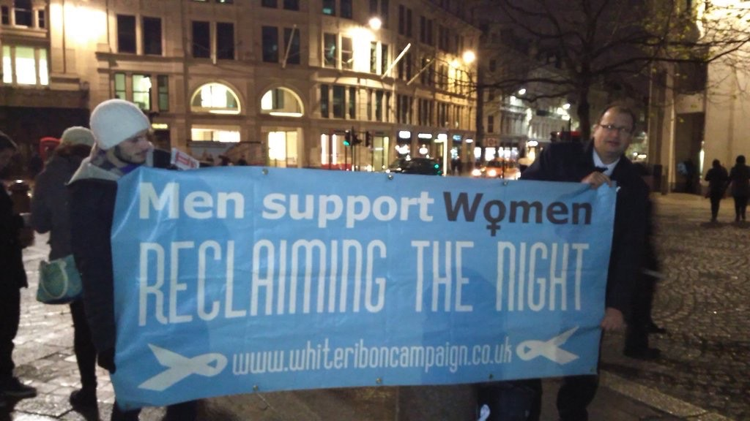

[Caption] Photo of White Ribbon Campaign banner in support of women’s *Reclaim the Night* march, and MACS decal, supplied courtesy of Chris Green OBE, founder of White Ribbon UK and co-founder of Male Allies Challenging Sexism (MACS); UN Leader of Men.

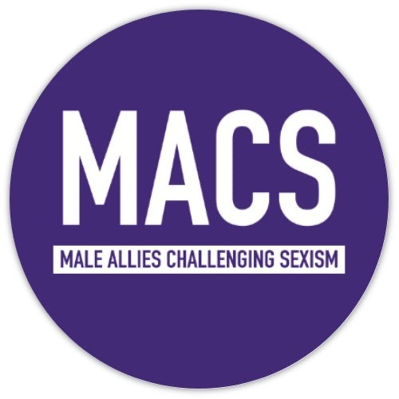

Further reading on this subject:

*https://www.theguardian.com/books/2009/aug/02/subjection-women-john-stuart-mill*

*www.reclaimthenight.co.uk*

*https://www.theguardian.com/commentisfree/2020/jul/08/it-is-all-men-to-varying-degrees-mens-violence-against-women-is-a-systemic-crisis*

*https://www.theguardian.com/commentisfree/2021/mar/17/breaking-silence-patriarchy-men-help-end-violence-against-women*

Essay: *On the Subjection of Women* by John Stuart Mill and Harriet Taylor, published by Longmans in 1869

Copyright © V. Irene Cockroft 1st January 2023

c. 900 words

1.