London Chilterns Region

The London Chilterns Challengers

Regional Theme for 2022/2023

“The Future is Ours to Challenge”

Regional Newsletter – December 2022

Christmas Greetings from Your Regional Executive Team!

Christmas each year gives us an opportunity to reflect on the year gone by, the highs and lows, moments to remember. During the past year life has gradually returned to a more normal pattern as we came out of the pandemic. As an executive we decided to continue to hold three of our four meetings via zoom and in June we celebrated our first face to face meeting near Ascot and what a joy it was to meet each other again.

We have no President again this year and as a Regional Executive we have chosen to call themselves “The London Chilterns Challengers” for a second year with the Theme “The Future is ours to Challenge” Click on the link to find out more https://sigbi.org/london-chilterns/president/
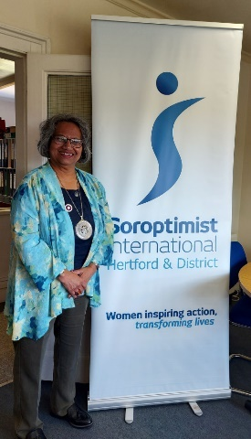
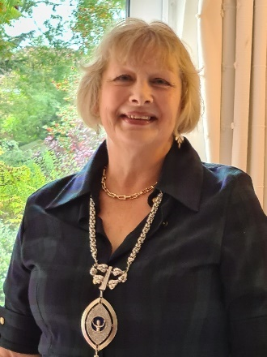
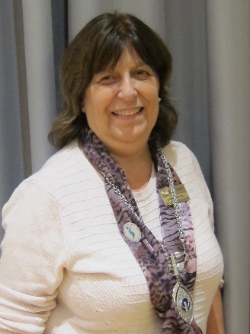
At the Belfast Conference Helen & Denise represented us at The Change of Insignia and did us proud

The year has finished with a good news story ~ we are delighted to let you know that Kate Belinis has joined the Regional Executive and has agreed to be our President Elect

Regional News
With Kate joining us that means your Regional Officers for the Coming Year are:
Post & District | Post Holder | Club | Contact Details
President | The London Chiltern Challengers | Regional Executive | r.beaumont3@ntlworld.com  Telephone: 01234 401475  Mobile: 07764500116
President Elect | Kate Belinis | SI Hertford & District | kate.belinis@cdaherts.org.uk
Secretary | Rita Beaumont  With  Pauline Panter | SI Bedford  SI Bedford | r.beaumont3@ntlworld.com  pauline.panter@hotmail.com
Treasurer | Denise Powell | SI St Albans & District | denise.m.powell@googlemail.com
Programme Action Officer | Pam Robertson | SI Hertford & District | pamelarobertson807@btinternet.com
Membership Officer | Helen Byrne | SI St Albans & District | helenbsorop@yahoo.co.uk
Public Relations Officer | Jane Slatter | SI St Albans & District | pinkyslatter@hotmail.com
Communications & Website Administrator | Jane Slatter | SI St Albans & District | pinkyslatter@hotmail.com
FCC | Jen Simpson | SI High Wycombe & District | jensimpson@blueyonder.co.uk
Benevolent Fund Trustee | Rita Beaumont | SI Bedford | r.beaumont3@ntlworld.com
63 Representative | Barbara Diamant | SI Central & South West London | barbdiamant@gmail.com

- However, Your Region Still Needs You!
We are ~ a friendly group who would like new members to bring fresh ideas to the management of the Region so why not join us for a meeting ~ just let Rita know so we can send you the papers and meting link All the meetings are via Zoom so you do not even have to travel into London

- Request from Denise Powell SILC Regional Treasurer

Members will recall that our long-time independent auditor has retired, and therefore I would ask if there is anyone in any of the Clubs who can propose a new auditor. It is a very small task, but one that we do need done, so I would appreciate any contacts that can be provided.

- Diary Date ~ Membership Development Group: Information from Helen Byrne
We will be holding second Development Group Meeting as another Zoom call on Saturday 14th January between 10am & 11.30am. We had a great turn out on 5th November and hope that you will all be able to send at least 1 member to the second session

- Programme Action ~ Pam Robertson

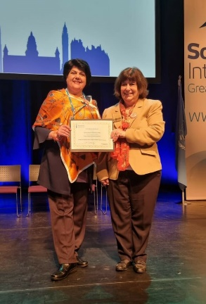

Congratulations to SI St. Albans for achieving a Best Practice Award for their Orange the World campaign, and to Ameeta and Denise for their excellent presentation at Belfast Conference.

And further congratulations to SI St. Albans on their new status as a Toilet Twinning City.

The Special Domestic Violence Courts Observations Project has now concluded – my thanks go to all Club Members who have participated in this project either as part of the London Collective or of the wider London Chilterns region. Many hours have been devoted and I thank you all for your time. Results are now being analysed and it is hoped that the final report will be launched for International Women’s Day. Our survey follows on from the Northumbria report, published in 2018 (available on the website) and the West Midlands report, recently published and circulated to all Clubs. A short presentation at the November UKPAC meeting given by Jess, the PhD student undertaking the analysis of our observations, indicates that similar issues are occurring across the board. The three reports should give a pretty comprehensive report on the specialist courts across the country. The West Midlands report has gone to many relevant associations – with action being taken - and we shall be looking at getting really good publicity for the entire project at the launch.

The UKPAC (United Kingdom Programme Action Committee) met face to face on 12th November. The three focus groups of Modern-Day Slavery, Special Domestic Abuse Courts, and Violence Against Women and Girls will continue, with the additional emphasis on Women and Girls’ Safety. Minutes of this meeting can be found on the website. The next meeting will take place on 21st January 2023, when we will be asked to highlight Programme Action work in our region. I can only highlight your project if it is on the data base! Gillie O’Rourke is the new Chair Email: ukpacchairman@gmail.com

NB UKPAC levy of £1.50 (50p for members under 25) 2023/2024 will be collected via SIGBI capitation fee and not through Region as in the past.

‘Opening Doors to a Bright Future’ – International President’s Appeal.
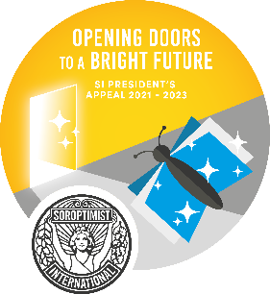
The first tranche of the Appeal was launched in Cambodia in early 2022 in partnership with Cambodian Community Dream Organisation (CCDO). Focused on education, and promoting gender equality and women in leadership, the programme set a target of reaching 2000 women and girls. By July, they had already reached 2438 – truly exceptional.

The second project is now underway in the Sohoti District Eastern Uganda. With the Soroptimist International Africa Federation, this project will support Rose Academies to work with 30 girls living in Sohoti, a remote, impoverished rural area. The girls will range in ages from 8-13 years, and attend, or should be attending, Primary grades 3-7. Private education will be provided to give the girls optimum learning experiences with the hope that they will excel and be inspired to pursue further academic achievements. It is also hoped that the parents and the community will learn about the value of education and therefore change mind-sets for their daughters’ futures. The project will run from 1st August 2022 through to December 2023.

The third tranche which was due to begin in October 2022 will partner with World Vision Georgia. This project will run until May 2023, empowering women and girls by improving life skills and employability.

Please remember our International President’s Appeal in your fundraising.

News From Clubs

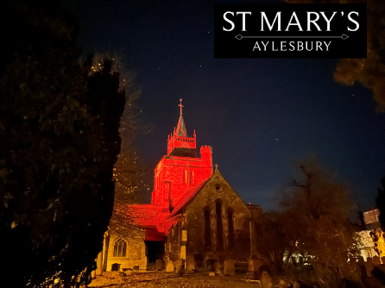
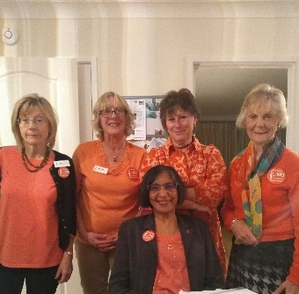
SI Aylesbury Celebrate Orange the World Day

The tower at St Mary’s in Aylesbury was floodlit Orange on 25th October and members attending the club business meeting in person (other members joined via Zoom) are pictured wearing orange

SI Bedford Pack Christmas Boxes with Added Extras

As we move towards another Christmas Season, we cannot help reflect on those less fortunate than ourselves especially in the present financial situation. The use of foodbanks across the Country has increased beyond the capacity of these organisations to cope.

It was therefore decided to support the local foodbank working in conjunction with a local Veterinary Surgery who annually collect, pack and deliver single person or family Christmas food parcels. These parcels have an “added extra” in the form of small packets of pet food or a pet toy. Many elderly or lonely people rely on their pets for emotional support and companionship.

However, as the Vets tell us, so many pets are being rehomed or sadly in some cases being put down because their owners are now unable to afford their food and the additional care they often require. Members of SI Bedford donated, packed and date checked 5 single person Christmas boxes and 2 Large Family Christmas boxes as pictured.

These boxes also included a Christmas card with good wishes and details of Soroptimist International. Additionally, several bags of pet’s food were also donated and delivered. Hopefully we have added a little extra in the form of something that the recipients would not buy for themselves, such as Chocolate, Sweets and other Christmas goodies!!!

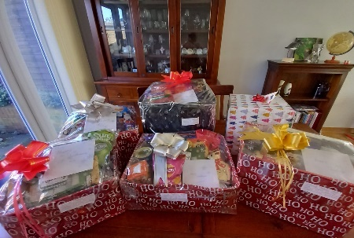

SI Milton Keynes Enjoy the Belfast Conference

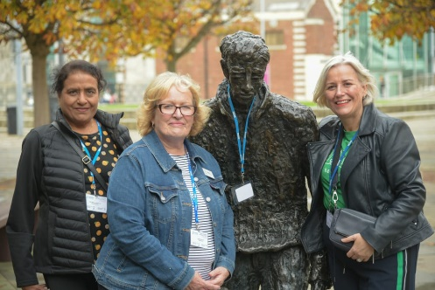

SI Newbury & District Celebrating Sylvia’s 25 Years of Service

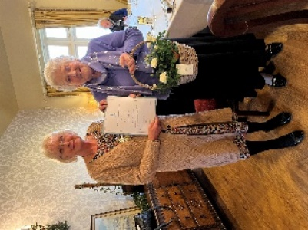
Sylvia Galbraith (on the right of the picture) receiving flowers and a 25 year Long Service Award Certificate as a member of SI Newbury and District from
President Joyce Lewis.

SI Hertford ~ Orange the World & Raise Money!
“Orange The World”. No, not quite at Soroptimist International, Hertford and District’s Quiz Night on 18th November at Wodson Park Sports Centre in Ware. However, with orange table cloths, balloons and members wearing orange, some looking very fetching, and the first round featuring “ORANGE’, made everyone aware of taking action to end Violence Against Women. Thirteen tables took part in a well contested Quiz which was won for a second time in a row by the team from Reed. Make a date for next year, 17th November, and bring a team to end Reed’s run of winning.
The Club will be able to send £800 to Hertfordshire Equality Council, a charity encouraging Communities working together to promote equality and understanding.

SI Oxford Welcome Friendship Clubs
The club have enjoyed welcoming on two clubs on separate occasions this autumn. Soroptimists from two of their friendship clubs, Madurai and Bonn, they have stayed with our members and enjoyed exploring Oxford. The club have also welcomed several new members and enjoyed meeting face to face once again. They are meeting via zoom for November, January and February but will share our December meeting face to face with their usual Christmas bring and share.
Christmas Greetings From Clubs
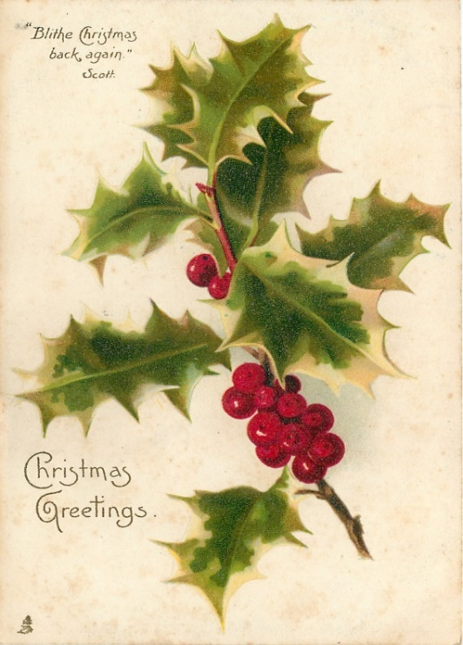

SI Aylesbury
SI Aylesbury & District sends best wishes to all Members of London Chilterns Regions for a Happy, Healthy and Peaceful Christmas and New Year 2023

SI Bedford
The Ladies from Bedford wish all our friends across the region Happy & Peaceful Christmas and New Year

SI Hertford
Greetings for a Happy & Peaceful Christmas and New Year

SI Slough Windsor & Maidenhead
The President and members of SI Slough Windsor and Maidenhead would like to wish everyone in the Region a Merry Christmas, Season’s Greetings and a Happy (and healthy) New Year.

SI London Central & South West
The members of SI London Central & South West send good wishes for a Happy & Peaceful Christmas and New Year

SI Oxford & District
The members of SI Oxford send Seasons Greetings you or friends across the Region

SI Newbury
Greetings for a Happy & Peaceful Christmas and New Year

SI Thames Valley
The Ladies from Thames Valley wish all our friends across the region a Peaceful Christmas and New Year

SI Greater London
Seasons Greeting to you all

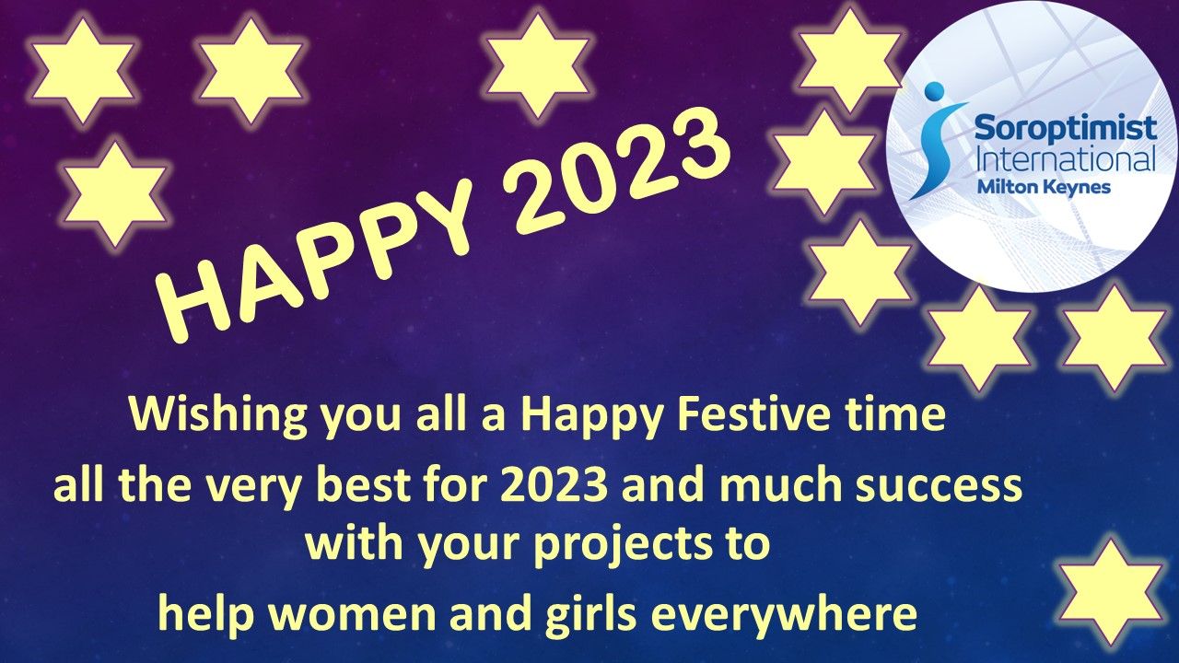
SI Milton Keynes

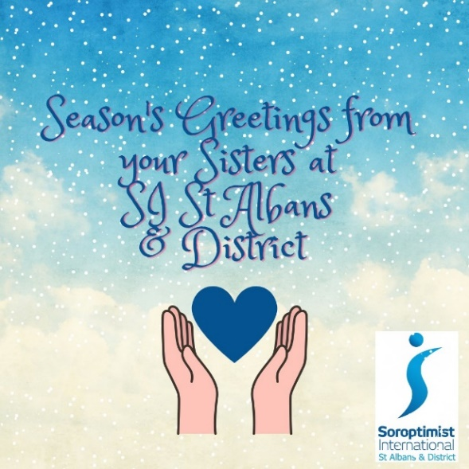
SI St Albans & District

Members of SI Albans & District would like to wish you all
a very merry Christmas and a happy, healthy and peaceful 2023. Instead of sending Christmas cards we are making a donation to the Soroptimist International President’s Appeal Opening Doors to a Brighter Future xx

SI High Wycombe & District

End Snip-Its!

Date for the Diary
Saturday 11th March 2023 - SILC Region Meeting/Conference and Celebration of International Women's Day - 10am to 4pm in person at Lancaster Hall Hotel, 35 Craven Terrace, London, W2 3EL
More details will be available nearer the time

Reminder re Dear Diary ~ do not forget to send entries to Jane at silondononchilterns@hotmail.com

In 2023 it is SIGBI’s turn to host Soroptimist International Convention.
It will be in Dublin 27-29 July 2023.

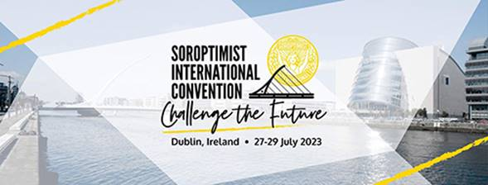

It would be wonderful if as many Members of our Region as possible could be there. Conventions are every 4 years and are hosted by each of the (now) 5 Federations in turn so the next one won’t be “on our patch” until 2043!

Please click here to find out more and to book sidublin2023.com.
Early Bird bookings are up to 21 January 2023

Let your Club be Part of the Next Newsletter
Copy Date for the April 2023 Edition of the Newsletter is March 26th 2023
If you have a speaker that you would like to recommend then send details to me for inclusion.
Send me your news on r.beaumont3@ntlworld.com

