London Chilterns Region

The London Chilterns Challengers

Regional Theme for 2022/2023

“The Future is Ours to Challenge”

Regional Newsletter – Welcome to Our Spring Edition

A New Club Year and Reflecting on the Year Just Gone – Jane Slatter, May 2023

Clubs will have started their new Club year now, always a time to reflect on the year just gone.
I wrote a report for my Club’s AGM and thought I would share a summary with all the Clubs in the Region – especially
as Rita is always asking for content for her excellent newsletter.

There are 12 Clubs in London Chilterns Region (SILC). The Region provides guidance and cohesion across the Clubs
and is a communication conduit with our Federation. The Region’s theme for the year is
“The Future is Ours to Challenge”. For information and news from the Region please see the website
https://sigbi.org/london-chilterns/ You can also follow on Facebook www.facebook.com/silondonchilterns and on Twitter https://twitter.com/SoroptimistLC

The Region's year runs from October (the same as the Federation year) and we haven’t had a President this year so
the role is being shared by Members of the Region’s Executive. https://sigbi.org/london-chilterns/region-officers/
We welcome anyone along to the Region’s Exec meetings who would like to find out more. Now the Exec meetings are
held on Zoom it is much easier to join in. Please just ask if you want to know the schedule of meetings.

There are usually four main Region Conferences a year, held on Saturdays with excellent speakers and where we hear
about inspiring projects from other Clubs and across the Region and the Federation.
Please click on the links in the text here to find out more – there is lots more information on the web pages about
the events.

Since COVID they are a mix of Zoom meetings and face-to-face meetings either in London or hosted by Clubs outside London. The most recent event was in March to mark International Women’s Day
https://sigbi.org/london-chilterns/2023/03/11/iwd23/ It was our first meeting in London since 2019 and it was great that it was well attended.

We had a speaker from the AVA Project (Against Violence and Abuse) which is a leading UK charity committed to ending gender-based violence and abuse. A coup for us was that Ruth Healey, SIGBI President-Elect could be with us for the whole day. Ruth’s presentation resonated well with the Region’s theme “The Future is Ours to
Challenge” motivating all Clubs to go and do things differently. Ruth showed us the membership forecast, declining like many other voluntary organisations and advising, as we know, that it is up to us to turn it round.

During the day we also had interactive sessions about the Special Domestic Abuse Courts Observations Project –
Members split into three groups – the London Collective, Clubs in the “North” of London Chilterns Region and Clubs in
the “West” of London Chilterns Region, to discuss how Clubs will promote the report, when it is published, to organisations who can work on the recommendations.
We also had a session on Membership where we all tried to come up with our “Elevator Pitch” for being a Soroptimist. Clubs shared programme action highlights too. You can see we made the most of the time spent together!

At the December Human Rights Day conference https://sigbi.org/london-chilterns/human-rights-day-2022 we were on
Zoom for the morning and heard from two excellent speakers:
- Major Kathy Betteridge, Director for Anti Trafficking and Modern Slavery, National Lead from the Salvation Army
(Kathy is planning to join Soroptimist International which is great news).
- Chris Green OBE, founder of the White Ribbon & Co Founder of Male Allies Challenging Sexism; Chris was awarded his OBE for Services to Equality.

Between speakers we had readings to mark United Nations Human Rights Day – the anniversary of the signing of The Universal Declaration of Human Rights probably the most significant date in the Soroptimist calendar. The traditional Soroptimist candle lighting ceremony is always very moving.
Attendees wore orange to mark the mark the last day of the global Orange the World Campaign – 16 days of activism
to end gender-based violence from 25 Nov, the International Day for the Elimination of Violence against Women, to 10 Dec, Human Rights Day.

At the AGM in October 2022 on Zoom https://sigbi.org/london-chilterns/agm22 we had three inspiring speakers:
- Roni Cherneva, the Modern Day Slavery and Human Trafficking Co-Ordinator working for Bedfordshire Police.
- Dr Kay Richmond: Federation Programme Director (now succeeded by Lindsay Green). St Albans Soroptimist
- Linda Shall on the Progress Towards the Climate Change COP26 Agreements ahead of the forthcoming COP27 in Egypt.

The Region Conference in June 2022 was in Sunningdale, Berkshire and was a wonderful celebration of being together again post-pandemic! https://sigbi.org/london-chilterns/jun22.
- Our first speaker was Amanda Findlay from FLAG DV flagdv.org.uk the charity is a Free Legal Advice Group for domestic abuse victims in Berkshire, Buckinghamshire, Oxfordshire, Hampshire and Wiltshire.
- We also heard from Nicki Nalton from the Alzheimer’s Society www.alzheimers.org.uk particularly about their
post-COVID strategy.
- It was wonderful to have an update on the Kori Women’s Development Project in Sierra Leone by Rose Simbo from SI Thames Valley https://koridp.org/
- We also heard about support for Ukrainian Refugees by SI Krakow by Gill Curry, of the SI Thames Valley Club.
- Pam Robertson, the Region’s Programme Action Officer, presented Violence Against Women & Girls: the Soroptimist UK Programme Action Orange Day initiative in support for the the UNiTE Campaign to end violence against women www.unwomen.org/en/what-we-do/ending-violence-against-women/take-action Orange Day takes place on 25th day of EVERY month.

Looking Forward….
June Region Meetings 2023 – in June are having a trial of with Clubs in the “North” of the Region (Aylesbury, Bedford, Hertford, Milton Keynes, St Albans) and Clubs in the “West” of the Region (High Wycombe, Newbury, Oxford,
Slough Windsor and Maidenhead, and Thames Valley) meeting in these smaller clusters of Clubs.
(The London Collective has been meeting separately).

Booking information has now been sent to Clubs and is on the website
3 June is for North Clubs https://sigbi.org/london-chilterns/2023/04/23/northjun23/ and 17 Jun is for West Clubs: https://sigbi.org/london-chilterns/2023/04/23/westjun23/
The pandemic has meant little opportunity for Clubs and Region to meet together and meeting with these geographical
groups could help Clubs gain renewed energy and support each other. Both North and West groups have speakers
booked and will also spend time working on next steps for the Special Domestic Abuse Courts Observations Project.

Attending Region Meetings is a great way to meet Members of other Clubs, share ideas, hear from excellent speakers
and get a broader picture of the Soroptimist organisation - highly recommended! I attended my first one about 25 years
ago and haven’t looked back.

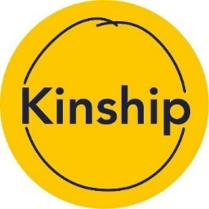
Update: Soroptimists International report - May 2023

In April 2022, you made a generous donation of £130 to support our work with kinship carers.
This report details the impact we have made over the last year and some of our current projects.

About Us

Kinship is the leading national charity providing support to kinship carers and their families across England and Wales. Kinship carers are family members or friends who have stepped up to care for a child because their parents are unable to.
We work with a community of more than 12,500 kinship carers across England and Wales, to develop evidence-based programmes including one-to-one support, family activities, peer support and advice services. We also campaign for long-term change and support and we commission research into kinship care.

The Need for Our Work

Kinship care affects all communities with more than 162,000 children growing up in the care of friends and relatives in England and Wales. It is the most common form of care for children who are unable to live with their parents, but despite this, kinship carers feel invisible and poorly supported. According to our 2022 Financial Survey, 84% of carers say they are not getting the support they need to care for their children.

Our Services: 1 April 2022 – 31 March 2023

More than 2,600 kinship carers were supported with expert and impartial advice from our free, national Advice Service. The team also secured £117,000 in unclaimed benefits.
More than 400 kinship carers received intensive, in-person one-to-one support from our Kinship Connected project workers.
More than 1,100 carers used our peer support service, launched in January 2022.
We held more than 80 workshops covering nine topics, including managing contact, self-care for the carer, and financial support, with total attendance of nearly 830 carers.

Current Projects
#ValueOurLove campaign - We launched our first national campaign during Kinship Care Week in October 2022. To date, more than 12,500 people have signed our petition which represents 12,500 letters sent to MPs – every MP in England has been contacted. Our campaign calls for parity of allowances, training and support between kinship carers and foster carers, and the same amount of paid leave that adoptive carers are currently entitled to. We still have a long way to go, but in February, we were delighted when the Government made a major commitment to supporting kinship families by publishing its new plan for children’s social care. This plan includes increased training and support for carers and the first-ever kinship care strategy.

Kinship Compass - a new and independent online information, advice and support hub just for kinship carers, at any point on their kinship journey. Helping them find advice and information, local groups, and emotional support from fellow kinship carers via online chat.

Thank You
We rely on donations like yours to help us improve the lives of kinship carers and their families, so that they can thrive. Thank you once again for your generous support.

Kinship spoke at our IWD event in Mar 22
https://sigbi.org/london-chilterns/2022/03/05/iwd22/
It's great to receive an update like this from a charity we have supported.

Your Regional Officers
Post & District | Post Holder | Club | Contact Details
President | The London Chiltern Challengers | Regional Executive | r.beaumont3@ntlworld.com  Telephone: 01234 401475  Mobile: 07764500116
President Elect | Kate Belinis | SI Hertford & District | kate.belinis@cdaherts.org.uk
Secretary | Rita Beaumont  With  Pauline Panter | SI Bedford  SI Bedford | r.beaumont3@ntlworld.com  pauline.panter@hotmail.com
Treasurer | Denise Powell | SI St Albans & District | denise.m.powell@googlemail.com
Programme Action Officer | Pam Robertson | SI Hertford & District | pamelarobertson807@btinternet.com
Membership Officer | Helen Byrne | SI St Albans & District | helenbsorop@yahoo.co.uk
Public Relations Officer | Jane Slatter | SI St Albans & District | pinkyslatter@hotmail.com
Communications & Website Administrator | Jane Slatter | SI St Albans & District | pinkyslatter@hotmail.com
FCC | Jen Simpson | SI High Wycombe & District | jensimpson@blueyonder.co.uk
Benevolent Fund Trustee | Rita Beaumont | SI Bedford | r.beaumont3@ntlworld.com
63 Representative | Barbara Diamant | SI Central & South West London | barbdiamant@gmail.com

- However, Your Region Still Needs You!

We are a friendly group who would like new members to bring fresh ideas to the management of the Region so why not join us for a meeting ~ just let Rita know so we can send you the papers and meeting link. All the meetings are via Zoom so you do not even have to travel into London

Helen & Jen ~ on duty in London Supporting the Landmarks Half Marathon!!

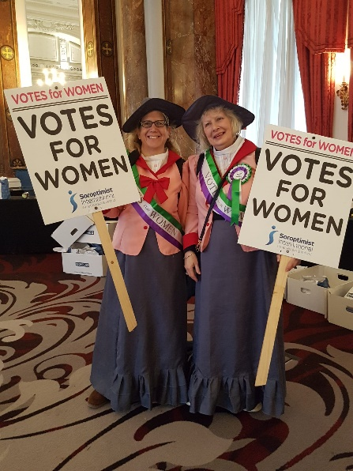

News From Clubs

SI Hertford

International Women’s Day

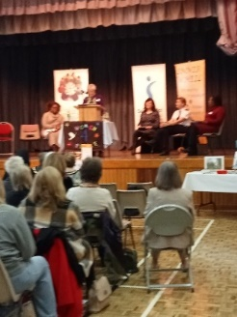
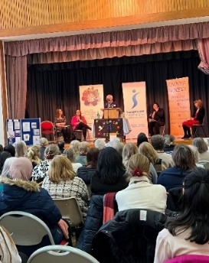
We were delighted to be part of an amazing celebration of International Women’s Day on 8th March, organised by President Kate in partnership with Inner Wheel and Stevenage World Forum. Eight inspirational women told ‘their story’ to an audience of over 100, including female students from the nearby college. There were Q&A sessions, display stands from various organisations (including our own) and time to network while enjoying a light lunch together. Attendees had been invited to bring along basic toiletry items; the very generous collection was divided between the Refugee Council and SADA (Standing Against Domestic Abuse).

Wine Into Water Evening
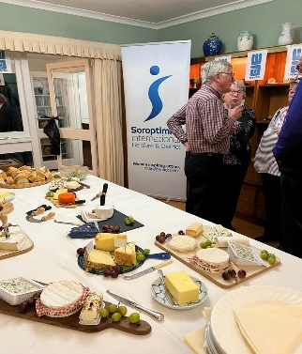
Club members, friends and neighbours came together for a lovely Wine and Cheese evening on 24th March to mark World Water Day (22nd March) and raise funds for
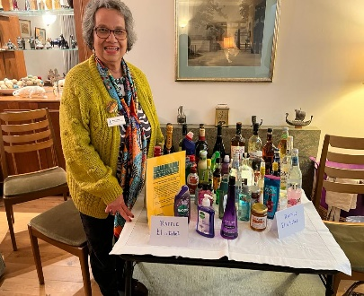
WaterAid. Hosted by Karin, we enjoyed a vast range of temptingly delicious cheeses, washed down with a choice of wines, soft drinks or simply water. To keep everyone entertained, there was wine and water tasting, cheese and wine quizzes, and a bottle raffle, with prizes ranging from a bottle of whisky to a bottle of bleach; as much fun was gained from winning the bleach as from winning the whisky! To date, over £600 has been raised with more donations promised.

SI High Wycombe & District
Eton Presentation on ARUK by Sue Granshaw

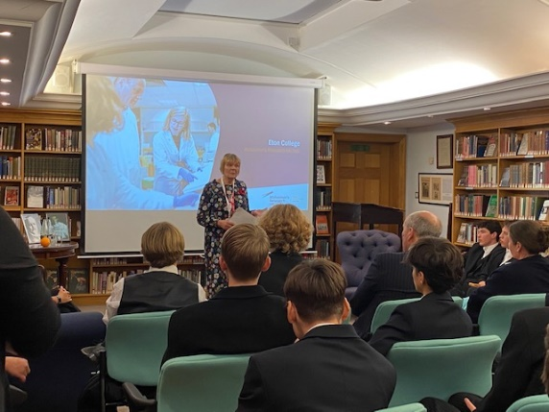
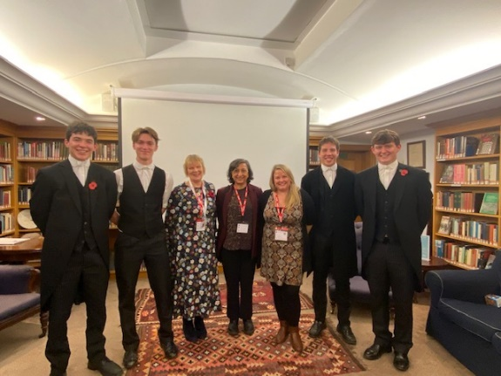

Following a presentation by Alzheimer’s Research UK (ARUK) at a London Chilterns Regional meeting I volunteered to be a Community Speaker for the charity as both my parents have lived with different types of dementia.

Last November I was asked to speak to the Social Impact Club at Eton College. This opportunity came about because four sixth formers had undertaken a gruelling sponsored ride in France and raised a staggering £12,000 for ARUK and cerebral palsy. I expected to just go along and give my talk – but no! There was a tour of the College, a drinks reception, dinner created by the Eton chef, and then we gave our presentation. It was a great experience.

ARUK is the largest charity in the UK, second in the world, devoted to finding research into the diagnosis, prevention, treatment and cure of all types of dementia, bringing together the top universities and pharmaceutical companies to bring drugs to clinical trials.

Thank you to the Region for introducing me to ARUK.

I am happy to present to Region or Clubs about the work of ARUK.

www.alzheimersresearchuk.org

SI Thames Valley: The Memorial Orchard in Sierra Leone
In the last two years Soroptimist Clubs have been busy throughout the federation planting trees to enhance our environment and to commemorate our centenary. Clubs of our Federation were also generous enough to send contributions amounting to £4000 to commemorate Johanna Raffan, a much-loved member of Thames Valley and of course at that time our Federation President.

SI Thames Valley are closely associated with the Kori Development Project Ltd. in Taiaima, Sierra Leone. When the villagers of Taiaima heard of Johanna’s death they gave some land for the planting of an Orchard in her memory. We thought that you would like to know how things are progressing. The villagers have now cleared the land and planted some of the trees. These are fruit trees – mango, lemon for example - and so the locals will also benefit from the tree planting in the form of food. The children at the local schools supported by the Kori Development Project Ltd- there are now 2 of them- will also hopefully have the planting and growing of trees in their curriculum and first-hand knowledge of this skill.

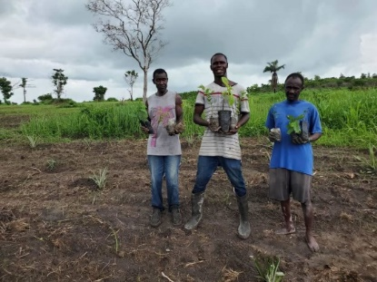
More has yet to be done at the end of the rainy season. The Orchard is to be fenced to keep out the local goats who would eat them before they grow properly and people too who might selfishly decide the harvest is for them alone! A watchman’s hut is to be installed in which gardening tools can be kept and a watchman sheltered. Here are some photos of the work in progress. We will keep you informed

SI Bedford
Members of SI Bedford were so excited when long time member Wendi Momen was chosen to represent the Bahia faith community at the Coronation Ceremony on 6th May in Westminster Abbey. Wendi was at the head of the 1st Procession in the Abbey made up of representatives of many faiths ~ congratulations Wendi, a very well deserved honour, we are so proud!

Membership Learning Opportunity
One of the many benefits of joining the Soroptimists is personal development and learning new things. Members can join the great Facebook Live session coming up on 20th May at 11am all about using social media to grow membership (it will be recorded and available in the Hub later too)

It'll take place on the closed Facebook group and will be available to watch back after http://facebook.com/groups/SIGBICommunicationsMembership

SIGBI Benevolent Fund Trustee: London Chilterns Region Vacancy from October 2023
We will have a vacancy for a Trustee representing our region when I complete my 4-year term of office in October 2023. The work of the Fund is carried out via email except for the November AGM that takes place at “63”.

The Trustees of the Benevolent Fund are elected by their Regions. Trustees include the Treasurer, Secretary and the Chairman, and a representative of the Soroptimist International Great Britain and Ireland (SIGBI) Limited Board.

The portfolio of investments held by the Benevolent Fund are ethically invested, with the Trustees delegating the management of the portfolio to the Investment Committee (comprising the Chairman, Treasurer, SIGBI Ltd Representative, Secretary and at least 2 other Trustees). The services of professional financial advisors are retained to ensure that the portfolio is properly managed. The Investment Committee meets twice a year to review the portfolio.

The Trustees meet annually following the SIGBI Ltd Conference, when all those who have received help during the past year are reviewed to ensure they are still getting the financial assistance they require and, if appropriate, to withdraw, or reduce funding for a beneficiary. The Department of Work and Pensions website is consulted to review the income and capital a beneficiary may receive/hold before becoming eligible for help from the Benevolent Fund.

Confidentiality is key in the work of the Benevolent Fund, as it is important that our beneficiaries can trust that their personal business is not discussed with any other member of a Club or a Region. The Trustee is the link person between a beneficiary and the Benevolent Fund, and they assist any potential applicant in completing the application form. They will meet with the beneficiary at least annually, or more often according to the support needed, to ensure that a balanced, well informed, report on a beneficiary’s needs is put to the Annual General Meeting of Trustees.

The Regional Trustees do not discuss individual cases with any other member of a Club or a Region.

The Benevolent Fund plays a vital role in helping to support members who find themselves unexpectedly in need of financial support in the short or medium term.
Want to find out more about the Role & Responsibilities I would be delighted to chat to you

Rita
r.beaumont3@ntlworld.com
01234 401475
07764511006

End Snip-Its!

Reminder re Dear Diary ~ do not forget to send entries to Jane at silondononchilterns@hotmail.com

In 2023 it is SIGBI’s turn to host Soroptimist International Convention.
It will be in Dublin 27-29 July 2023.

It would be wonderful if as many Members of our Region as possible could be there. Conventions are every 4 years and are hosted by each of the (now) 5 Federations in turn so the next one won’t be “on our patch” until 2043!

Please click here to find out more and to book sidublin2023.com.

London SIGBI Conference 2023

Join the London Conference 2023 at Friends House, Euston Road, London NW1. The Conference will take place over two days on 3 and 4 November 2023.

Keep checking the London 2023 Conference Website for regular updates.

Let your Club be Part of the Next Newsletter
Copy Date for the next Edition of the Newsletter to be confirmed
If you have a speaker that you would like to recommend then send details to me for inclusion.
Send me your news on r.beaumont3@ntlworld.com

