

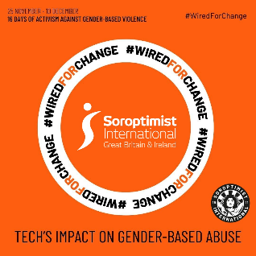

London Chilterns Region

**President Kate Belinis**

**Theme for the Year: “Celebrating Inspirational Women”**

**Regional Newsletter – December 2023**

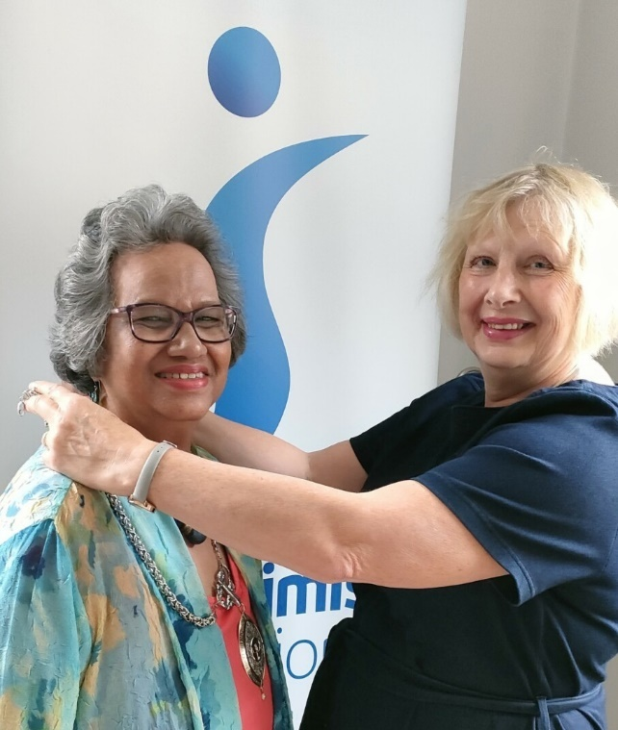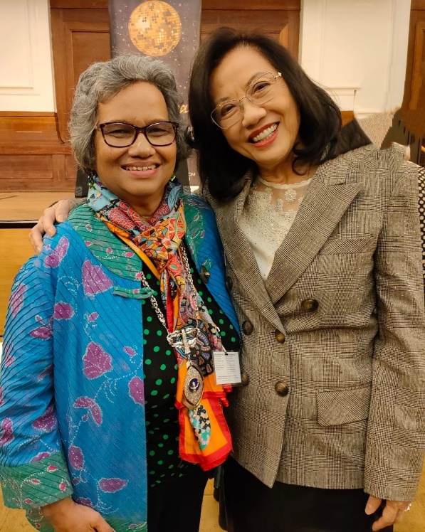

**President Kate with Incoming International All Change! Kate & Helen**

**President Siew Yong at the London Conference**

**“Celebrating Inspirational Women”**

“Thank you for the honour and privilege of having me as the new Soroptimist International London Chilterns Region

President.

My theme **‘Celebrating Inspirational Women’** is to highlight the many Club Members’ wonderful and inspirational achievements who in turn will bring women from their own networks to our notice and perhaps each club to celebrate during the year at a club meeting.  I would be delighted to attend such celebrations, please invite me!

It would be fantastic if we could collate the stories from each club into our very own Regional “booklet” to share not only from within our SILC Region but with the other Regions too.  Please send your photos to Jane.

I look forward to meeting you and learning how and what each club does with your programme action and aligning with our Sustainable Development Goals.

**Regional News**

**Your Regional Officers for the Coming Year are:**

|  |  |  |  |
| --- | --- | --- | --- |
| **Post & District** | **Post Holder** | **Club** | **Contact Details** |
| **President** | Kate Belinis | SI Hertford & District | [katebelinissi@gmail.com](mailto:katebelinissi@gmail.com) |
| **Secretary** | Rita Beaumont | SI Bedford | [r.beaumont3@ntlworld.com](mailto:r.beaumont3@ntlworld.com)  Telephone: 01234 401475  Mobile: 07764500116 |
| **Treasurer** | Denise Powell | SI St Albans & District | [silondonchilterns.treasurer@gmail.com](mailto:silondonchilterns.treasurer@gmail.com) |
| **Programme Action Officer** | Pam Robertson | SI Hertford & District | [pamelarobertson807@btinternet.com](mailto:pamelarobertson807@btinternet.com) |
| **Membership Officer** | Helen Byrne | SI St Albans & District | [helenbsorop@yahoo.co.uk](mailto:helenbsorop@yahoo.co.uk) |
| **Public Relations Officer** | Jane Slatter | SI St Albans & District | [pinkyslatter@hotmail.com](mailto:pinkyslatter@hotmail.com) |
| **Communications & Website Administrator** | Jane Slatter | SI St Albans & District | [pinkyslatter@hotmail.com](mailto:pinkyslatter@hotmail.com) |
| **FCC** | Jen Simpson | SI High Wycombe & District | [jensimpson@blueyonder.co.uk](mailto:jensimpson@blueyonder.co.uk) |
| **Benevolent Fund Trustee** | Rita Beaumont | SI Bedford | [r.beaumont3@ntlworld.com](mailto:r.beaumont3@ntlworld.com) |
| **63 Representative** | Barbara Diamant | SI Central & South West London | [barbdiamant@gmail.com](mailto:barbdiamant@gmail.com) |

 **A Call to Action ~ Your Region Still Needs You**

We are a friendly group who would like new members to bring fresh ideas to the management of the Region so why not join us for a meeting ~ just let Rita know so we can send you the papers and meting link All the meetings are via Zoom so you do not even have to travel into London

**SI London Chilterns Region at the SIGBI Conference London 2023**

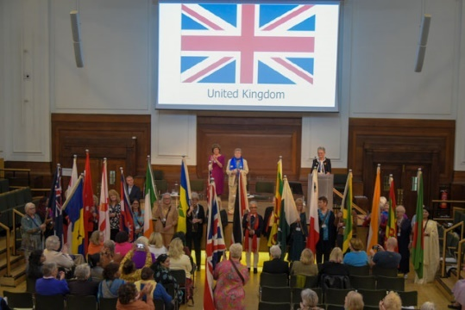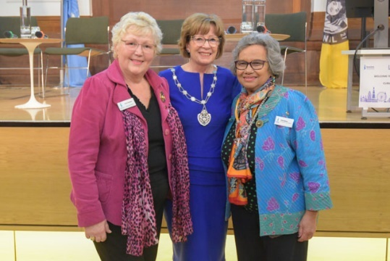

**Great Conference and great turnout from our Region**

Nearly 50 Soroptimists from SI London Chilterns Region thoroughly enjoyed attending the wonderful Soroptimist International Great Britain and Ireland Federation Conference at the Friends Meeting House in London on 3rd and 4th Nov 2023. There were about 500 Soroptimists there from all over the Federation and it was inspiring to all be together. You can read about the two days and see lots of smiling happy faces in photos on the Conference website

<https://sigbi.org/london-chilterns/london-2023>

**The SI London Chilterns Shop -** [**https://sigbi.org/london-chilterns/shop/**](https://sigbi.org/london-chilterns/shop/) **- Silk Scarves (Books and Roses!)**

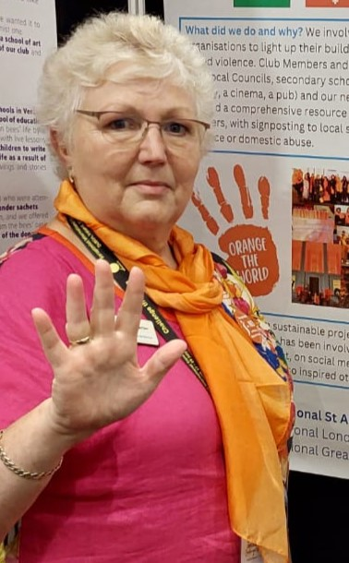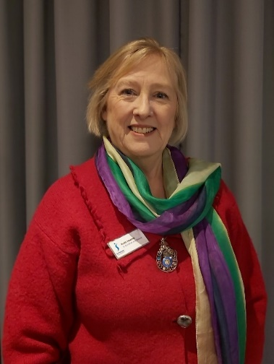

Many Soroptimists have bought **Sushila’s silk scarves** in the past. In addition to the one in the **colours for women’s suffrage (model, SIGBI President Ruth Healey** when she visited our Region as President-Elect) she now has beautiful **blue and orange ones (model, Jane Slatter at the Dublin Convention**).

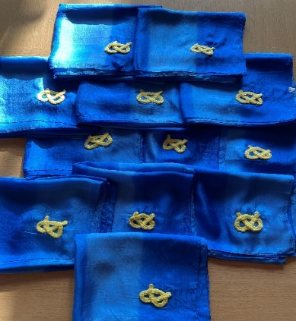

**Sushila Sadarangani from SI Greater London Club** imports the scarves from India and profits go to her Club’s charities.

The latest news is that **SI Stafford have added the Staffordshire knot to embellish the** **scarves for their Members to wear at Conference and other occasions**. The scarves are **£13.00** each or 3 for £35 (plus post & packing) - please email [ssadarangani@nhs.net](mailto:ssadarangani@nhs.net).

These items are also listed in the **SIGBI online shop** under items recommended by Clubs. The SIGBI shop has a full range of other items too so please take a look [**https://sigbi.org/sigbi-shop/**](https://sigbi.org/sigbi-shop/)

**Programme Action ~ Pam Robertson**

It was lovely to see so many of you at what I thought was an excellent **Conference at the Friends House**. The Programme Action section was inspiring, and **I echo the words of Programme Director Lindsey Green who said that** **every project, however small, counts.** So, get those Programme Action Report Forms completed on The Hub and help to provide the evidence for us to retain our UN status.

At the **UKPAC meeting on 18th November**, I chose to highlight **SI Milton Keynes Refugee Campaign.** Over the past 18 months, with support from partner associations, they have delivered a campaign to support refugees arriving in their city from Afghanistan and Ukraine, providing essential resources to help people be re-housed and to stay in touch with families.

On **20th October**, I was privileged to attend **SI Milton Keynes’ Violet Awards Evening** and, on **17th October SI Thames** **Valley’s Club meeting where an** **IDVA** (Independent Domestic Violence Advocate from Wycombe Aid) gave and excellent and insightful talk on her role. I look forward to seeing both events recorded on The Hub in due course!

Do you have plans for the **16 Days of Activism**? A reminder that there is a Trello Board with images and key messages for the 16 Days of Activism. It also includes templates for posters which can be printed. **Go to the Library in The Hub and search Trello Board.**

**News from Clubs**

**SI Hertford and District – Oranging our Quiz Night**

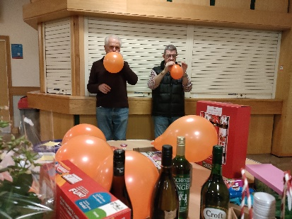

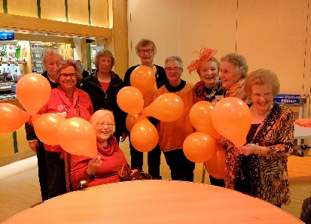

Ahead of the **16 Days of Activism**, our annual Quiz Night was a really fun evening and a great opportunity to raise awareness and take **action to end Violence Against Women and Girls (VAWG).**

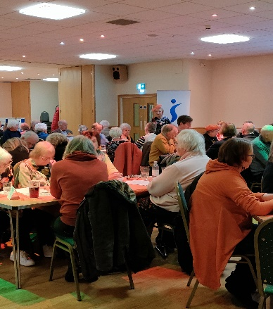

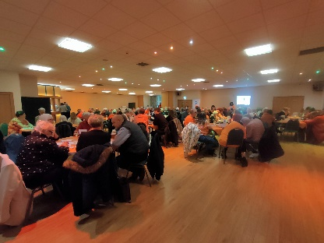

Quizzers had been encouraged to wear something orange, orange tablecloths covered the tables, orange balloons decorated the room so, of course, we had to explain why.

A plug for the orange lighting up of County Hall on 30th November was followed by a short introduction to our two local charities benefitting from the proceeds of our quiz **– The Living Room in Stevenage (a centre supporting those living with addictions) and Safer Places (our local Women’s Refuge).**

We were delighted that staff from Safer Places had fielded a table, and they were welcomed with a heartfelt round of applause as we highlighted their invaluable work supporting women fleeing domestic abuse and helping them to regain control of their lives.

# **SI Milton Keynes ~Viva Violet Awards 2023 – Women of Action**

***Violet Richardson was the original founder of Soroptimist International, her motto was It’s what you do that counts and therefore, hence the name Violet Awards for “Women of Action”.***

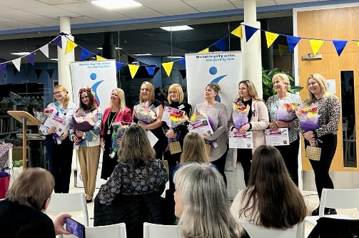**On Friday 20 October, the current generation of members here in MK gathered at MK SNAP for their second Violet Awards evening**, where local women were recognised for their unsung efforts in going above and beyond their normal roles in helping other women and girls calling upon the services of our charities and to help these women achieve their potential.

SI:MK fundraises all year to help our chosen charities and community groups meet small gaps in provision for their clients. **Currently we are supporting. MK Act, MK YMCA, UnityMK (formerly Winter Night Shelter MK), Ukraine Appeal and Works for Us (now part of Citizens Advice MK)**

The awards were very **kindly sponsored by Jan Flawn CBE and founder of P J Care the award-winning specialist of** **neurological care and rehabilitation.**  **Our keynote speaker was Zoe Raven, Chief Executive of Acorn Early Years,** who spoke about the demands of juggling child care with personal development. Warm thanks to both of them for making the evening so interesting and enjoyable.

This evening was all about the women working, volunteering for their charities and their stories of devotion and hard work which were told by their managers.  It was an emotional and inspiring event and we say again to all the nominees thank you, you are much valued.  Every nominee received a certificate, flowers and a Violet heart but the winners, women from **MK: ACT** and the **Ukraine Appeal** also received an additional prize.   Many congratulations to them – what role models they are!

**Soroptimist International Milton Keynes**

**Taking part in the Guinness World Record attempt by MK Foodbank**

[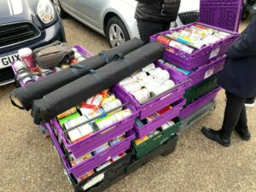](https://sigbi.org/milton-keynes/2023/10/26/mk-foodbank-mk-can-new-world-record/mk-can-oct-2023-2/)Soroptimists in Milton Keynes may be a small club, but we are always keen to help our community and so back in July, when we heard about **MK Foodbank's plans for the MK Can** **event to break the Guinness World Record** for the number of tinned food cans in a continuous line, we thought could we do this.

All our tins dropped off and ready to be taken round to our section, 11 crates with 42 tins in each.

The outline of the record attempt was that on **Monday 16 October (World Food Day) MK Foodbank along with** **businesses, clubs, churches, schools, parish councils, organisations and charities throughout Milton Keynes** would attempt to break the world record for the number of tin cans in a continuous line.  The record was made in 2014 in Canada and stood at 44,966**.  MKFoodbank wanted to aim for 10km continuous line of tins which would equate to** **132,000 tins.**  Based on currently high levels of demand the MK Foodbank is dealing with this would give them 6 months’ worth of food supply in tinned food.

[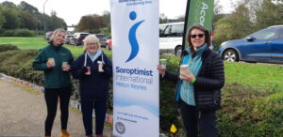](https://sigbi.org/milton-keynes/2023/10/26/mk-foodbank-mk-can-new-world-record/mk-can-oct-2023-8/)

Here we are at the start of our line with one of our helpers from Acorn Early Years Foundation about to put the first tins down.

The plan was that businesses and community groups apply for a 25 meter section.  A 25-meter section equates to approx. 350 400g food tins. **The record attempt would take place in Campbell Park and would start and end at The Rose at the World Food Day Pillar.**

And so, our club got together and said can we do this.  We will need to ask all our friends and family to help obtain 350 tins of food and we would need to start in July.   The Foodbank gave us a list of items they wanted: pasta, meat, fish, fruit, soup, pasta sauces, veg etc.  **And we had to have the 350 tins before 16 October**.  That is a lot of tins but we said we can do this; our club's motto is we are doer's.

Our first concern was would we do it in time.  Then where would we store them!  And then how would we get them there.  We needn’t of worried, the tins stared coming in.  A couple of our members started storing them and then we started to count to make sure we would reach the 350.  Well, we did that alright and some more.  In the end **we collected** **nearly 1,000 and were able to help out MK Snap and YMCA MK with their collections**.  And MK Snap helped us, they picked up all our tins and delivered them to Campbell Park on the 16th.

[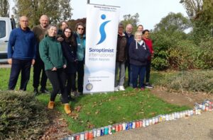](https://sigbi.org/milton-keynes/2023/10/26/mk-foodbank-mk-can-new-world-record/mk-can-oct-2023-7/)

We had to be there by 8.30am, our allotted time to drop off our tins.  We had been given a line opposite the Parks Trust offices, by the pond.  And the weather was on our side, it stayed dry although chilly, so we were all wrapped up.

Thank you to all our helpers on the day.

And again our friends helped us and we had a helper from Acorn Early Years Foundation help out.   They came along to help us unload the tins, get them to our pitch and then from 10am we had to lay the tins out, making sure we got our full 350 in our stretch and that they were all touching and that we then linked up to the next organisation in the line.

Tins laid out with one of our banners we were allowed to use to tell people about ourselves.

[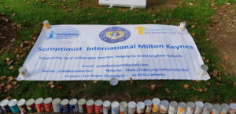](https://sigbi.org/milton-keynes/2023/10/26/mk-foodbank-mk-can-new-world-record/mk-can-oct-2023-10/)It was a great day, there was a marvellous community spirit going on, we were all helping each other, chatting.  If one section had spare, they went to another who was short, if someone needed help, we all helped out.  And then there was the wait for the adjudicators to come round and count.  The adjudicator was filmed counting each section.  And at each section he started from 1 again to make sure the section had its full count.  That was nerve racking but we had counted and recounted ours so we knew we were okay.  And then we had to wait for the official Guinness Book of Records to do his checks.

And whilst we waited in the afternoon, members of the public could walk the line and we had a lovely visit from the Acorn Early Years nursery based at the YMCA.  As you walked round, we were all talking and saying what a lovely event it was.

**And then around 3pm the announcement was made. And we had all smashed the record.  From being 44,966 the new Guinness World record is 102, 447.**

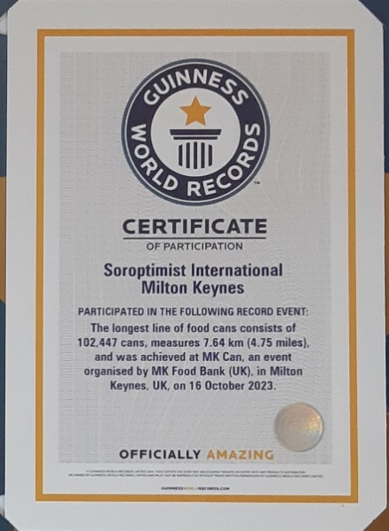

Well done everyone, and for us **Soroptimist Milton Keynes**, we feel very humble by the response from our friends and their friends friends who all gave tins.   A very big thank you from us but also from MK Community.

**One of the reasons for taking on this record was to raise awareness of the work foodbanks do, the impact of the cost-of-living crisis and the high demand the Foodbank** are dealing with to support people in the MK Community**.**  They estimate they have supported around **1 in 30 households in Milton Keynes over the** l**ast** **18 months**. **This represents one child in every class, at least** **one household in every street** and possibly at least **one in most workplaces.** **And every week** about **50** people are contacting them for the very first time. People who have never had to ask for help before.

If you are able to continue to help MKFoodbank with donations, [click here to visit the website](https://mkfoodbank.org.uk/).

**A Snippet from Kathleen Martin from SI High Wycombe**



I have just finished a new book by **Philippa Gregory – “Normal Women”.**

It is non-fiction about 900 years of women in UK.

As Philippa say**: “our history has been written by men, about men and for men”** forgetting the women.

It is a tome but fascinating and extremely well researched.

BENEVOLENT FUND

**CARING FOR OUR OWN**

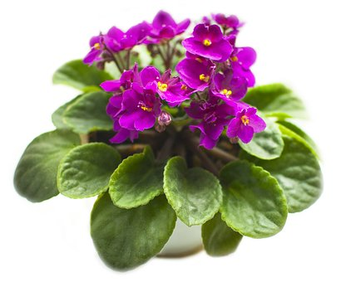

In Debt?   
Can’t pay Bills?   
Struggling?

Can we help?

**SIGBI BENEVOLENT FUND**Registered Charity No 211840

**The Benevolent Fund has been helping Soroptimists for over 80 years.**  
Did you know that you have contributed to this fund?

*Who’s eligible for assistance?*

Any woman who has been a member of a Soroptimist Club in the UK or Republic of Ireland, including the Channel Islands, for **three** years or more. *

*Talk to your Region’s Benevolent Fund Trustee for more details.*

*Be assured that all enquiries and applications are treated with the strictest confidence. Your Region’s Benevolent Fund Trustee is:*

|  |
| --- |
| *Name:* Rita Beaumont |
| *Email:* [*r.beaumont3@ntlworld.com*](mailto:r.beaumont3@ntlworld.com) |
| *Telephone:* 01234 401475 & 07764511006 |

***The Purpose of the Benevolent Fund***

To ease applicants’ financial difficulties by:

* **either** a quarterly payment where income does not sufficiently cover outgoings
* **or** a one-off payment for an unexpected expense.

The discretionary help from the Fund includes grants towards:

* utility bills
* essential living expenses
* maintenance of house/garden
* stair lift/shower installation
* daily living aids e.g. magnifying viewer/computer aids

*(These are simply examples. Every application is considered on its own merits.)*

The Fund supports an average of 25 women each year and is available to anyone within the UK and Republic of Ireland, including the Channel Islands, who has been a member for **three** years or more* (or a past member who is in financial difficulty **up to three years** after resigning), provided their income is within the limits currently set by the Trustees.   
Payments are grants, not loans, so do not have to be repaid. They do not count as income.

*\* In exceptional circumstances the Board has discretion to consider applications from newer   
 members.*

***How can you apply?***

For further information and an application form contact your Region’s Benevolent Fund Trustee or the Benevolent Fund Secretary – email: [sigbi.benevolentfund@yahoo.co.uk](mailto:sigbi.benevolentfund@yahoo.co.uk)  
SIGBI Website: sigbi.org/what-we-do/our-charities/benevolent-fund/

The Benevolent Fund derives its income from levies made by all Soroptimist members in the UK and Republic of Ireland, including the Channel Islands, as well as from donations and legacies all of which are invested in an ethical investment portfolio. The income from these investments is used to support beneficiaries.

**Donations and legacies make an enormous difference to the lives of the women supported by this Fund.**

***Donations***

SIGBI Benevolent Fund always welcomes donations. Bank Transfer is preferred.  
Payee: SIGBI Benevolent Fund Sort Code: 40-52-40   
Account Number: 00093701   
Reference: Your name or club or region

Cheques may be sent to SIGBI, 2nd Floor, Beckwith House, 1-3 Wellington Road North, Stockport SK4 1AF. (Cheques should be made payable to ‘SIGBI Benevolent Fund’)  
If you pay tax, please consider adding gift aid to your donation. Your Region Trustee has forms.  
If an acknowledgement is required, please email [sigbi.benevolentfund@yahoo.co.uk](mailto:sigbi.benevolentfund@yahoo.co.uk)

***Legacies:*** Please consider leaving a legacy to the Benevolent Fund in your Will.

**End Snip-Its!**



**Dates for Your Diary!**

President Kate looks forward to welcoming you to the **Region’s Human Rights Day event** on Zoom on **Saturday 9 December 10am to 1pm 2023**

We are going to be inspired by two amazing speakers to celebrate the

**75th anniversary of Human Rights Day**



**Saturday 16th March 2024 ~ Celebration of International Women’s Day**

Face to Face Meeting ~ watch out for exciting details



**SIGBI Conference 2024** in Edinburgh between 1st to 3rd November



**Reminder re RED** ~ do not forget to send entries to Jane at [silondononchilterns@hotmail.com](mailto:silondononchilterns@hotmail.com)

**Let your Club be Part of the Next Newsletter**

Copy Date for the **April 2024 Edition of the Newsletter is 5th April 2024**

If you have a speaker that you would like to recommend then send details to me for inclusion.

Send me your news on [**r.beaumont3@ntlworld.com**](mailto:r.beaumont3@ntlworld.com)