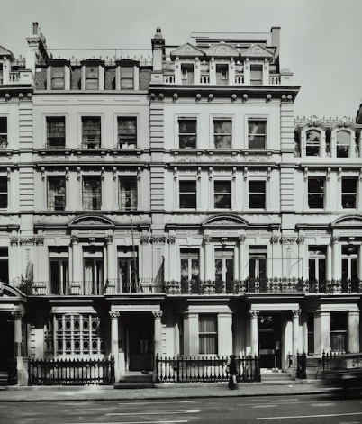
Soroptimist International Greater London History for Knebworth Soroptimist International London Chilterns International Women’s Day Event, 16 March 2024
At this event we have been honouring an inspirational woman, Lady Constance Lytton and the history of the Suffragettes.
We have some special history of inspiring Soroptimists to celebrate because it is the Centenary of the first Soroptimist Club to be chartered in Britain* – SI Greater London! a Club in London Chilterns Region.
The Club was started in 1923 and received its charter a year later, with the charter celebration taking place on the 14 February (Valentine’s Day) 1924 at the fashionable new Criterion Restaurant in Piccadilly Circus.
Sadly we don’t have a picture of that first meeting but it must have been a very prestigious affair with many very important women amongst the Club’s 100 members.
The Club’s founder and first President Kathleen, Viscountess Falmouth was chair of Swanley Horticultural College for Women and is also thought to have been involved with the development of Roehampton Hospital. She explained that in looking for members she
“looked for women who were not only outstanding in their professions, but were champions of women’s rights too”.
Early Club members included George Bernard Shaw’s executive secretary, the actress, Dame Sybil Thorndyke and Ernestine Mills, Enameller and Suffragette – Great Aunt of current SI Greater London Member and historian, Irene Cockroft.
An early SI Greater London member who deserves a special mention is Elizabeth Hawes MBE, whose contribution to Soroptimist International is described as unsurpassed. She was involved in the Founding of our Federation, Soroptimist International of Great Britain and Ireland in 1934, was its President in 1937-1938 and as the 1st International Liaison Secretary of the Soroptimist Federations for 10 years before and during WWII, she held the 3 existing Federations together and worked tirelessly to support Soroptimists across occupied Europe. You can read more about Elizabeth here https://sigbi.org/london-chilterns/files/2021/05/Elizabeth-Hawes-MBE-WhoIsShe.pdf
This gives you a flavour of some of the important programme action which Greater London Club Members have been involved in during its 100 years.

* NB - The early history of UK Soroptimist Clubs is confusing. The Bristol Club was formed earlier – in 1920 - but as a Venture Club. In 1930, when it was realised Venture Clubs and Soroptimist Clubs had shared goals, the two organisations amalgamated. I hadn’t realized but the London Central & South West Club (the Club which is just about to close) was also founded as a Venture Club and later became a Soroptimist Club. They formed after SIGL – in 1927.

