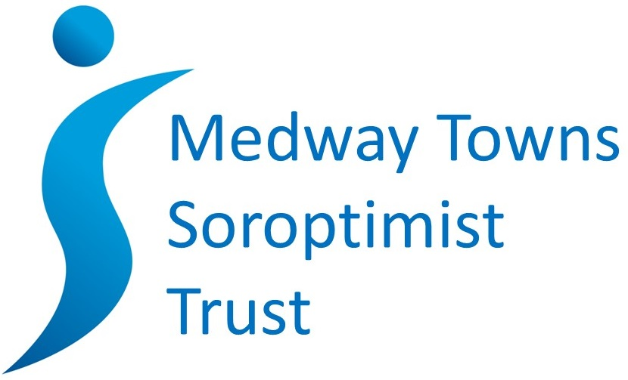

Grant application form

The Medway Towns Soroptimist Trust is an independent registered charity, number 1175474, which was established in October 2017 with an endowment of funds from Soroptimist International Medway Towns (now Soroptimist International Medway and Maidstone). Therefore the Trust’s prime motivation is the continuance of the Soroptimist mission:

SI mission: Soroptimists transform the lives and status of women and girls through education, empowerment and enabling opportunities.

Please read our grant application guidelines to learn about Soroptimists and their work, and the application process.

The Medway Towns Soroptimist Trust occasionally makes very modest donations to projects which fit within our priorities. To make an application, please complete this form and return it by email to the Trust chairman at the address below.

In the first instance, it is acceptable to email the form without signature. If you are offered a grant, a signed version will be required.

Please email the completed form to MedwayTST@yahoo.com

Name of your organisation | Charity number, if applicable
Purpose of your organisation
Name of applicant
Address
Telephone
Email
Name of project
What activities will the grant fund?
When will the activities take place? (We do not usually fund retrospectively)
Where will the activities take place?
What need will this meet?
What are your anticipated outcomes?

How will you measure these outcomes?
What is the total cost of your project?
How much funding are you requesting from Medway Towns Soroptimist Trust?
What measures will you take to secure the balance of funding required?
How does your project meet the Trust’s priority of supporting women and girls through education, empowerment and enabling opportunities
How many people will the funding help?
Where do the beneficiaries come from? (e.g. Medway, all of Kent)
If requested, would you be prepared to give a short talk about your project?
Yes ☐ No ☐
How did you hear about Medway Towns Soroptimist Trust?

Declaration

In submitting your application, you are confirming that:
- the funding will be spent as described;
- funding will be spent within one year of being awarded;
- you will report back progress as requested, possibly by giving a short presentation;
- you will complete a monitoring report at the end of the funded activities;
- you will acknowledge the support of the Medway Towns Soroptimist Trust in communication as appropriate.

Name |  | Role
Signature |  | Date

