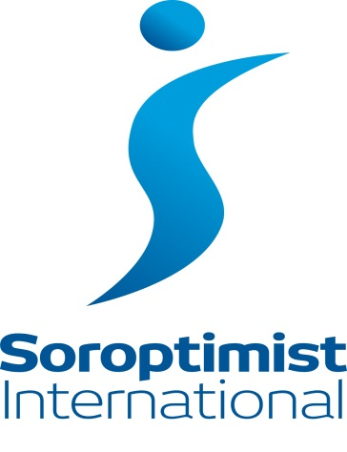
Soroptimist International Middlesbrough

QUIZ NIGHT

in aid of Marie Curie Cancer Care

Saturday 15th March, 7.15pm – 9pm
at
Marton Community Centre, Cypress Rd, Marton, Middlesbrough. TS7 8PZ

Ticket £6.00 includes light buffet

Tickets from SI Middlesbrough Treasurer Alwyn Kraus
tel.01642 325924
Cheques payable to SI Middlesbrough

