**SOROPTIMIST INTERNATIONAL STOURBRIDGE & DISTRICT**

**IWD 2021 – MONDAY 8 MARCH 2021 at 7.30PM by ZOOM**

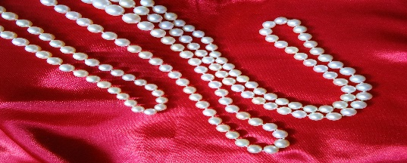

This Photo by Unknown Author is licensed under CC BY-SA

**PEARLS, PURPLE and POETRY**

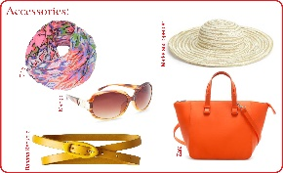

This Photo by Unknown Author is licensed under CC BY-NC-ND

**SILENT AUCTION OF HATS and ACCESSORIES**

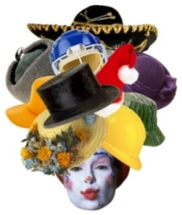**JOIN OUR MEMBERSHIP EVENT TO CELEBRATE**

**INTERNATIONAL WOMEN’S DAY 2021**

**PLEASE WEAR SOMETHING PURPLE AND YOUR PEARLS**

**RECITATION OF POETRY BY LOCAL POET STEVE POTTINGER**

**WANT TO ATTEND? REGISTER WITH SU: susan.roxburgh@virginmedia.com**

**WANT TO DONATE SOMETHING? SEND YOUR IMAGE TO:** **racheltennant01@hotmail.co.uk**

**WANT TO SEE THE ITEMS? WANT TO BID ON SOMETHING?**

**ASK RACHEL:** **racheltennant01@hotmail.co.uk**

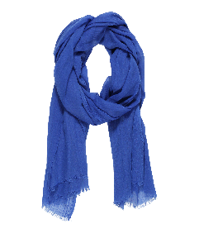

This Photo by Unknown Author is licensed under CC BY-NC

**LAST BIDS TO RACHEL BY 5PM SUNDAY 7 MARCH**

**JOIN US BY ZOOM LINK ON MONDAY 8 MARCH AT 7.30pm**

**TO SEE IF YOU HAVE BEEN SUCCESSFUL WITH YOUR BID(S)**

**THEN THE FUN BIT – POETRY RECITATION BY LOCAL POET**

**STEVE POTTINGER**

**PROCEEDS TO MARY STEVEN’S HOSPICE**

**DONATIONS TO: SI Stourbridge bank account: BARCLAYS Sort Code: 20-27-17 Account Name: Soroptimist International of Stourbridge and District**

**Account No: 40324051 BUSINESS ACCOUNT REFERENCE: AUCTION**