A Brief History of Soroptimist International Bromsgrove and Redditch

Charter and Insignia
The club was chartered in October 1966 at the Golden Cross Hotel Bromsgrove. There were 17 at the first meeting following the charter.

Our archives include proposals on the insignia to be adopted, reporting on discussions with the local authorities and the College of Arms with a view to incorporating the arms of both Bromsgrove & Redditch. In the end, a simpler design was agreed upon. The Insignia was first worn at the 21st Charter Dinner of Kidderminster, our Mother Club, in 1973.

Friendship Links
We have had several friendship links over the years with the longest being with SI Neuss in Germany. This friendship link is just over 30 years strong and we still make exchange visits regularly. Our latest link is with Burton on Trent club.

Members
Many of our members have received national recognition for the work they have done.
Four of our club members have served as Regional President (Mary Inglis, Margaret Toole, Nancy Doyle and Gail Teague) and also members have served on Federation Committees.

Charities
The club has supported many charities over the years, international, national and local, including:

Alzheimer’s Society
Basement Project in Bromsgrove
Breast cancer unit Worcestershire
Help the Aged
Help for Heroes
Home-Start North East Worcestershire
Karma Nirvana
Meru Garden Project
Newspapers for the Blind
Night Stop in Redditch
Water Aid
West Mercia Women’s Aid
We have worked in partnership with other agencies to provide support or much needed help, including recent projects addressing modern day slavery and trafficking.

For hands-on projects, we have:
- Decorated rooms to enable children to receive supervised visits in a convivial area
- Planted Trees
- Maintained a sensory garden at Saltways Cheshire Home

The attached photos are just some from our archives

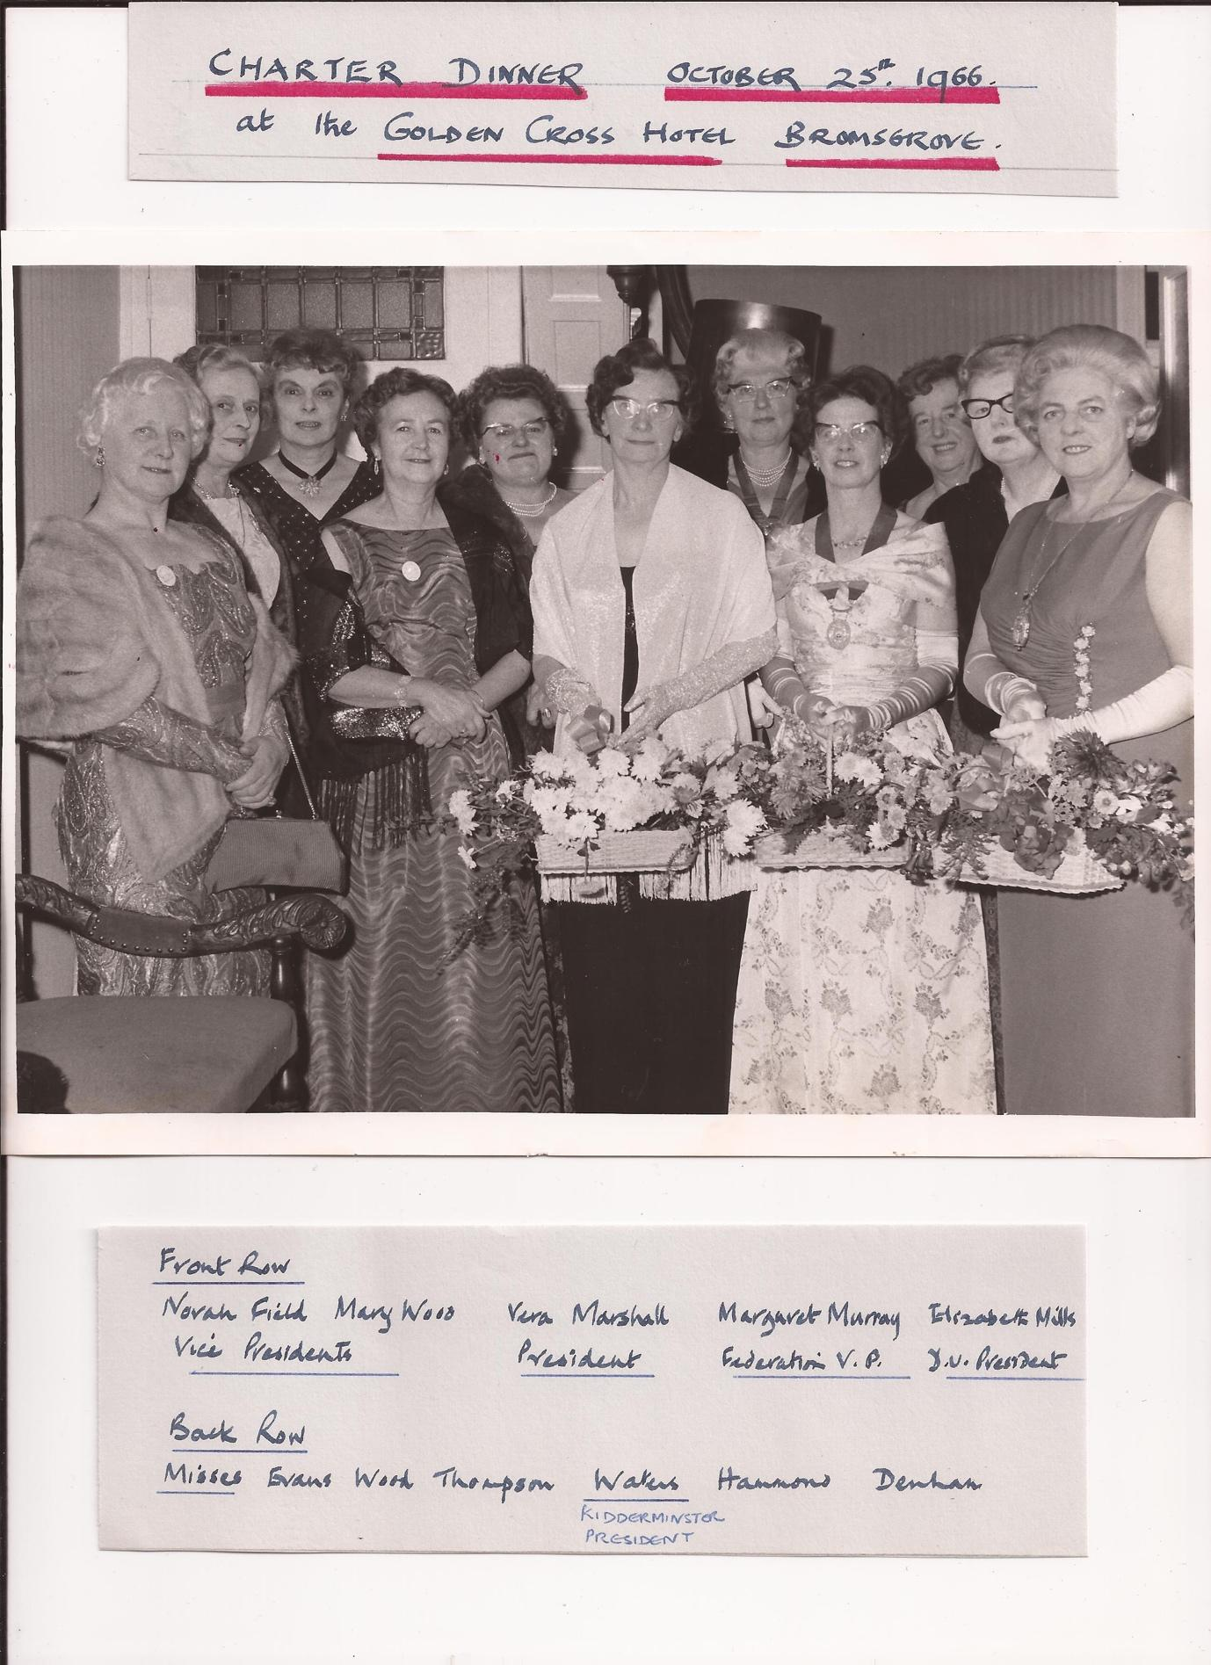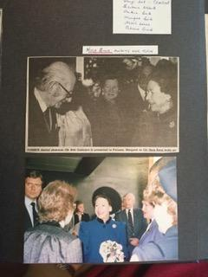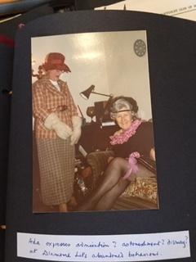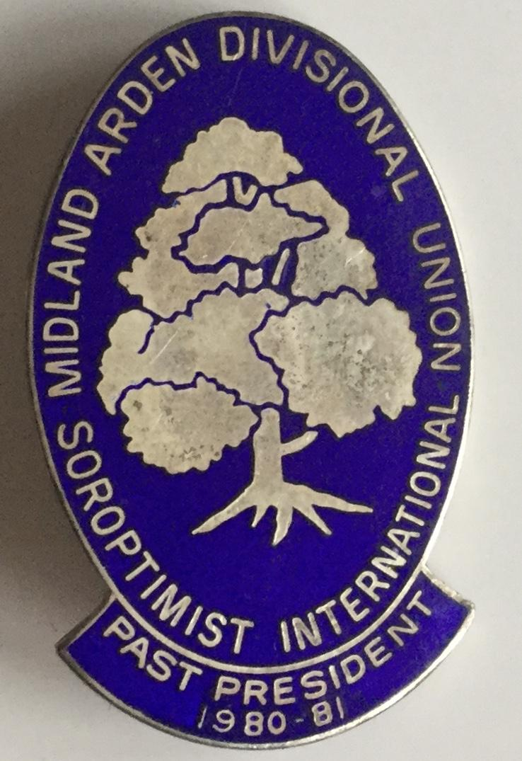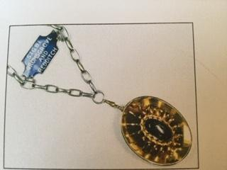
Club Insignia Sapphire stone set in gold
Members being introduced to Princess Margaret on her visit to Bromsgrove
Past regional President Badge worn by several of the club with pride over the years
Entertaining club members with the Annual Pantomime

