SOROPTIMIST INTERNATIONAL CENTENNIAL YEAR
TREE PLANTING CEREMONY

SI Worcester and District will be hosting a tree planting ceremony in Fort Royal Park, Worcester to celebrate 100 years of Soroptimism
Attended by the Mayor of Worcester and members of SI Worcester and District, friends and relatives.
The date of this event is 23rd September 2021, time 2pm.
Followed by Tea / Coffee and Celebration Cake at Fort Royal House.

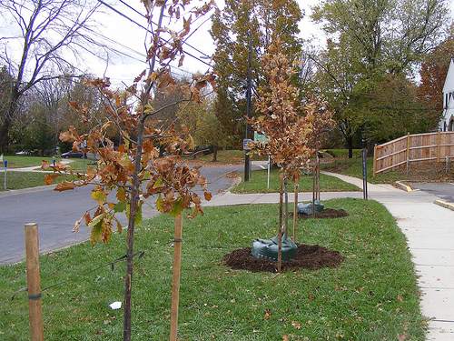

As places are limited please RSVP to
carol.mclucas@btinternet.com if you would like to attend.
Attendance is free

