Latest news from the Kori Development Project in Sierra Leone.
The Bob Simson Secondary school is now complete! We had to make it bigger because so many children want to enrol!

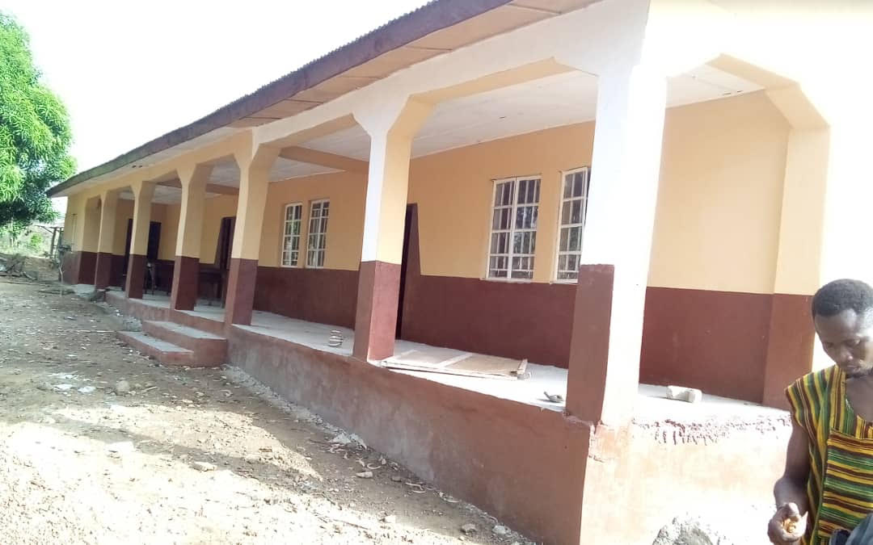

The solar panels and batteries are ready to be installed when school year starts in September. We are storing them in the library.

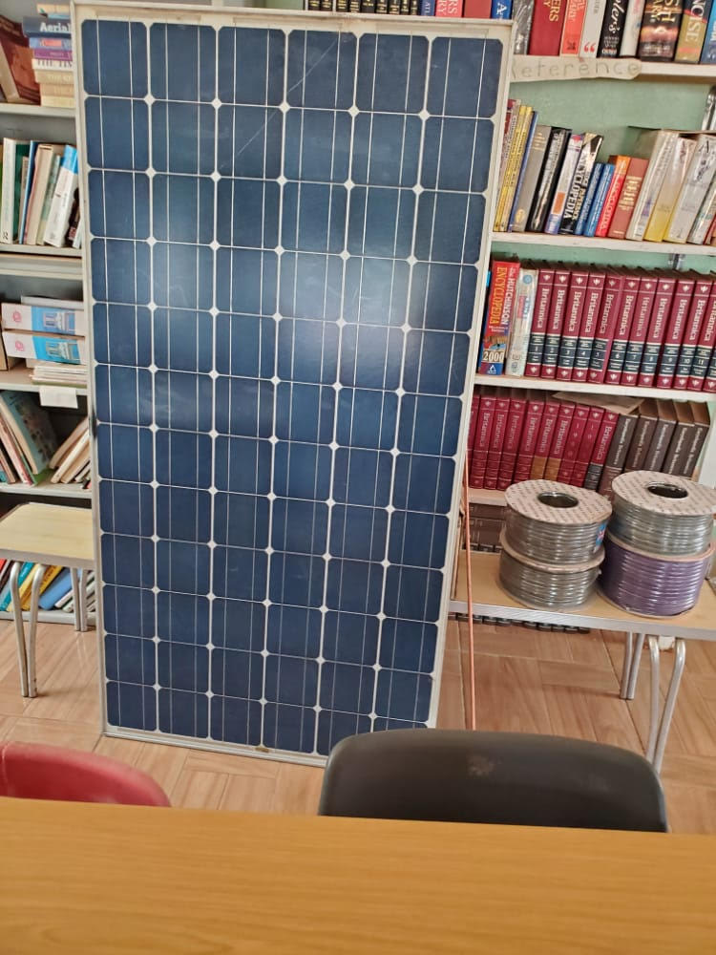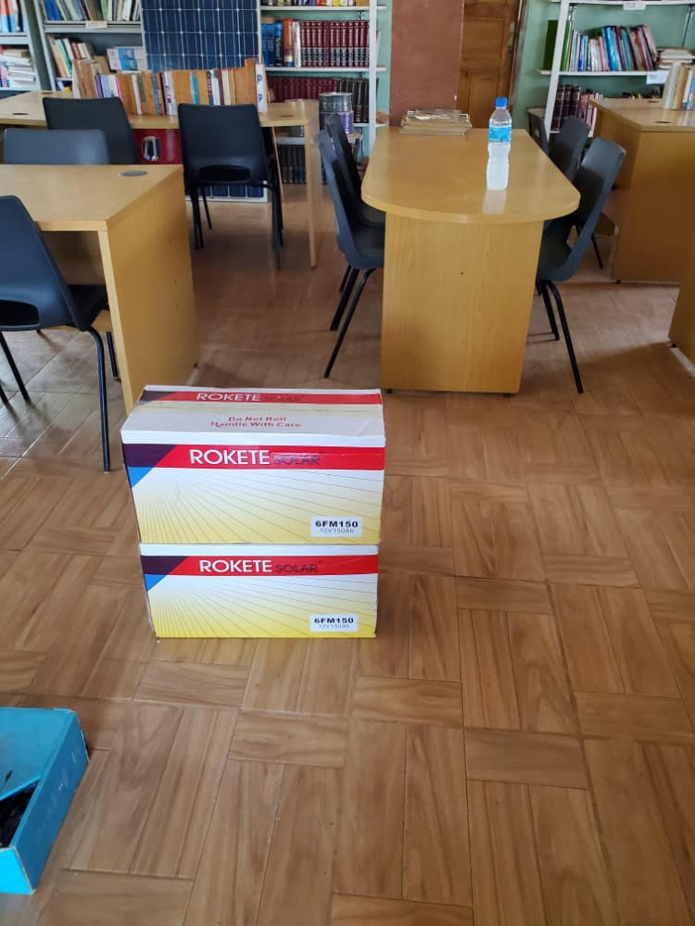

New pupils are queuing up to enrol at the school and bursaries have been awarded to two girls for their exceptional results so far. More bursaries would be very welcome. They really make a difference in keeping girls in school.
If you would like to know how to award a bursary, get in touch with us via the form on the Contact page of the website: www.koridp.org

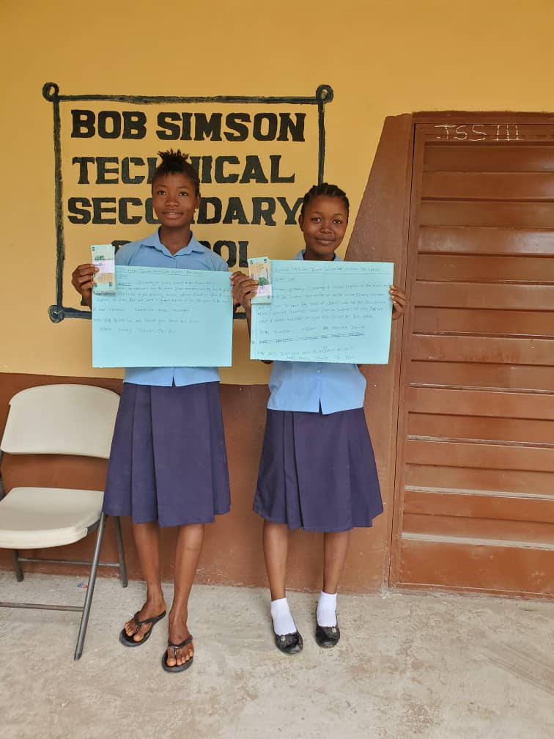

The Gill Curry Primary School is in the process of having new teachers’ accommodation built. This is in a very rural area and we need to be able to recruit and retain good teachers, so we have added on sturdy but simple living quarters.No photos of the accommodation yet, but they will be available on the website when construction and painting is finished.

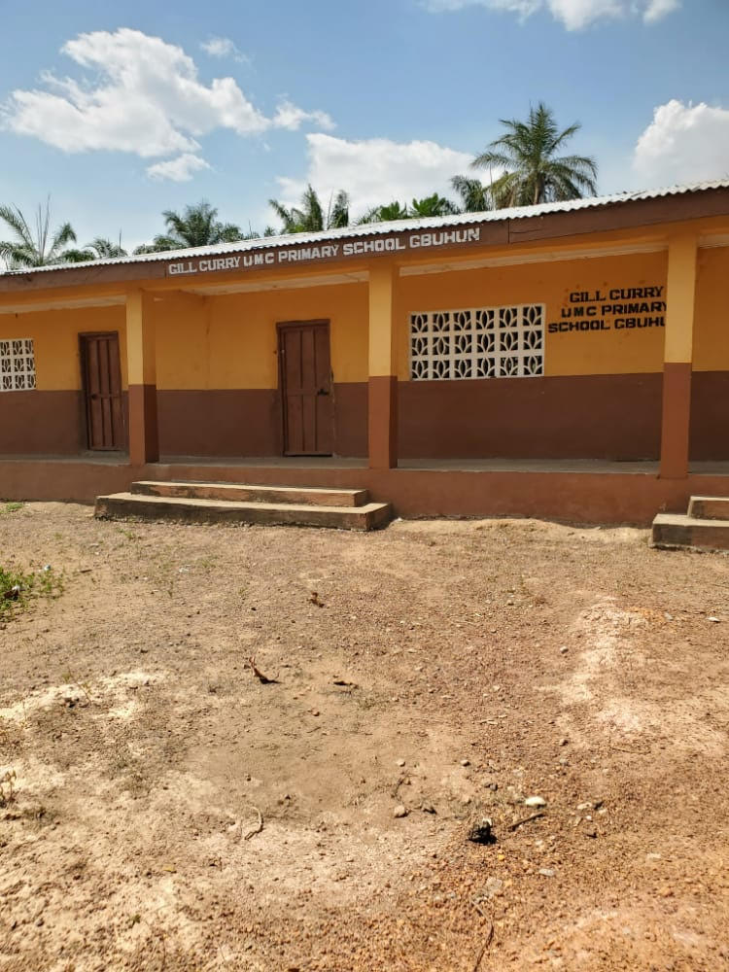

The Ann Hay Vocational Education Centre is celebrating its first set of graduating students. These students were from the cohort who missed so much school because of Ebola and having learned useful skills in sewing, weaving, and printing, they have now won the contract to provide uniforms for local schools.

The new display area outside the Centre, kindly donated by Midland Arden Region Soroptimists, has been a huge success because it gives a bright open space which has a roof to keep out rain and too much sunshine. It is right in the middle of Taiama and so attracts lots of attention – and buyers!

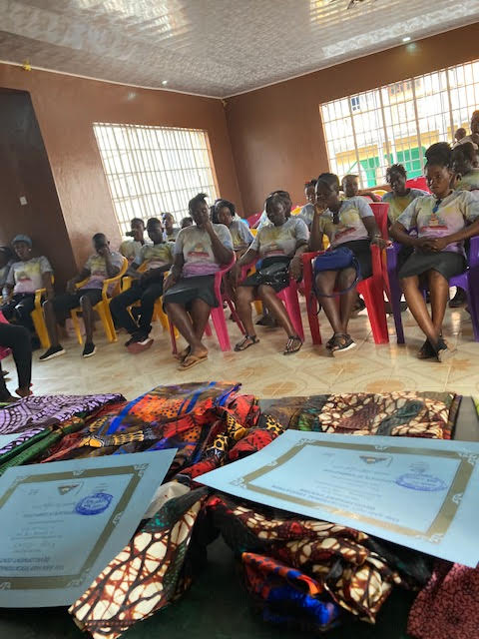

JOHANNA RAFFAN MEMORIAL ORCHARD

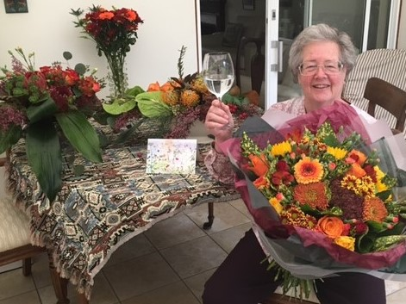

Johanna Raffan celebrating her appointment as President of Soroptimist International with members of her club Soroptimist International Thames Valley.
Soroptimists were saddened by the sudden death of Johanna Raffan, founder member of SI Thames Valley club and President of Soroptimist International of Great Britain and Ireland.
She was also the first Chair of Kori Development Project Ltd. This led to the proposal to plant a Memorial Orchard in Kori District and villagers there have kindly donated the land for this project.
Soroptimists everywhere have been celebrating their 100 year anniversary by planting trees and many also kindly donated money towards creating this Orchard, for which we are very grateful.
The land has been cleared by local people and many fruit trees planted – mangoes, sugar plums, guava, avocados and pineapples.
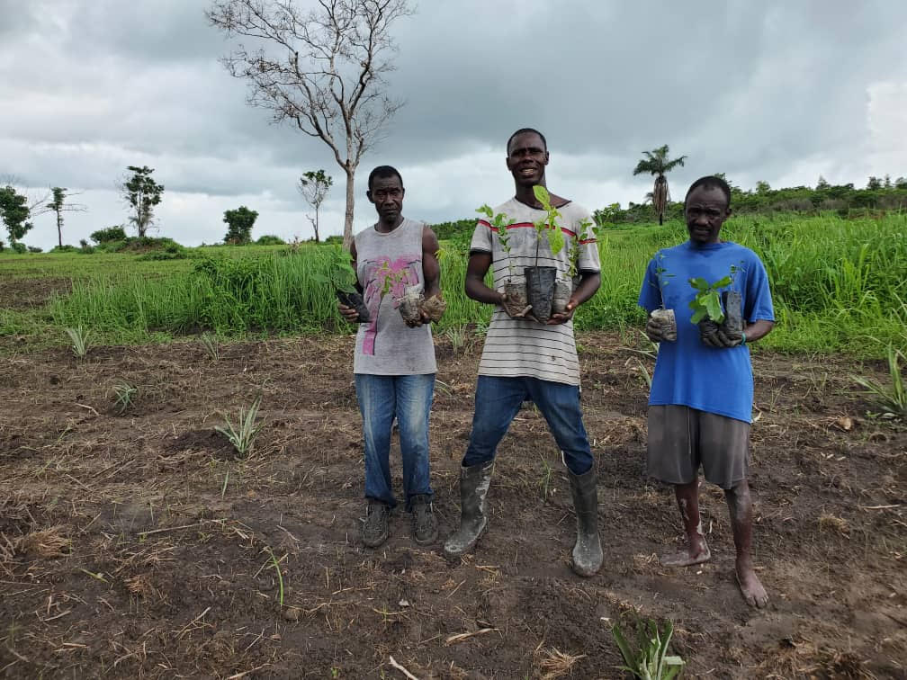
Would you like to donate to the Memorial Orchard or perhaps towards a bursary for one of the pupils at the Bob Simson Technical School? . We’d love to hear from you – just go to the website www.koridp.org and the contact page where you will find all the details.
You can also “unsubscribe” to the newsletter there, or by emailing us back.

