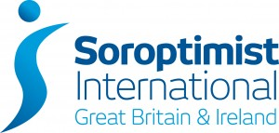
Midland Arden Regional Meeting
Saturday 10 September 2022
9.30am for 10.00am start
The Holiday Inn Kenilworth CV8 1ED

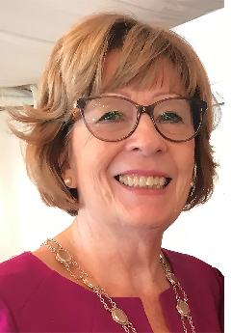
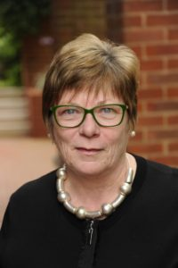
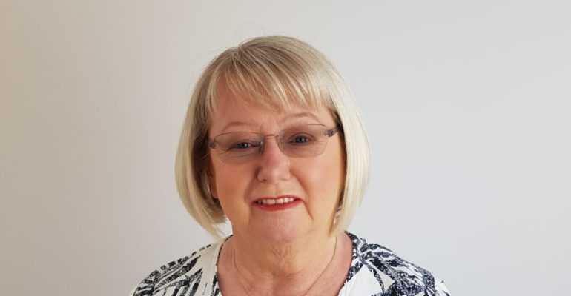

Keynote speakers:
Cathy Cottridge - President Soroptimist International Great Britain and Ireland
Maureen Maguire - President of Soroptimist International
Anne Garvie – Chair of the Board of Directors No. 63

Programme Action Awards – This years theme – ‘Partnerships’
All clubs in the region will present their work and compete for an award

Annual General meeting and Election of Regional Officers 2022-2023

Two course buffet lunch for £25 per member.
Bookings are needed by: 26 August 2022
Please return the Booking form to our treasurer - Andrea

Opportunities for a spot of shopping too!
Craft stalls in aid of the Kori Project and the Kerala Partnership already booked
Sales tables cost £10, please book with Andrea

Looking forward to seeing you all again.
Anne Rogers

President – SI Midland Arden Region
www.sigbi.org/Belfast2022

