

MIDLAND ARDEN REGION MEETING
SATURDAY 27th SEPTEMBER 2025

Old Sillhillians Sports Club & Conference Centre
Warwick Road, Copt Heath, Solihull, B93 9LW
9.30am arrival for 10.00am start

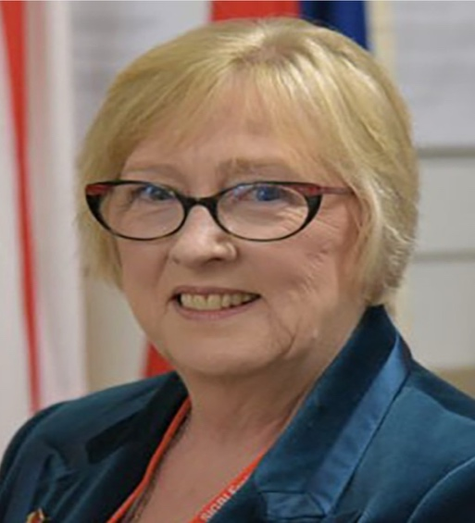
SPEAKER
Ruth Healey SIGBI President
Followed by
Best Practice Programme Action Awards
-All Clubs-

COST £15.00 for Members and Visitors,

RAFFLE
In Aid of The Diamond Education Fund
(SIGBI Federation)

SALES TABLES AVAILABLE @£10.00 EACH

Booking forms and sales tables requests to be sent to Anita Hornbrook,
Please see details on the Booking Form

Looking forward to seeing you and hearing your PA Projects!

