A Very Warm Return to Ngwino Nawe Special School
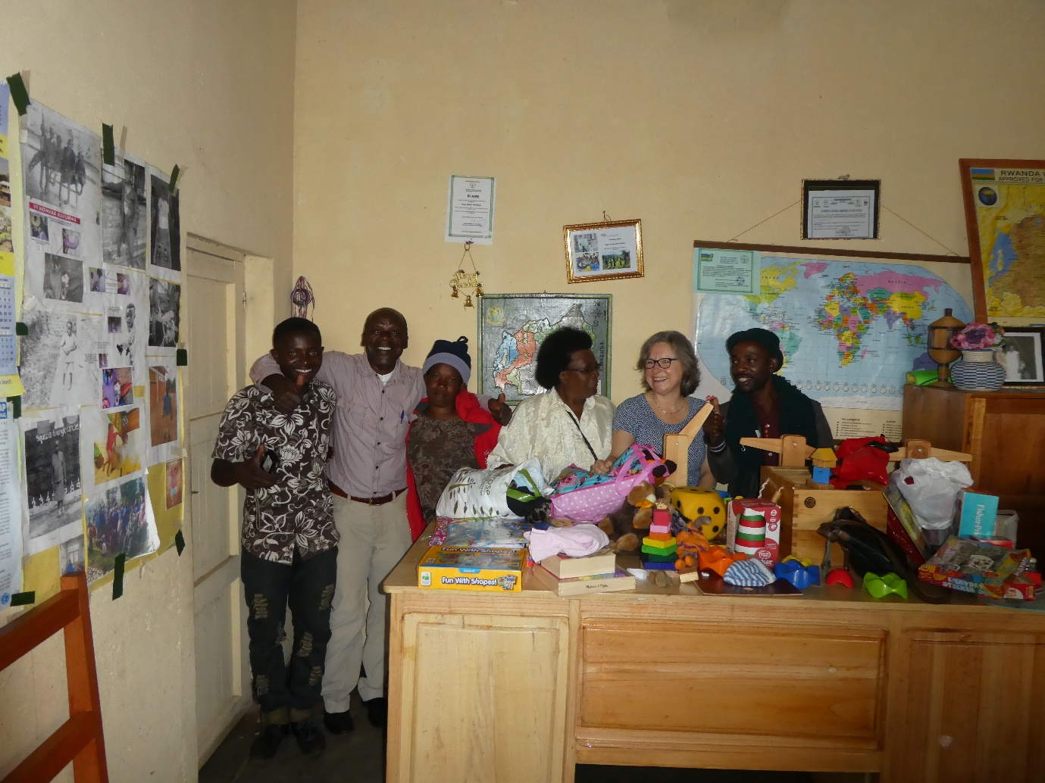

Dear Soroptimists of Milford Haven,
Happy New Year and big messages of thanks to all of you who continue to support this lovely school in the far western reaches of Rwanda.
My partner Dave and I arrived here on our second day of our trip, loaded with the two suitcases of contributions as well as the additional items bought and collected from my friend’s business in Kigali. The latter included, a new set of children’s books written in Kinyarwanda, a large box of wooden building blocks, three balances, cloth memory games and book cases, and a jenga set. On top of this, I had spent a little money buying playground chalk and classroom mirrors to support the speech therapy programmes.
We spent the whole morning unpacking and exchanging ideas as to how each item could be used to enhance different aspects of the curriculum. I must say, the biggest gasp that went up, was for the plastic bibs!! I knew that would happen as the poor children who drool can get so terribly wet and then sick, so this very every day item is just perfect and so more dignified than the various cloths and alternatives we had so far tried.
On our tour round the classrooms, we were shown the new blackboards, lockable cupboards, tables and chairs that now grace each classroom. They are beautifully made by young people with disabilities who work in a sister organisation in the neighbouring district, so they have also been very pleased to receive so many commissions.
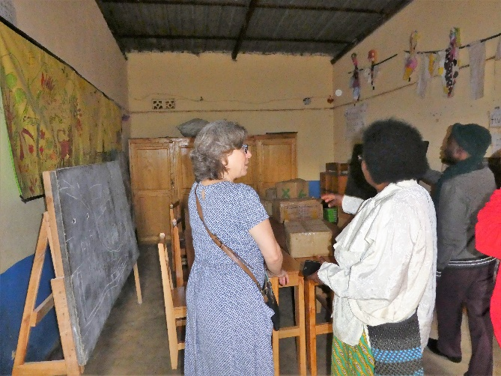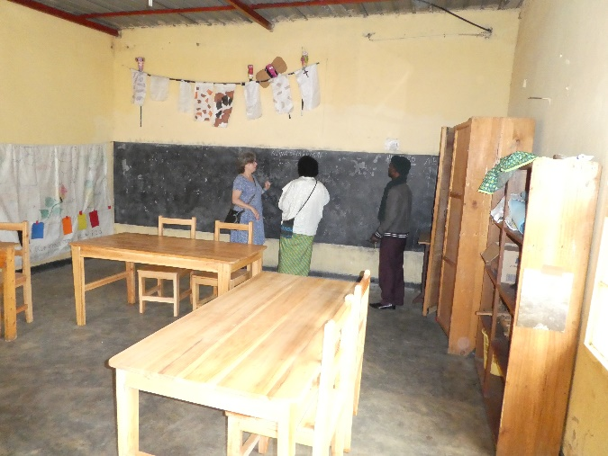
Sadly, there were no children at the school on this visit as, of course, it was their Christmas holiday as well.
Finally, Therese took us on a tour of the dormitories, where the old, small classroom tables and chairs are now used by the children who attend the local mainstream school to do their homework. Most of these children have hearing impairments and are supported by sign language interpreters. As a result of this support, many do very well in primary school and for the first time this year, Ngwino Nawe have three deaf pupils who now attend a specialist secondary school. This is very exciting and thanks to Rwanda Aid, they have got sponsorship and funding to continue their studies.

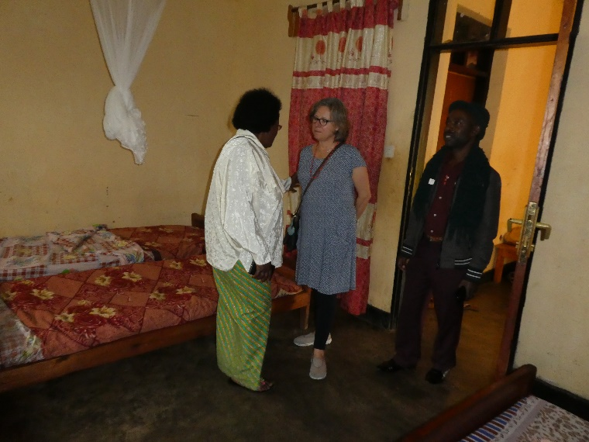
I hope my mother will be able to give you a small gift each from the children of Ngwino Nawe. Every Thursday afternoon, children spend time together making beads to sell to visitors, so I hope you like them.
So, finally with £700 raised, you have basically refurnished each classroom, given storage to ensure that resources can be taken care of, and provided resources to make lessons more active, more interesting and more fun. This has a very motivating impact, not only on the children, but also on the lovely staff who get such a thrill that you have been following their progress and that you care…….
I just have a surplus cheque of £98 to give to Rwanda Aid and I am sure that this will be put to good use at the beginning of the next term.
A very big thank you to you all! Joanna Doyne (Ex Rwanda Aid/VSO volunteer)

