Information about SI Belfast

Highlights from 2015-16
The Belfast Club enjoyed a wonderful calendar of events under the presidency of Elaine Molyneaux. We were especially delighted and proud to support our club member Alice Chapman OBE when she became Northern Ireland Regional President. Alice came in as President at the Federation Conference in Glasgow (November 2015) and was supported at conference by club members: Elaine, Joan and Yvonne. Here are just a few highlights:

North/South Joint Conference 2015 – Belfast
All NI Soroptimist Groups will agree that the North/South conference, which was held in Belfast’s Europa Hotel in May 2015, was a great highlight of the year. The Belfast club attended the conference and some members supported the conference committee by taking on conference duties at check-in etc. This was a very enjoyable event.

Fundraising Evenings on behalf of Alzheimer’s Society: Crabtree and Evelyn, Belfast– December 2015
Our member Emily Wilson organised an extremely successful fundraising event at Crabtree and Evelyn, Belfast. All those who supported the event, including Soroptimists from a wide range of clubs had a very enjoyable evening and the event raised a substantial sum for the Alzheimer’s Society.

Film Night at the Tudor Cinema, Comber
This was an excellent fundraising event for the Alzheimer’s Society. The film ‘The Second Best Marigold Hotel’ was very entertaining and the club raised £700 at this event. Seonaid Murray, who provides music therapy for people with Alzheimer’s, attended the event and spoke briefly about this good cause.

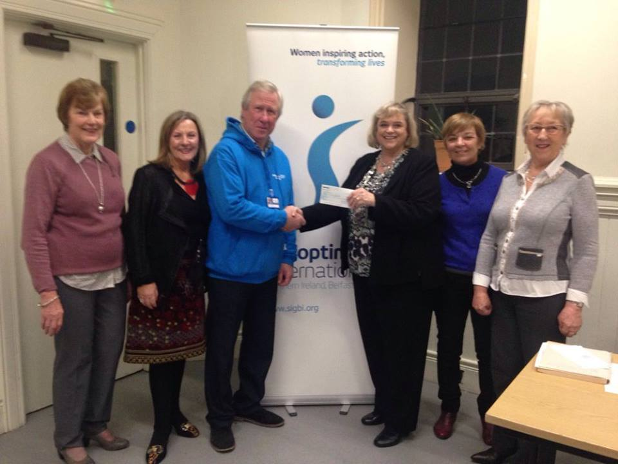

Presentation of Cheque to Alzheimer’s Society

Soroptimist Public Speaking Competition– Belfast Club
The Belfast Public Speaking Competition was held in the NI Civil Service Pavilion at Stormont in November 2015. This was a well-supported event with twenty girls competing. The winner was Caoimhe Quinn, who represented Aquinas Diocesan Grammar School, Belfast. Overall the standard of the public speaking was exceptionally high and the organiser, Yvonne Molyneaux, was pleased to see many club members support the event.

Soroptimist Public Speaking Final in Hillsborough – January 2016
Congratulations to the NI Regional winner Caoimhe Quinn. The event was hosted by Elaine Molyneaux, the Regional Public Speaking convenor. She was supported by the Regional President Alice Chapman and members of the club. We were honoured to be joined by Andrea Begley (Winner of The Voice UK, 2013), who presented the awards.
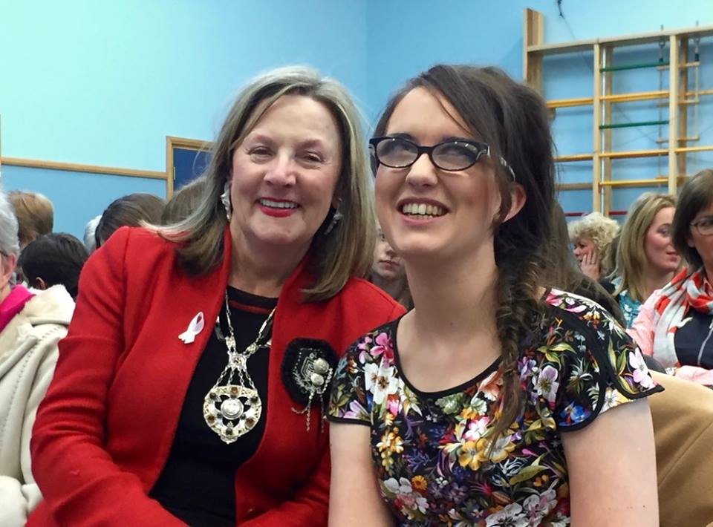
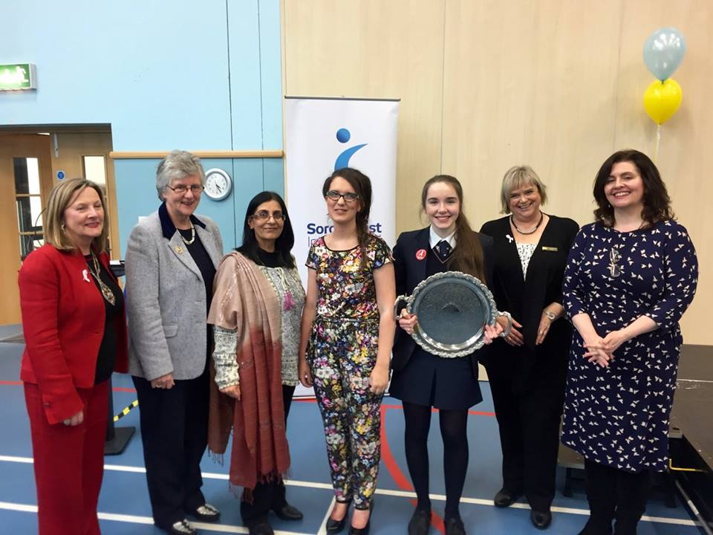

President Alice and Caoimhe Quinn President Alice and Andrea Begley

International Women’s Day – March 2016
Belfast Soroptimists were represented at the unveiling of the Women's Window at Belfast City Hall as part of the International Women’s Day activities.
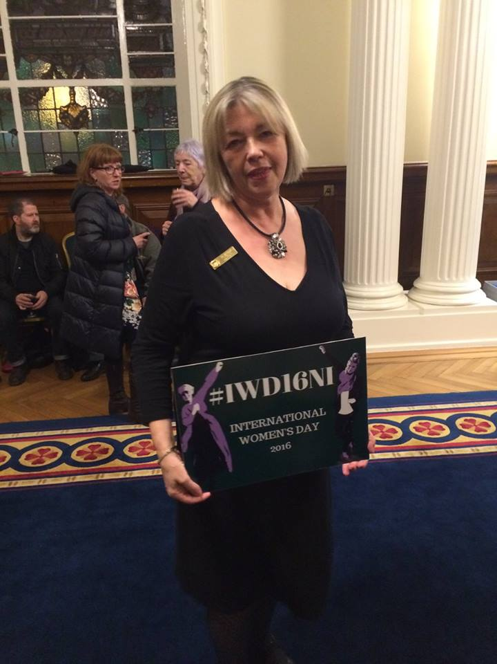
Yvonne Molyneaux representing Belfast Soroptimists at the unveiling of the Women's Window at Belfast City Hall - March 2016.

Belfast Soroptimists Support ‘FAIRTRADE’ Produce
Club member Frances Fulton attended the ‘All Party Group on FAIRTRADE’ at Stormont in Februaryand Elaine Molyneaux attended a FAIRTRADE Event with Bangor Chamber of Commerce in March 2016.

Our Charity Work
- The Belfast club made a donation to the project ‘Mums for Mums’.
- We helped the charity ‘Flourish NI’ with bag packing in Tesco to raise funds to help them support and provide homes for people who have been rescued from human trafficking.
To learn more about Flourish NI, click on their Facebook page;
https://www.facebook.com/flourishni/?ref=br_rs

The club has an ongoing project to provide school exercise books, pencils, pens etc for the Ndirande Primary School in Malawi.

