Home Club Programme What we do Locally What we do Internationally Friendships

FRIENDSHIP
As a Soroptimist you become part of a global network linked together through friendship. withSoroptimists in 127 countries some 87000 women ‘ A Global Voice for Women’
The Bangor club have close friendship with Soroptimists in.

Barnstaple-----Calcutta------Cork----Glasgow----Limbe----St Petersburg

Soroptimists have the opportunity to;
- To attend conferences where you meet Soroptimists from around the world
- To visit any club in the world
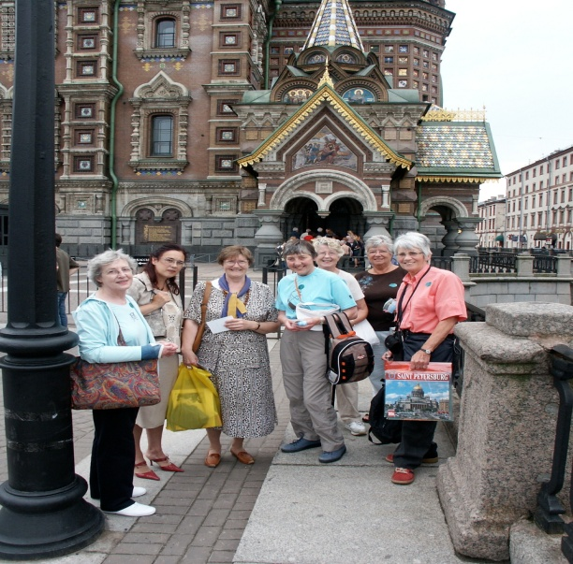
- To correspond on a regular basis

Bangor Soroptimsts meet with
our St Petersburg friends.

