Home Club Programme What we do Locally What we do Internationally Friendships
As an International organisation we support women and girls throughout the world
Our focus
EDUCATE EMPOWER ENABLE
SOLAR COOKING WATER AID
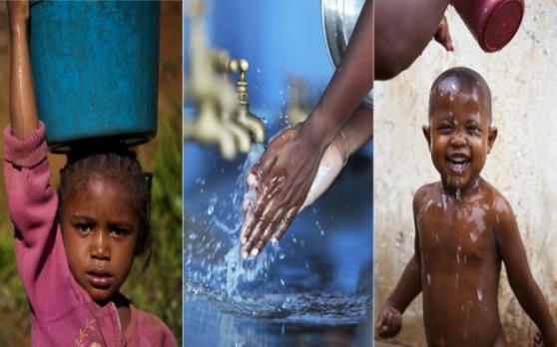
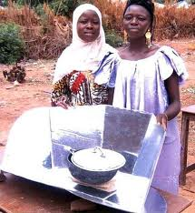

www.wateraid.org/uk
www.google.co.uk/solar+cookers+in+africa
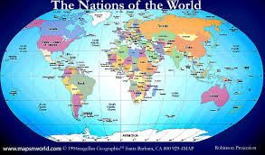

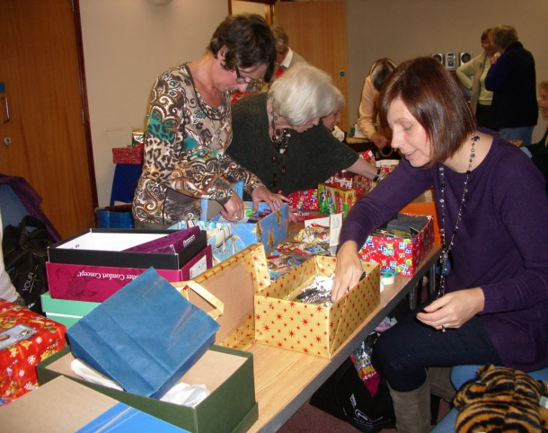
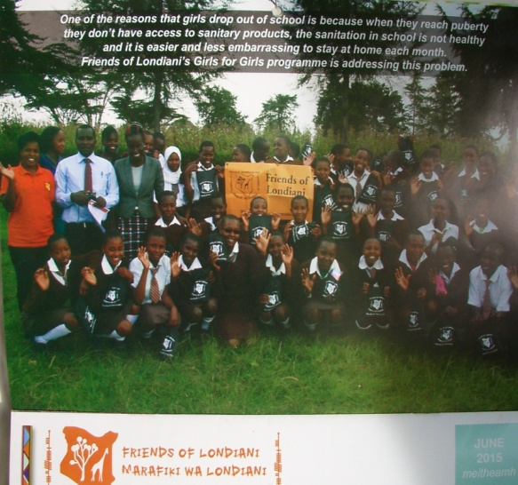
Girls for Girls project Operation Christmas Child

www.friendsoflondiani.com

