Home Club Programme What we do Locally What we do Internationally Friendships
Here are our local Soroptimists projects
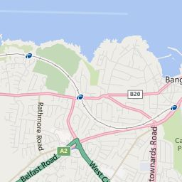

TALKING NEWS
PUBLIC SPEAKING STOREHOUSE

GIRL GUIDING
AWARENESS RAISING ON
HUMAN TRAFFICKNG

PUBLIC SPEAKING
Each year we hold a competition for girls from the local schools, the winner then competes in the Soroptimist Northern Ireland Regional finals.
Talking news:
Each week we read andrecord items from the local newspaper these recordings are then sent out on disc to over one hundred visually impaired people in the North Down area.
Storehouse:
Some members help out at the Storehouse North Down. And on a regular basis we all contribute food items for the store.
Girl Guiding:
We help at the annual Lorne walk and assist Girl Guiding when asked.
Human trafficking:
Weraise public awareness on this issue.

