The club was chartered on the 24TH March 1995

Club Presidents
1995-1996 Roisin Alexander
1996-1997 Kathleen Mc Kenny
1997-1998 Myrea Graffin
1998-1999 Nuala Mc Aleenan
1995-2000 Deirdre Brady
2000-2001 Ann Hinds
2001-2002 Heather Steele
2002-2003 Heather Nelson
2003-2004 Myrea Graffin
2004-2005 Kathleen Mc Kenny
2005-2006 Moira Mc Kenna
2006-2007 Marion Lewis
2007-2009 Pauline Morgan
2009-2011 Miriam Hamilton
2011-2012 Bridie Mc Keating
2012-2014 Maria Duggan
2014-2015 Anne King
2015-2016 Margaret Read
2016-2018 Catherine Milhench

SI Downpatrick and District Chain of Office

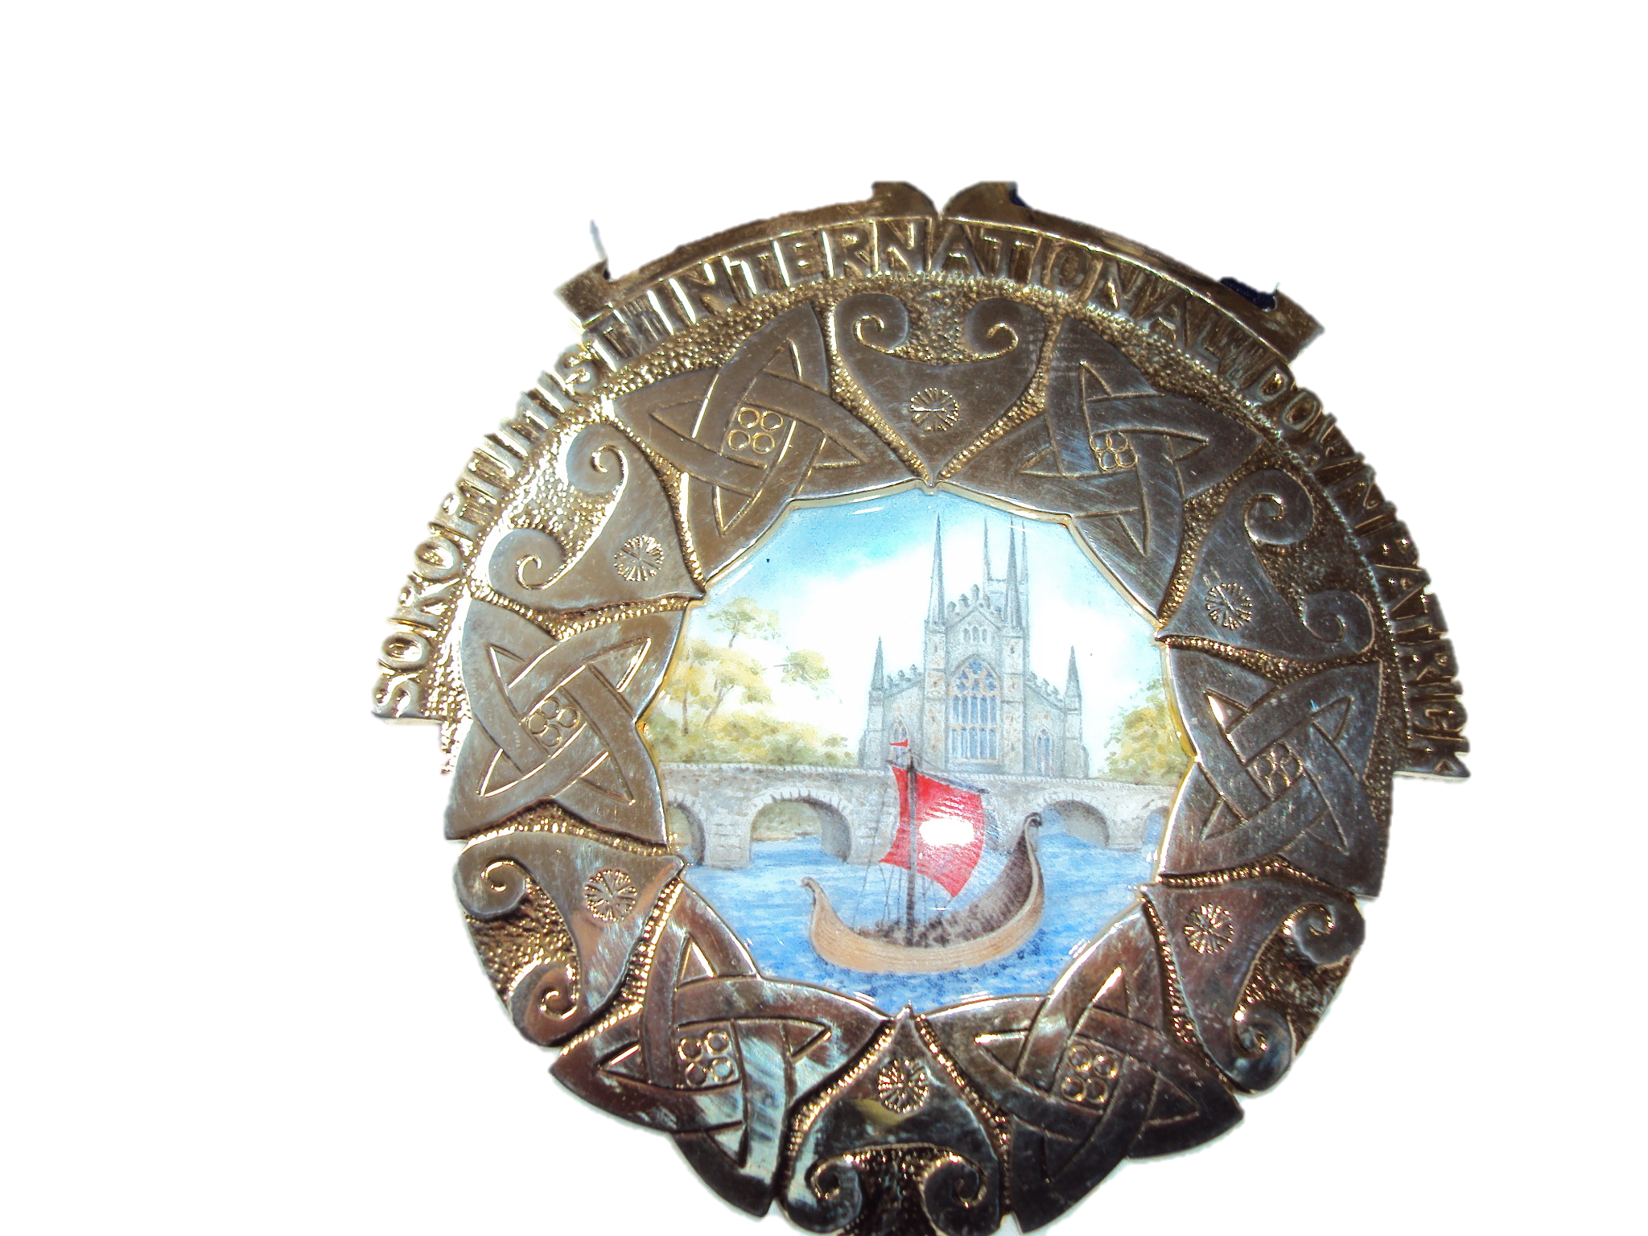

Designed and made by Bernadette Breen in 1995.We were fortunate in having Bernadette , a talented and gifted artist as a founder member.

The Northern Ireland Region Friendship Quilt marking the
Sincerity of Friendship in the year 2000
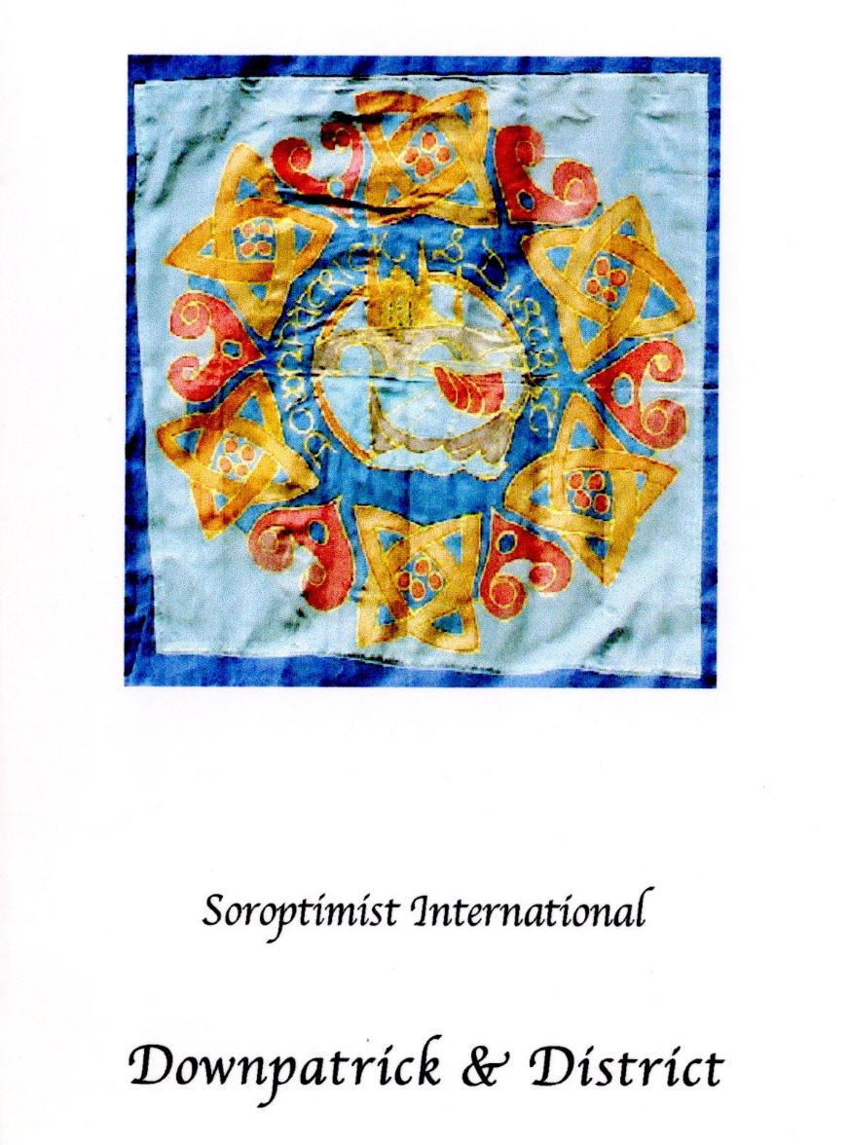

Our square was designed and worked in silk paints
by club member Bernadette Breen.
Bernadette drew her inspiration for the square from
the local environment-The lovely Quoile River and Bridge,
Downpatrick Cathedral and the local history of the Viking invasion.

