Programme Action Update January 2018

Now that Christmas is over and the decorations put away, we look forward to the new year programme.

During the break, Maureen, Frances and I have delivered bulbs and other garden materials to We R Here's base in Arnold. They were delighted and some of us might look forward to giving a few days of service to brighten up the garden, once the better weather arrives. Thank you to all who contributed.

You will know by now that the Purple Teardrop bra project has closed. It has been replaced by a call for gently used (once-loved?) ties. Purple Teardrop are working in partnership with the Purple Community Fund who teach disadvantaged people in the Philippines, Tanzania and other countries how to make upcycled handbags and other accessories out of ties. Please bring ties to Club and I will pack them up and send off (an easier job than packing bras).
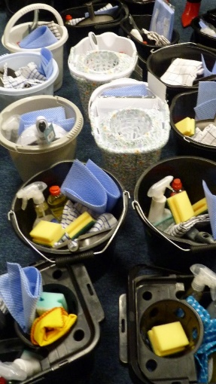
Thank you for your contributions to the Moving-On Packs. 36 buckets were assembled. These will be delivered within the next week.

Our next fundraising evening is the Silent Auction on 19th February. Please bring items which you do not want/need and which others might buy. Goods and services please.

At our last meeting, we discussed again the possibility of having a day out with a group/family of refugees. A number of ideas were put forward and I will make up a plan before the next meeting. Please do let me have your suggestions for any aspect of this.

You may remember the awareness-raising work that was done throughout SIGBI about trafficking and modern-day slavery. We asked people to complete questionnaires, both face-to-face and on line. The results are now all in and are being collated for presentation at UKPAC Study Day in July.

Thank you for all your help.
Barbara

Report from Region

Next Region Meeting is Saturday 24th March at the Link Hotel Loughborough.
Don’t miss the opportunity to hear Steve Arthur and Rev Rosemary Solomon talk about Water Aid.
Names and £20 per person to me no later than March 5th.

Perdita

Concert Update
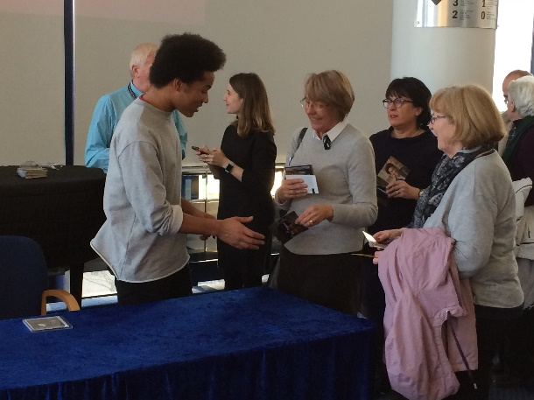
Plans are progressing well for our Charity concert and we have had our first success with sponsorship from Nelsons Solicitors. If you have other suggestions of potential sponsors, please let us know. Contracts have been done with St Mary’s and Clements pianos and Frances is ‘sorting’ St John to keep us all safe and well on the night. The flyers, posters and tickets have been designed
A fan getting her CD signed!
and are being printed. Thanks to everyone for their ideas on where posters and flyers can be placed. We will be getting these out to you for distribution which you are asked to do in mid to late March.
Ann, Audrey, Viv and Margaret O.
Social Events

- Charter Meal. Booked for 19th March, Beeston Fields Golf Club. The menu and order form are attached to the email. Menu choices and money to Sue Goodley by 19 February.
- Pub Quiz. Put the date 19 April 2018 in your diary now. We will be having a Pub Quiz night at the Wollaton in Nottingham. It is a night that has been thoroughly enjoyed in previous years and has the advantage of raising money from non- Soroptimists for our Charities, as well as publicity for ourselves.
- Kettering Charter Dinner. Attached to the email is an invite to Kettering’s Charter Dinner on 14 April. Menu choices and money to be returned by 19 March.

Membership News

From Claire Bell in Lewes, Sussex

She wishes us all the best for 2018, and will see us in September, when she comes for
the concert.

Birthdays
February Beth Tate 5th

We all wish Beth a VERY HAPPY BIRTHDAY!

Forthcoming ~Dates for your diary
Monday 5 February Discussion of 2018/19 subscription and Club Development
Monday 19 February Silent Auction
Monday 5th March Clare Copping will give a ‘My Job’ talk
Monday 19 March 82nd Charter Meal, Beeston Fields Golf Club.
Saturday 24th March 2018 Region Meeting. The Topic will be Water Aid and the Speakers Steve Arthur (known to many already) and Rev. Rosemary Solomon whose life was changed after visiting a Water Aid project.
Thursday 19 April Pub Quiz at The Wollaton
Friday 14 September Kanneh Mason Concert

And Finally.

What the heck – another fan!

Audrey

