Programme Report Form Template
Please use this form to pre-plan your Programme Reports before putting them on the SIGBI Programme Database. When completed you can copy and paste the information from Step 2 of this form directly into the online form.
Hints and Tips are given for each field at the end of this form so that you refer to them if necessary or delete them if you do not need them.
This form is divided into the same five Steps as you will find on the online form. Required fields are marked with an asterisk, as they are on the online form.
Step 1 – Project Information
- Scope*
Club Project
Region
National Association
Network
Federation

Please check the following box if you are inputting this report on behalf of a Region/National Association/Country

Note: this box allows you to specify that it is a Region/NA/Country Report, and the Club Name will be removed from your details. Only tick this box if you are completing the form on behalf of a Region/National Association/Country, NOT if you are completing it on behalf of a Club that is participating in a Region/NA/Country project.

2, 3, 4, 5 – These fields are all pre-populated (Name, Club, Region/NA/Country, Email) (If you have ticked the Region box as shown above, the Club Name will not be displayed).

6. Project Title*
#PlantTrees -

7. Start Date
Enter the date your Project started: …/…/….

8. End Date (if applicable)
Enter the date your Project ended: .../.../….
9. Country in which the project took place

10. Did you have an outside Organisation as a partner on this Project?
Only identify organisations you worked actively with on this project, not ones to which you made a donation. Please enter the name of the Organisation below.

11. Did you work with a Friendship Link on this Project?
Please select the Friendship Link that you worked with from the list below.

Step 2 – The Story of your Project . . .
Your project should demonstrate how the lives of women and girls have been improved through education, empowerment and enabling opportunities. Use these words where possible in the write up below. Overwrite the words already in the boxes:

12. Please enter a concise summary of your project below, so that it could be used in publicity material.*
Type a summary of your report. This should give all the salient information about the project – the Charity helped, what that charity does, how the lives of women and girls were improved by this project and if applicable how much was raised and what the funds raised would finance. The information provided should be able to be extracted in its entirety and used, for example, in Soroptimist News.
500 characters (approx. 80 words)

13. Why did your Club/Region/NA/Network choose this project? What issue did you tackle with this project?*
What was the reason that your Club chose this Project? It may be that it is an issue close to your Club President’s heart, or you may have had a speaker on the subject and decided to support it for that reason.
700 characters (approx. 120 words)

14. What did the project involve?*
What did your Club actually do in support of this project? What event(s) did you hold to raise funds? Did the project involve hands on service such as packing toilet bags for your local refuge or volunteering at the local food bank?
700 characters (approx. 120 words)

15. What was the result of this project?*
How were the lives of women and girls improved as a result of this Project?
700 characters (approx. 120 words)
Step 3 – Programme Focus

16. Please select the Programme Focus which best describes what your project was above and then click "Add Options".*:
People
Prosperity
Planet
Peace
Partnerships

Note: If you choose People from the list, then the following will be displayed – each P displays a different list of SDGs for you to select. You can choose more than one P and SDG, but only one can be selected as the “Primary SDG”:

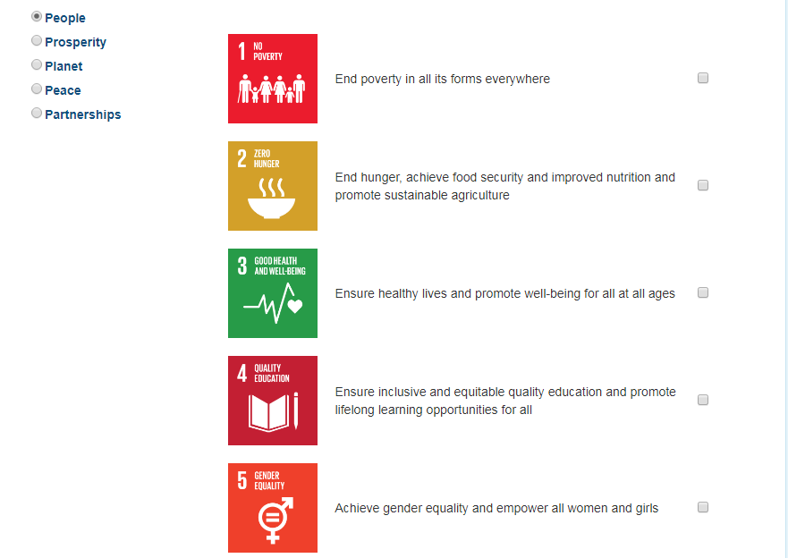

As you select each SDG, it will be added to the table (as shown below). The first SDG selected will be displayed as the Primary SDG, but this can be changed if required, by ticking another SDG in the Primary SDG column. There MUST be a Primary SDG shown before you can move on. You can select SDGs from other Ps as well.

You can also remove an SDG from the list if it was chosen in error. If the SDG that you remove is the Primary SDG then you will not be able to move on until you select a Primary SDG.

17. Please tick which of the 3E's and 3As below apply to your project:
You need to select at least one E and one A from the list, but can selected two or three of each, if appropriate.
Educate - To impart knowledge or skill; |  |  | Awareness - Knowledge of...
Enable - To make possible |  |  | Advocacy - Plead in support of...
Empower - To give power to |  |  | Action - To take active steps...

Step 4 – Project Results

18. Our project’s main targets were:
Women/Girls Children Community

19. How many people benefitted from your project in total?

If you know the actual number of Women and Girls helped enter the number in the box on the right, otherwise tick the “Number not known” box.

Number not Known Exact Number:

20. How much did you raise? Please insert the exact figure.

£

21. Please give a direct quotation from a beneficiary below, if possible
We may use quotations on recruitment leaflets and other publicity items.
Insert a quotation from a beneficiary of your project if you have one.
700 words
22. Is this Project a continuation of a previous Project? Please select any other projects that are linked to this one, from the drop down list of projects previously input by your Club/Region/NA/Network. You can select more than one linked Project:
Linked Projects – we cannot put a drop down list in this Word template, so you may need to wait until completing the online version before completing this field.

Step 5 – Supporting Materials

23. Add Images

You can upload up to 6 JPEGS, up to 5Mb each. You need to add a descriptive name for each picture, then click “Choose File” to browse your computer for the picture. You must click “Save this image to Report” once the file has been selected, or it will not be uploaded.

24. Add a PDF file

If you want to include more words to describe your Project than are allowed in Step 2, or already have a separate report of the Project available, you can upload it to your report.

The report MUST be a PDF file, so if it is in Word convert it to PDF ready to upload to the online report.

You will need to give the report a descriptive title, then click “Choose File” to browse your computer for the report, and finally click “Upload File” to upload the PDF.

25. Add a YouTube Video

You can add a link to a YouTube Video, which will be available from the report on the website.

Finally

Click “Submit” to send your report through to the database. It cannot be searched for online until it has been approved.

You will receive an email to confirm that your report has been successfully submitted, and another when it has been approved.
APPENDIX: Notes for Completing the SIGBI online Programme Report form
Print these notes once for your records and then delete these pages to save paper and ink if you want to print copies of your completed forms before putting on the online Programme Database.

The numbers shown below refer to the field numbers used on the database. Not all fields have notes attached so the numbers below are not necessarily consecutive.

Before you Start
Have any photographs or reports connected with this Project to hand on your computer ready to upload to the report when completing it online.
Step 1 – Project Information
- Scope* - you must select one option from the drop down list provided. If you are unsure which option to choose refer to the hints below:

- Club Project – select this option if the project is a standalone Club project – eg it may be your Club President’s charity for her year, or a local women’s refuge that you support. Even if it is supporting a wider project, eg Water Aid, if your Club has decided to support it and the Region/NA/Network has NOT requested all Clubs to support it, then it is a Club Project.

- Region or National Association - These are listed separately, but if your Region or your National Association has asked your Club to participate in a project along with the other Clubs in your Region or National Association, then choose the relevant option.

If you are a Club that is supporting a Region Project then do not tick the option that you are reporting on behalf of the Region/NA/Country.

Only tick the Region/NA/Country box if you are reporting on behalf of the Region/NA/Country, ie it is a Region/NA/Country Report.

- Federation – If the project your Club is supporting is one of the following then choose this option:

- International President’s Appeal
- Empowering Girls in Nepal
- Diamond Education Grant
- Emergency Relief Fund
- Benevolent Fund

6. Project Title* – Some fields will already have words in them, which describe what information should be put in the field. Project Title is one of these. When you click in the box the words “Give your Project a Title – include the name of the Charity supported if applicable” will disappear. There is no word limit on the title of your Project but try to be succinct. Include the name of the Charity or project being supported in the title.
7. Start Date – You do not need to put a start date for your project, but you may want to record when it started. Choose the date from the calendar provided.
8. End Date – You do not need to put an end date for your project, but if the project is complete you may want to do so. For ongoing projects you should leave this blank. Choose the date from the calendar provided.
9. Country (Location) in which the Project took place - You need to think about the beneficiaries of the project and which country they are in. For example, if you hold a fundraiser in support of Empowering Girls in Nepal, then the country is Nepal.
10. Did you have an outside Organisation as a partner on this Project? You can enter several Organisations in this field. Separate them by a comma. If another Club was your partner but is not a Friendship Link, then put them in this field. Note the instruction that a Partner is an organisation that you worked WITH to complete this project, not an organisation to which you made a donation.

11. Did you work with a Friendship Link on this Project? This question has a drop down box that displays all your friendship link Clubs. However, only one can be selected. If you have a friendship link Club that does not appear on the list, or a Club appears on the list but is no longer a friendship link then please contact SIGBI HQ – sally@sigbi.org – who will amend this.

Step 2 – The Story of your Project

Hint: for the boxes in this section you are limited as to the number of characters you can use. There is a character counter on the online form, but not in the form in this Word document. The limits are 500 characters for the summary field (12) and 700 characters for the other fields. If an average of 6-7 characters per word is estimated, you have approximately 80 words for the summary and 120 words for the other fields. In this Word template, if you highlight all the text in a field, in the blue bar at the bottom left hand side of the screen it will tell you how many words you have used. Double-click on the “80 of 2,000 Words” part of the blue bar, and it will open up a dialogue box showing how many characters you have used.

Step 3 – Programme Focus

There are only two questions on this step.

Firstly (Q16), you need to select which Ps (People, Prosperity, Planet, Peace, Partnerships) fit your project, and which of the SDGs. You can choose as many as required, but only ONE can be allocated as the Primary SDG.

The Primary SDG will be used to identify how many projects have been entered under, for example, People, or SDG1.

The Secondary SDGs will note activity towards the other SDGs, but reports will not count as being entered under these SDGs. This will ensure that we do not count reports twice when reporting on our contribution.

Secondly (Q17), you need to select at least one E and one A (you can select two of each or all three of both if appropriate).

Step 4 – Project Results
When adding exact number of women and girls helped, only put an integer. Do not include text such as “Approx” or “About”.

When adding the funds raised, only put a number. You can use a decimal point, to include pence, but do not add a £ sign. This will be added by the system.

For 22. Linked Projects – When you click the down arrow a list of Projects previously entered by your Club will be displayed. You need to select one from the list AND THEN YOU NEED TO CLICK THE “ADD” BUTTON. The linked project will then be displayed in a separate box, and you can select another project to link if you wish. If you do not click the “Add” button then an error message will be displayed and your report will not be linked.

You can add more than one linked project.

Step 5 – Supporting Materials

23. Add Images and 24. Add Reports – Ensure you have all the images and reports that you want to upload to the report in an easily accessible folder that you know the location of, before starting to complete the report online. Images must be less than 5Mb and reports less than 6Mb in order to be able to upload them, so you may need to resize them first.

However, if your images are already less than 5Mb do not resize them, as the higher the resolution the better if we decide to use them in publications.

You MUST click the “Save Image to the Report” or “Upload File” buttons respectively, or your images/PDFs will not be saved to the report. The reason for this extra step is because you can upload more than one image or report. Once you have clicked “Save Image” or “Upload Report” you will be able to search for another image or report to upload.

