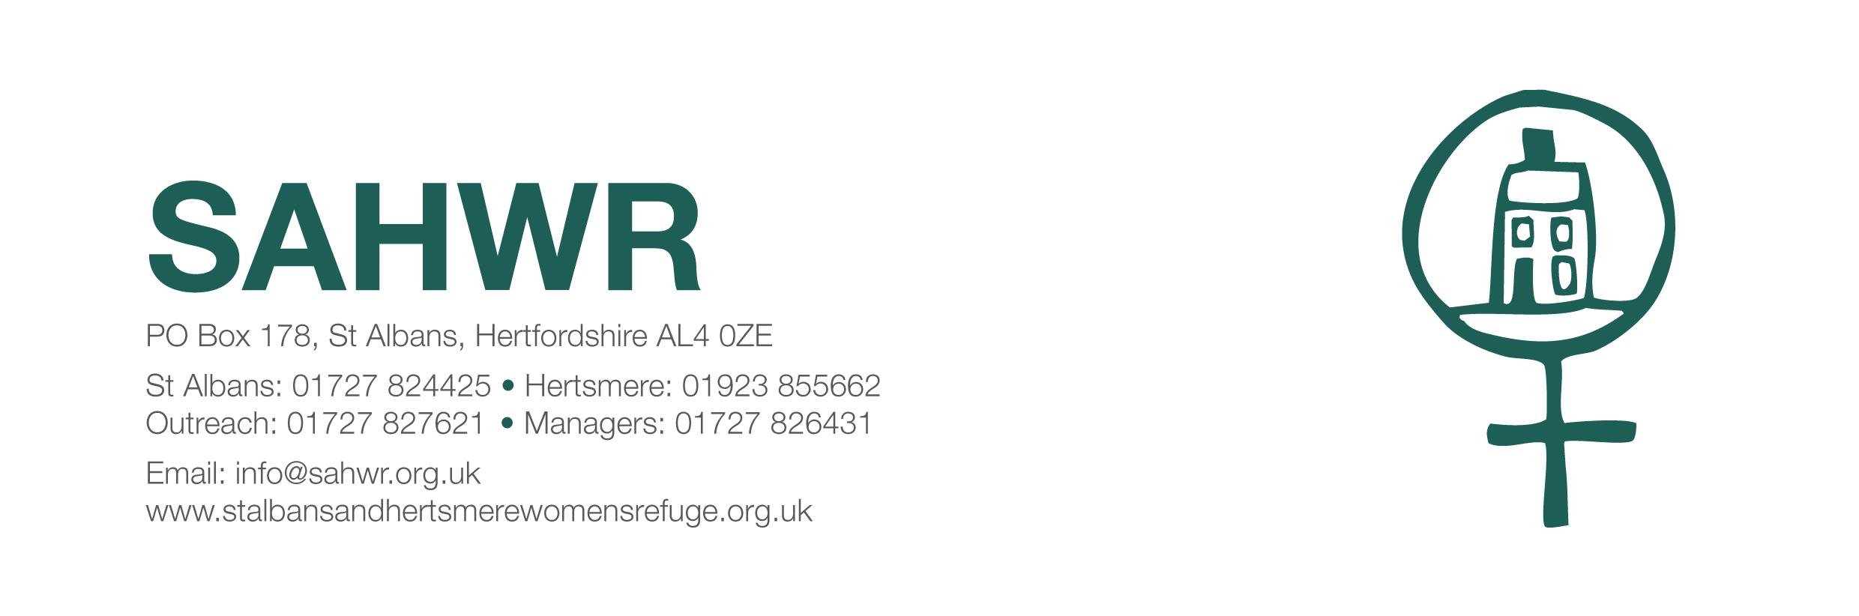

Date

28 January 2019

Dear Jennie,

It was lovely to see you on Monday and as always receive such a warm welcome.
Once again, on behalf of the Management Committee, managers, staff and residents, a very big thank you to the members of Soroptimists International [St Albans], for the most generous cheque of £1,000 towards the work of the refuge.

Please pass on our appreciation to all concerned and tell them that their kindness in continuing to support our project makes an enormous difference to the lives of so many of our residents and their children.

With best wishes to you all for a healthy and happy 2019,

Yours sincerely,

Liz

Liz Perry
Manager
St Albans and Hertsmere Women’s Refuge

