Dr Elise Cartmell
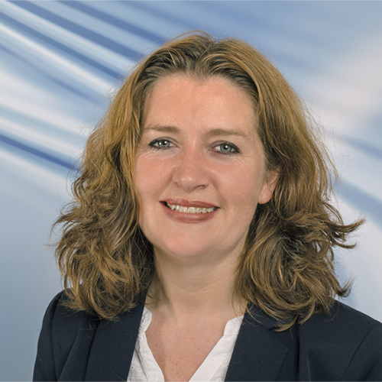
The 100-year anniversary of Women in Engineering and Sciences in the UK was celebrated throughout 2019. Despite the recognised need for diversification in STEM-related roles, statistics show that only 12% of professional engineers, 21% of all academic professors and 20% of the UK water sector’s workforce identify as women. This under-representation of women has resulted in a loss of talent within these sectors, with diversity recognised as being crucial for a more holistic approach in research, especially when providing solutions that aim to serve societies. However, change is on the horizon, and there is a need to continue to raise the profile of ‘women in water’ and encourage women to aspire to exciting careers within academia and industry.
Elise Cartmell is the Chief Scientist at Scottish Water,
responsible for sampling, laboratory and scientific services and for
research and innovation.
Elise joined Scottish Water in April 2016 following a career in academia
at Cranfield University, where she was Professor of Water Technology
and Director of Environmental Technology. Here she specialised in wastewater
treatment with particular reference to trace contaminants and anaerobic processes.
Elise is a chemist with a BSc (Hons) from the University of Edinburgh and
PhD from Imperial College, London. Prior to joining Cranfield in 2000 she
was a research scientist at WRc plc. She is a fellow of the Royal Society
of Edinburgh and Royal Society of Chemistry and is on the Board of UKWIR.
Elise most recently contributed to COP 26, the 2021 conference about climate change and discusses how the Scottish water industry is tackling climate change issues such as water quality, flooding of sewers and shortage of water andhow the industry needs to reduce its use of energy. Currently Scottish Water has nearly halved emissions but is focusing on reducing this by a further 20%. They are also investing in peatbogs which can both trap carbon and improve the quality of water whilst encouraging customers to reduce water usage at home. See Youtube Dr Elise Cartmell

