Message from President Sue
Happy New Year
Welcome back to all those people who signed up to become one of our 80 for our 80th supporters and received a copy of our last newsletter and greetings to all those who signed up later in the year. Thank you for all your feedback on the last edition.

80th Charter Dinner 6th October 2018
Our 80th birthday celebrations are now behind us but the highlight of our year was our Charter Dinner at which we were able to showcase our 80 years of service in the Stockport area.
Among our guests were the Mayor and
Mayoress of Stockport , our Federation and
Regional Presidents, Edwina Currie and Detective Inspector Julia Bowden who proposed the toast to Soroptimist International and talked of our long standing partnership
work with Greater Manchester Police to support victims of rape and domestic violence. On a more light-hearted note our exhibition of photos from our archives reflected on how fashions, including hats, have changed over the years.

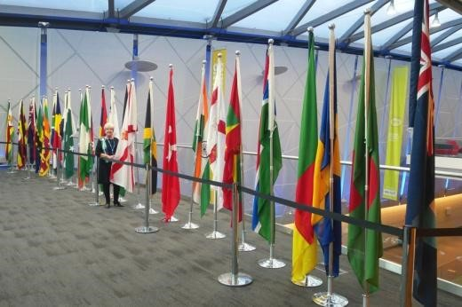
Federation Conference in Liverpool 25-27 October 2018

Our annual Federation Conference brings together members from 28 countries and 350 different clubs. As well as Great
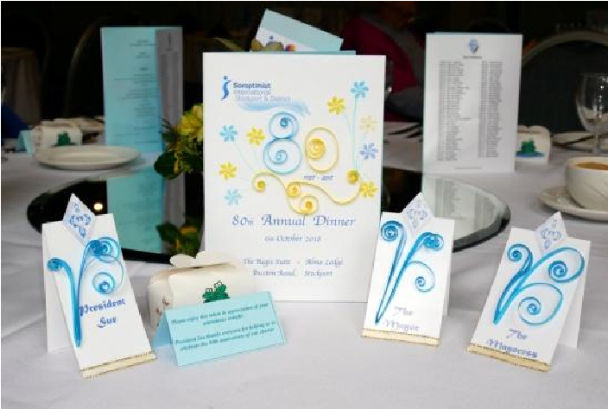
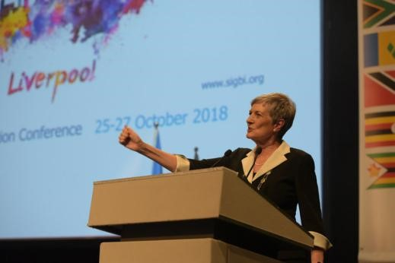
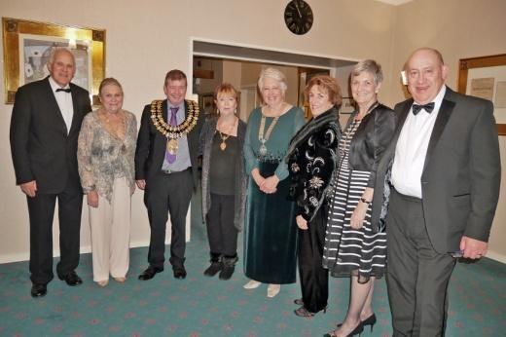
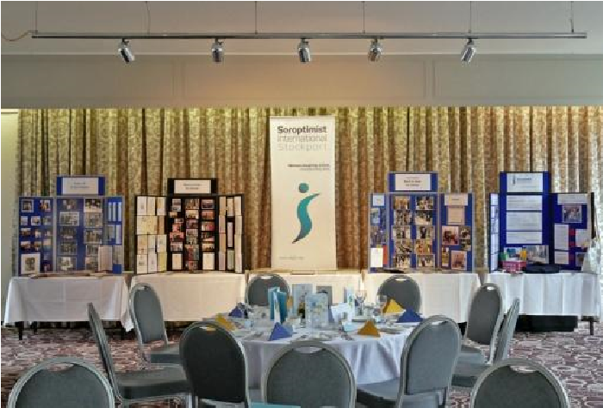
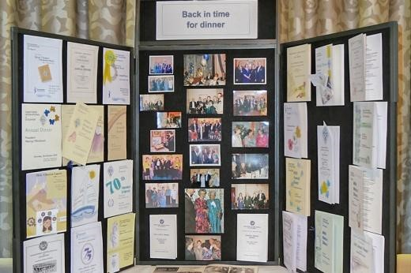
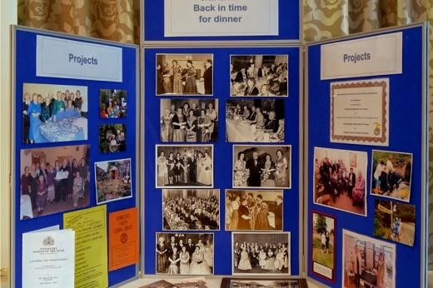
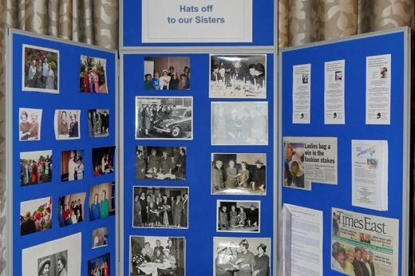
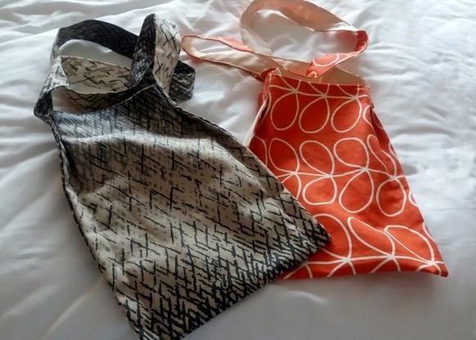
Britain and Ireland there are clubs in Africa Asia the Caribbean and Malta so it is an amazing opportunity not only to hear about a variety of different projects but also to network with other Soroptimists. Conferences mainly rotate around areas in the UK, but occasionally hosted by overseas clubs and in the past twenty years we have been able to travel to Durban , Barbados and Malta This year it was here in the North West. A number of members and partners attended. Inspirational speakers included Terry
Our Charter Dinner had been the last
formal engagement in the outgoing
Federation President’s diary and we
were all very pleased if somewhat
surprised as we watched a slideshow of
highlights of her year in office at the
Change of Insignia ceremony at the
conference to see this slide of our
dinner menus which had been hand
made by Pamela Brown one of our
members.

Stockport and District

80
for 80

Supporters Newsletter

Issue 2

Waite, Helen Pankhurst and Sir Ranulph Fiennes. More details can be found at www.sigbi.org/liverpool2018 . In October 2019 we will be off to Bournemouth.

Update on projects since the last newsletter

Syringe Driver Bags
Production of our syringe driver bags has continued and we have already had to top up supplies with one of the district nursing teams as they are used by palliative care patients. We will be having a day on 21 January devoted to cutting out and pressing material ready for sewing. If any of our readers would like to help with sewing or have friends who sew please let us know. Materials and full instructions can be provided. Each bag takes around 20 minutes for a machinist to complete.

Period Poverty
It astounded us all to learn that school days were being lost in the UK because girls could not afford to buy the products they needed each month so we wanted to do something about it. As we worked on raising awareness of this issue in the UK it began to gather a momentum of its own and readers will be aware from the press that a number of initiatives are already in place to make free supplies available in schools and colleges. The issue has not gone away so we are reassessing how effective the initiatives have been and how we should move forward to be most effective.
Charity Fashion Show
Unfortunately we had to cancel our charity fashion show as low ticket sales meant we could have faced a loss on the event.

A sad end to the year
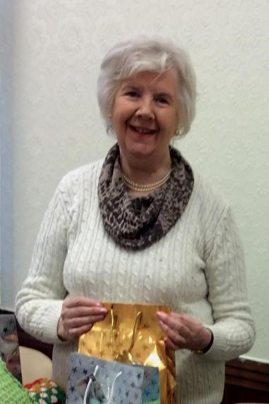
After such a successful year there was a sad end for all of us as one of our longest serving, but not by any means oldest, member lost her battle against cancer in St Ann’s Hospice on 20 December. Pat Danby joined the club in 1975 and had been an active member until just a few months before her death. Video footage of our Charter Dinner was viewed avidly from her hospital bed and a full report of dresses and speakers was requested. Pat was always interested in any way she could find of helping other people and chaired our welfare committee for many years ensuring that any members who were ill were visited and/or looked after. Undoubtedly she will be best remembered for her years of involvement in our work with Stockport Without Abuse where she purchased the items needed for the welcome baskets we supply to women moving into the Refuge and at Wellspring.
80
for 80 Supporters Newsletter

Toilet Twinning

Sanitation is transformational for communities in the developing world.
We have been steadily adding to our list of twinned toilets and following
a number of donations to mark our special birthday we will be able to
fund a toilet block at a cost of £240 in a school in Malawi to prevent
some of the estimated 443million school days lost each year because of
poor sanitation and unsafe water causing illness.

.

Page 2

In recent years a number of Soroptimist Clubs
have been working with the Purple
Community Fund to support their work both
in the UK and overseas. The charity collects
ring pulls from drinks cans ( food cans are not
suitable) and aims to get women into work by
teaching them skills which enable them to
convert the ring pulls into items such as
jewellery and bags which can be sold.

We want to organise local collections and if you would be willing to pass ring pulls
onto us please let us know. Just a few from lots of people will soon start to mount up.

Even in her final weeks Pat always wanted news of what we were doing and how projects were progressing so we must now look forward to 2019. Alongside our ongoing work we aim to introduce new projects as the year progresses

Ring Pull Collection
We hope you have enjoyed this update. If you have any feedback or know anyone else who would like to receive our newsletters please e mail SIStockport80for80@gmail.com
More information about us is available on our club website www.sistockport.co.uk

