A message from President Rose…..

My first few months as President for Midland Arden Region have passed very quickly indeed.

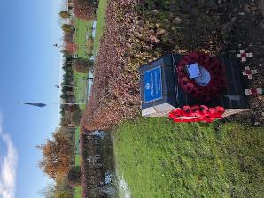
My first duty was to lay a poppy wreath at the National Memorial Arboretum. The service beforehand was very moving and although part of our plot was underwater, we were able to access one of the plinths to attach our memorials.

I joined members of SI Kidderminster for their Floral Art evening raising money for their local Women’s aid group. This was led by one of their members and demonstrated how much talent we have amongst us.

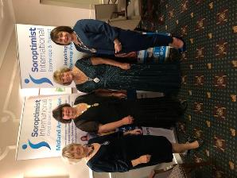
SI Stourbridge held their ever popular Literary Dinner which I attended along with Federation President Isobel and other members of the region. I had heard so many excellent reports about this event but this was my first attendance. It was a lovely evening and lived up to its reputation. I returned to SI Stourbridge for their Christmas meeting.
Thank you all for your kind hospitality it was good to see you all at work.

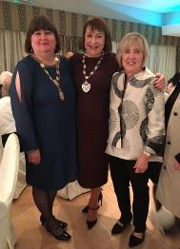

Our Annual Public Speaking Competition on Saturday 21 March is in Stratford this year, and there will be at least 10 candidates, so please do join us for this. Plans are also coming along well for the Change of Insignia tea on Sunday 19 April. Further details will be announced soon.

I am delighted with the progress of our Domestic Violence Courts Observation work which started on 6 January, and I thank all those who are participating. There has been a huge amount of support and interest for this project across our region and I think this is the first piece of work to be shared with another Region.

Many of you will now be aware that Central Birmingham club will be closing at the end of March. This is a moment of great sadness for us all and I am sure you will support the members in any way you can.

Finally, I am looking forward to seeing you all at our next Regional meeting on Saturday 7 March at Wolston Leisure Centre, where we will have Dame Vera Baird QC and Dishi Attwood with us.
A full and informative agenda is planned.

SI CENTRAL BIRMINGHAM

Future of SICB
During 2019, for a range of reasons, SICB, which has a long history stretching back to 1928, began to consider its situation and future. With great regret and sadness, SICB decided to put in motion the procedure for the closure of the Club. An Extraordinary General Meeting of the Club, to which President Rose has been invited, will be held on Tuesday 4 February 2020 to ratify the closure decision. Should the closure resolution be passed, the Club will close on 31 March 2020.

Loves Me, Loves Me Not Project: Update
Thank you to those clubs who have accepted Jean Nutt’s challenge and successfully delivered to schools in your area. Jean has delivered the presentation to 27 schools in Birmingham and spoken to over 20,000 young people, with a further 16 new schools in the pipeline, giving a potential audience of another 15,000 young people. Recently the news was full of the awful cases of historic grooming which took place in Manchester and of course Rotherham. Maggie - the police whistle-blower - is in the news once more. She is telling us all that it is still happening - all over the country. We should and can help to stop this horrible use of our young people - whether through sexual abuse or coercion to work within the county lines drug rings.
The "Loves Me, Loves Me Not" assembly supports schools to make their pupils aware of the dangers and where to obtain help if needed. The schools like "That other voice". If any club would still like to get involved please contact Jean, and consider:
- delivering the Assembly yourself or with a partner organisation
- providing schools with the hard drive and a set of cards and posters allowing them to deliver themselves (all materials are free to clubs)
- simply putting cards in places where teenagers/students/families go - libraries, universities, Students’ Unions or to support organisations such Women's Aid. SICB has delivered 2000 cards in this way.
Will you help make our young people aware and keep them safe?
Birmingham Crisis Centre
For many years, Club members, family and friends have donated toiletries and other items, which were used to fill 23 shoe boxes, then wrapped in Christmas paper for the Centre. Additionally, a vast range of other items were bagged separately for the Centre to use as needed during the remainder of the year.

Knit and Natter
This group meets on a regular basis, enjoying chatter and a lot of knitting for blankets and other items for the Fistula Hospital in Ethiopia, the ARK and Crisis Centre in Birmingham, “Fish and Chip” vests in support of SI Kidderminster’s links with Hoima Partnership in Uganda. We meet in one member’s home.

SI CENTRAL BIRMINGHAM continued

Tree Planting
Two plantings, in association with Birmingham Trees for Life (a partnership between the Birmingham Civic Society and Birmingham City Council) were held in 2014 at Sheldon Country Park, and in 2015 Ley Hill Park in Birmingham to commemorate the lives of nine former members of the Club. A further planting is due to be held on March 14th 2020.

Recycling
- Used postage stamps for St Mary's Hospice (Birmingham), which either sells or recycles the stamps to raise funds towards its running costs (some £8 million per year), thus helping in a small way to support the valuable work of the hospice in the local community.
- Ink jet cartridges: collected and sent to Samaritans, Birmingham, for recycling to raise much needed funds in order to continue is support for people, often in desperate need.
- Ink tank cartridges accepted by Osbornes, Stationers, for general recycling whereas other organisations do not, thereby reducing by a small amount waste going to landfill sites and helping to prevent the degradation of the environment.

SI BROMSGROVE & REDDITCH

Twiddlemuffs
Our Creative Group’s first project was to knit Twiddlemuffs. As we already had contacts with local knitting groups for our teddies, We contacted them and they also began knitting for us. To date we have received 112 Twiddlemuffs and distributed them throughout our community, e.g. local nursing homes with dementia accommodation, our local hospital in Redditch, friends and family who have a relative living with dementia, also our local Dementia Cafe in Redditch.

Every Twiddlemuff that comes through our hands for distribution is checked and a crochet FORGET ME NOT added. If anyone would like to get knitting themselves, we can email the pattern and information as to why they are so badly needed.
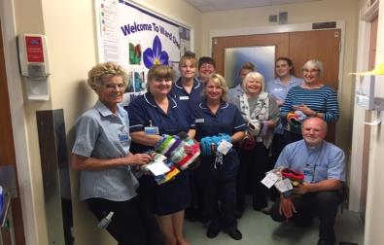
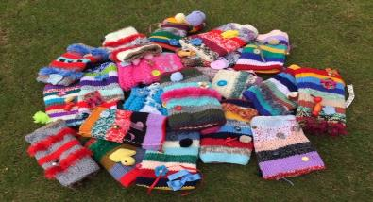

SI BROMSGROVE & REDDITCH continued

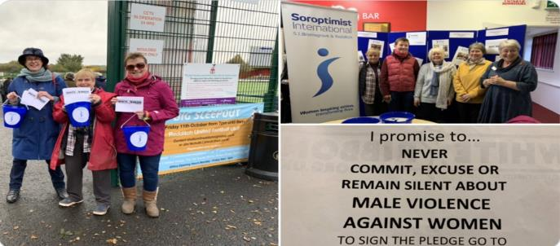
Redditch United Football Club had been contacted in July 2019 to see if they would be interested in becoming accredited to the White Ribbon Campaign. We arranged with the club to go to one of their home matches in November to be close to White Ribbon Day. We had handouts with the White Ribbon logo on one side and the promise.

We handed out about 60 flyers and the generous fans gave us donations totalling £70.00 which was sent to the White Ribbon Campaign. Redditch United Football Club signing up to The White Ribbon Campaign will act as a brilliant role model for fans young and old. We are now contacting Bromsgrove Football Club to encourage them to sign up as well.

MODERN DAY SLAVERY AND HUMAN TRAFFICKING AWARENESS DAY - OCTOBER 19th 2019

The Awareness Day was held in Bromsgrove Methodist Church Centre.
The speakers were ‘Hope for Justice’, ‘Hope at Home’, ‘Transforming Communities Together’, ‘The Children’s Society’ and ‘Stop Loan Sharks’. They told us about their work identifying victims and finding them accommodation until they could get back on their feet. “The Car Wash App”, tells how to identify and report victims spotted in Car Washes, children involved in “County Lines”, and finally how people can get drawn into using Loan Sharks which then leads to exploitation and Slavery.
It was a very interesting day and drew out many questions from the large audience.
If anyone is interested in having the presentations from that day, please email liz.every@talktalk.net

SI COVENTRY
Dates for Diaries
Tuesday 11 February – supper meeting, with presentation about Coventry’s Night Shelter
Sunday 29 March – Annual Lunch at Coventry Golf Club
Tuesday 12 May – supper meeting, with presentation by Mandy Sanghera, International Human Rights Activist
Saturday 18 July – Cream Tea Garden Party
** Saturday 3 October ** Autumn Charity Fashion show - £15 including glass of Prosecco and afternoon tea. High Street brands e.g. Monsoon, Wallis, M&S. Full details to follow

BIG CURRY NIGHT
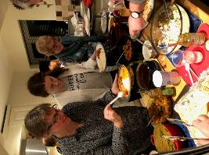
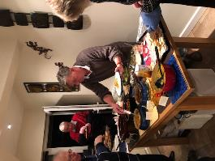
It was a full house at President Carol’s at the end of January for a wonderful curry spread, including Indian salad starters, many different curry dishes, dahl, pickles, followed by homemade mango ice cream as well as kulfi and Indian sweets. Rayner Rees from SI Bridgend came to tell everyone about ChoraChori in Nepal, and we raised £400 for the project.

Loves Me Loves Me Not project

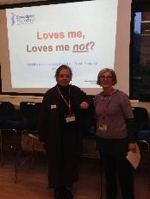
Carol, Sarah, and Sue presented this project in four separate assemblies at Finham Park 2 School in the week beginning 25 November. Except for most Year 11 pupils, who were taking mock exams, all pupils attended as well as many of their mentors. Each pupil received one of the ‘bookmark’ project cards, and we left a range of resources with the school for follow-up sessions.

South Sudanese Refugees in Uganda
In September, member Hazel told about her work with South Sudanese refugees in Uganda. Uganda has an open policy to all refugees - 1½ million have fled ​over the border from South Sudan ​since 2016. Uganda has opened 3 ​gateways to cope with this in-flow and, after being processed by the UNHCR (the UN refugee agency), refugees are registered, thus securing rights such as food rations, shelter, and access to education and healthcare.

SI COVENTRY continued

Hazel undertook research at three refugee settlements in 2018 to investigate refugee experiences of sexual and gender-based violence and torture, as well as access to appropriate services for survivors. They interviewed 20 men and 31 women survivors as well as 50 stakeholders. South Sudanese militia were mainly involved in the torture and violence. Both women and children were gang-raped and men were sodomised. Many men were exposed to torture and had been left disabled or mentally ill. Within the settlements there are still issues of insecurity, sexual violence, and domestic abuse, mainly affecting girls and women.
Hazel secured a small amount of funding from Coventry University to help these survivors set up small social enterprises, to enable them to provide income for their families and offer social and psychological support to each other. In May 2019 a visit to the same refugees found things much improved. Tarpaulin shelters had been replaced by mud huts, with access to clean water and latrines. The refugee groups had set up a number of small-scale businesses including a basic pharmacy run by a qualified apothecary, local convenience stores, and a business manufacturing soap. Those involved all had improved mental health, and they really appreciated being able to work with and be supported by the cooperative nature of the social enterprise governance structures.

Women’s Research Group
Our speakers in October were Christine and Elizabeth from the Coventry Women’s Research Group, who took us through some of the stories from their books. These were stories about inspirational women from Coventry and highlighted the strength of purpose of these women who fought for women's rights before it was accepted that women had rights. Tales of how they coped during the second World War especially, when they had to cope with the Blitz, encouraged members to tell of their own or family experiences. We have a lot to live up to but as Soroptimists we do our best to follow the examples of the strong women who have gone before.
For details of the group’s books see:
https://thewomensreseachgroup.weebly.com/published-books.html

Some things are worth repeating...
... and coming to the SI Conference is amongst them for Health Help International (HHI). Not only do June and I [Chris Byrne] get to visit a variety of places across the country, the conferences give us an opportunity to sell our crafts and raise funds for our work in Zambia and India. This was a bumper year - £387! However, it is more than just raising funds; we get to talk to other Soroptimists about our work, spreading the word across the UK. There is also a hope that we will be invited to present our work to other SI clubs (one invite from Southport already) and see where that relationship takes us. Hopefully in the same way as SI Coventry, who have donated so much and given us such encouragement. So strong is our bond with SI Coventry that we see the club not only as generous supporters but, just as importantly, as friends.

SI HEREFORD
No report this time

SI KENILWORTH AND DISTRICT
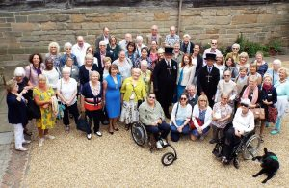
Soroptimist International Kenilworth & District has had a superb year for the club’s 50th anniversary. We held events specifically to celebrate our anniversary with local dignitaries, service clubs and national and international guests. At our celebration weekend in July 2019 we welcomed 17 overseas guests from our friendship clubs in Holland, Germany, the UK and our club members. On the Friday, one of our members hosted a welcoming party at her home. On Saturday at Lord Leycester Hospital, we were joined by members of Midland Arden Region Clubs. Isobel Smith attended on behalf of Federation President Sue Williams. Saturday was rounded off with a most enjoyable supper and Barn Dance at the Kenilworth Golf Club. On the Sunday, after a service at St Nicholas Church, we had lunch at the Holiday Inn before our visitors returned home.

New Members
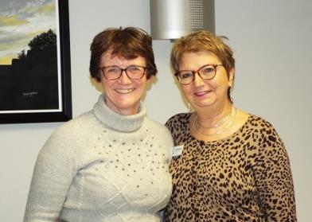
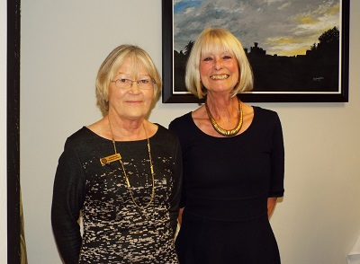

We are very pleased to have inducted Marion Adcock, Rachel Hextall, and Julie Pemberton as members of the club since last April. Arrangements have been made to induct Julie Montgomerie and Lin Sullivan at our next meeting. We welcome all of these members and hope that they will soon feel at home in the club and enjoy being involved in our programme action and social events.

SI KENILWORTH AND DISTRICT continued

CHRISTMAS CELEBRATIONS

Our Christmas celebrations began quite early this year as our December business meeting was replaced by an evening of old-fashioned fun and games.
Club members were asked to wear a festive hat, jumper or a complete Christmas outfit (if they so desired!) to be judged by a Soroptimister later in the evening!

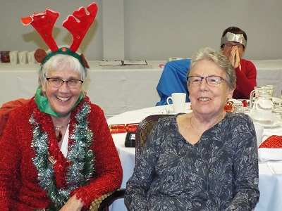
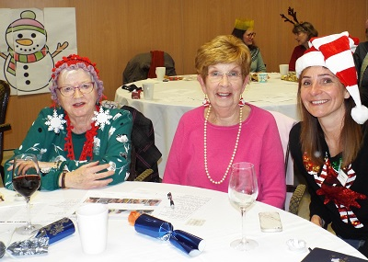
So, what on earth do I say now? –

Domestic Violence Training
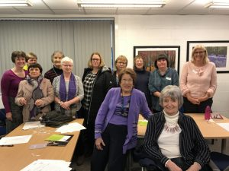
Would you know how to respond in those first moments if someone had enough courage to tell you that they thought they were being abused?
Would you recognise the signs that someone might want to tell you something important about their situation?
Would you know how to raise the subject if you thought someone might be in an abusive relationship?
Working with a trainer on behalf of Warwickshire Refuge, eighteen members of Club and three daughters attended a workshop to look at these questions. The trainer based our session on IRIS, a course she uses to train GP surgeries about supporting victims of domestic abuse.

Our aims were to raise awareness of the basic issues surrounding Domestic Abuse, and, to be aware of safe and appropriate ways to respond to a personal disclosure of Domestic Abuse.

SI KIDDERMINSTER AND DISTRICT

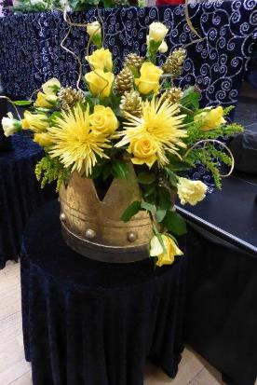
On Tuesday, 19 November approximately one hundred people joined us for our Floral Art Event. Our demonstrator for the evening was one of our members, Mrs Janet Ince. She delighted us with no less than five beautiful Christmas flower arrangements. The colours of the flowers and Janet’s superb talent brightened everyone’s evening. A light supper was also served.

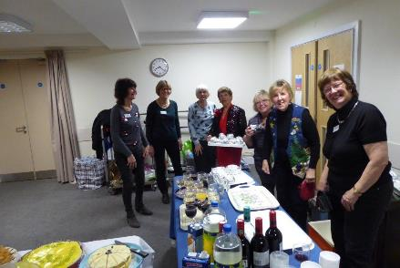
The flower arrangements were raffled along with two further raffle prizes kindly donated by La Brasserie and The Rose Theatre. We are grateful for their support.

With the ticket sales, donations and the raffle we have exceeded our fund raising expectations and we would like to thank all those generous people who attended. Approximately £1,000 was raised. The event was organized to raise money for West Mercia Women’s Aid.

To mark the 25th anniversary of the Beijing Declaration and Platform for Action, there was a call for 16 days of activism to people from all walks of life to learn more and take a stand against the pervasive rape culture that surrounds us. On the afternoon of 25 November, we turned Kidderminster Town Hall orange to draw attention to the ‘End Violence Against Women campaign’. Members of our club, joined by some of our friends from the Kidderminster charity ‘Nightstop’, organised the event to share information about the campaign with the general public.
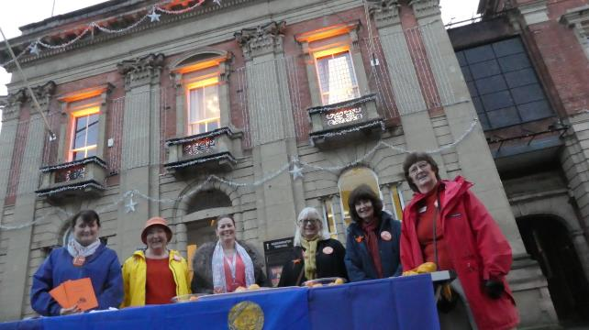

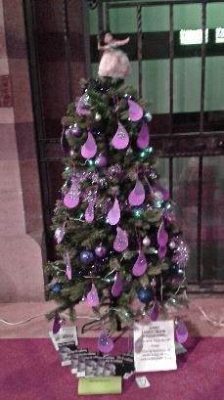
SI RUGBY

SI Rugby is looking back at a Christmas Season of celebration and service. We began in November with a Diwali meal and then continued the international theme with a Mexican Christmas meal.
Each year we enter a Christmas tree in the St Andrews church festival and this year our theme was Purple Tear Drop to raise awareness of Modern Day Slavery.

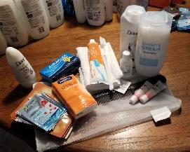
Christmas presents were given to the children in the Rugby Refuge and to the young people at the Rugby Young Carers and we gave each child at the refuge a wrapped gift to give to their mother. Toiletry packs were assembled for the women users of Hope

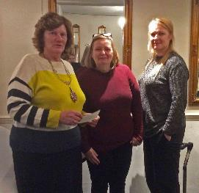

Our January meeting was attended by Tracey and Rachel from Refuge in Warwickshire and we were pleased to present a cheque for £1000, money raised at the International Women’s Day Wellness evening and from the sale of bras collected from around the town.

Another new member in February brings our membership up to 25 with one linked member.

We will be celebrating International Women’s Day on 13 March with another Wellness Evening to bring together the women of Rugby for an evening of pampering and demonstrations.

SI SOLIHULL AND DISTRICT

Our club continues to have a healthy membership of 50 members.
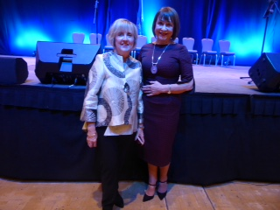
Following the Bournemouth Conference in November and into December, our club celebrated our member Isobel Smith becoming Federation President. Being very proud of her great achievement, we presented her with a drawing of our club members as well as catching her out with the 'big red book', 'Isobel Ann Smith, this is your Soroptimist Life' during our Christmas Party at Hogarth’s Hotel.
Socially we enjoyed seeing our members modelling clothes at John Lewis in Solihull in aid of Action for ME. We donated 100 books to the Beanstalk charity and we collected for the Women's refuge toiletries and other essentials. As part of President Jan's chosen charity, we gave out 14 information packs to borough schools and doctor’s surgeries on behalf of Action for ME.
We raised £1,500 at a coffee morning for the Karma Nirvana charity and we are working on raising awareness about the White Ribbon campaign. Thus far, £5,100 for Action for ME has been raised to provide an advocacy group in the West Midlands. Marina McGoldrick leads on much good PA work this year in these areas.
At our January business meeting, President Jan Tilsley welcomed Fiona Joseph who gave us a fascinating talk on the life of the respectable Quaker girl Beatrice Cadbury - the heiress who gave away her fortune as she sought to pursue a fairer and more equal society as a bold anti-capitalist and peace activist.
Our Friendship Links group held a Scotch Broth soup lunch on Burns Day, January 25th, at the home of Angela Sadler which raised several hundred pounds for our Friendship link group in SI Masaka who are struggling to pay their subscriptions
Happy New Year to all our fellow Soroptimists in the region.
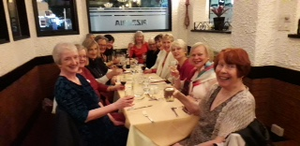

SI STOURBRIDGE AND DISTRICT
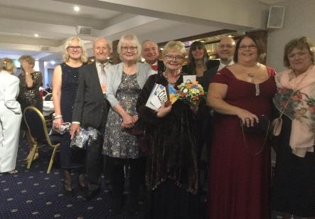
President Anne Rogers was pleased to welcome SIGBI President Isobel and MAR President Rose to our Annual Literary Dinner in November, where authors Cathy Hunt, Mike Gayle and performance poet Emma Purshouse impressed us with their work. Table flower arrangements included some orange to advocate for abolition of Violence against Women. We raised £1,200 from raffle and tickets towards our Toilet Twinning Town and Chora Chori Nepal objectives. Members have been developing new partnerships during the autumn and wearing orange to raise awareness at a number of social events.
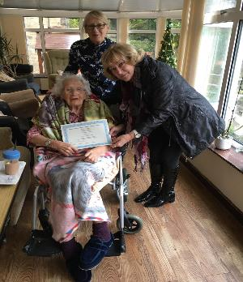
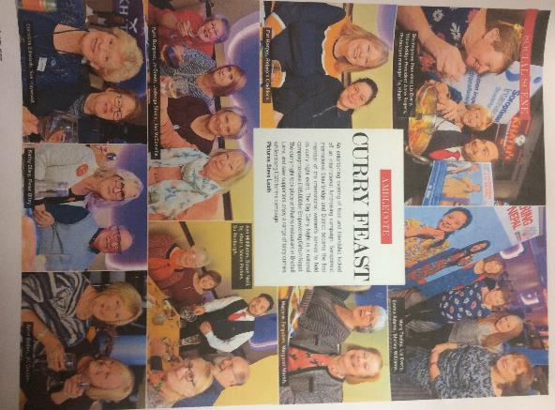
A memorable and very moving Memorial Tea for Sarah Bookey was held at the beginning of December at the Botanical Gardens and attended by many of us, raising donations for Sarah’s charity, The Eve Brook Scholarship Fund. President Anne Rogers and Su Roxburgh also visited in December our longest serving Soroptimist, Marion Griffiths, now in residential care in Wrexham, and presented her with her 50-year Long Service Award. Despite being Honorary for some years, Marion has generously still paid her membership fee. We are grateful to local Soroptimists for arranging visits to help settle her.

Looking forward to the future, an extremely successful first ‘Curry Night’ was held in aid of ChoraChori, our Federation project, at a local Nepalese restaurant, Khatri’s. The night was well photographed by local press and made a Select magazine edition, significantly raising our media profile. Our most recent new member, Elizabeth Attfield, was welcomed with her induction that evening. Since that evening we have sent a £1,800 cheque to SIGBI for Chora Chori.

So it is planning time again for next year’s programme, with our President Elect Rachel Tennant and our Vice-President Linda Sanders seen on my left in the Literary Dinner photo. We shall be Standing Up for Women on IWD 8th March with a President’s Sunday afternoon tea, profits going to our local charity Mary Stevens Hospice.

SI STRATFORD upon AVON AND DISTRICT
We have continued our community engagement through:
Supporting our local Women’s Refuge – Over the last six months the Club has developed links with our local Refuge, a charity we have chosen to support in 2019-20. So far, the Club is delighted in that through the initiative and connections of one of our members, it has been able to steer the Refuge to obtaining a grant from the Singer Foundation of over £1,000. This funding was given on the basis of providing educational related resources for those children who come into refuge. Items included Fire Kindles, white boards, Chad Valley sets, electronic keyboards and card games.

At the request of the Refuge we have also distributed literature and posters throughout the district to raise awareness of helplines and support contacts. Amongst the places we have sought help in our cause to raise awareness we have approached doctor’s surgeries, dental practices, hospitals, libraries, churches, gyms, cafes, shops, supermarkets, stores and posted on a range of notice boards.
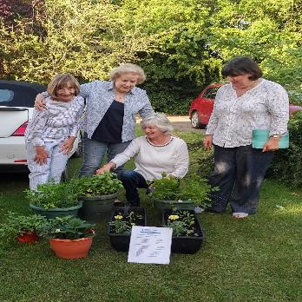
Collectively through our education, environment and health groups we have been able to hand over to the Refuge, welcome packs for the women and children as well as planters for the garden.

The planters, provided a wonderful range of herbs, salad items and strawberries which were well received saying “these are something the children will enjoy as much as the adults”. We also provided recipe cards along with ingredients that enabled families to make a hearty pasta and use some of the herbs that were in the planters.

Guests attending our practical workshop during our 60th anniversary celebration weekend kindly helped in packing goods for our first delivery of welcome packs. Along with pretty toilet bags full of important essentials, we included household essentials, bed linen, towels, writing pads, sewing kits, nail varnish, hair accessories and more importantly - chocolate, all put together in colourful useful bags for using on onward journeys. For children, we filled handmade toilet bags, and put soft toys, crayoning books, crayons, stickers and beautifully illustrated reading books in their welcome packs.

The five packs are given to new arrivals and seen as being “a lovely idea for women and children – making a real difference to their self-esteem”.

SI STRATFORD upon AVON AND DISTRICT continued

The relationship continues to grow and in December Refuge staff came to our December meeting and gave a stimulating talk on the work that the Refuge does, all set within the national and local context. We presented a further 5 welcome packs and herb replenishments for the planters along with 5 Christmas hampers and individual gifts for each lady in Refuge, and for all children.
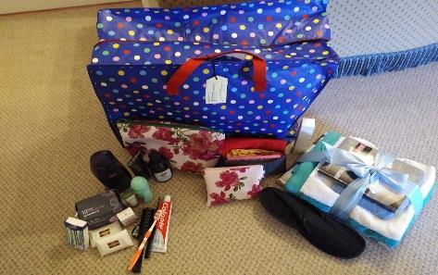
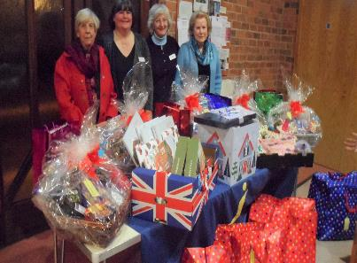

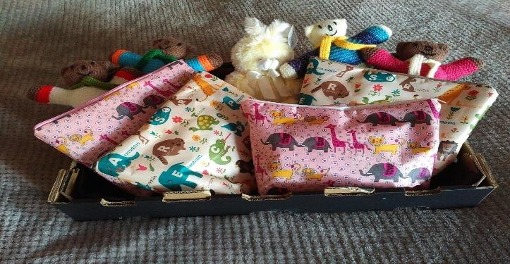

Fund raising for Smart Works -
Following on from a recent Midland Arden Region presentation from Smart Works, the Club is sponsoring several members (or their partners) to a bicycle challenge. The challenge is to complete a 200-mile bike ride during week commencing 9th March, finishing on the Greenway in Stratford on Sunday 15th March. Best of luck to Judy, Sarah and Pete. All funds raised will go to Smart Works.

International engagement
Practical sessions have been held, where sanitary towels have been assembled to go to ladies for sewing and selling in Sierra Leone.

SI WORCESTER
In order to continue operating in 2019/20, the Club agreed to empower its members by working in three separate programme focussed groups; each group also taking turns to organise the administrative functions. With this approach each member had “ownership” for future decision-making and an individual role in the Club’s success.
During the period from September to December, the Club was led by the “Violence and Conflict Resolution” group. A variety of speakers from local charities covering this topic(s) came along to our Supper meetings to educate, empower and enable us to better understand their needs and to focus our activities in the future.
On 21st September, alongside SI Hereford we co-hosted the Regional AGM at Worcester County Cricket Ground, which was a great success.
A number of fundraising events have taken place, including a Sunday lunch at a member’s house followed by board games, another success. A Garden Fete in the summer raised £300 for Meru. Also a full afternoon tea at a member’s house. Both the lunch and tea raised around £200 each which for a small club is excellent.
In January 2020, the “Economic Empowerment and Environmental Sustainability” group under the leadership of Pat Martin took over. The initial meeting was a ‘Reflection Afternoon’ with the objective of reviewing the current progress of the 2019/20 arrangements and forward planning for 2020/21. This meeting was well attended and numerous positive comments and opinions were offered, making it a most constructive afternoon.
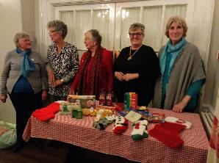
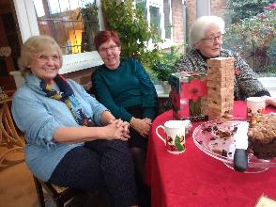
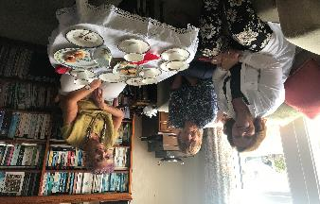
The second meeting in January saw 16 members and friends from both a WI and Friendship Group visit Envirosort, the largest recycling plant for Worcester and Herefordshire County Councils. This ‘partnership’ event was educational and provided much food for thought on a damp and foggy afternoon. There will be more on this in the next edition of News and Views.

SUNDAY 8 MARCH 2020
www.internationalwomensday.com
Celebrate women's achievement.
Raise awareness against bias.
Take action for equality.

#EachforEqual #IWD2020

