News and Views from SI Stourbridge - July 2023
Coronation supper – As an early celebration of King Charles III coronation we gathered together in Linda Sanders beautiful garden for a fantastic, shared supper. There was live music, bubbles, amazing food and of course a raffle!
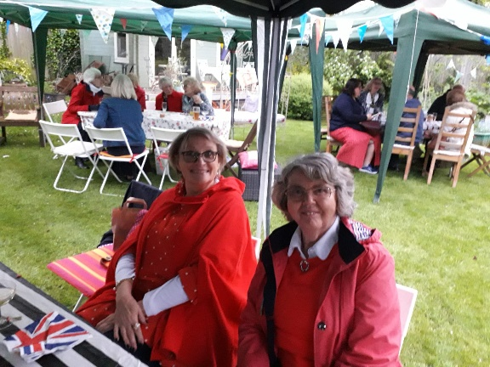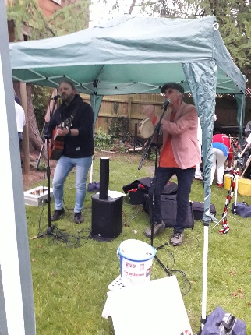
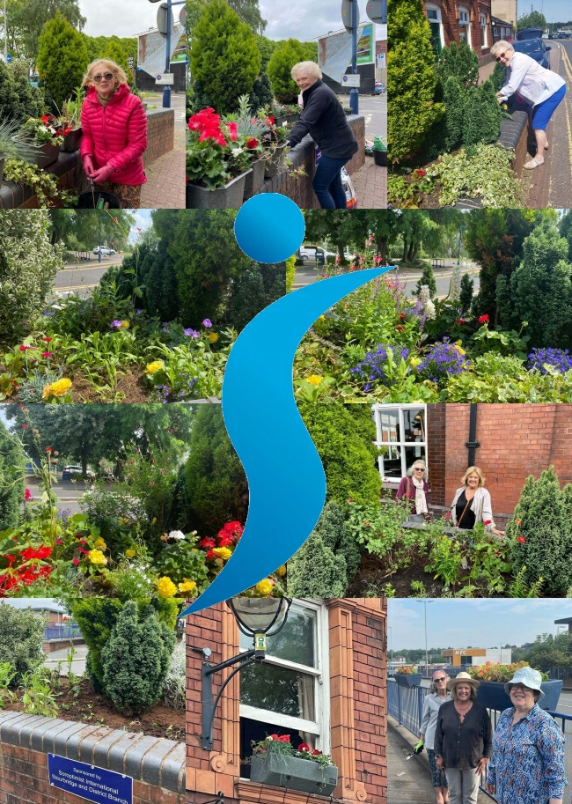
Stourbridge in Bloom – It’s summer so it all hands to the watering can to make sure our raised bed and 7 troughs are looking their best for the Britain in Bloom judging!
We have a fantastic team who water and weed with gusto. Here is the poster we produced for the judging day showing us at work.
Sadly, the judging day was a bit damp!!!
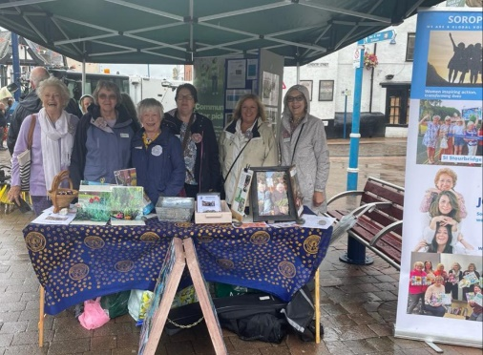

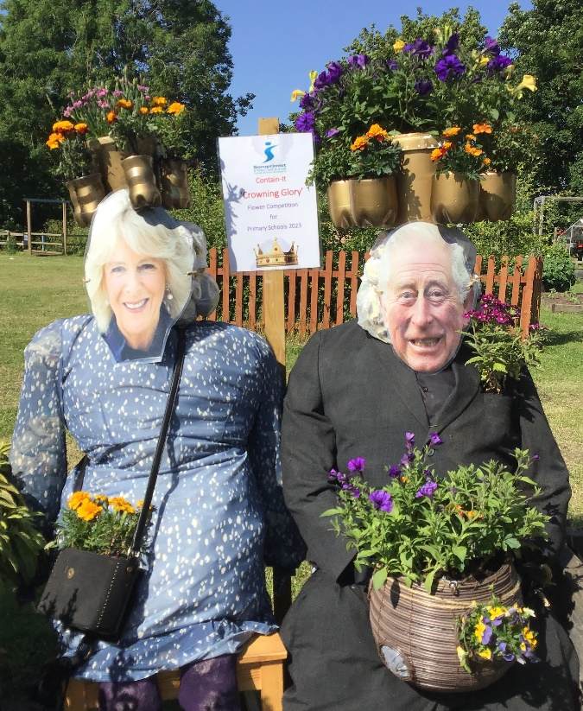
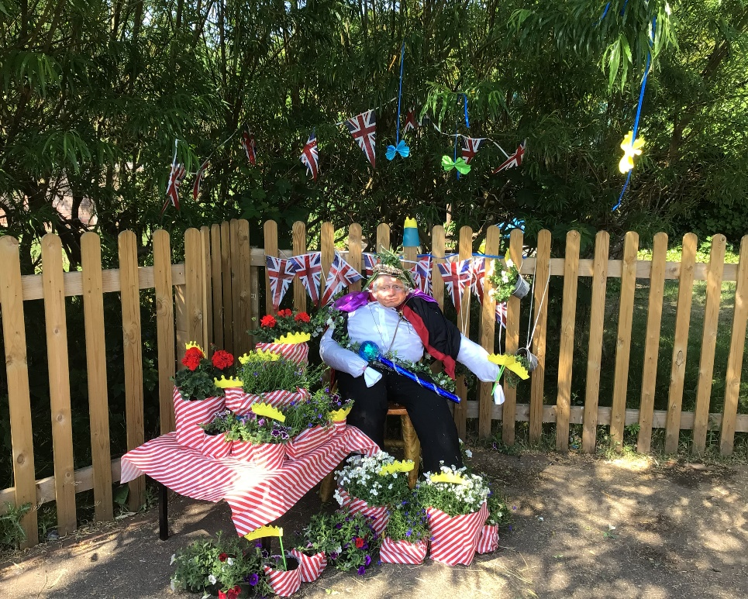
We have run again our primary schools “Contain - It” Competition, for container gardening. This year was a coronation theme ‘Crowning Glory’ and we had some entertaining entrants! Here are a couple of the finalists.

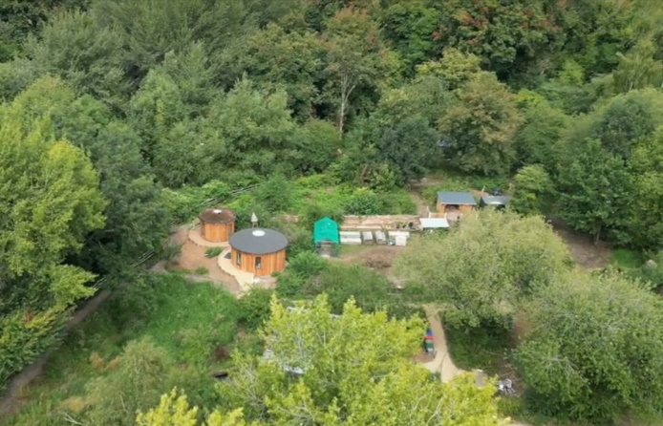
We have formed an advisory group to help support Riverside House, a fantastic Environmental and wellbeing project that is transforming part of our town between canal and river. Lloyd Stacy who runs the project came to share his vision with us at our June dinner meeting
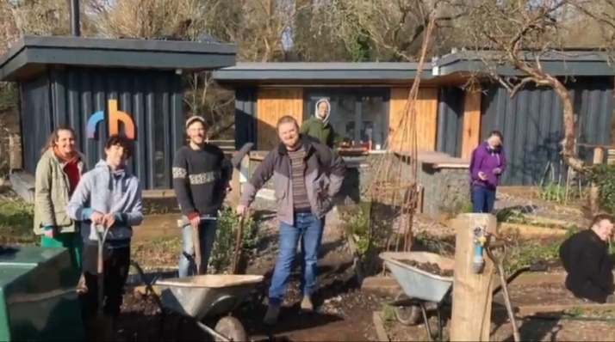
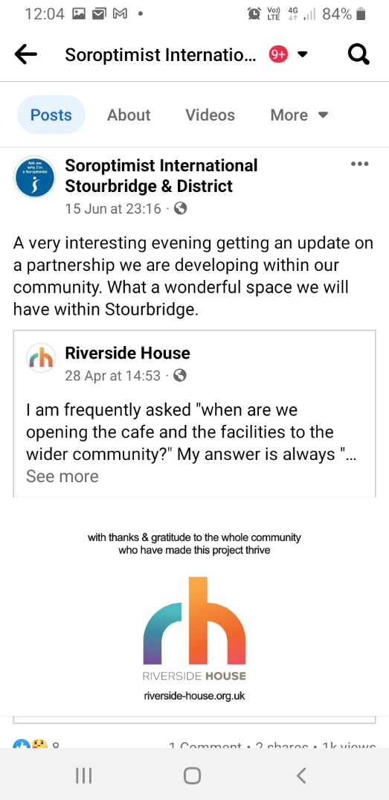

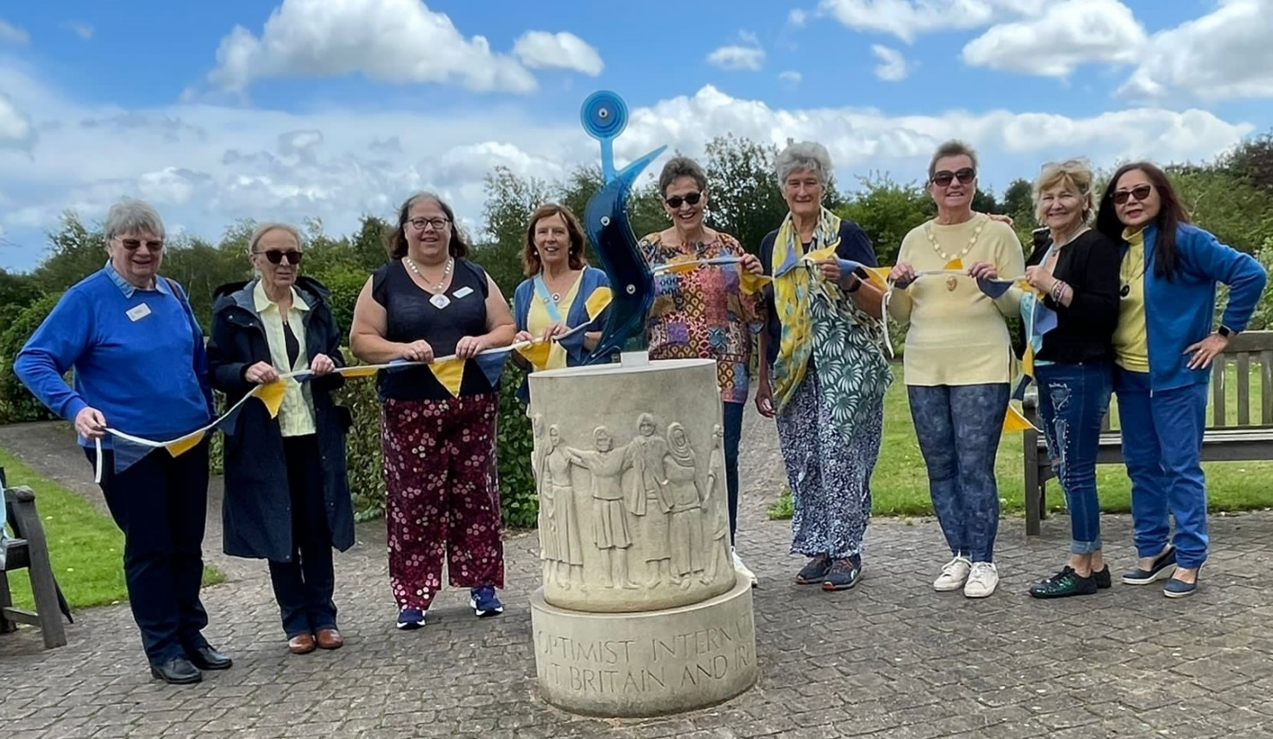
And finally, our president Rachel marks the Day of Action 3 regions picnic at the National Memorial Arboretum on 15th July!
Jane Clarke MBE
SI Stourbridge

