News and Views from SI Stourbridge – January 2024
Happy New Year from all of us at SI Stourbridge and District, wishing you all health and happiness!
We will be planning for the year ahead at our meeting this month and that will include for our club a change of venue to keep our meetings affordable, something which I know affects many clubs.
We had 2 great events in November and December at Hagley Golf club, our Literary Dinner and Christmas meal and it may be possible still to hold our major events there.
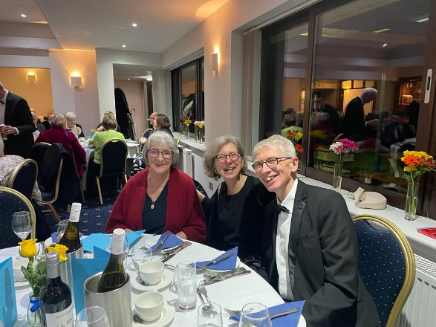
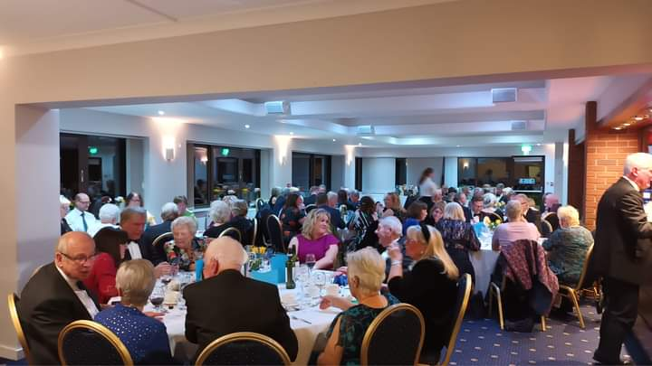
Our Literary Dinner
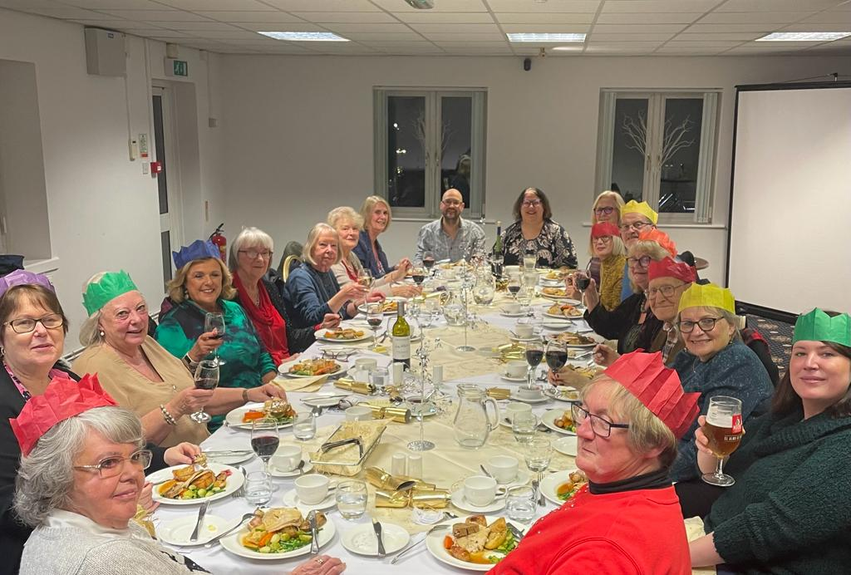
Christmas Meal

In November 4 members enjoyed the Annual Conference in London, great meeting up with old friends and new!
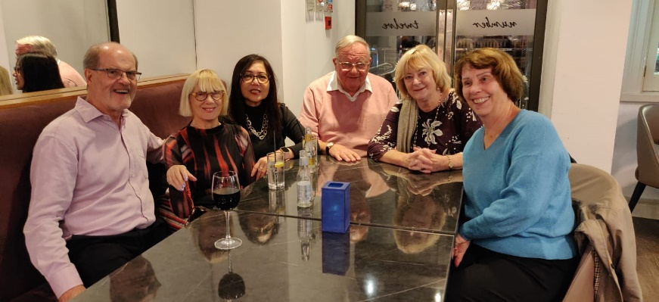
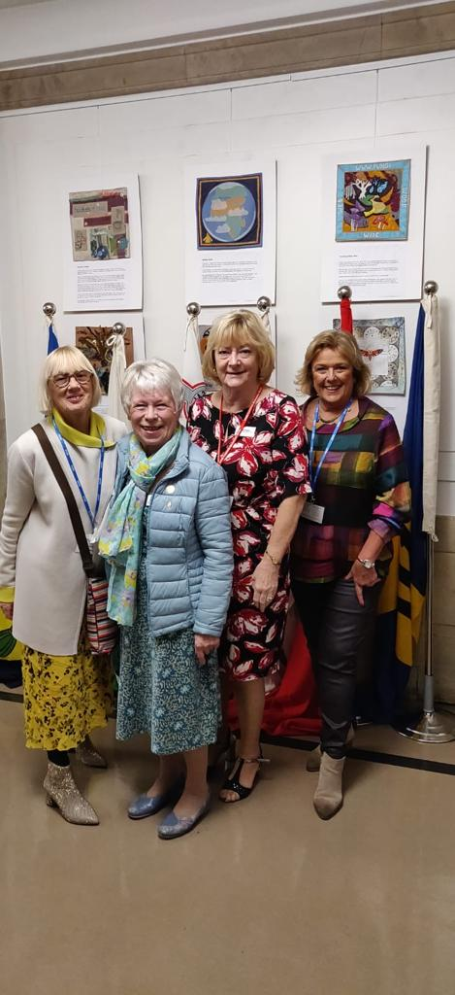

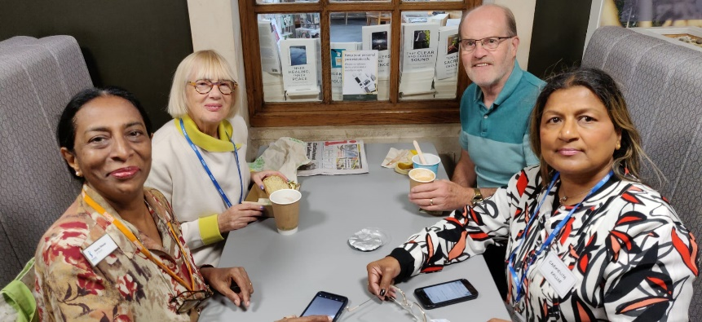

We promoted Soroptimist International by creating 2 wonderfully decorated trees at 2 different venues in the area which were much admired and accompanied by literature about the club.
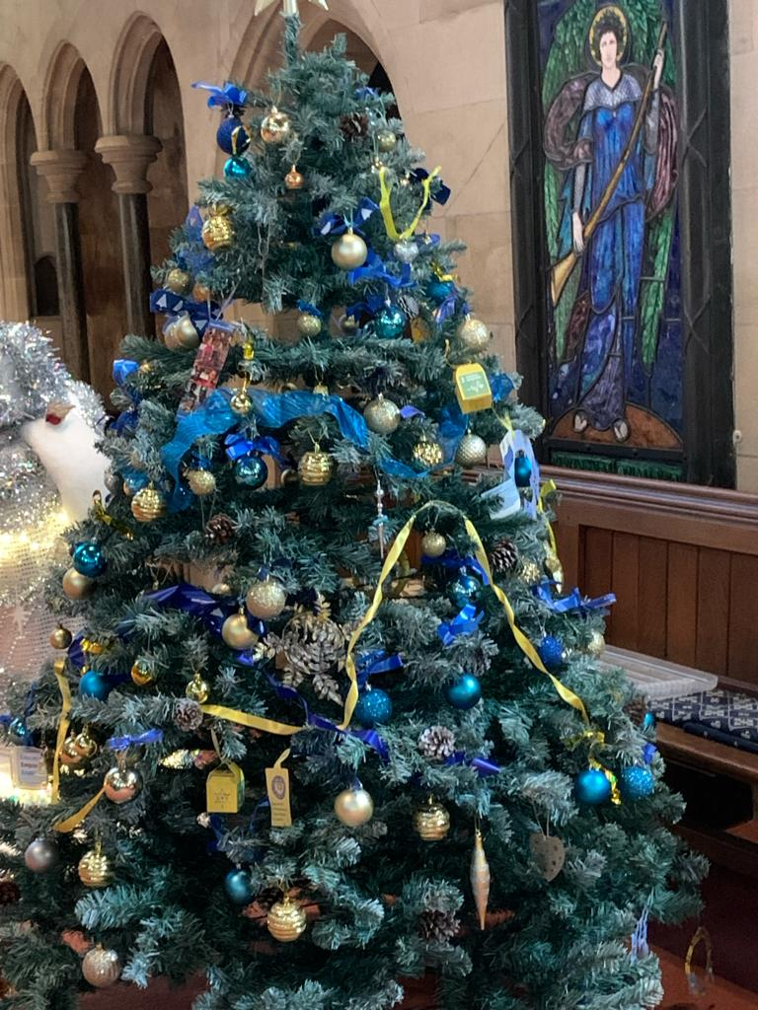
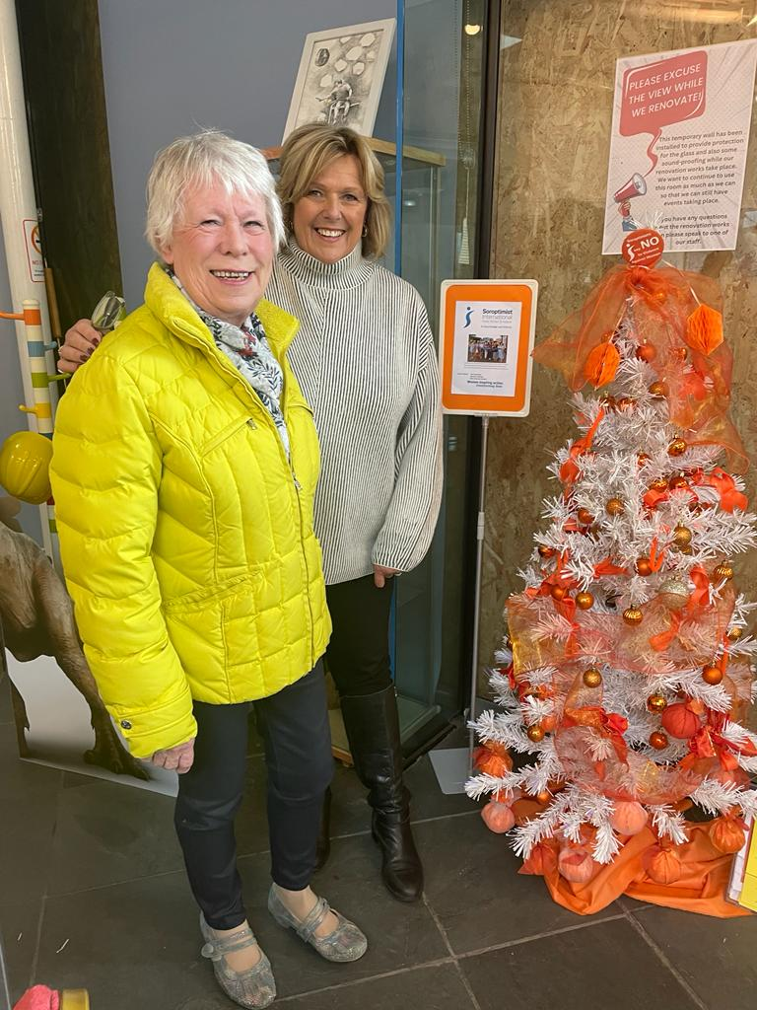

As usual we also supported families in our local refuge with gifts for Christmas.

And finally, as another change for the New Year we thought we would share some stories of how individual members are putting their Soroptimist values and Goals into action.

Starting with a lovely story of Janet in Uganda.
Janet was just 9 years old when our member Ann read about her in the Farmers Overseas Action Group (FOAG) newsletter and paid for her first prosthetic leg, that was 10 years ago. (Another of our members Jan is Treasurer of that group and keeps us up to date with all their news.) Janet has over the years become regarded as part of Ann’s extended family and the club has also taken a keen interest in her welfare and supported her when Ann has suggested ways we might help.
Janet moved from Masindi Handicap School to IKOBA secondary school during lockdown where she studied 10 subjects and she is now preparing to start college, keeping Ann informed using the phone which the club provided. She had her 19th birthday on 6th December and was so grateful to have a new leg fitted on 20th of December ready for Christmas.
Here is Janet proudly showing us her new leg and the new shoes she had for her birthday
“Now I can walk with everyone”.

Well done to Ann for the many ways she makes life better for Janet and her family and for Jan and other club members who support FOAG.

Jane Clarke
for SI Stourbridge & District.

