CHORACHORI APPLICATION FOR THE FEDERATION PROJECT 2019/22 – SUPPORTING TIPLING GIRLS AND WOMEN.
Where? | Why? | What? | Who? | How?
 | 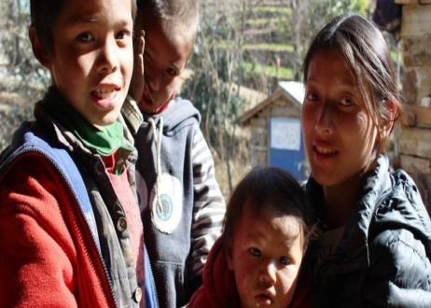 |  |  | 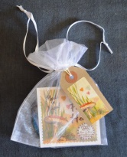
The charity works in Nepal, funding and supporting trafficked children until they can be safely returned home. Using Soroptimist International funding the charity supported a group of vulnerable girls from Tipling in the Dhading District of Nepal. The 2015 earthquakes devastated this beautiful area, which is quite close to the Tibet border. In areas such as Tipling, violence and abduction against girls seems to be treated as a social norm.  (To find out more contact:  Rayner on 07894940033 and look at the charity web site -  www.chorachori.org.uk) | Using the SI grant ChoraChori has been very successful in supporting Tipling girls who completed their School Leaver’s Certificate (Grade 10) to achieve further academic progression. This was so successful that in June 2017 they admitted a further eight girls. The girls attend college in the mornings and in the afternoons they are taught craft skills  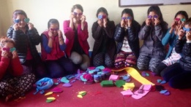  The charity would love to build upon this and continue to support women and girls in this area. | The Soroptimists International President’s Appeal 2015-2017 “Educate to Lead” has funded this project within the broader programme of educational and training support to vulnerable girls in Nepal. The charity would like to build on this and SI Bridgend asks Wales South to support the charity in applying to be our next Federation project (2019 – 2022).  ChoraChori will purchase land and construct an earthquake resistant girls’ empowerment centre in Tipling, which will be staffed by girls educated by ChoraChori in Kathmandu. The centre will be self-supporting by offering accommodation for paying visitors, craft training and support for the local primary school.  This would almost entirely a SIGBI project leaving a lasting legacy in this poor area. (Maybe they could paint the building in SIGBI colours!) | ChoraChori is the Nepalese word for children. Philip Holmes is the CO-Founder (UK). He is a former British Army officer who joined the charitable sector in 1999. He has been the CEO of two previous charities for Nepalese children and in the period 2004-2012 headed up a programme that closed down a child trafficking route between Nepal and India.  SI Bridgend would work closely with the charity to ensure that the project is on track and fulfilling its promise.  ‘Once again we are grateful to the Soroptimist International President’s Appeal 2015-17 for their funding thus far under their Educate to Lead programme’ | If successful in becoming our new Federation project clubs would support ChoraChori by raising funds. We would also be able to purchase and promote the craft items made by the girls from Tipling. These are carrier bags made from recycled rice and lentil sacks and hand-stitched felt heart that has a little pocket for milk teeth and three blank notes for the child to write a personal message to the tooth fairy.  