CHORACHORI APPLICATION FOR THE FEDERATION PROJECT 2019/22 – EMPOWERING GIRLS IN NEPAL
Where? | Why? | What? | Who? | How?
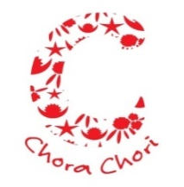 | 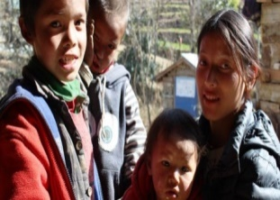 | 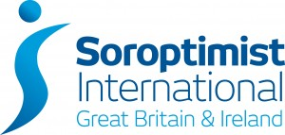 |  | 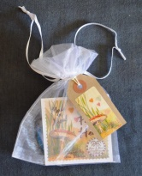
The charity works in Nepal, funding and supporting trafficked children until they can be safely returned home. Using Soroptimist International funding the charity supported a group of vulnerable girls from Tipling in the Dhading District of Nepal enabling them to complete their secondary school up to grades 11 and 12  The refuge is based in Kathmandu  (To find out more contact:  Rayner on 07894940033 and look at the charity web site -  www.chorachori.org.uk) | ChoraChori want to continue … “Making a sustainable difference to the lives of vulnerable and trafficked girls and young women through education and training to enable them to continue their education safely at home, enhance their employability and become role models and leaders of the future.”  The charity wants to build upon its proven success and in February 2018 ChoraChori became involved in the ‘#metoo’ movement and supported a girl, in Tipling, who had been the victim of an attempted rape. In the past few weeks five rape victims have been admitted to the refuge and have received counselling and attended the same crafts classes as the Tipling girls which has helped reintegrate them with their peers  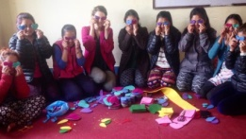  The charity would love to build upon this and continue to support women and girls in this area. | The Soroptimists International President’s Appeal 2015-2017 “Educate to Lead” has funded the original project and the charity would like to build on this. SI Bridgend asks Wales South to support the charity in applying to be our next Federation project (2019 – 2022).  The intention is to rent buildings close to the existing refuge and which would act as a training and income generating centre. The intention is to support 40 to 50 girls every year the majority of whom would be victims of sexual trauma alongside up to 10 girls from Tipling. While staying at the facility, most of the girls will attend the local school while engaging in part time craft training and income generation. Skills taught will include English and computing, alongside life skills and financial awareness. Local people will provide training as much as possible. | ChoraChori is the Nepalese word for children. Philip Holmes is the CO-Founder (UK). He is a former British Army officer who joined the charitable sector in 1999. He has been the CEO of two previous charities for Nepalese children and in the period 2004-2012 headed up a programme that closed down a child trafficking route between Nepal and India. He woks closely with Bhaskar Karki who is the CEO in Nepal.  They are supported by well qualified team of trustees.  SI Bridgend would work closely with the charity to ensure that the project is on track and fulfilling its promise. | If successful in becoming our new Federation project clubs would support ChoraChori by raising funds. We would also be able to purchase and promote the craft items made by the girls from Tipling. These are carrier bags made from recycled rice and lentil sacks and hand-stitched felt hearts that have little pockets for milk teeth and three blank notes for the children to write a personal message to the tooth fairy. Products can be for the local market and for export and range from craft items such as felt, textiles and jewellery through to agricultural products.  