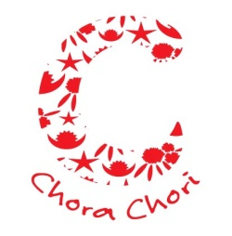
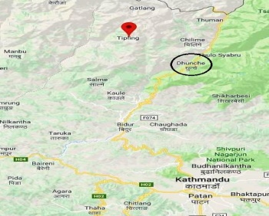
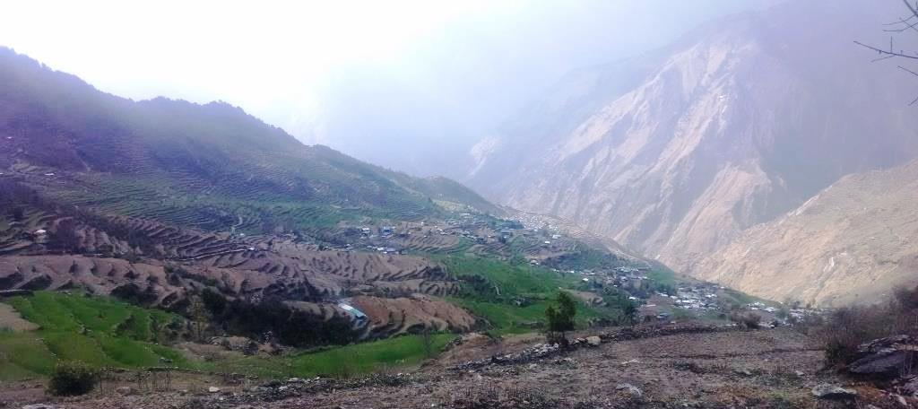

Empowering girls in Nepal 2019 - 2022
1. Introduction
ChoraChori is a UK registered charity (reg no 1159770) that supports a range of child-related projects in Nepal. These are implemented by an autonomous NGO partner, ChoraChori-Nepal.
This is a proposal for a three year programme for the empowerment and upliftment of girls at Tipling, a remote Nepalese rural community close to the Tibet border. The programme will be entirely self-sufficient after three years through income derived from volunteering and associated schools-based fundraising.

2. Background
In 2015 a Jesuit priest based in Tipling, Dhading District, asked for our assistance following the massive earthquake that had devastated that community. Most of the homes and schools in the community had been destroyed and he requested that we help a group of girls whom he had been teaching to complete their Grades 11-12 education (“Plus two”) by admitting them to our refuge in Kathmandu. Accordingly, we accepted ten girls in 2016 and a further seven girls in 2017. While with us – and attending the local secondary school - we have also trained the girls in craft skills as a secondary activity, further enhancing their employability.
The girls have responded well with one of them due to begin her Bachelors of Business Studies (BBS) degree course in 2018. Others have possibly reached their academic ceiling and we are reviewing their future options and providing career counselling support. We are finding that these beneficiaries are unenthusiastic about returning to their community where life is tough and especially so for girls. Girl abduction that leads to forced marriage has been commonplace and recently ChoraChori was involved in supporting a girl through a high profile attempted rape case. Our beneficiaries prefer the safety and life choices that come with living in Kathmandu. Also, this de facto “brain-drain” is of course detrimental to the Tipling community. We wish to improve circumstances and options at Tipling to encourage girls to continue their education at home while becoming role models and leaders of the future.

3. An opportunity at Tipling
The Tipling community has a population of 3,681 in 839 households, made up primarily of the traditionally marginalised Tamang ethnic group. 45% of the community is under the age of 19. People are very poor, getting by on subsistence agriculture, with 86% managing on a household income of £69 per month. Reconstruction of homes using earthquake-resistant designs are underway, using modest government grants (just over £2k per household). The Nepal army has rebuilt the school as a temporary structure and it is expected that another aid agency will rebuild the school definitively over the coming year.
One of Tipling’s major challenges has been its inaccessibility. It takes two days to get there from Kathmandu, travelling by road and then by foot over a difficult trail. However a road is currently being constructed that is expected to reach the village by October this year. This represents a significant opportunity as it will open up markets and make the village much more accessible to visitors and tourism. Tipling is in itself a strikingly beautiful village set against the backdrop of snow-covered Mount Ganesh yet there is no decent accommodation that meets even the most basic standards that trekkers might expect.

4. Programme Aim
To empower girls and young women from Tipling towards the betterment of the community.

5. Project objectives
a. To empower girls through education and training
b. To empower girls through employment
c. To provide community upliftment through girl empowerment

6. Outline plan
The programme will be conducted at two centres, Tipling and in Kathmandu.
Tipling
Once road access to the village has been completed, ChoraChori will purchase land and construct an earthquake-resistant girls’ empowerment centre that can be staffed by girls whom ChoraChori has educated in Kathmandu. The centre will serve several functions:
a. Provide accommodation for visitors/volunteers. These can be:
- ChoraChori international volunteers who can provide skills training to the community and develop its capacity to look after itself
- Schools groups who may undertake specific projects at Tipling as part of the International Baccalaureat (IB) community service module. These groups may be made up of 16-18 year olds with or without some parents
- Gap year students who wish to spend a month or two embedded in the community where they can experience life in a very different part of the world
- More mature visitors who may have interests such as photography, art, ornithology, writing and who seek inspiration while on an “escape” or a “retreat”
The accommodation should be for 16 people, self-contained with single, double and four person bedrooms, a kitchen, showers and toilet facilities. Tentage can allow an overflow capacity for a further ten people.

b. A computer room with internet access. This will offer:
- Teaching computing to children at the local school (which has no computers)
- Continuing education for girls who return from our programme in Kathmandu. Specifically girls may wish to study through the Indira Gandhi national open university programme that is highly regarded within Nepal.
- Allow girls the capacity to communicate and access information that may be useful for small business purposes or for seeking employment

c. A shared office that can be used for small business and income generation projects. We see potential for developing existing skills such as weaving and in niche agricultural products. For example, wild mushrooms grow prolifically in the nearby forests (see picture) and if these are dried it is expected that there could be a good market for organic Nepali wild mushrooms.

d. As an earthquake relief centre where emergency stores can be maintained. This can operate in coordination with the local health centre in terms of turnover of drugs and medical consumables. Sadly, it is only a matter of time before this facility is put to use.

Kathmandu
ChoraChori will continue to accept Grade 10 (School Leaver’s Certificate – SLC) graduates for completion of their studies. However, there will be a shift in emphasis whereby girls will be trained in skills that enhance employability with the “Plus two” education element becoming of secondary importance. The employability skills will be:
a. Developing a good command of English, both written and spoken
b. Computer training with a focus on MS Office
c. General communication and life skills, including financial management
d. Craft and agricultural training appropriate to Tipling needs
e. Hospitality training

At the end of the Kathmandu phase graduates have the options of finding employment in Kathmandu (or elsewhere) or of returning to Tipling where grant support can continue at a more modest level for one additional year as an incentive to return. This will be subject to returnees putting something back into the community (e.g. teaching computing) or of hosting guests at the Centre. Beyond the grant girls may become economically self-sufficient through craft or agricultural activities (see above).

7. Programme implementation
The programme will launch when year one funding is in place and the building can begin. Initially, the prime mover in Tipling will be Mr Som Ghale, a highly respected local man who is currently teaching in Birgunj, close to the Indian border. He is keen to return to his parent community and, along with some of his peers, work towards local development. After one or two years we expect to see a woman or women taking leading roles alongside Mr Lama.
ChoraChori-Nepal will provide local support and supervision of the project with head office paying at least six-monthly visits to the programme. ChoraChori in the UK will make an annual visit. However its major role will involve fundraising, including through communicating with the schools and volunteers who will interact with the Centre.

8. Sustainability
The programme’s sustainability is based upon fees paid by visitors/volunteers to the Centre, supplemented by fundraising from associated schools. We would expect a visitor to contribute £750 for a one month stay at the Centre, net of insurance and international flight costs.

Philip Holmes
Lt Col (retd)
Founder/CEO ChoraChori
28th March 2018

