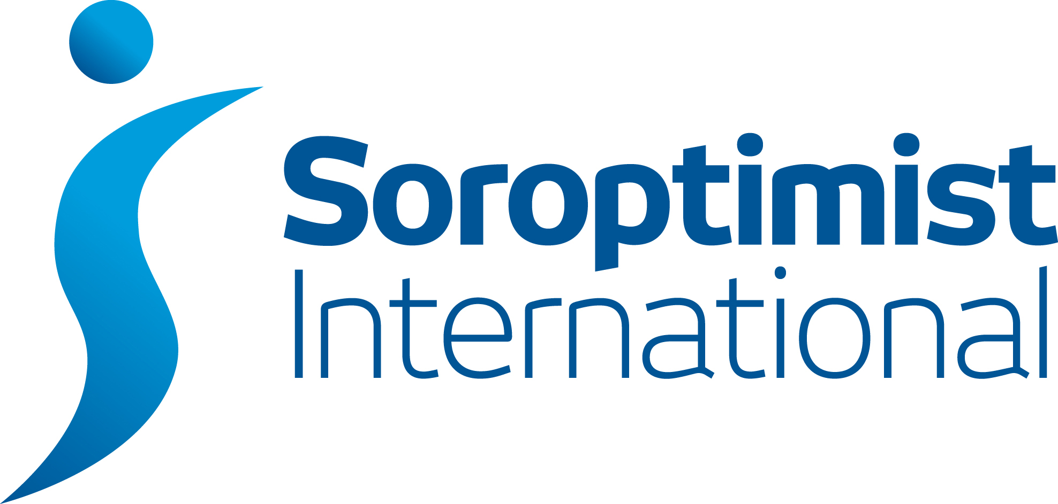

Wales South

SIWS Club PA Report to Regional Meeting

Club | Club PAO
DATE OF SIWS MEETING | 14th May 2016
Date report sent to Regional PAO & Regional Secretary
Please give a brief report on activities within your club on the following categories (boxes will expand as you key in your report). You will have 5 minutes at the Regional meeting to give a verbal report on ONE item.
Educate
Enable
Empower
Regional Project
International President’s December Appeal
Federation Project
Work with Partners and Government
Local Projects

